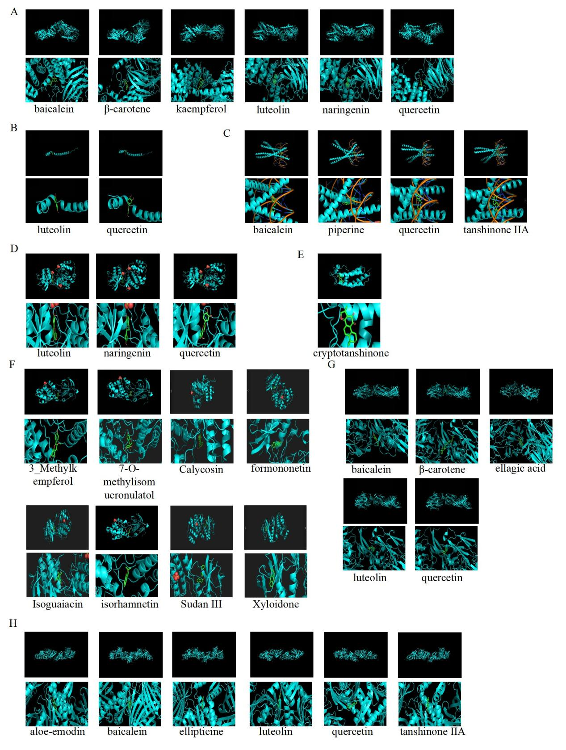
Figure S1: All active compounds can enter and bind the active pocket of the protein, A, Molecular docking between the six small molecule ligands and protein 5WBL (encoded by AKT1). B, Molecular docking between the two small molecule ligands and protein 2RGP (encoded by EGFR). C, Molecular docking between the four small molecule ligands and protein 1FOS (encoded by FOS). D, Molecular docking between the three small molecule ligands and protein 3W55 (encoded by MAPK1). E, Molecular docking between the one small molecule ligands and protein 6NUQ (encoded by STAT3). F, Molecular docking between the eight small molecule ligands and protein 3L8X (encoded by MAPK14). G, Molecular docking between the five small molecule ligands and protein 2VPF (encoded by VEGFA). H, Molecular docking between the six small molecule ligands and protein 7BWN (encoded by TP53). On the top shows the 3D structure of ligands and receptors, at the bottom shows the surface of the receptor and 3D structure of the ligands. AKT1: AKT Serine/Threonine Kinase 1, EGFR: Epidermal Growth Factor Receptor, FOS: Proto-oncogene c-Fos, MAPK1: Mitogen-activated protein kinase 1, MAPK14: Mitogen-activated protein kinase 14, STAT3: Signal transducer and activator of transcription 3, TP53: Cellular tumor antigen p53 and VEGFA: Vascular endothelial growth factor A.

