Appendix 1. Questionnaire on current motivation
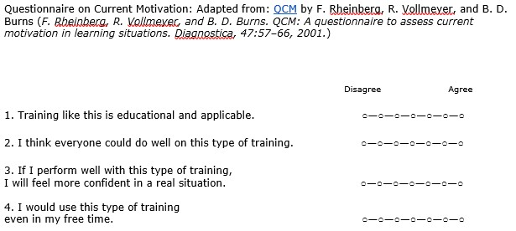
Note. Adapted from: F. Rheinberg, R. Vollmeyer, and B. D. Burns. QCS: A questionnaire to assess current motivation in learning situations. Diagnostica, 47:57-66, 2001.

