Supporting information

Supporting Information
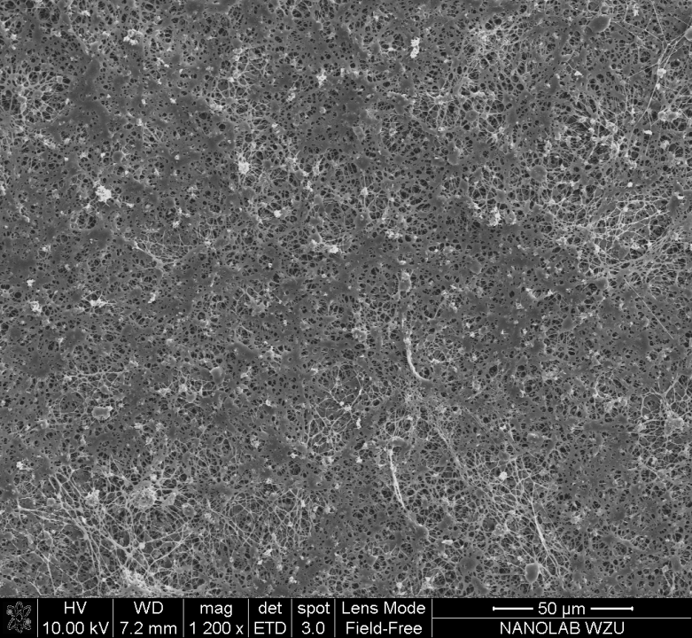
Fig. S1: SEM image of MgONPs-PCL/PTH-PCL nanofibers (MgONPs=0.5)

Fig. S2: Antibacterial effects of MgONPs-PCl/PTH-PCL (MgONPs=0.1 and 0.3) and PCL/PTH-PCL against S. aureus and E. coli. Values are mean ± SD from 3 independent experiments.
Fig. S3: The effects of PCL and MgONPs-PCL/PTHn-PCL membranes on proliferation of MC3T3-E1 cells. Values are mean ± SD from 4 independent experiments. Significant effect of treatment, **p < 0.01, *p < 0.05.

