Supplementary materials
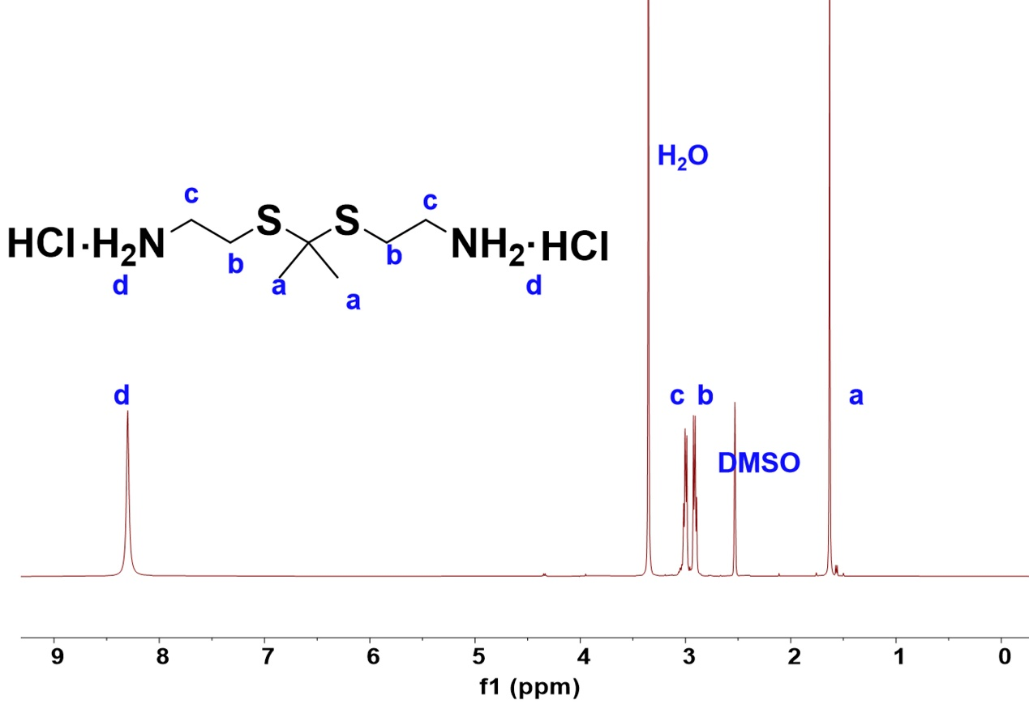
Figure S1. ¹H NMR spectrum of thioketal (TK) in DMSO-d6.

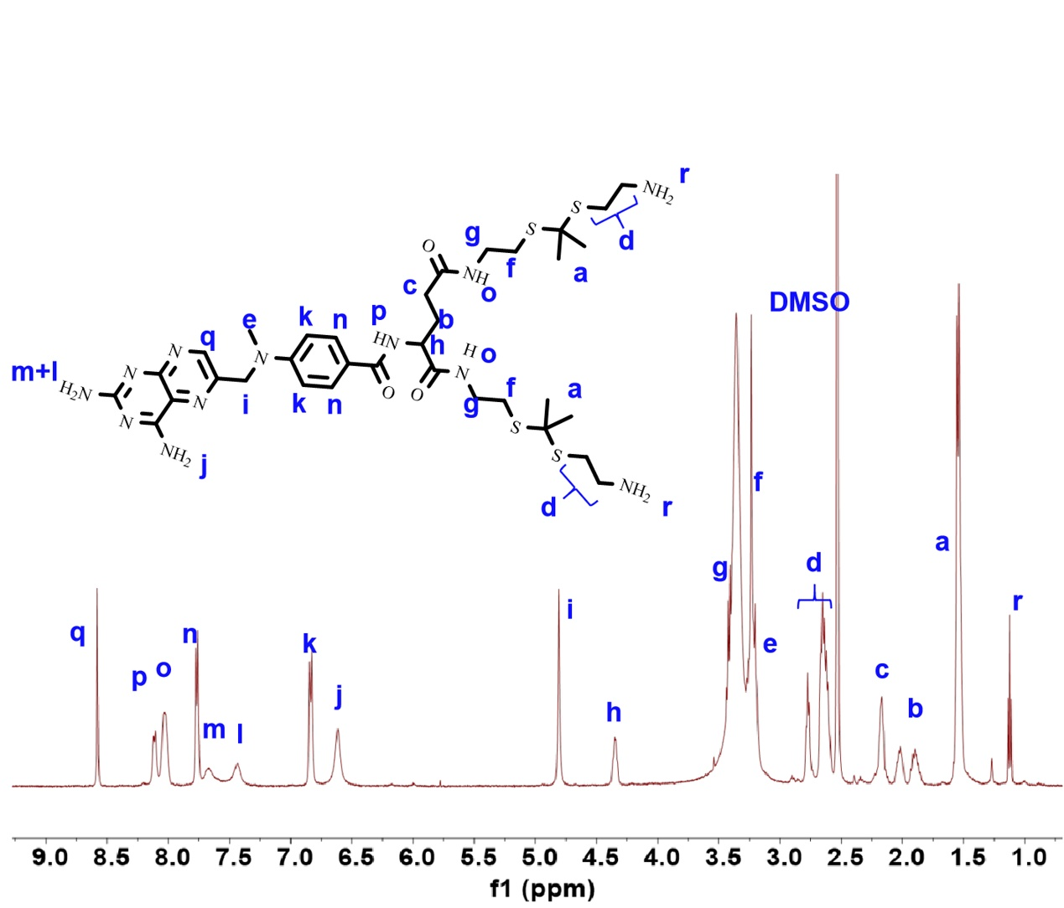
Figure S2. ¹H NMR spectrum of MTX-TK in DMSO-d6.

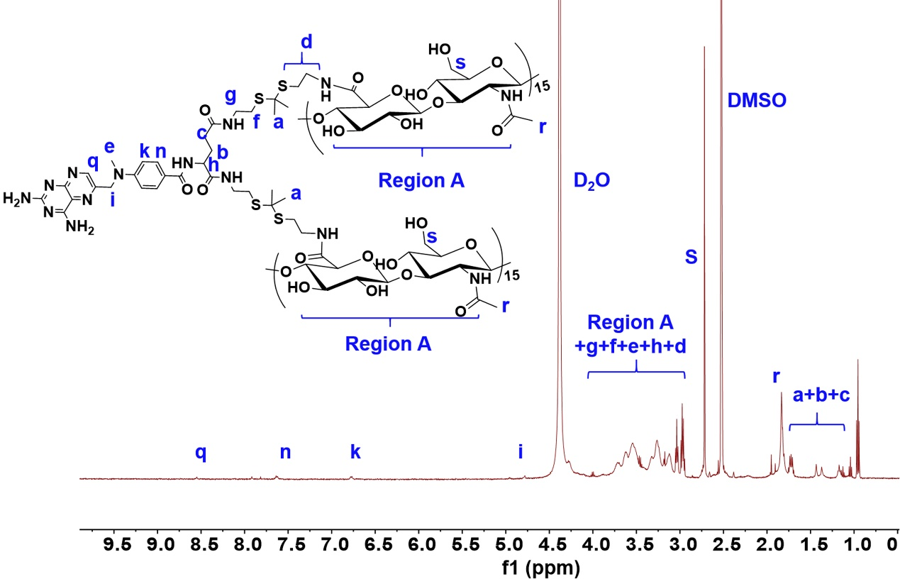
Figure S3. ¹H NMR spectrum of MTX-TK-HA in D₂O and DMSO-d6 (1:1, v/v).

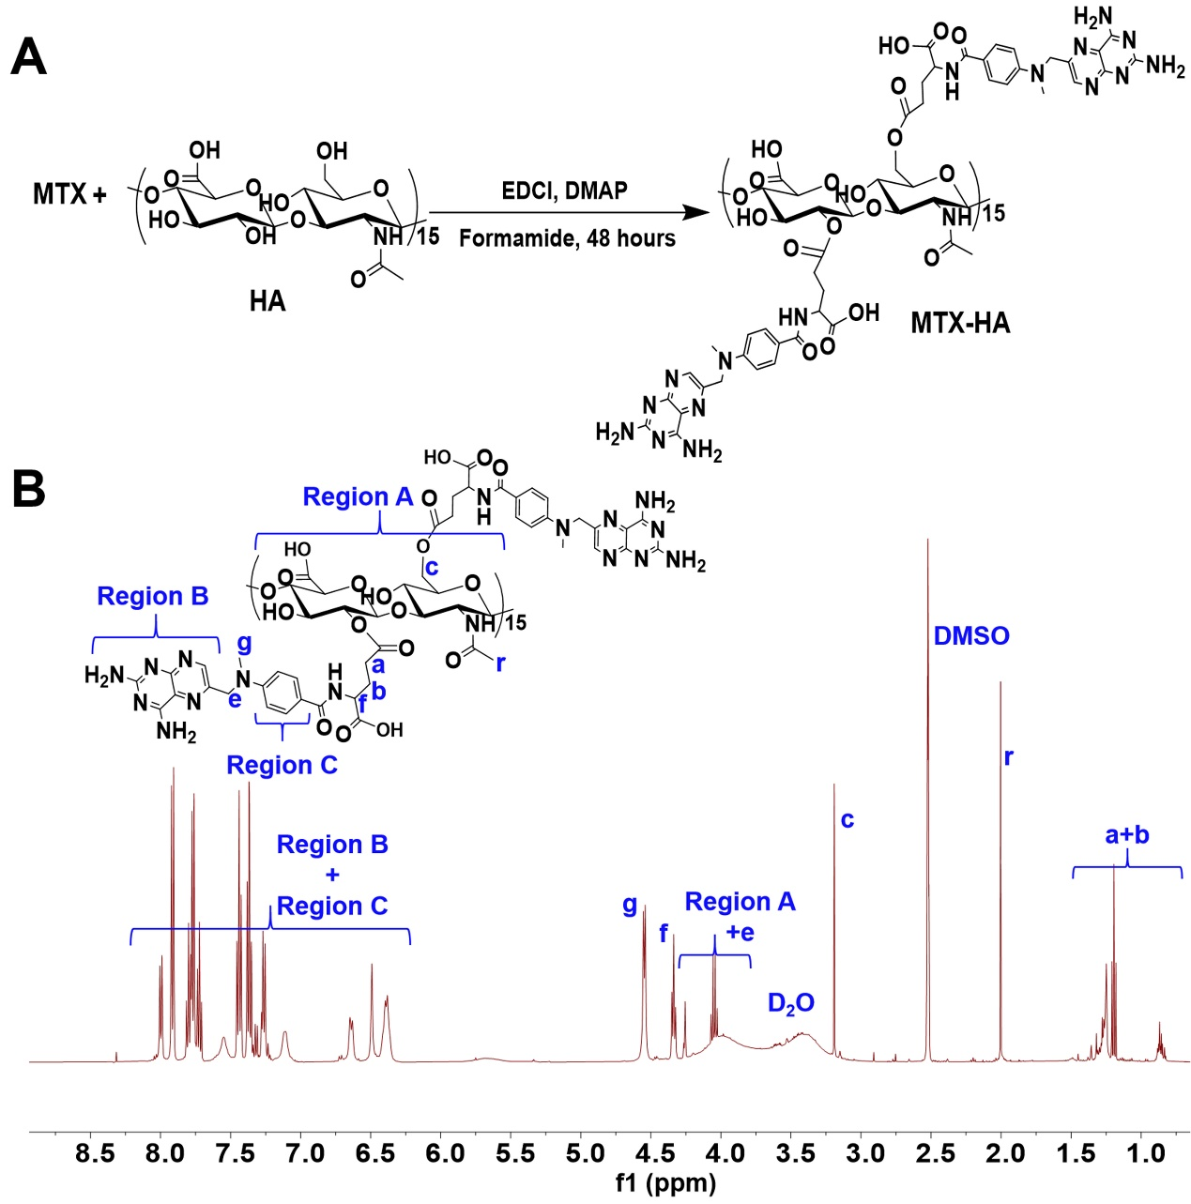
Figure S4. (A) Synthesis scheme for MTX-HA. (B) ¹H NMR spectrum of MTX-HA in D₂O and DMSO-d6 (1:2, v/v).

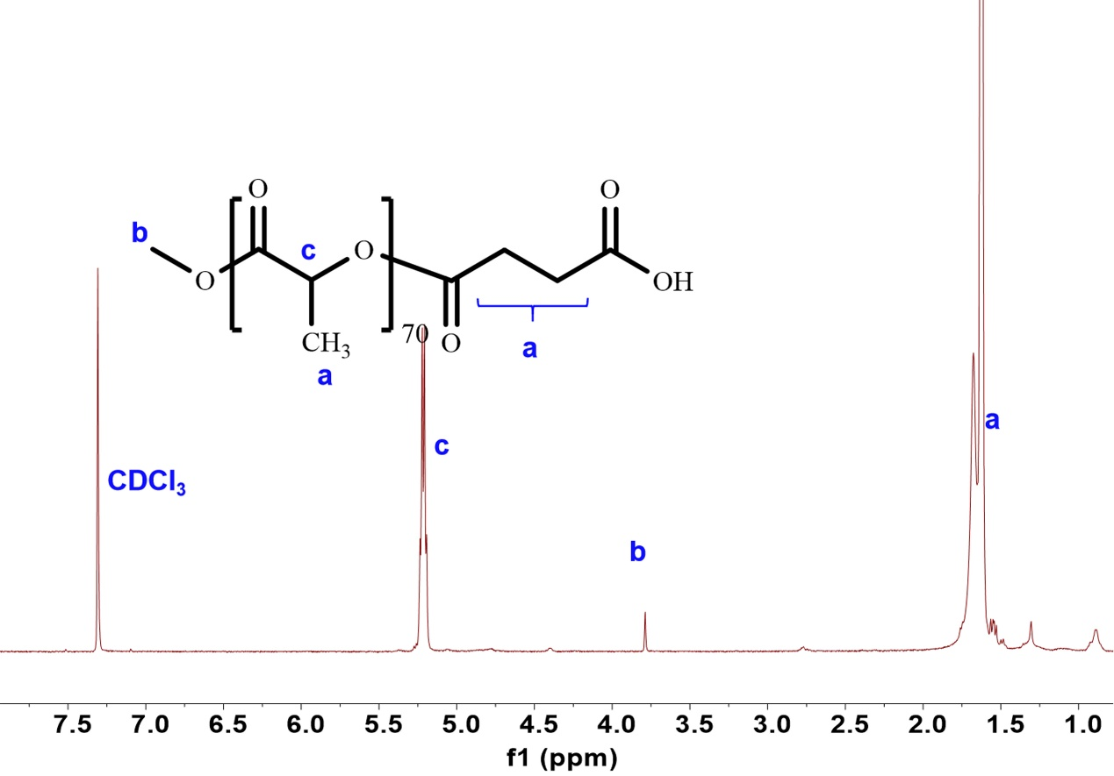
Figure S5. ¹H NMR spectrum of PLA-COOH in CDCl₃-d6.

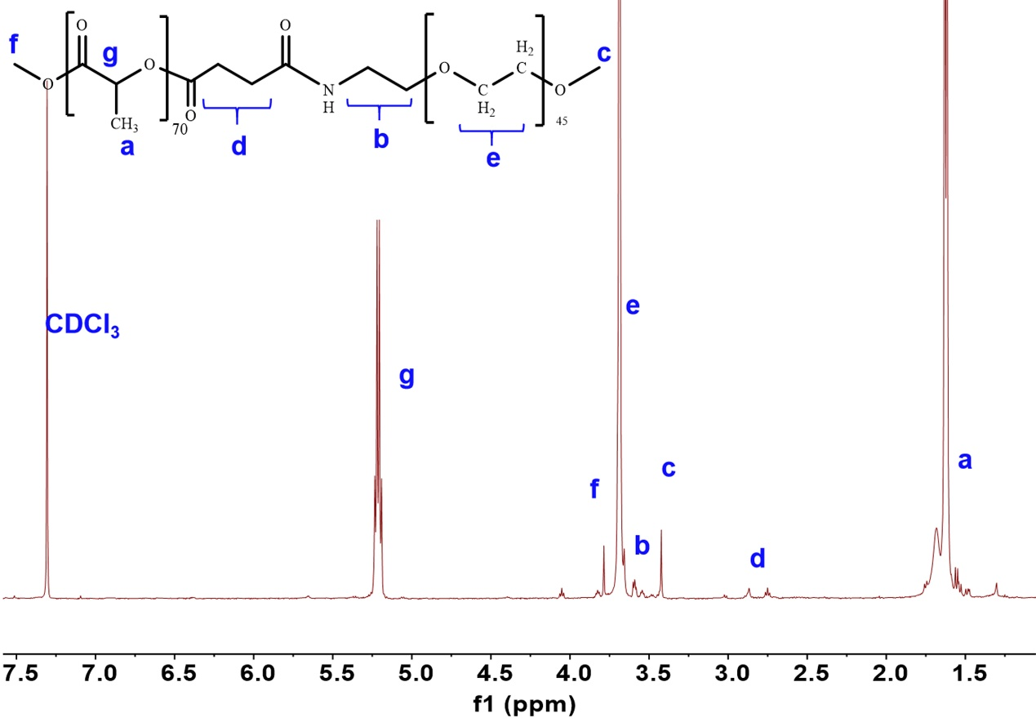
Figure S6. ¹H NMR spectrum of PLA-mPEG in CDCl₃-d6.

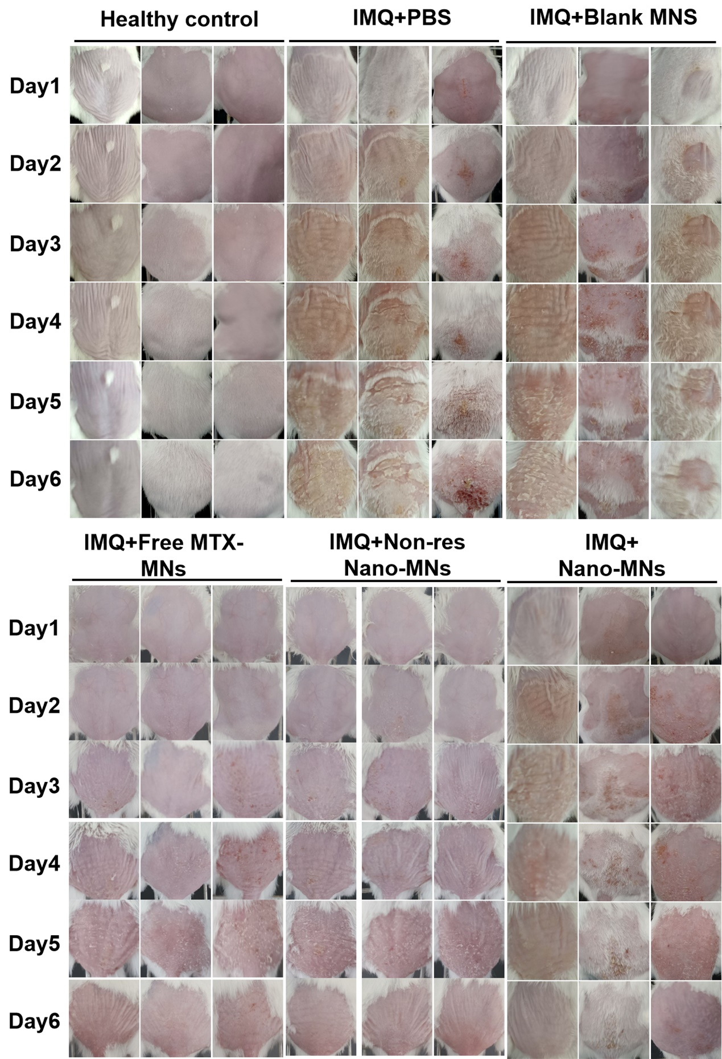
Figure S7. Photographs of the appearance for the imiquimod-induced psoriatic back skin from day 1 to day 6 (n=3).

