Figure S1 DSC thermograms of ICG, DOX, ICG@, PSC, PSC/ICG@ and PSC/ICG@+DOX nanoparticles.

Figure S2 (A) RBC, (B) WBC, (C) platelet counts, (D) AST, (E) ALT, (F) total bilirubin, (G) BUN and (H) creatinine levels after intravenous treatment in Kunming mice (n=5).
Figure S3. Body weight changes of Kunming mice after the treatment of 5% glucose, PSC, PSC/ICG@ and PSC/ICG@+DOX nanoparticles (n=10).

Figure S4 TUNEL staining of the tumors with the treatments of (A) 5% glucose, (B) PSC, (C) ICG(NIR), (D) PSC/ICG@, (E) PSC/ICG@ (NIR), (F) DOX·HCl, (G) DOX·HCl+ICG (NIR), (H) PSC/ICG@+DOX, and (I) PSC/ICG@+DOX (NIR), respectively. Scale bar, 50 μm.

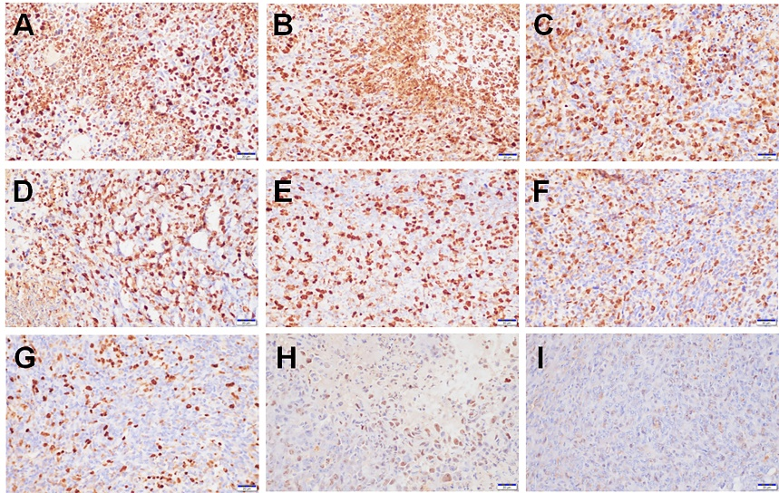
Figure S5 Typical images of Ki67 immunohistochemical staining of the tumors with the treatments of (A) 5% glucose, (B) PSC, (C) ICG(NIR), (D) PSC/ICG@, (E) PSC/ICG@ (NIR), (F) DOX·HCl, (G) DOX·HCl+ICG (NIR), (H) PSC/ICG@+DOX, and (I) PSC/ICG@+DOX (NIR), respectively. Scale bar, 20 μm.

