Supplementary Material
Anticancer evaluation of methoxy poly(ethylene glycol)-b-poly(caprolactone) polymeric micelles encapsulating fenbendazole and rapamycin in ovarian cancer
Yu Been Shin¹
Ju-Yeon Choi³
Dae Hwan Shin¹
Jeong-Won Lee^{2,3}

¹College of Pharmacy, Chungbuk National University, Cheongju, 28160, Republic of Korea; ²Department of Obstetrics and Gynecology, Samsung Medical Center, Sungkyunkwan University School of Medicine, Seoul, South Korea; ³Research Institute for Future Medicine, Samsung Medical Center, Sungkyunkwan University School of Medicine, Seoul, South Korea;

Correspondence: Dae Hwan Shin
College of Pharmacy, Chungbuk National University, Osongsaengmyeong 1-ro, Osong-eup, Heungdeok-gu, Cheongju 28160, Republic of Korea.
Phone: +82 43 261 2820
Fax: +82 43 268 2732
E-mail: dshin@chungbuk.ac.kr
Jeong-Won Lee
Department of Obstetrics and Gynecology, Samsung Medical Center
Sungkyunkwan University School of Medicine
81, Irwon-ro, Gangnam-gu, Seoul, South Korea, Zip: 06351
Phone: +82-2-3410-1382
Fax: +82-2-3410-0630
Email: garden.lee@samsung.com

Figure S1 In vitro cytotoxicity assay of HeyA8 cells treated with (A) fenbendazole:rapamycin=1:1, (B) fenbendazole:rapamycin=2:1, (C) fenbendazole:rapamycin=1:4 and (D) fenbendazole:rapamycin=4:1.
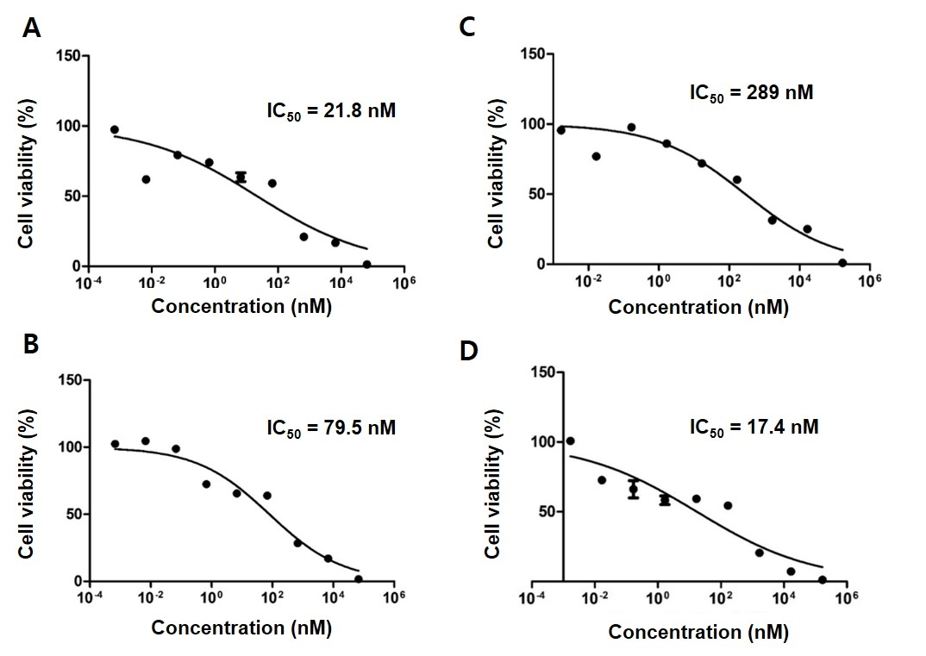

Figure S2 CI value of fenbendazole and rapamycin at various molar ratios based on fenbendazole.
Abbreviations: CI, combination index.