Supporting information

Gold nanoparticles reduce food sensation in Caenorhabditis elegans via the voltage-gated channel EGL-19
Meimei Wang¹*, Zhenzhen Zhang²*, Ning Sun³, Baolin Yang⁴, Jihao Mo⁵, Daping Wang², Mingqin Su¹, Jian Hu¹, Miaomiao Wang⁶, Lei Wang^{7, 8#}

Affiliations

1 Department of Pathophysiology, School of Basic Medical Science, Anhui Medical University, No. 81, Mei-Shan Road, Hefei, Anhui, 230032, China.
2 Department of Biomedical Engineering, Southern University of Science and Technology, Shenzhen, 518055, China.
3 Institute of Clinical Laboratory Science, Jinling Hospital, School of Medicine, Nanjing University, Jiangsu, 210002, China.
4 Institute of Technical Biology & Agriculture Engineering, Hefei Institutes of Physical Science, Chinese Academy of Sciences, Anhui, 230032, China.
5 Department of Medical Laboratory, Luoyang Orthopedic Hospital of Henan Province, Orthopedic Institute of Henan Province, Henan, 459001, China.
6 School of Medical Science, Huang He Science and Technology University, Zhengzhou, Henan, 459001, China
7 School of Biological Sciences, Nanyang Technological University, Singapore, 639798, Singapore.
8 Department of Physiology and Biophysics, Miller School of Medicine, University of Miami, Miami, FL, 33136, USA.

Corresponding Author:
# Lei Wang, Department of Physiology and Biophysics, Miller School of Medicine, University of Miami, Miami, FL, 33136, USA. Tel: +1 786-620-1400, Email: lxw561@miami.edu.

*These authors contributed equally to this work.

Supplementary Figure 1. (A) Protein-protein interaction map of the genes upregulated in AuNPs-exposed C. elegans group. (B) Protein-protein interactions between the top 20 upregulated genes. The biological process of each gene was marked according to gene functions. (C) Bar graph of the biological process analysis of genes upregulated in the AuNP-exposed C. elegans group based on p value. Biological processes associated with development were marked in blue, others were marked in yellow. (D) DNA motif sequence enriched in the promoter region of the upregulated genes in C. elegans after AuNPs exposure.

Supplementary Figure 2. UMAP projection showed ins-22 expression was detected in sensory neurons. (A) UMAP projections of all ciliated neurons. (B) Expression of ins-22 in all ciliated neurons.

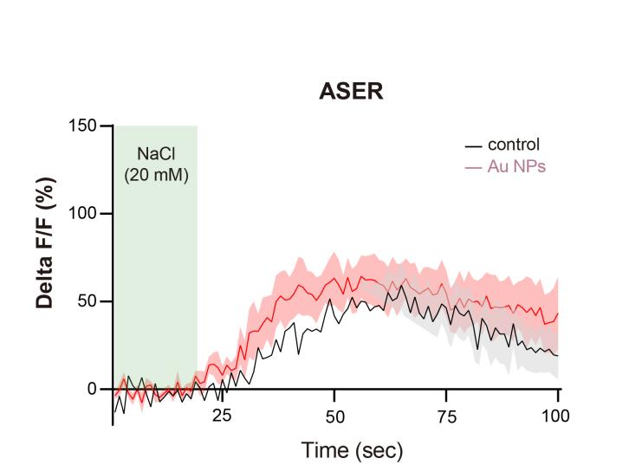
Supplementary Figure 3. The calcium transit dynamics of florescence signal of ASER neuron of 0 and 100 μg/mL AuNP-pre-exposed worms from 20 mM NaCl change to 0 mM.

Supplementary Figure 4. Heatmap of individual ASEL neurons of worms from (A) control and (B) AuNPs-exposure group in response to NaCl. (C) Time slot of ASEL GCaMPs worms expose to 20 mM NaCl.

Supplementary Figure 5. UMAP projection showed that the expression of egl-19 was detected in all ciliated neurons.

Supplementary Table 1.Strains used in this study.
Strains | Source | Identifier
N2 | Caenorhabditis Genetics Center | wild type: N2
eat-2(ad1116) | Caenorhabditis Genetics Center | DA1116
tax-2(p691) | Caenorhabditis Genetics Center | PR691
odr-3(n2150) | Caenorhabditis Genetics Center | CX2205
otIs670 V; otIs672 | Caenorhabditis Genetics Center | OH16230
otIs3 V | Caenorhabditis Genetics Center | OH3191
ntIs1 V | Caenorhabditis Genetics Center | OH3192
Ex[flp-6p::GCaMP6s] | This study | WMM0102
ftn-1(ok3625) | Caenorhabditis Genetics Center | RB2603
ins-22(ok3616) | Caenorhabditis Genetics Center | RB2594
ins-35(ok3297) | Caenorhabditis Genetics Center | RB2412
C06C6.5(ok671) | Caenorhabditis Genetics Center | RB844
egl-19(n582) | Caenorhabditis Genetics Center | MT1212
egl-19(n582);Ex[flp-6p::GCaMP6s] | This study | WMM0103
zIs356 | Caenorhabditis Genetics Center | TJ356

Supplementary Appendix:
S medium:
1L H₂O, 5.85g NaCl, 1g K₂HPO₄, 6g KH₂PO₄, 10ml 1M potassium citrate pH6, 0.0186g disodium EDTA, 0.0069g FeSO₄ •7H₂O, 0.002g MnCl₂•4H₂O, 0.0029g ZnSO₄ •7H₂O, 0.00025g CuSO₄ •5H₂O, 3ml 1M CaCl₂, 3ml 1M MgSO₄
K-Medium:
1.23 g NaCl, 0.968 g KCl, H₂O to 400 ml

