Supporting Information
Multifunctional nano-realgar hydrogel for enhanced glioblastoma synergistic chemotherapy and radiotherapy: a new paradigm of an old drug
Yihan Wang,†^{a,b} Yizhen Wei,†^{a,b} Yichun Wu,†^{a,b} Yue Zong,†^{a,b} Yingying Song,^{b} Shengyan Pu,^{b} Wenwen Wu,^{b} Yun Zhou,ª Jun Xie*^{b} and Haitao Yin*ª

ª Department of Radiotherapy Central Hospital, Affiliated Xuzhou Clinical College of Xuzhou Medical University, Xuzhou, 221009, P. R. China. E-mail: yinhaitao@njmu.edu.cn
^{b.} Key Laboratory for Biotechnology on Medicinal Plants of Jiangsu Province, School of Life Science, Jiangsu Normal University, Xuzhou 221116, P. R. China. E-mail: xiejun@jsnu.edu.cn
Correspondence: Haitao Yin, Jun Xie, Email: yinhaitao@njmu.edu.cn, xiejun@jsnu.edu.cn

Supplementary Figure
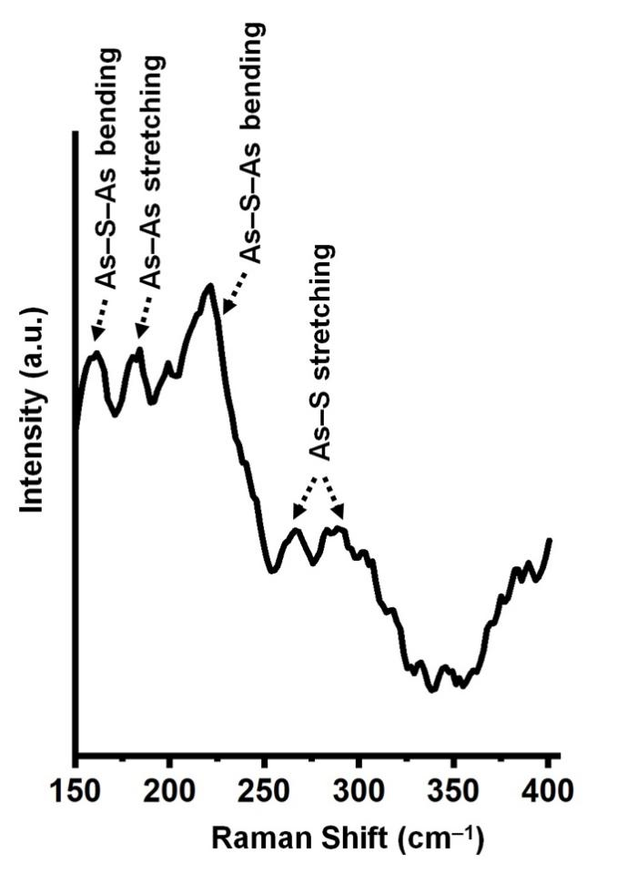
Figure S1. Laser Raman spectra of NR QDs.

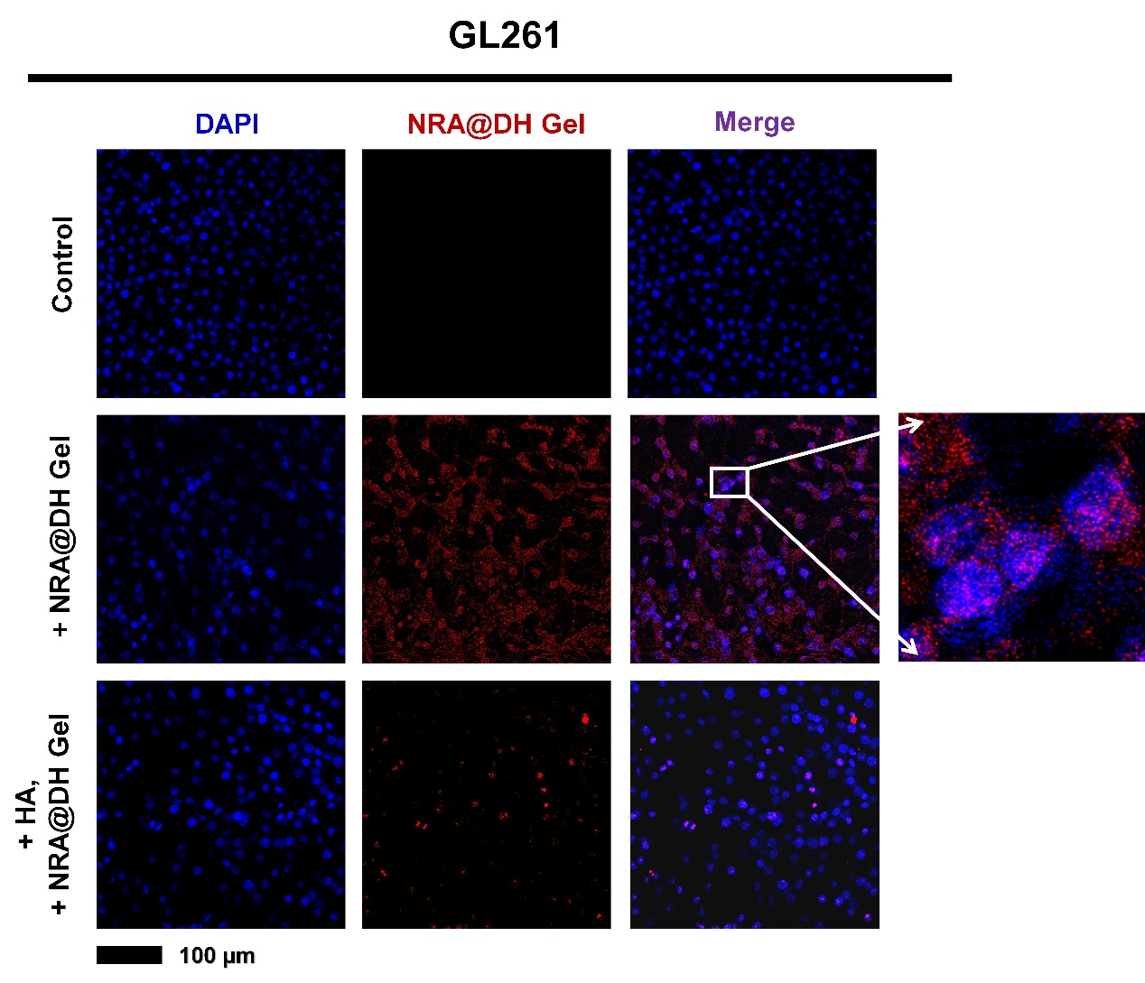
Figure S2. Upper row: in vitro specific nuclear targeting effect of NRA@DH Gel on GL261 cells observed by CLSM images. Cell nucleuses stained with DAPI were blue and fluorescent NRA@DH Gel were shown in red signal. Bottom row: In vitro competition assay observed by CLSM images to detect specific targeting effect of NRA@DH Gel on GL261 cells. The cells were preincubated with free HA for 12 h and then incubated with NRA@DH Gel for 24 h (0.7 μg As mL⁻¹).

Figure S3. Concentration of γH2AX in different treatments in GL261 cells.

Figure S4. Histogram of the necrosis rate in different groups.

Figure S5. The semi-quantitatively of immunohistochemical in different groups.

Figure S6. Routine serological parameters (WBC, RBC, PLT, HGB, HCT, MCV, and MCH) and liver and kidney function parameters (AST, ALP, ALT, BUN, UA and CREA) in blood collected from mice treated with NRA QDs.

Figure S7. Body weight changes in NRA QDs group over the 16-day observation period.

Flotillin2β-Actin
β-Actin
β-Actin
GPR56
β-Actin

Figure S8. Unprocessed and completed western blot result for Figure 5D.

