Supplementary Figure 1: The Distribution of Lp(a) levels in 268 subjects. The 43th, 50th (median), 67th and 80th percentiles are marked separately.
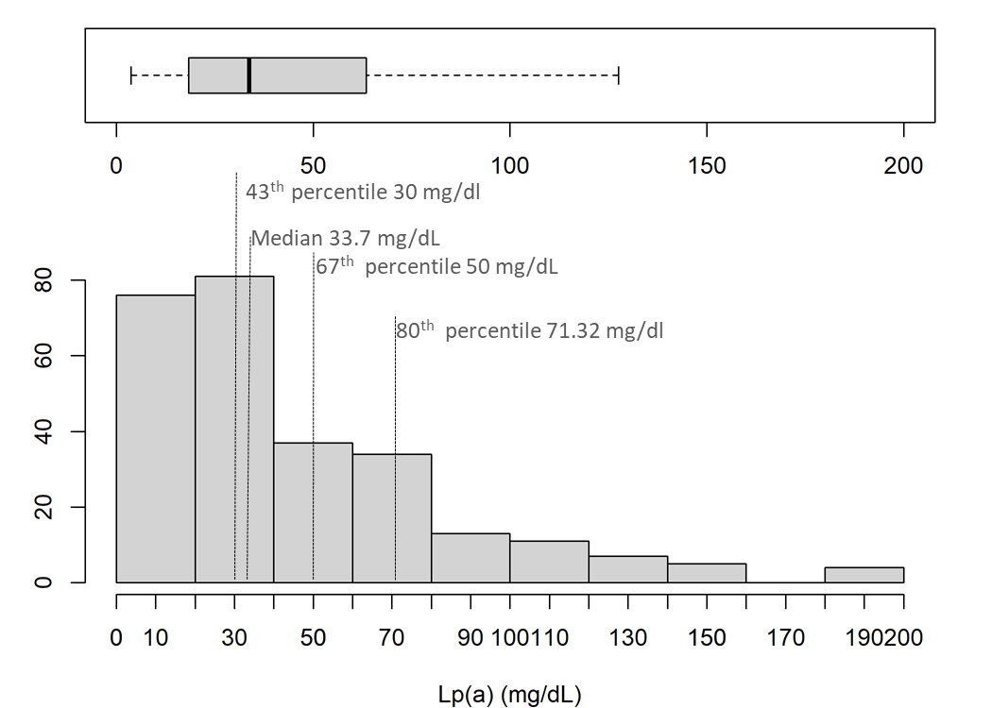

Supplementary Figure 2: (a) Correlation plot between Lp(a) and HDL-cholesterol; (b) Scatter plots representing the relationship between HDL-cholesterol and Lp(a) among CAD cases and controls using Lp(a) 30 mg/dL (d) Histograms showing the number of cases (subjects with > 50% stenosis) and controls (subjects with ≤ 50% stenosis) with high HDL (≥35 mg/dL) differentiated by Lp(a) levels (≥30 mg/dL vs ≤30 mg/dL). P-value=0.007 using Chi-squared test.
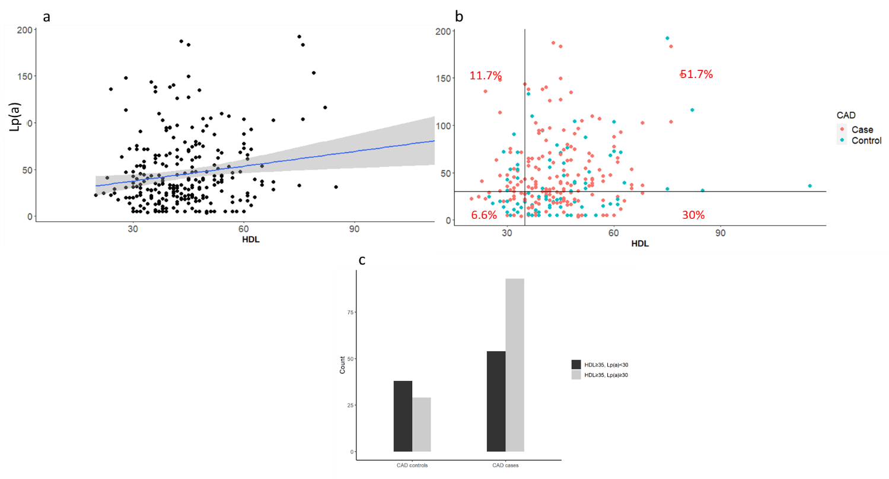

(a) The correlation between HDL-cholesterol and Lp(a) was calculated with Pearson method. r= 0.18 and P-value= 0.004. (b) X-intercept was set at 35 (HDL-cholesterol 35 mg/dL), Y-intercept was set at 30 (Lp(a) 30 mg/dL). (c) P-value=0.007 was calculated using Chi-squared test.

Supplementary Figure 3: Binomial Logistic Regression with CAD (>50% stenosis) as an outcome and (a) High Lp(a) (Lp(a)≥30mg/dL) (b) High Lp(a) (Lp(a)≥50mg/dL) and (c) High Lp(a) (Lp(a)≥80th percentile) as predictor stratified by obesity, age, gender, LDL with a cut-off 100 mg/dL and HDL with a cut-off 35 mg/dL.
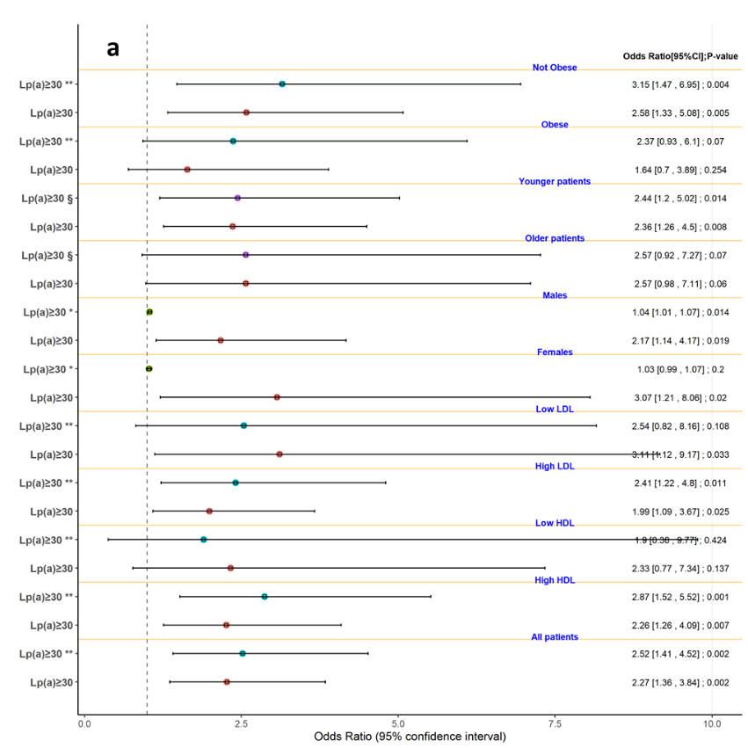
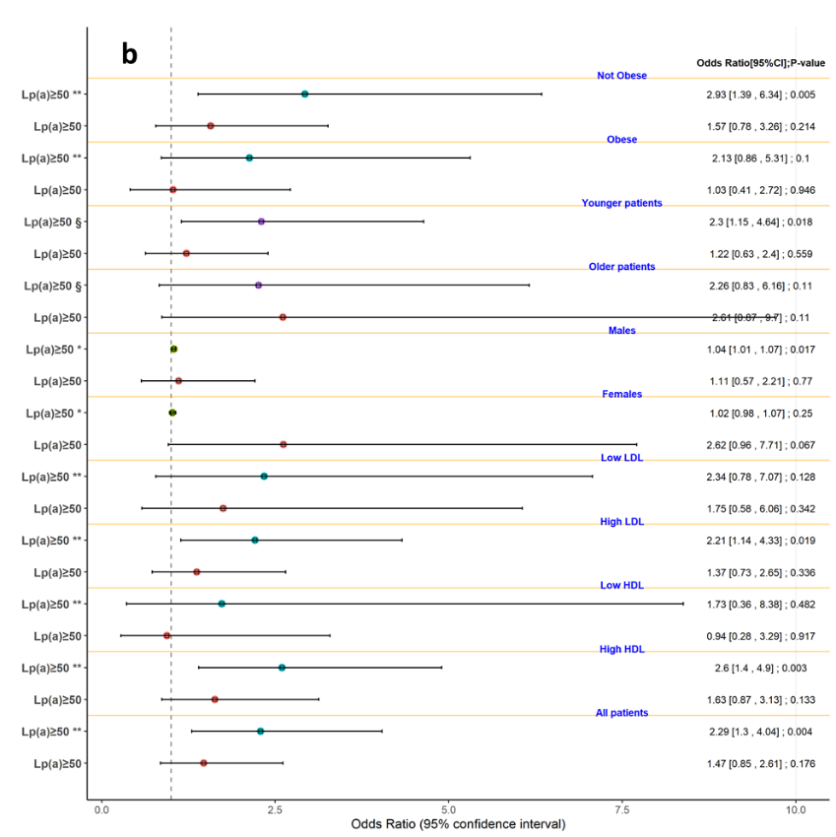
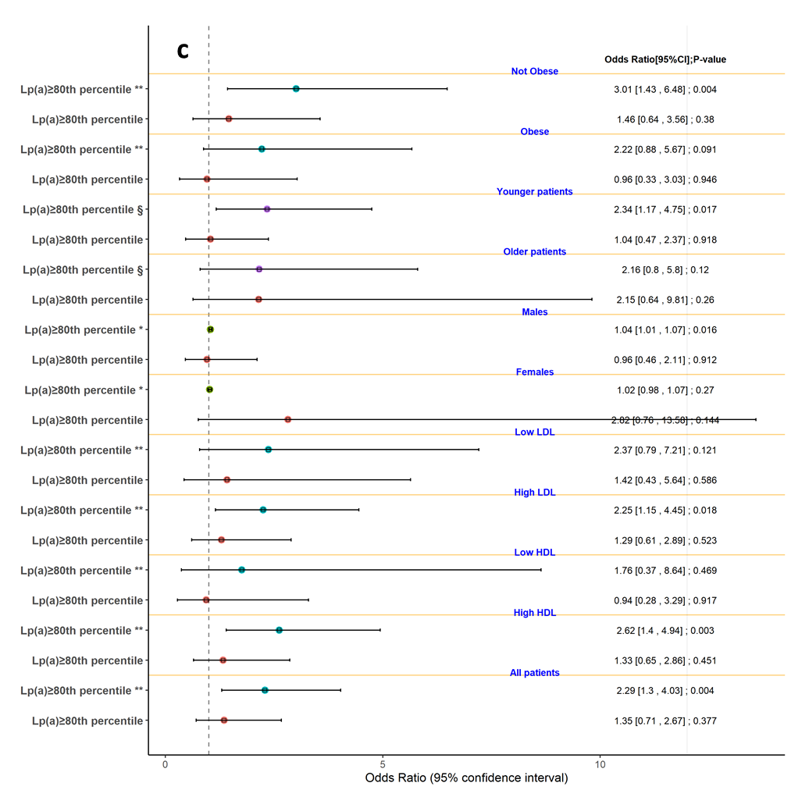
CAD: Coronary artery disease. Lp(a): lipoprotein (a). **: adjusted for age and sex. *: adjusted for age. §: adjusted for sex. CI: Confidence Interval.

Supplementary Figure 4: Lp(a) levels according to stenosis in the four major coronary arteries.
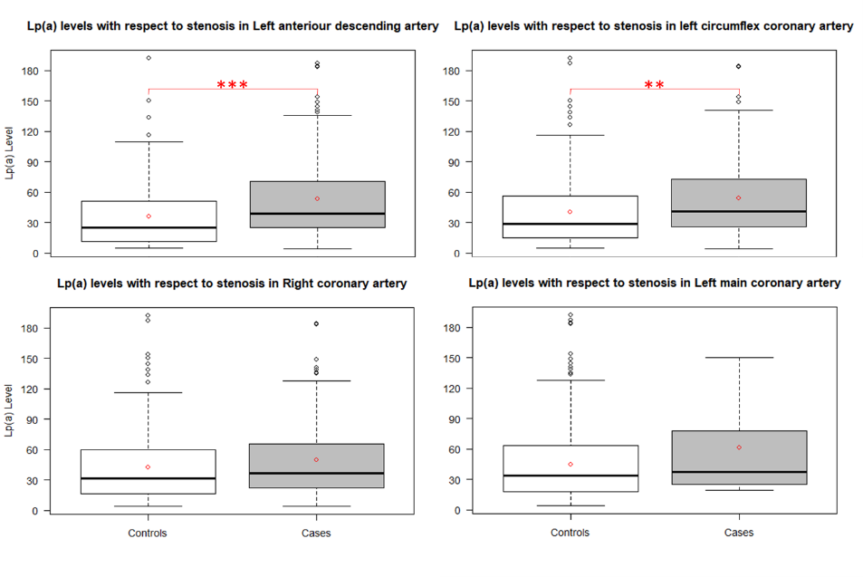
The boxplots show the median (horizontal line in the box) and the mean (red diamond) of the data. P-values were calculated using Two Sample t-test. Controls: subjects with no stenosis or stenosis ≤50%. Cases: patients with >50% stenosis. ** P-value<0.001, *** P-value<0.0001.

Supplementary figure 5: Lowess spline curve for the relationship between CAD category (number of vessels with >50% stenosis) and Lp(a) levels.
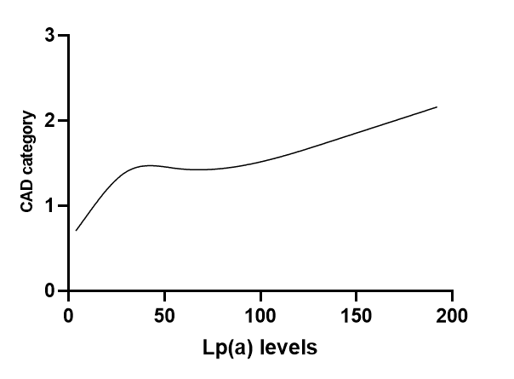

Supplementary Table 1. CAD risk factors according to Lp(a) categories.

 | Lp(a)<30 | Lp(a)≥30 | P | Lp(a)<50 | Lp(a)≥50 | P | Lp(a)<80th percentile | Lp(a)≥ 80th percentile | P
 | N= 116 (43%) | N= 152 (57%) |  | N= 180 (67%) | N= 88 (33%) |  | N= 214 (80%) | N= 54 (20%)
No CAD | 50 (43.1%) | 38 (25.0%) | 0.002 | 64 (35.6%) | 24 (27.3%) | 0.17 | 73 (34.1%) | 15 (27.8%) | 0.37
CAD | 66 (56.9%) | 114 (75.0%) |  | 116 (64.4%) | 64 (72.7%) |  | 141 (65.9%) | 39 (72.2%)
CAD category 0 | 50 (43.1%) | 38 (25.0%) | 0.002 | 64 (35.6%) | 24 (27.3%) | 0.292 | 73 (34.1%) | 15 (27.8%) | 0.13
1 | 33 (28.4%) | 37 (24.3%) |  | 49 (27.2%) | 21 (23.9%) |  | 57 (26.6%) | 13 (24.1%)
2 | 14 (12.1%) | 38 (25.0%) |  | 33 (18.3%) | 19 (21.6%) |  | 44 (20.6%) | 8 (14.8%)
3 | 19 (16.4%) | 39 (25.7%) |  | 34 (18.9%) | 24 (27.3%) |  | 40 (18.7%) | 18 (33.3%)
Age <65 | 70 (60.3%) | 97 (63.8%) | 0.561 | 112 (62.2%) | 55 (62.5%) | 0.965 | 136 (63.6%) | 31 (57.4%) | 0.405
Age ≥65 | 46 (39.7%) | 55 (36.2%) |  | 68 (37.8%) | 33 (37.5%) |  | 78 (36.4%) | 23 (42.6%)
Female | 31 (26.7%) | 47 (30.9%) | 0.454 | 54 (30.0%) | 24 (27.3%) | 0.644 | 66 (30.8%) | 12 (22.2%) | 0.213
Male | 85 (73.3%) | 105 (69.1%) |  | 126 (70.0%) | 64 (72.7%) |  | 148 (69.2%) | 42 (77.8%)
No diabetes | 91 (78.4%) | 102 (67.1%) | 0.04 | 131 (72.8%) | 62 (70.5%) | 0.6 | 155 (72.4%) | 38 (70.4%) | 0.763
Diabetes | 25 (21.6%) | 50 (32.9%) |  | 49 (27.2%) | 26 (29.5%) |  | 59 (27.6%) | 16 (29.6%)
No hypertension | 65 (56.0%) | 69 (45.4%) | 0.084 | 94 (52.2%) | 40 (45.5%) | 0.298 | 110 (51.4%) | 24 (44.4%) | 0.361
Hypertension | 51 (44.0%) | 83 (54.6%) |  | 86 (47.8%) | 48 (54.5%) |  | 104 (48.6%) | 30 (55.6%)
No Obesity | 67 (58.8%) | 96 (65.3%) | 0.28 | 108 (60.7%) | 55 (66.3%) | 0.385 | 130 (61.9%) | 33 (64.7%) | 0.711
Obesity | 47 (41.2%) | 51 (34.7%) |  | 70 (39.3%) | 28 (33.7%) |  | 80 (38.1%) | 18 (35.3%)
Low LDL | 32 (27.8%) | 40 (26.3%) | 0.78 | 50 (27.9%) | 22 (25.0%) | 0.6 | 56 (26.3%) | 16 (29.6%) | 0.62
High LDL | 83 (72.2%) | 112 (73.7%) |  | 129 (72.1%) | 66 (75.0%) |  | 157 (73.7%) | 38 (70.4%)
Low HDL | 24 (20.7%) | 30 (19.7%) | 0.84 | 39 (21.7%) | 15 (17.0%) | 0.3 | 45 (21.0%) | 9 (16.7%) | 0.475
High HDL | 92 (79.3%) | 122 (80.3%) |  | 141 (78.3%) | 73 (83.0%) |  | 169 (79.0%) | 45 (83.3%)
No Fx CAD | 24 (20.9%) | 18 (11.9%) | 0.04 | 32 (17.9%) | 10 (11.5%) | 0.18 | 35 (16.4%) | 7 (13.2%) | 0.565
Fx CAD | 91 (79.1%) | 133 (88.1%) |  | 147 (82.1%) | 77 (88.5%) |  | 178 (83.6%) | 46 (86.8%)
No smoking | 25 (21.6%) | 49 (32.2%) | 0.053 | 40 (22.2%) | 34 (38.6%) | 0.005 | 56 (26.2%) | 18 (33.3%) | 0.293
Smoking | 91 (78.4%) | 103 (67.8%) |  | 140 (77.8%) | 54 (61.4%) |  | 158 (73.8%) | 36 (66.7%)
Statins No | 76 (74.5%) | 92 (66.2%) | 0.165 | 116 (73.0%) | 52 (63.4%) | 0.127 | 139 (73.2%) | 29 (56.9%) | 0.025
Yes | 26 (25.5%) | 47 (33.8%) |  | 43 (27.0%) | 30 (36.6%) |  | 51 (26.8%) | 22 (43.1%)

CAD: patients with > 50% stenosis. CAD category 0: patients with ≤50% stenosis. CAD category 1: patients with >50% stenosis in one vessel; CAD category 2: patients with >50% stenosis in 2 vessels; and CAD category 3: patients with >50% stenosis in 3 or 4. Obesity: BMI ≥30 Kg/m². High HDL: HDL ≥ 35 mg/dL. Low HDL: HDL<35 mg/dL. High LDL: LDL ≥ 100 mg/dL. Low LDL: LDL<100 mg/dL. Data are number of individuals and percentages. P: P-value generated with X² test. P-value is significant if P-value < 0.05.

Supplementary Table 2. Association analysis of the stenosis in the major coronary vessels and Lp (a) levels.
Major coronary arteries | Lp(a)≥30 |  |  | Lp(a)≥50 |  |  | Lp(a)≥80th percentile |  |  | Lp(a)
Major coronary arteries | OR | 95%C.I. | P-value | OR | 95%C.I. | P-value | OR | 95%C.I. | P-value | Regression coefficient (SE) | OR | 95%C.I. | P-value
Left Main coronary artery stenosis | NA | NA | NA | NA | NA | NA | NA | NA | NA | NA | NA | NA | NA
Left anterior descending artery stenosis | 1.89 | 1.09-3.34 | 0.03 | 1.72 | 1-2.99 | 0.05 | 1.68 | 0.98-2.92 | 0.06 | 0.6 (0.28) | 1.83 | 1.05-3.22 | 0.03
Right coronary artery stenosis | 2.14 | 1.2-3.92 | 0.01 | 2.08 | 1.17-3.79 | 0.01 | 2.08 | 1.17-3.79 | 0.01 | 0.74 (0.29) | 2.12 | 1.19-3.88 | 0.01
Circumflex stenosis | 2.07 | 1.15-3.83 | 0.02 | 1.91 | 1.08-3.49 | 0.03 | 1.88 | 1.06-3.43 | 0.03 | 0.69 (0.3) | 2.00 | 1.12-3.69 | 0.02

Logistic regression (adjusted for age and sex) assessing the association between stenosis of the four major coronary vessels and Lp(a)≥30, Lp(a)≥50, Lp(a)≥80th percentile or Lp(a) levels. Stenosis: lesion between 50% and 70% or lesion ≥70%. OR >1 indicates increased occurrence of stenosis. Regression coefficient >0 indicates that higher values of Lp(a) are associated with higher likelihood of stenosis. Association with stenosis is significant if P-value < 0.05. OR: odd ratio; 95%C.I.: 95% confidence interval. SE: standard error. NA: not available.

Supplementary Table 3. Multinomial logistic regression analysis between CAD category (number of vessels with >50% stenosis) and Lp(a) levels.
 | Coefficient | Exp(coefficient) | Standard error | p.value | 95% Confidence Interval
CAD category 1 | 0.006 | 1.004 | 0.005 | 0.192 | -0.003 | 0.016
CAD category 2 | 0.011 | 1.010 | 0.005 | 0.030 | 0.001 | 0.020
CAD category 3 | 0.015 | 1.015 | 0.005 | 0.001 | 0.006 | 0.024

CAD category 1: patients with >50% stenosis in one vessel; CAD category 2: patients with >50% stenosis in 2 vessels; and CAD category 3: patients with >50% stenosis in 3 or 4. Exp(): exponential function.

