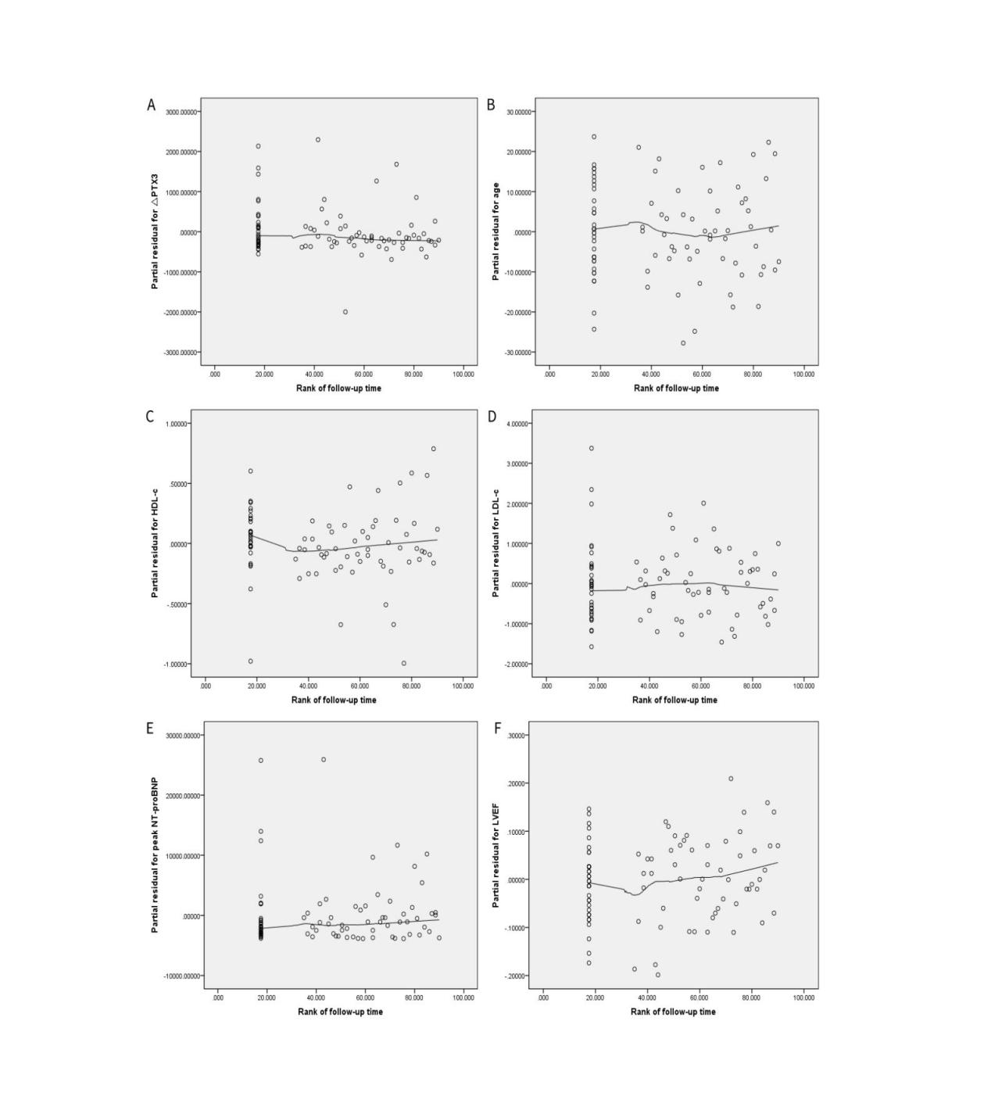
Supplementary Figure 1. Simple scatter diagram of partial residual for △PTX3 (A), age (B), HDL-c (C), LDL-c (D), peak NT-proBNP (E), and LVEF (F) and the rank of follow-up time.
Abbreviations: PTX3, pentraxin 3; △PTX3, the change in PTX3 from admission to post-pPCI 24-hour; HDL-C, high-density lipoprotein cholesterol; LDL-C, low-density lipoprotein cholesterol; LVEF, left ventricular ejection fraction.

Supplementary Table 1. Correlation between partial residual and time rank
 | Partial residual | △PTX3 | Age | HDL-c | LDL-c | Peak NT-proBNP | LVEF
Rank of follow-up time | r | -0.152 | -0.027 | -0.04 | -0.039 | 0.029 | 0.152
Rank of follow-up time | p | 0.153 | 0.799 | 0.707 | 0.717 | 0.789 | 0.153
Abbreviations: PTX3, pentraxin 3; △PTX3, the change in PTX3 from admission to post-pPCI 24-hour; HDL-C, high-density lipoprotein cholesterol; LDL-C, low-density lipoprotein cholesterol; LVEF, left ventricular ejection fraction.

