A multifunctional, highly biocompatible, and double-triggering caramelized nanotheranostic system loaded with Fe₃O₄ and DOX for combined chemo-photothermal therapy and real-time magnetic resonance imaging monitoring of triple negative breast cancer
Fangqing Wang, MS^{a*}
Nianlu Li, MD^{b*}
Wenbo Wang, MSª
Long Ma, MS^{c}
Yaru Sun, MS^{d}
Hong Wang, MSª
Jinhua Zhan, MD, PhD^{e*}
Dexin Yu, MD, PhD^{a*}
a. Department of Radiology, Qilu Hospital, Shandong University, Affiliated Hospital of Shandong University, Jinan, Shandong Province, 250012, People’s Republic of China
b. Physical and Chemical Laboratory, Shandong Academy of Occupational Health and Occupational Medicine, Affiliated Hospital of Shandong First Medical University & Shandong Academy of Medical Sciences, Jinan, Shandong Province, 250002, People’s Republic of China
c. The Testing Center of Shandong Bureau of China Metallurgical Geology Bureau, Shandong Normal University, Jinan, Shandong Province, 250014, People’s Republic of China
d. Department of Nuclear Medicine, The Second Hospital of Shandong University, Affiliated Hospital of Shandong University, Jinan, Shandong Province, 250033, People’s Republic of China
e. School of Chemistry and Chemical Engineering, Shandong University, Jinan, Shandong Province, 250100, People’s Republic of China
Fangqing Wang, MS^{a*} and Nianlu Li, MD^{b*} contributed equally to this work and share the first authorship.
Jinhua Zhan, MD, PhD^{e*} and Dexin Yu, MD, PhD^{a*} contributed equally to this work and share corresponding authorship
Jinhua Zhan*, School of Chemistry and Chemical Engineering, Shandong University, Jinan, Shandong Province, 250100, People’s Republic of China. Email: jhzhan@sdu.edu.cn
Dexin Yu*, Department of Radiology, Qilu Hospital, Shandong University, Affiliated Hospital of Shandong University, Jinan, Shandong Province, 250012, People’s Republic of China. Tel: 86-18560081629, Fax: 86-531-86927544, Email: yudexin0330@sina.com (Handle correspondence at all stages of refereeing and publication, also post-publication.)
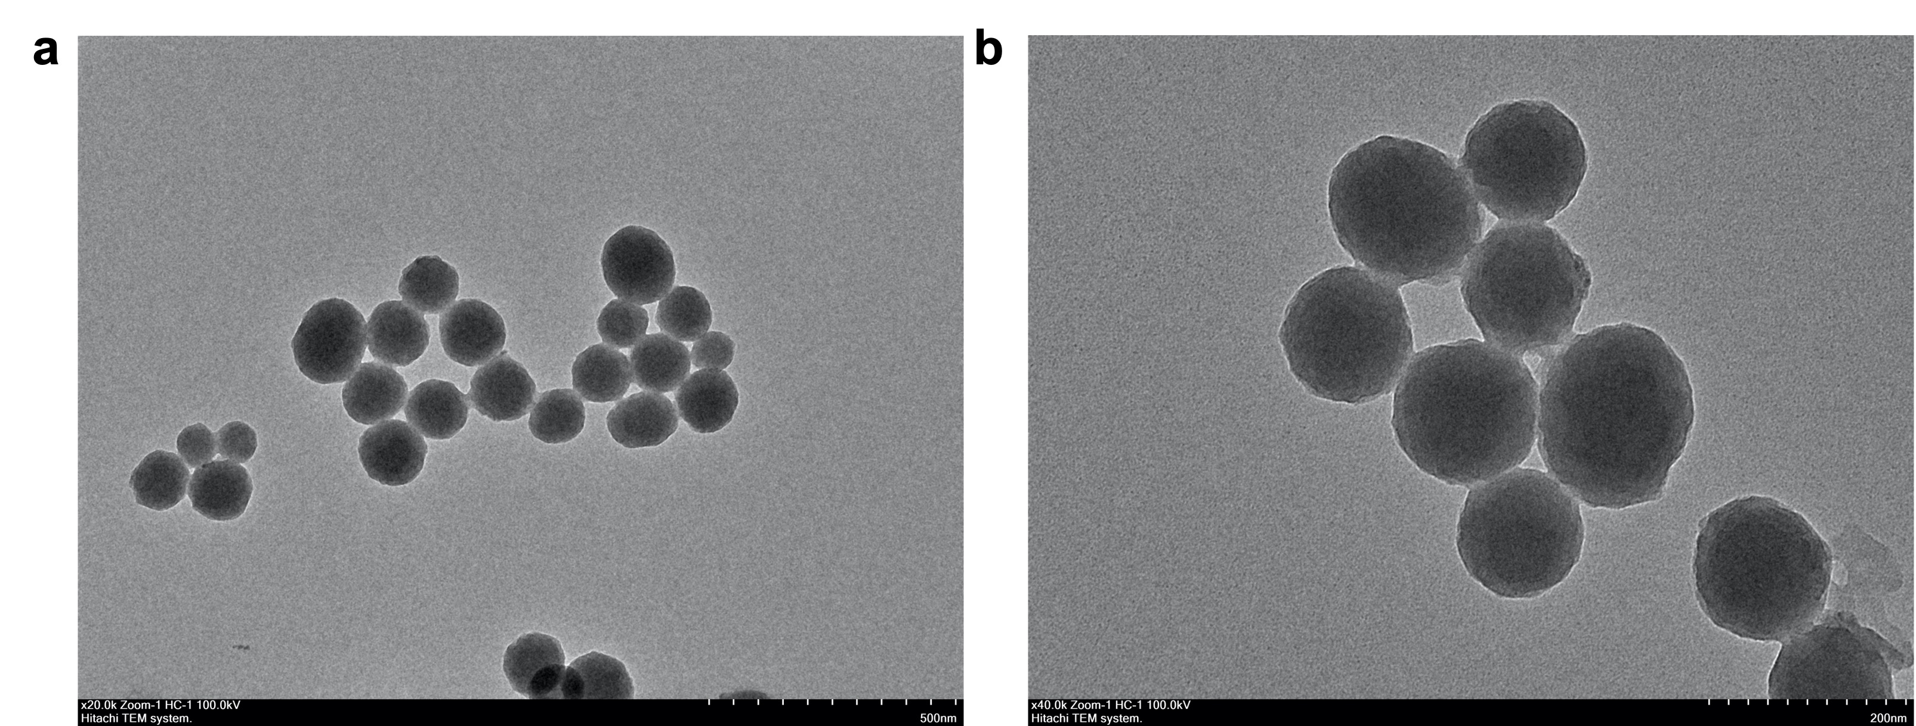Figure. S1 TEM (a) and (b) imagines of CNSs

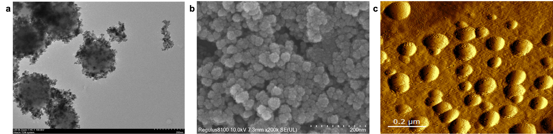
Fig. S2 TEM (a), SEM (b) and AFM (c) images of Fe₃O₄@CNSs@DOX.
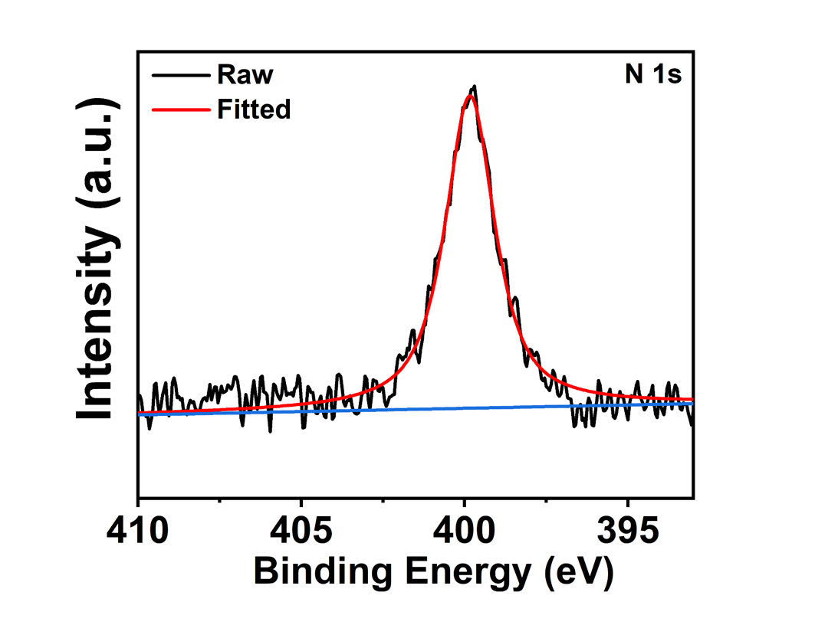
Figure. S3 XPS spectra of N 1s.

Fig. S4 The TEM of Fe₃O₄/DOX@CNSs after placed in PBS solution (pH=5) for 24 h.

Figure. S5 Hemolysis diagram.
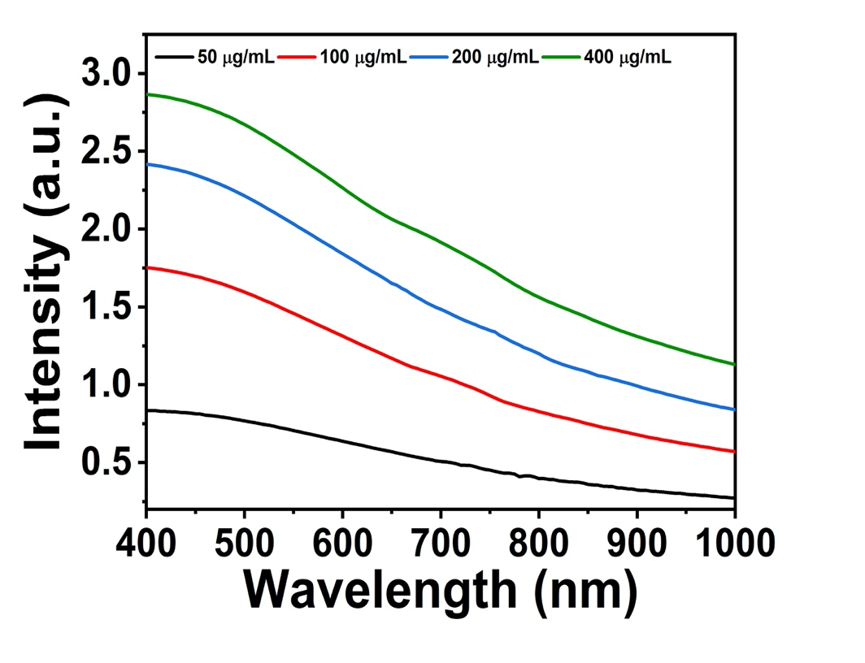
Figure. S6 The vis-NIR absorption spectra of Fe₃O₄/DOX@CNSs.
Figure. S7 Temperature elevation of NS and different concentrations of Fe₃O₄/DOX@CNSs with laser irradiation (808 nm, 2.0 W/cm², 10 min)

Figure. S8 T2 Signal intensity change plot of tumor site at various time intervals.

Figure. S9 Photographs of changes in tumor volume after different treatments.

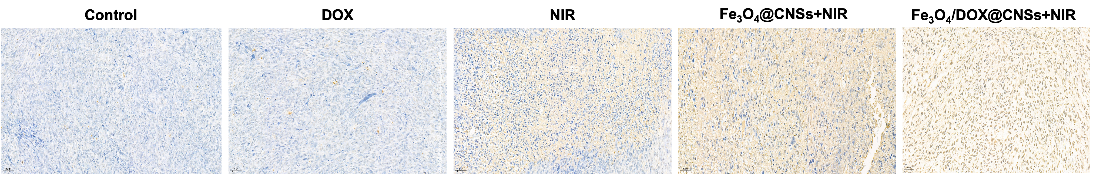
Figure. S10 TUNEL staining analysis of tumor tissue sections after various treatments, Scale bar＝50 µm.

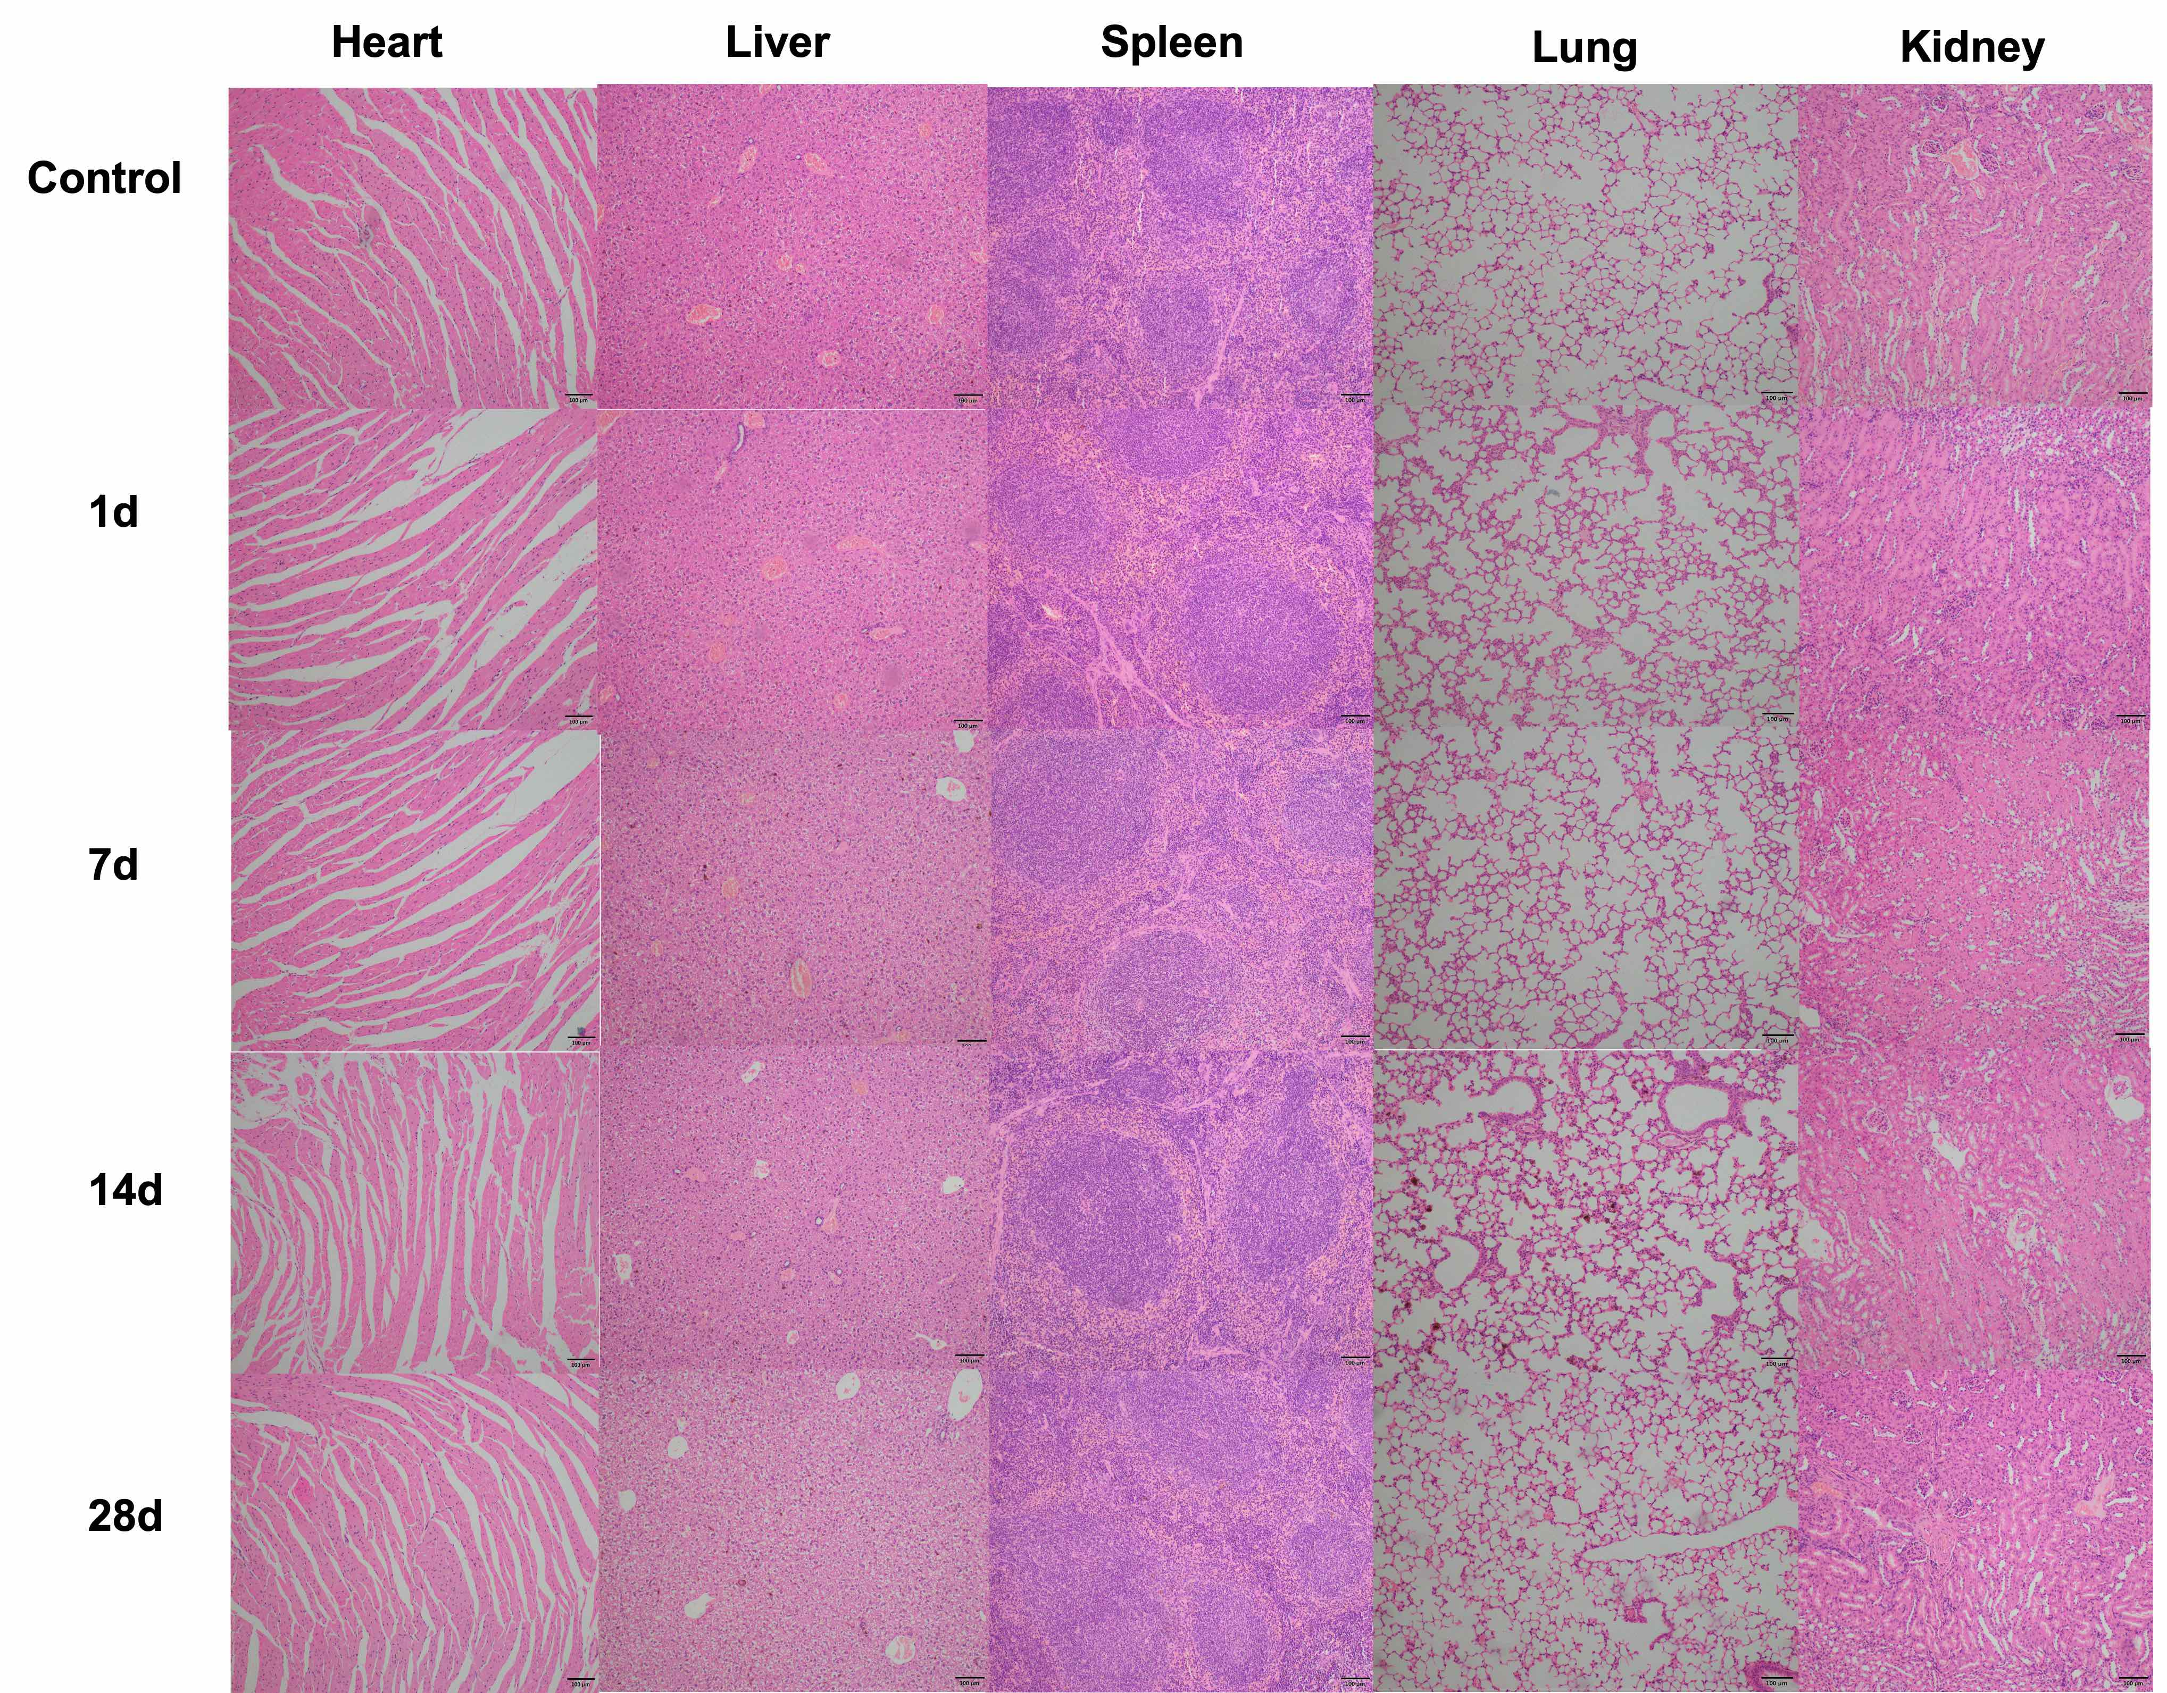
Figure. S11 H&E staining of the heart, liver, spleen, lung and kidney after various treatment (control group, DOX group, NIR group, Fe₃O₄@CNSs ＋NIR group,Fe₃O₄@CNSs@DOX + NIR group), Scale bar＝50um.

Table S1 HR with different concentrations of Fe₃O₄/DOX@CNSs (10, 50, 100, 200 μg/mL).

Groups | OD value | HR（%）
NS | 0.0146±0.006 | -----
10 μg / mL | 0.0195±0.006 | 0.79
50 μg / mL | 0.0215±0.007 | 1.11
100 μg / mL | 0.0217±0.008 | 1.14
100 μg / mL | 0.0267±0.007 | 1.95
DDW | 0.6352±0.006 | -----

