Supplementary Information

Polydopamine Nanoparticles-Based Photothermal Effect against Adhesion Formation in a Rat Model of Achilles Tendon Laceration Repair
Zekun Zhou^{1,2}, Shaoyan Li^{1,2}, Xu Gong^{1,2}

¹Department of Hand and Podiatric Surgery, Orthopedics Center, The First Hospital of Jilin University, Changchun, 130021, People’s Republic of China
²Jilin Province Key Laboratory on Tissue Repair, Reconstruction and Regeneration, The First Hospital of Jilin University, Changchun, 130021, People’s Republic of China

Correspondence: Professor Xu Gong
Department of Hand and Podiatric Surgery, Orthopedics Center
The First Hospital of Jilin University
1 Xin Min Street, Changchun, Jilin Province
130021
People’s Republic of China
Tel: +86 13944099151
Email：gongxu@jlu.edu.cn

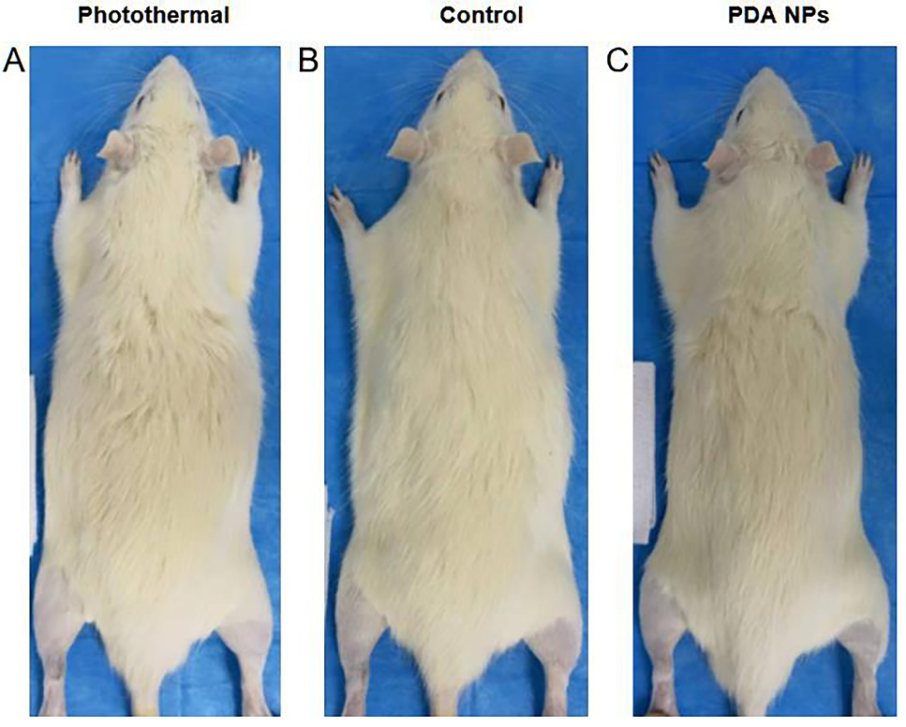
Supplementary Information Figure 1: The skin healed well without infection and ulceration. (A) The gross observation of the photothermal group. (B) The gross observation of the control group. (C) The gross observation of the PDA NPs group.
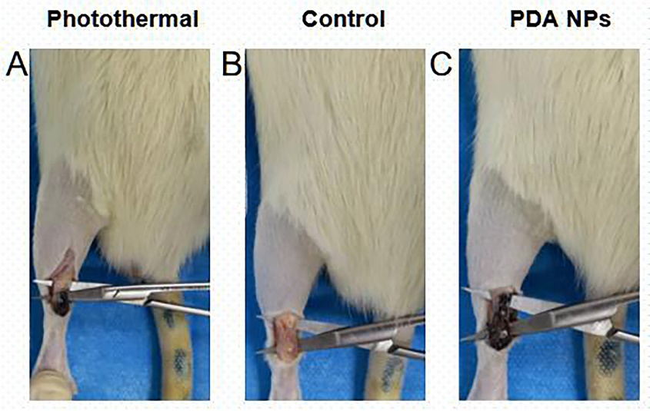
Supplementary Information Figure 2: (A, B, C) At two weeks after surgery, the tendon healed completely. (A) The healed tendon of the photothermal group. (B) The healed tendon of the control group. (C) The healed tendon of the PDA NPs group.

