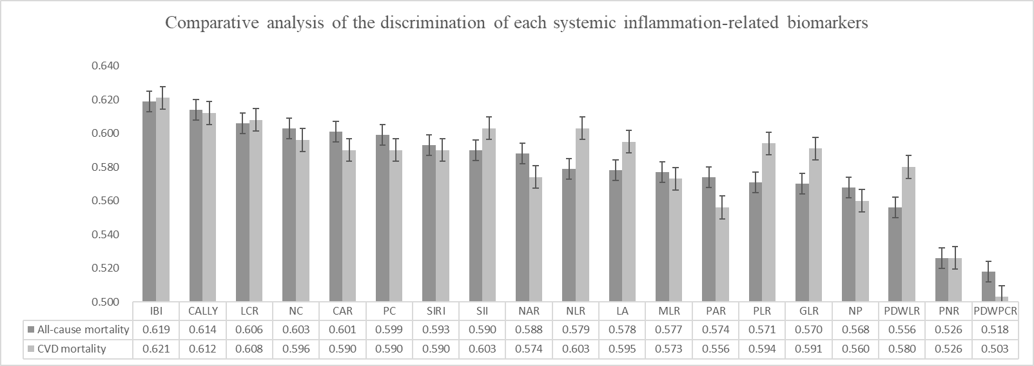
Figure S1. Comparative analysis of the discrimination of each systemic inflammation-related biomarkers for all-cause and CVD mortality in PD patients
Abbreviations: IBI: inflammatory burden index (C-reactive protein–neutrophil–lymphocyte ratio); CALLY: C-reactive protein-albumin-lymphocyte index; LCR: Lymphocyte-to-C-reactive protein ratio; NC: Lymphocyte C-reactive protein score; CAR: C-reactive protein-to-albumin ratio; PC: Platelet-C-reactive protein score; SIRI: Systemic inflammation response index; SII: Systemic-immune-inflammation index; NAR: Neutrophil-to-albumin ratio; NLR: Neutrophil-to-lymphocyte ratio; LA: Lymphocyte–albumin score; MLR: Monocyte-to-lymphocyte Ratio; PAR: Platelet-to-albumin ratio; PLR: Platelet-to-lymphocyte ratio; GLR: Glucose to lymphocyte Ratio; NP: Neutrophil–platelet score; PDWLR: Platelet distribution width to lymphocyte ratio; PNR: Platelet-to-Neutrophil Ratio; PDWPCR: Platelet distribution width to platelet count ratio.

Table S1 The prognostic value of systemic inflammation-related biomarkers in the prognosis assessment in PD patients.
 | Model 1 | p value | Model 2 | p value | Model 3 | p value
All-cause mortality
NC | 1.006(1.005,1.007） | <0.001 | 1.004(1.002,1.005) | <0.001 | 1.003(1.002,1.004) | <0.001
CAR | 3.044(2.401,3.861） | <0.001 | 1.954(1.523,2.507) | <0.001 | 1.718(1.302,2.267) | <0.001
PC（per SD） | 1.250(1.186,1.317) | <0.001 | 1.133(1.072,1.199) | <0.001 | 1.104(1.035,1.178) | 0.003
NAR | 1,447(1.338,1.566) | <0.001 | 1.288(1.182,1.405) | <0.001 | 1.240(1.118,1.376) | <0.001
PAR | 1.093(1.068,1.118) | <0.001 | 1.046(1.020,1.072) | <0.001 | 1.123(1.005,1.255) | 0.041
SII（per SD） | 1.194(1.157,1.232) | <0.001 | 1.177(1.137,1.219) | <0.001 | 1.182(1.137,1.228) | <0.001
SIRI | 1.057(1.045,1.069) | <0.001 | 1.043(1.030,1.056) | <0.001 | 1.044(1.029,1.058) | <0.001
GLR | 1.035(1.021,1.048) | <0.001 | 1.024(1.009,1.038) | 0.001 | 1.019(1.003,1.035) | 0.023
NP（per SD） | 1.144(1.098,1.192) | <0.001 | 1.089(1.040,1.141) | <0.001 | 1.115(1.038,1.197) | 0.003
MLR | 1.434(1.329,1.547) | <0.001 | 1.335(1.226,1.453) | <0.001 | 1.330(1.213,1.457) | <0.001
NLR | 1.029(1.023,1.035) | <0.001 | 1.029(1.022,1.035) | <0.001 | 1.030(1.023,1.037) | <0.001
PLR（per SD） | 1.174(1.136,1.213) | <0.001 | 1.153(1.114,1.194) | <0.001 | 1.141(1.099,1.184) | <0.001
PDWLR | 1.015(1.011,1.020) | <0.001 | 1.012(1.007,1.016) | <0.001 | 1.012(1.008,1.016) | <0.001
PNR | 0.996(0.993,0.999) | 0.006 | 0.996(0.993,0.999) | 0.011 | 0.994(0.990,0.997) | <0.001
PDWPCR | 0.952(0.112,8.073) | 0.964 | 2.431(0.322,18.334) | 0.389 | 9.672(1.055,88.651) | 0.045
LA | 0.987(0.984,0.991) | <0.001 | 0.989(0.985,0.993) | <0.001 | 0.989(0.985,0.994) | <0.001
LCR | 0.813(0.753,0.877) | <0.001 | 0.858(0.799,0.921) | <0.001 | 0.889(0.830,0.951) | 0.001
CALLY | 0.939(0.918,0.960) | <0.001 | 0.955(0.935,0.975) | <0.001 | 0.966(0.947,0.986) | 0.001
CVD mortality
NC | 1.006(1.004,1.007) | <0.001 | 1.004(1.002,1.005) | <0.001 | 1.003(1.002,1.005) | <0.001
CAR | 3.153(2.302,4.319) | <0.001 | 2.095(1.508,2.910) | <0.001 | 1.938(1.349,2.784) | <0.001
PC（per SD） | 1.273(1.189,1.364) | <0.001 | 1.168(1.086,1.256) | <0.001 | 1.148(1.055,1.248) | 0.001
NAR | 1.426(1.282,1.587) | <0.001 | 1.275(1.133,1.433) | <0.001 | 1.258(1.092,1.449) | 0.001
PAR | 1.084(1.051,1.118) | <0.001 | 1.040(1.006,1.076) | 0.023 | 1.159(1.000,1.344) | 0.05
SII（per SD） | 1.196(1.148,1.246) | <0.001 | 1.181(1.129,1.235) | <0.001 | 1.193(1.135,1.255) | <0.001
SIRI | 1.056(1.040,1.072) | <0.001 | 1.042(1.024,1.060) | <0.001 | 1.043(1.023,1.064) | <0.001
GLR | 1.035(1.018,1.053) | <0.001 | 1.025(1.005,1.044) | 0.012 | 1.022(1.002,1.044) | 0.035
NP（per SD） | 1.138(1.075,1.204) | <0.001 | 1.094(1.024,1.168) | 0.007 | 1.114(1.010,1.228) | 0.032
MLR | 1.428(1.290,1.580) | <0.001 | 1.327(1.183,1.490) | <0.001 | 1.327(1.169,1.506) | <0.001
NLR | 1.030(1.022,1.037) | <0.001 | 1.030(1.021,1.038) | <0.001 | 1.032(1.023,1.041) | <0.001
PLR（per SD） | 1.177(1.129,1.228) | <0.001 | 1.159(1.109,1.212) | <0.001 | 1.153(1.099,1.210) | <0.001
PDWLR | 1.016(1.011,1.022) | <0.001 | 1.013(1.008,1.019) | <0.001 | 1.013(1.007,1.019) | <0.001
PNR | 0.995(0.991,0.999) | 0.015 | 0.996(0.992,1.000) | 0.034 | 0.993(0.988,0.998) | 0.004
PDWPCR | 4.072(0.317,52.275) | 0.281 | 9.319(0.816,106.467) | 0.072 | 48.555(4.038,583.882) | 0.002
LA | 0.982(0.977,0.987) | <0.001 | 0.984(0.979,0.989) | <0.001 | 0.981(0.976,0.987) | <0.001
LCR | 0.682(0.592,0.786) | <0.001 | 0.731(0.639,0.836) | <0.001 | 0.761(0.665,0.871) | <0.001
CALLY | 0.896(0.861,0.933) | <0.001 | 0.917(0.883,0.952) | <0.001 | 0.927(0.893,0.963) | <0.001
Abbreviations: NC: Lymphocyte C-reactive protein score; CAR: C-reactive protein-to-albumin ratio; PC: Platelet-C-reactive protein score; NAR: Neutrophil-to-albumin ratio; PAR: Platelet-to-albumin ratio; SII: Systemic-immune-inflammation index; SIRI: Systemic inflammation response index; GLR: Glucose to lymphocyte Ratio; NP: Neutrophil–platelet score; MLR: Monocyte-to-lymphocyte Ratio; NLR: Neutrophil-to-lymphocyte ratio; PLR: Platelet-to-lymphocyte ratio; PDWLR: Platelet distribution width to lymphocyte ratio; PNR: Platelet-to-Neutrophil Ratio; PDWPCR: Platelet distribution width to platelet count ratio. LA: Lymphocyte–albumin score; LCR: Lymphocyte-to-C-reactive protein ratio; CALLY: C-reactive protein-albumin-lymphocyte index;
Model 1: unadjusted.
Model 2: adjusted for age, sex, BMI, systolic pressure, diastolic pressure, DM, and CVD history.
Model 3: Model 2 plus smoking, alcohol consumption, medication (CCB, ACEI, ARB, β-blocker, ɑ-blocker, Diuretic, Aspirin), PLT, HB, UA, ALB, TC, TG, calcium, phosphorus, iPTH, eGFR and Kt/V.
BMI, body mass index; DM：diabetes；CVD, cardiovascular disease; CCB, calcium channel blocker; ACEI, angiotensin-converting enzyme inhibitor; ARB, angiotensin receptor blocker; PLT, platelet; HB, hemoglobin; UA, Uric acid; ALB, albumin; TC, cholesterol; TG, triglyceride; iPTH, intact Parathyroid hormone; eGFR, estimated glomerular; Kt/V, K dialyzer clearance of urea.

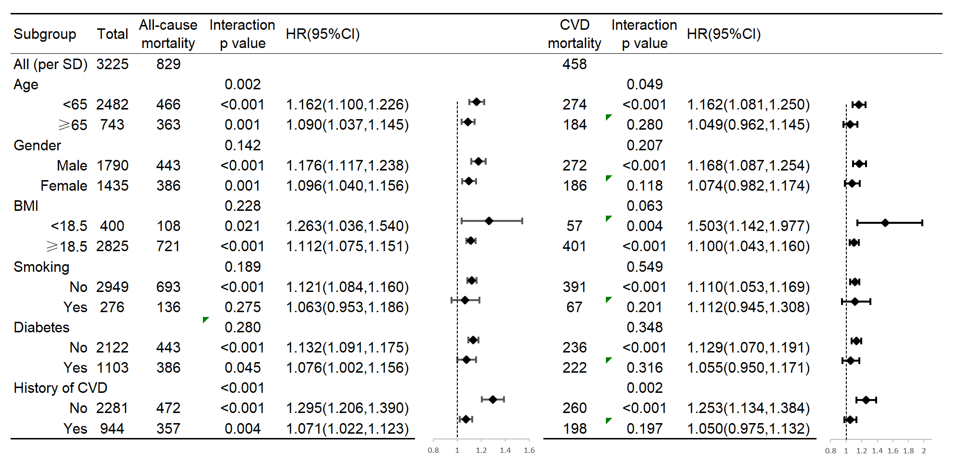
Figure S2 Forest plot of the relationship between IBI and all-cause, CVD mortality in different subgroups. The interaction P value corresponds to the interaction test between the IBI and the subgroups variable of interest.

Table S2 Demographics of PD patients between validation cohort A and validation cohort B.
Variables | Total (n = 3225) | Validation cohort A | Validation cohort B | p value
Variables | Total (n = 3225) | (n = 2257) | (n = 968) | p value
Sex, female (%) | 1435 (44.5) | 1023 (45.3) | 412 (42.6) | 0.148
Age (years) | 52.6 ± 14.8 | 52.8 ± 14.8 | 52.0 ± 14.6 | 0.163
BMI (kg/m²) | 22.3 ± 3.4 | 22.3 ± 3.5 | 22.3 ± 3.3 | 0.742
Smoking, n (%) | 276 (8.6) | 204 (9) | 72 (7.4) | 0.136
Alcohol consumption, n (%) | 75 (2.3) | 54 (2.4) | 21 (2.2) | 0.700
Diabetes, n (%) | 1103 (34.2) | 787 (34.9) | 316 (32.6) | 0.222
CVD, n (%) | 944 (29.3) | 671 (29.7) | 273 (28.2) | 0.382
Systolic pressure (mmHg) | 146.1 ± 23.7 | 146.0 ± 23.7 | 146.5 ± 23.7 | 0.628
Diastolic pressure (mmHg) | 85.2 ± 15.3 | 85.0 ± 15.2 | 85.6 ± 15.4 | 0.268
Medication
CCB, n (%) | 2027 (62.9) | 1424 (63.1) | 603 (62.3) | 0.667
ACEI, n (%) | 781 (24.2) | 554 (24.5) | 227 (23.5) | 0.506
ARB, n (%) | 936 (29.0) | 668 (29.6) | 268 (27.7) | 0.273
β-blocker, n (%) | 1112 (34.5) | 791 (35) | 321 (33.2) | 0.302
ɑ-blocker, n(%) | 670 (20.8) | 484 (21.4) | 186 (19.2) | 0.153
Diuretic | 175 (5.4) | 132 (5.8) | 43 (4.4) | 0.108
Aspirin, n (%) | 236 (7.3) | 179 (7.9) | 57 (5.9) | 0.041
Laboratory variables
White blood cell (10^9/L) | 6.79 ± 2.34 | 6.76 ± 2.28 | 6.84 ± 2.49 | 0.405
Platelet (10^9/L) | 203.8 ± 70.1 | 204.2 ± 68.1 | 203.0 ± 74.5 | 0.665
Hemoglobin (g/L) | 96.4 ± 19.8 | 96.5 ± 19.7 | 96.1 ± 19.9 | 0.618
Neutrophils (10^9/L) | 4.62 ± 2.02 | 4.59 ± 1.96 | 4.68 ± 2.17 | 0.297
Monocytes (10^9/L) | 0.50 ± 0.26 | 0.50 ± 0.26 | 0.49 ± 0.27 | 0.252
Lymphocytes (10^9/L) | 1.31 ± 0.53 | 1.31 ± 0.54 | 1.32 ± 0.53 | 0.968
Albumin (g/L) | 34.8 ± 5.6 | 34.7 ± 5.6 | 35.0 ± 5.6 | 0.108
Uric acid (mmol/L) | 416.7 ± 113.8 | 415.5 ± 114.8 | 419.3 ± 111.6 | 0.378
Cholesterol (mmol/L) | 4.65 ± 1.34 | 4.66 ± 1.34 | 4.61 ± 1.33 | 0.298
Triglyceride (mmol/L) | 1.70 ± 1.37 | 1.70 ± 1.39 | 1.69 ± 1.31 | 0.894
Glucose (mmol/L) | 5.43 ± 2.14 | 5.44 ± 2.20 | 5.38 ± 2.01 | 0.465
Calcium (mmol/L) | 2.11 ± 0.28 | 2.11 ± 0.28 | 2.11 ± 0.28 | 0.941
Phosphorus (mmol/L) | 1.65 ± 0.56 | 1.65 ± 0.55 | 1.66 ± 0.57 | 0.793
Intact Parathyroid hormone (pg/mL) | 326.3 ± 259.2 | 326.8 ± 265.9 | 325.1 ± 243.0 | 0.863
eGFR(mL/min/1.73m²) | 6.80 ± 3.10 | 6.87 ± 3.13 | 6.64 ± 3.02 | 0.058
Kt/V | 2.18 ± 0.82 | 2.18 ± 0.80 | 2.20 ± 0.85 | 0.545
Continuous variables are shown as the mean ± SD or median (IQR).
Abbreviations: BMI, body mass index; CVD, cardiovascular disease; CCB, calcium channel blocker; ACEI, angiotensin-converting enzyme inhibitor; ARB, angiotensin receptor blocker ; eGFR, estimated glomerular; Kt/V, K dialyzer clearance of urea.

Table S3 Association between inflammatory burden index and overall survival of PD patients at validation A.
 | Model 1 | p value | Model 2 | p value | Model 3 | p value
All-cause mortality
Continuous（per SD） | 1.191 (1.153,1.231) | <0.001 | 1.150(1.108,1.193) | <0.001 | 1.145（1.098,1.193） | <0.001
Cut-off value
C1(<50.57) | ref |  | ref |  | ref
C2(≥50.57) | 2.101 (1.742,2.534) | <0.001 | 1.734(1.423,2.099) | <0.001 | 1,721(1.406,2.107) | <0.001
Quartiles
Q1(<4.99) | ref |  | ref |  | ref
Q2(4.99-13.95) | 1.177 (0.907,1.528) | 0.221 | 1.091 (0.839,1.417) | 0.517 | 1.039 (0.789,1.368) | 0.785
Q3(13.95-34.12) | 1.514 (1.176,1.948) | 0.001 | 1.364 (1.058,1.757) | 0.017 | 1.308 (1.002,1.707) | 0.048
Q4(>34.12) | 2.282 (1.803,2.888) | <0.001 | 1.760 (1.385,2.235) | <0.001 | 1.582 (1.229,2.037) | <0.001
CVD mortality
Continuous（per SD） | 1.197 (1.148,1.248) | <0.001 | 1.145(1.093,1.200) | <0.001 | 1.156（1.095,1.220） | <0.001
Cut-off value
C1(<50.57) | ref |  | ref |  | ref
C2(≥50.57) | 2.092 (1.627,2.689) | <0.001 | 1.713(1.327,2.212) | <0.001 | 1.663 (1.268,2.184) | <0.001
Quartiles
Q1(<4.99) | ref |  | ref |  | ref
Q2(4.99-13.95) | 1.423 (0.992,2.042) | 0.055 | 1.307 (0.910,1.877) | 0.147 | 1.293 (0.887,1.885) | 0.182
Q3(13.95-34.12) | 1.936 (1.369,2.738) | <0.001 | 1.754 (1.239,2.484) | 0.002 | 1.698 (1.180,2.445) | 0.004
Q4(>34.12) | 2.440 (1.747,3.410) | <0.001 | 1.914 (1.363,2.686) | <0.001 | 1.735 (1.213,2.483) | 0.003
Abbreviations:
Model 1: unadjusted.
Model 2: adjusted for age, sex, BMI, systolic pressure, diastolic pressure, DM, and CVD history.
Model 3: Model 2 plus smoking, alcohol consumption, medication (CCB, ACEI, ARB, β-blocker, ɑ-blocker, Diuretic, Aspirin), PLT, HB, UA, ALB, TC, TG, calcium, phosphorus, iPTH, eGFR and Kt/V.
IBI, inflammatory burden index；BMI, body mass index; DM：diabetes；CVD, cardiovascular disease; CCB, calcium channel blocker; ACEI, angiotensin-converting enzyme inhibitor; ARB, angiotensin receptor blocker; PLT, platelet; HB, hemoglobin; UA, Uric acid; ALB, albumin; TC, cholesterol; TG, triglyceride; iPTH, intact Parathyroid hormone; eGFR, estimated glomerular; Kt/V, K dialyzer clearance of urea.

Table S4 Association between inflammatory burden index and overall survival of PD patients at validation B.
 | Model 1 | p value | Model 2 | p value | Model 3 | p value
All-cause mortality
Continuous（per SD） | 1.352 (1.228,1.489) | <0.001 | 1.313 (1.181,1.460) | <0.001 | 1.278（1.132,1.442） | <0.001
Cut-off value
C1(<50.57) | ref |  | ref |  | ref
C2(≥50.57) | 2.208 (1.667,2.923) | <0.001 | 1.905 (1.429,2.541) | <0.001 | 1.791 (1.287,2.494) | 0.001
Quartiles
Q1(<4.99) | ref |  | ref |  | ref
Q2(4.99-13.95) | 1.572 (1.026,2.410) | 0.038 | 1.510 (0.983,2.320) | 0.060 | 1.563 (0.993,2.460) | 0.54
Q3(13.95-34.12) | 1.950 (1.302,2.920) | 0.001 | 1.764 (1.174,2.651) | 0.006 | 1.712 (1.112,2.637) | 0.015
Q4(>34.12) | 2.892 (1.966,4.254) | <0.001 | 2.229 (1.502,3.308) | <0.001 | 2.034 (1.322,3.128) | 0.001
CVD mortality
Continuous（per SD） | 1.448 (1.292,1.622) | <0.001 | 1.409(1.245,1.595) | <0.001 | 1.409 (1.214,1.635) | <0.001
Cut-off value
C1(<50.57) | ref |  | ref |  | ref
C2(≥50.57) | 2.806 (1.967,4.001) | <0.001 | 2.458(1.708,3.538) | <0.001 | 2.555 (1.679,3.889) | <0.001
Quartiles
Q1(<4.99) | ref |  | ref |  | ref
Q2(4.99-13.95) | 1.104 (0.611,1.994) | 0.744 | 1.072 (0.592,1.943) | 0.818 | 1.220 (0.648,2.297) | 0.538
Q3(13.95-34.12) | 1.794 (1.063,3.027) | 0.029 | 1.562 (0.920,2.651) | 0.099 | 1.517 (0.858,2.682) | 0.151
Q4(>34.12) | 2.966 (1.814,4.849) | <0.001 | 2.282 (1.379,3.777) | 0.001 | 2.355 (1.353,4.098) | 0.002
Abbreviations:
Model 1: unadjusted.
Model 2: adjusted for age, sex, BMI, systolic pressure, diastolic pressure, DM, and CVD history.
Model 3: Model 2 plus smoking, alcohol consumption, medication (CCB, ACEI, ARB, β-blocker, ɑ-blocker, Diuretic, Aspirin), PLT, HB, UA, ALB, TC, TG, calcium, phosphorus, iPTH, eGFR and Kt/V.
IBI, inflammatory burden index；BMI, body mass index; DM：diabetes；CVD, cardiovascular disease; CCB, calcium channel blocker; ACEI, angiotensin-converting enzyme inhibitor; ARB, angiotensin receptor blocker; PLT, platelet; HB, hemoglobin; UA, Uric acid; ALB, albumin; TC, cholesterol; TG, triglyceride; iPTH, intact Parathyroid hormone; eGFR, estimated glomerular; Kt/V, K dialyzer clearance of urea.

