Supplementary

Supplementary Tables

Supplementary Table 1: Numerical Ranking of Novel Memory Scoring Example
Person | Memory performance score | Levels of difficulty | Mistakes | Total time
1 | 100 | 35 | 2 | 88.419998
2 | 99 | 35 | 10 | 67.38999
3 | 98 | 35 | 13 | 129.49001
4 | 81 | 27 | 13 | 102.93
5 | 79 | 27 | 14 | 131.59
6 | 53 | 20 | 11 | 69.57
7 | 52 | 20 | 11 | 117.65
8 | 21 | 14 | 12 | 73.839996
9 | 18 | 14 | 17 | 266.29001
10 | 9 | 9 | 11 | 76.75

Supplementary Table 2: Post-hoc Analysis of Participants’ Characteristics
Factor | MetS vs No MetS (No risk factors) - p-value | MetS vs MetS (with 1-2 risk factors) -p-value | MetS (No risk factors) vs MetS (with 1-2 risk factors) – p-value
Age | 0.0000 | 0.0010 | 0.0000
BMI | 0.0000 | 0.0000 | 0.0000
Gender | 0.3719 | 1.0000 | 0.1744
Nationality | 0.1397 | 0.1573 | 0.9421
Waist Circumference | 0.0000 | 0.0000 | 0.0000
HbA1c | 0.0000 | 0.0000 | 0.0000
Triglycerides | 0.0000 | 0.0000 | 0.0000
HDL | 0.0000 | 0.0000 | 0.0000
Blood pressure | 0.0000 | 0.0000 | 0.0000
Physical Activity | 0.1124 | 0.0437 | 1.0000

Supplementary Table 3. Comparison of Memory Performance and Speed of Reaction Score by Component
Factor | N | Memory performance, median (IQR) | P-value | Speed of reaction score, median (IQR) | P-value
Dysglycaemia
Yes | 528 | 43.3 (21.8, 70.5) |  | 99.7 (54.1, 213.4)
No | 472 | 57.6 (30.9, 78.3) | <0.001 | 83.8 (50.5, 165.1) | 0.012
Low HDL
Yes | 318 | 49.8 (21.4, 77.0) |  | 96.1 (54.8, 190.3)
No | 682 | 50.3 (26.0, 74.5) | 0.79 | 89.1 (50.7, 173.4) | 0.12
Raised blood pressure
Yes | 252 | 41.6 (19.0, 67.3) |  | 97.8 (54.4, 182.7)
No | 748 | 52.4 (27.7, 76.9) | <0.001 | 92.1 (51.8, 183.5) | 0.41
Raised Triglycerides
Yes | 315 | 48.5 (26.0, 73.2) |  | 95.8 (51.0, 176.4)
No | 685 | 50.8 (24.5, 75.6) | 0.55 | 90.7 (52.6, 185.6) | 0.87
Raised waist circumference
Yes | 397 | 42.0 (20.5, 66.9) |  | 115.2 (60.1, 235.7)
No | 603 | 54.8 (28.3, 78.4) | <0.001 | 82.8 (49.7, 156.1) | <0.001
Adjusted for age, sex, income, physical activity, diet, cigarette, and shisha smoking.

Supplementary Table 4. Association Between Metabolic Syndrome Components and Cognitive Dysfunction – Multivariable Logistic Regression

 | OR | 95% CI | P-value
Model 1: Speed of reaction score (for MetS components)
Dysglycaemia | 1.38 | 0.98-1.95 | 0.064
Raised waist circumference | 1.53 | 1.09 -2.15 | 0.015
Raised blood pressure | 0.84 | 0.56-1.27 | 0.417
Low HDL | 1.06 | 0.75 - 1.5 | 0.747
Raised triglycerides | 1.07 | 0.74-1.56 | 0.702
Model 2: Memory performance score (for MetS components)
Dysglycaemia | 1.21 | 0.88-1.66 | 0.243
Raised waist circumference | 1.17 | 0.85-1.62 | 0.97
Raised blood pressure | 1.4 | 0.99-1.99 | 0.059
Low HDL | 1.16 | 0.84-1.61 | 0.36
Raised triglycerides | 0.97 | 0.69-1.36 | 0.844
Adjusted for age, sex, income, physical activity, diet, education, cigarette, and shisha smoking.

Supplementary Table 5: Association Between Metabolic Syndrome and Cognitive Dysfunction- Stratified Analysis Based on Level of Education
Below tertiary education group |  |  |  | Tertiary education and above group
 | OR | 95% CI | P-value | OR | 95% CI | P-value
Memory Performance Score
No MetS components | Ref
1-2 MetS components | 2.00 | 0.89 -4.52 | 0.093 | 1.49 | 0.81 -2.76 | 0.202
MetS | 2.52 | 1.08 -5.83 | 0.032 | 1.29 | 0.65 -2.59 | 0.461
Constant (baseline odds) | 0.54 | 0.18- 1.59 | 0.264 | 0.49 | 0.22-1.14 | 0.100
Speed of Reaction Score
No MetS components | Ref
1-2 MetS components | 2.08 | 0.88 -4.94 | 0.095 | 0.77 | 0.43-1.39 | 0.393
MetS | 2.90 | 1.18 – 7.15 | 0.021 | 1.05 | 0.55-2.01 | 0.885
Constant (baseline odds) | 0.48 | 0.13-1.69 | 0.253 | 0.18 | 0.42-0.64 | 0.001

Adjusted for age, sex, income, physical activity, diet, cigarette, and shisha smoking,

Supplementary figure 1. Comparison of memory performance by MetS components
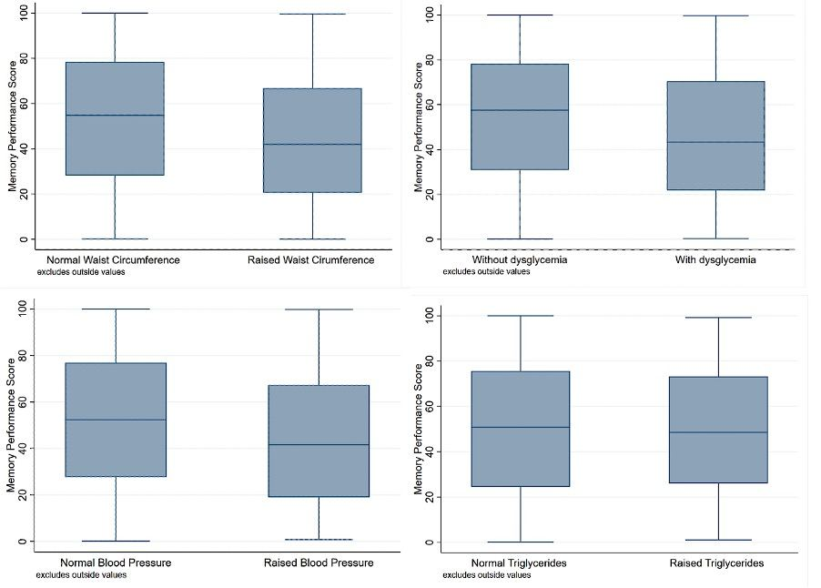

Supplementary figure 2. Comparison of speed of reaction score by MetS components
