Supplementary Material

Effects of curative-intent treatments on hepatocellular carcinoma survival in alcohol-related cirrhosis: a nationwide study
Frederik Kraglund¹, Gerda Elisabeth Villadsen¹, Peter Jepsen^{1, 2}
¹ Department of Hepatology and Gastroenterology, Aarhus University Hospital, Aarhus, Denmark
² Department of Clinical Epidemiology, Aarhus University Hospital, Aarhus, Denmark

Table of contents
Supplementary Fig. S1. 2
Supplementary Fig. S2 3
Supplementary Table S1 4
Supplementary Table S2 5

Supplementary Figure S1. Overall (crude) survival in by resection and ablation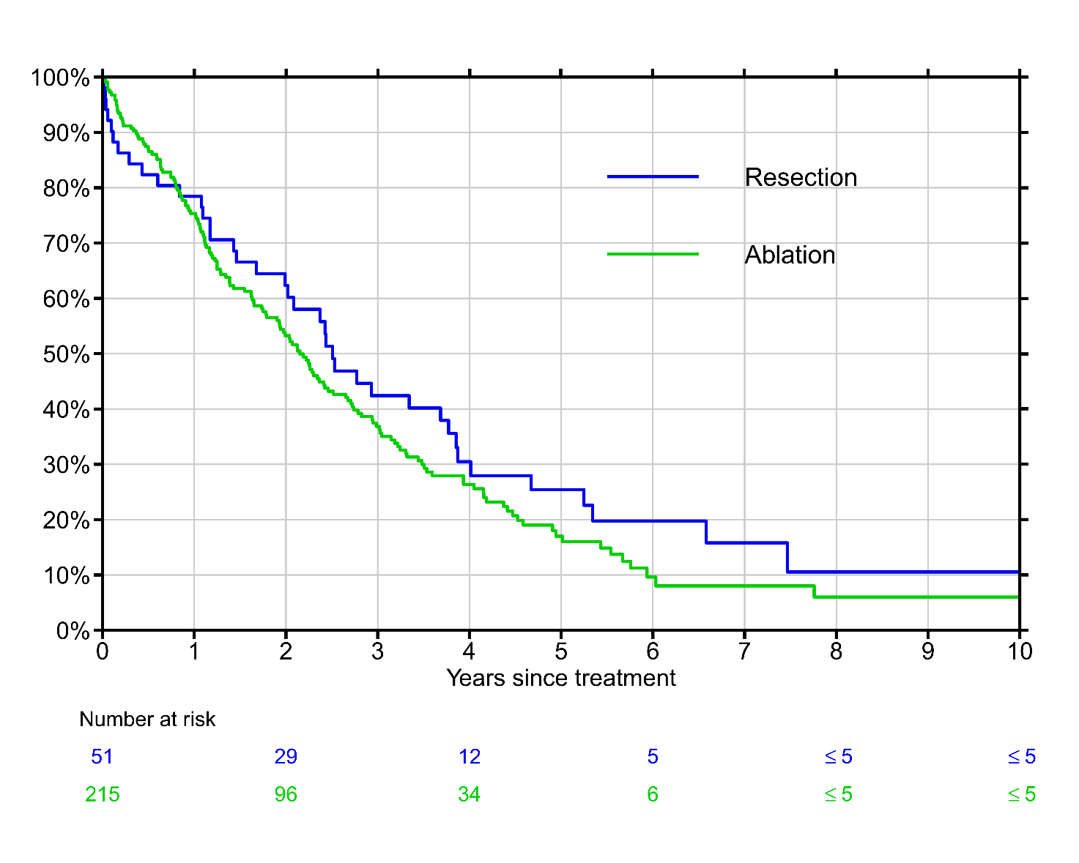
Supplementary Fig. S2. The average number of CT and MR liver scans received by patients in the resection (top) and ablation (bottom) cohorts per person-year per year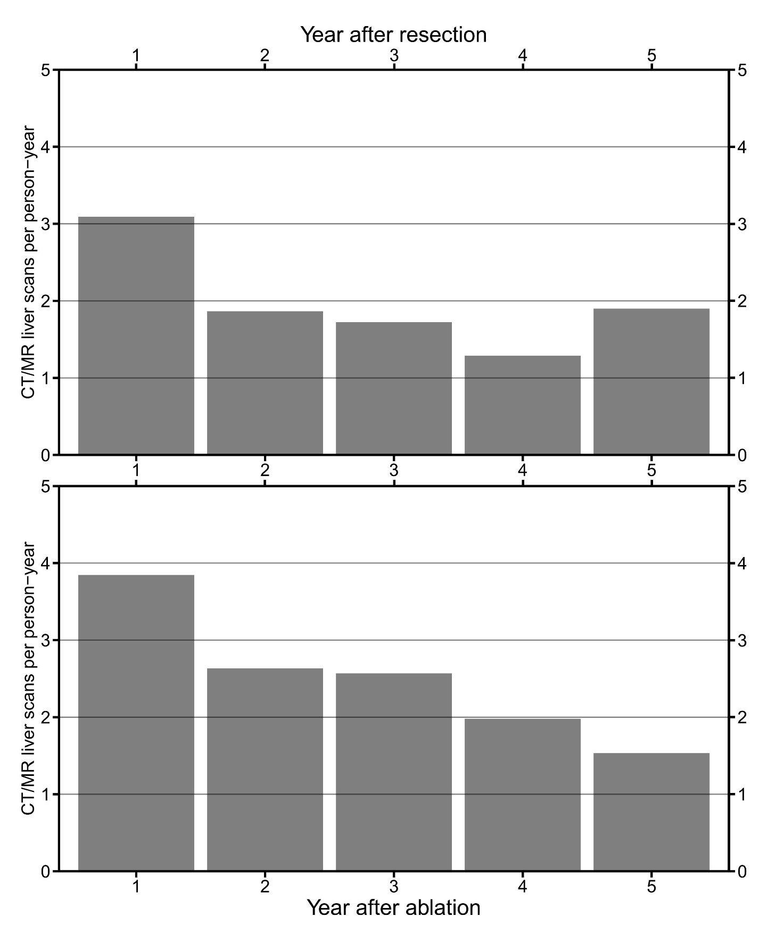

Supplementary Table S1. List of codes used to define the study population and treatment cohorts.
Danish National Patient Registry
 | Diagnoses
 |  | Hepatocellular carcinoma | ICD-10: C22.0x
 |  | Cirrhosis due to alcohol-related liver disease | ICD-10: K70.3x, ICD-8: 571.0x
 |  | Ascites | ICD-10: R18x
 |  | Spontaneous bacterial peritonitis | ICD-10: K65.8I
 |  | Hepatorenal syndrome | ICD-10: K76.7
 |  | Variceal bleeding | ICD-10: I85.0, I86.4A
 | Surgical procedures
 |  | Liver transplantation | NCSP: JJC 00, JJC 10, JJC 20, JJC 30, JJC 40
 |  | Liver resection | NCSP: JJB xx, JJA 40, JJA 41
 |  | Ablation of pathological liver tissue | NCSP: JJA 43x, JJA 44, TJJ 10
 |  | Transarterial chemoembolization (TACE) or selective internal radiation therapy (SIRT) | NCSP: PCT 20; DCT: WGG2A, WHA110, WHA102
 |  | Treatment of esophageal varices | NCSP: JCA 20, JCA 22, JCA 32
 |  | Ascites drainage | NCSP: TJA 10x
 | Non-surgical treatments
 |  | Treatment with Sorafenib | DCT: WHA407
 |  | Treatment with Regorafenib | DCT: WHA422
 |  | External beam radiation therapy | DCT: WGC22
 |  | Best supportive care | DCT: XB xx
 | Referrals
 |  | Referral to oncology or palliative medicine | Hospital department-classification: 022, 014
Danish Cancer Register
 | Diagnoses
 |  | Hepatocellular carcinoma | ICD-10: C22.0x
 | TNM codes
 |  | TNM-T | ICD-10: AZCD13x-AZCD16x, AZCD19, AZCE13x-AZCE16x, AZCE19
 |  | TNM-N | ICD-10: AZCD30x-AZCD33x, AZCD39, AZCE30x-AZCE33, AZCE39
 |  | TNM-M | ICD-10: AZCD40x-AZCD41x, AZCD49, AZCE40x-AZCE41x, AZCE49
Abbreviations: ICD-10, International Classification of Diseases - 10th revision; ICD-8, International Classification of Diseases – 8th revision; NCSP, NOMESCO Classification of Surgical Procedures; DCT, Danish Classification of Therapies.

Supplementary Table S2. Causes of death of all deceased patients in the resection and ablation cohorts. Cells with five or less patients have been omitted to ensure patient anonymity.
 | Number of patients (% of all deaths)
Cause of death | Total | Resection | Ablation
HCC | 113 (56.8) | 21 (53.9) | 91 (57.5)
Liver cirrhosis complication, not due to HCC | 36 (18.1) | 5 (12.8) | 31 (19.4)
Infection | 19 (9.6) | 6 (15.4) | 13 (8.1)
Cardiovascular disease | 16 (8.0) | - | -
Other cause | 9 (4.5) | - | -
Unknown cause (ICD-10: R99) | 6 (3) | - | -

