Supplementary Table 1: In Silico prediction of the ADME profiles of potential SARS-CoV-2 main protease inhibitors from Thymus schimperi
No | Compound CID | Common name | Structure | Water solubility | GI absorption | BBB permeant | Bioavailability score | Synthetic accessibility
1 | 13357 | Butanoic acid | 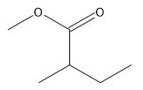 | Very soluble | High | Yes | 0.55 | 1.32
2 | 17868 | Thujene alpha | 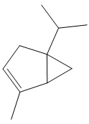 | Soluble | Low | Yes | 0.55 | 3.99
3 | 123737810 | Pinene alpha | 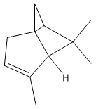 | Soluble | Low | Yes | 0.55 | 4.81
4 | 561243 | 7-Ethylcycloheptatriene | 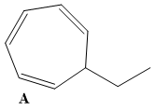 | Soluble | Low | Yes | 0.55 | 3.82
5 | 6616 | Camphene | 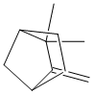 | Soluble | Low | Yes | 0.55 | 3.50
6 | 123730774 | Pinene beta | 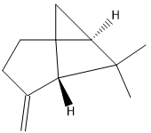 | Soluble | Low | Yes | 0.55 | 3.78
7 | 137888 | Flourazophore P | 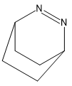 | Very soluble | High | Yes | 0.55 | 3.83
8 | 12473722 | 3-Octane | 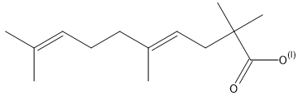 | Soluble | High | Yes | 0.85 | 2.95
9 | 31253 | Myrcene | 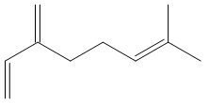 | Soluble | Low | Yes | 0.55 | 2.85
10 | 7460 | Alpha-phellandrene | 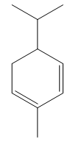 | Soluble | Low | Yes | 0.55 | 4.15
11 | 26049 | 3-Carene | 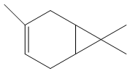 | Soluble | Low | Yes | 0.55 | 3.84
12 | 10703 | O-Cymene | 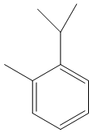 | Soluble | Low | Yes | 0.55 | 1.00
13 | 22311 | Limonene | 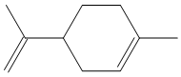 | Soluble | Low | Yes | 0.55 | 3.46
14 | 2758 | Eucalyptol | 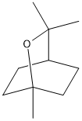 | Soluble | High | Yes | 0.55 | 3.65
15 | 142246827 | Ocimene (Z) | 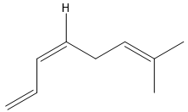 | Soluble | Low | Yes | 0.55 | 3.54
16 | 7462 | Alpha-Terpinene | 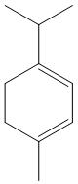 | Soluble | Low | Yes | 0.55 | 3.63
17 | 7461 | Gamma-Terpinene | 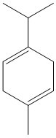 | Soluble | Low | Yes | 0.55 | 3.11
18 | 10975 | Myrcenol | 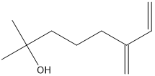 | Soluble | High | Yes | 0.55 | 2.20
19 | 11463 | Terpinolene | 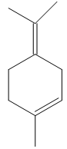 | Soluble | Low | Yes | 0.55 | 2.98
20 | 6549 | Linalool | 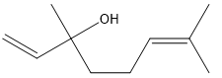 | Soluble | High | Yes | 0.55 | 2.74
21 | 527426 | Dehydrosabinaketone | 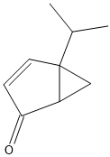 | Very soluble | High | Yes | 0.55 | 3.70
22 | 1252759 | Alpha-Campholenal | 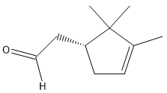 | Very soluble | High | Yes | 0.55 | 3.33
23 | 5368821 | Alloocimene | 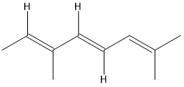 | Soluble | Low | Yes | 0.55 | 4.00
24 | 45095936 | Sabinol trans | 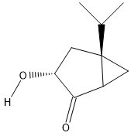 | Very soluble | High | Yes | 0.55 | 2.71
25 | 64685 | Isoborneol | 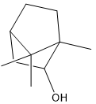 | Soluble | High | Yes | 0.55 | 3.43
26 | 110952 | 1-(3-Methylphenyl)Ethanol | 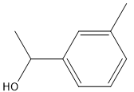 | Soluble | High | Yes | 0.55 | 1.23
27 | 442501 | (+)-Alpha-Terpineol | 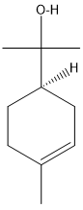 | Soluble | High | Yes | 0.55 | 3.24
28 | 556287 | Cyclohexane | 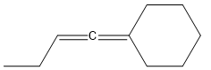 | Soluble | Low | Yes | 0.55 | 2.91
29 | 573025 | 2-Isobutylideneamino-3-Methylbutyronitrile | 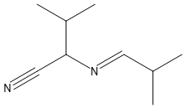 | Soluble | High | Yes | 0.55 | 3.10
30 | 8182 | dodecane |  | Moderately soluble | Low | No | 0.55 | 1.83
31 | 443183 | (1S,4S)-Dihydrocarvone | 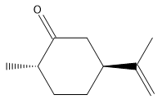 | Soluble | High | Yes | 0.55 | 2.75
32 | 564375 | 3,5-Methanocyclopentapyrazole | 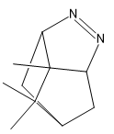 | Soluble | High | Yes | 0.55 | 4.46
33 | 562380 | 1,4-Methano-1H-Cyclopenta[D]Pyridazine | 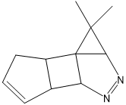 | Soluble | High | Yes | 0.55 | 5.09
34 | 80790 | Carvacrol Methyl Ether | 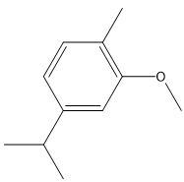 | Soluble | High | Yes | 0.55 | 1.19
35 | 643779 | Neral | 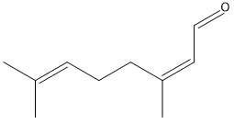 | Soluble | High | Yes | 0.55 | 2.49
36 | 527143 | Menthadienol | 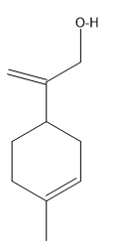 | Soluble | High | Yes | 0.55 | 3.25
37 | 6989 | Thymol | 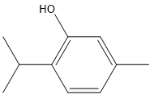 | Soluble | High | Yes | 0.55 | 1.00
38 | 10364 | Carvacrol | 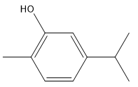 | Soluble | High | Yes | 0.55 | 1.00
39 | 68252 | Thymol Acetate | 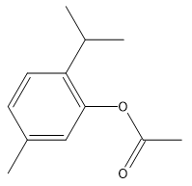 | Soluble | High | Yes | 0.55 | 1.72
40 | 80792 | Carvacryl Acetate | 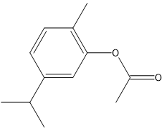 | Soluble | High | Yes | 0.55 | 1.69
41 | 56927990 | 7-Epi-Sesquithujene | 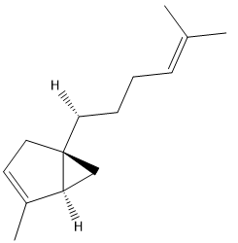 | Soluble | Low | No | 0.55 | 4.32
42 | 324224 | Beta-Bourbonene | 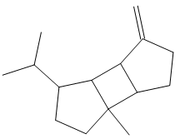 | Moderately soluble | Low | Yes | 0.55 | 3.94
43 | 5281515 | BETA-CARYOPHYLLENE | 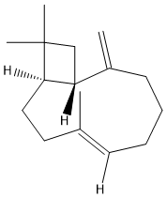 | Moderately soluble | Low | No | 0.55 | 4.49
44 |  | Beta-Gurjunene | 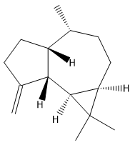 | Moderately soluble | Low | Yes | 0.55 | 3.70
45 | 6429302 | Trans-Alpha-Bergamotene | 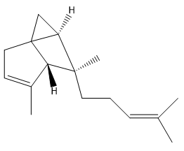 | Soluble | Low | No | 0.55 | 5.40
46 | 91746537 | Alloaromadendrene | 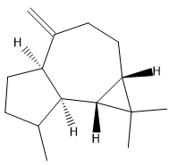 | Moderately soluble | Low | Yes | 0.55 | 3.70
47 | 564375 | 3,5-Methanocyclopentapyrazole | 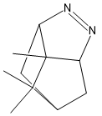 | Soluble | High | Yes | 0.55 | 4.46
48 | 132350838 | Germacrene D | 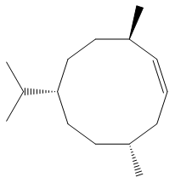 | Poorly soluble | Low | No | 0.55 | 4.44
49 | 12313019 | Gamma-Amorphene | 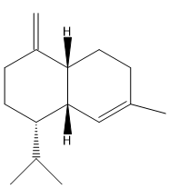 | Soluble | Low | No | 0.55 | 4.35
50 | 87203412 | Nerylisobutanoate | 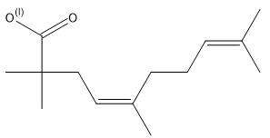 | Soluble | High | Yes | 0.85 | 2.95
51 | 10910653 | Ledene | 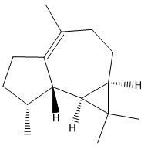 | Soluble | Low | No | 0.55 | 4.45
52 | 12473722 | Geranylisobutanoate | 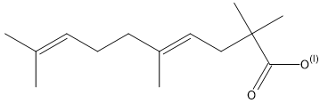 | Soluble | High | Yes | 0.85 | 2.95
53 | 519764 | Sesquiphellandrene | 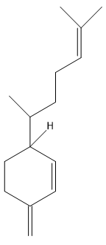 | Moderately soluble | Low | No | 0.55 | 4.42
54 | 14475467 | Beta-Vetivenene | 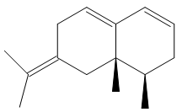 | Soluble | Low | No | 0.55 | 4.44
55 | 181580 | Beta-Atlantone | 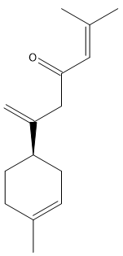 | Moderately soluble | High | Yes | 0.55 | 3.73
56 | 12592 | N-tetracosene | 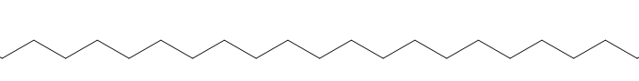 | Poorly soluble | Low | No | 0.55 | 3.20

Supplementary Table 2: In Silico prediction of the toxicity of potential SARS-CoV-2 main protease inhibitors from Thymus schimperi
No | Compound CID | Common name | In silico toxicity
No | Compound CID | Common name | LD₅₀  (mg/kg) | Toxicity class | Hepatotoxicity | Carcinogenicity | Immunotoxicity | Mutagenicity | Cytotoxicity
1 | 13357 | Butanoic acid | 5000 | 5 | No | No | No | No | No
2 | 17868 | Thujene alpha | 5000 | 5 | No | No | No | No | No
3 | 123737810 | Pinene alpha | 4800 | 5 | No | No | No | No | No
4 | 561243 | 7-Ethylcycloheptatriene | 175 | 3 | No | No | No | No | No
5 | 6616 | Camphene | 5000 | 5 | No | No | No | No | No
6 | 123730774 | Pinene beta | 5000 | 5 | No | Little | No | No | Little
7 | 137888 | Flourazophore P | 334 | 4 | Little | Yes | No | Little | No
8 | 12473722 | 3-Octane | 4260 | 5 | Yes | No | No | No | No
9 | 31253 | Myrcene | 5000 | 5 | No | Little | No | No | No
10 | 7460 | Alpha-phellandrene | 5700 | 6 | No | No | No | No | No
11 | 26049 | 3-Carene | 4800 | 5 | No | No | No | No | No
12 | 10703 | O-Cymene | 1370 | 4 | No | Yes | No | No | No
13 | 22311 | Limonene | 4400 | 5 | No | No | No | No | No
14 | 2758 | Eucalyptol | 2480 | 5 | No | No | No | No | No
15 | 142246827 | Ocimene (Z) | 113 | 3 | No | Yes | No | No | No
16 | 7462 | Alpha-Terpinene | 1680 | 4 | No | No | No | No | No
17 | 7461 | Gamma-Terpinene | 2500 | 5 | No | No | No | No | No
18 | 10975 | Myrcenol | 5300 | 6 | No | No | No | No | No
19 | 11463 | Terpinolene | 4390 | 5 | No | No | No | No | No
20 | 6549 | Linalool | 2200 | 5 | No | No | No | No | No
21 | 527426 | Dehydrosabinaketone | 1450 | 4 | No | Yes | No | No | No
22 | 1252759 | Alpha-Campholenal | 5000 | 5 | No | No | No | No | No
23 | 5368821 | Alloocimene | 1900 | 4 | No | Yes | No | No | No
24 | 45095936 | Sabinol trans | 3000 | 5 | No | No | No | No | No
25 | 64685 | Isoborneol | 500 | 4 | No | No | No | No | No
26 | 110952 | 1-(3-Methylphenyl)Ethanol | 1300 | 4 | No | No | No | No | No
27 | 442501 | (+)-Alpha-Terpineol | 2830 | 5 | No | No | No | No | No
28 | 556287 | Cyclohexane | 5000 | 5 | No | Yes | No | No | No
29 | 573025 | 2-Isobutylideneamino-3-Methylbutyronitrile | 120 | 3 | No | No | No | No | No
30 | 8182 | dodecane | 750 | 3 | No | No | No | No | No
31 | 443183 | (1S,4S)-Dihydrocarvone | 5000 | 5 | No | No | No | No | No
32 | 564375 | 3,5-Methanocyclopentapyrazole | 880 | 4 | No | Yes | No | No | No
33 | 562380 | 1,4-Methano-1H-Cyclopenta[D]Pyridazine | 260 | 3 | No | Yes | No | No | No
34 | 80790 | Carvacrol Methyl Ether | 880 | 4 | No | Yes | No | No | No
35 | 643779 | Neral | 500 | 4 | No | No | No | No | No
36 | 527143 | Menthadienol | 3000 | 5 | No | No | No | No | No
37 | 6989 | Thymol | 640 | 4 | No | No | No | No | No
38 | 10364 | Carvacrol | 810 | 4 | No | No | No | No | No
39 | 68252 | Thymol Acetate | 2000 | 4 | Yes | No | No | No | No
40 | 80792 | Carvacryl Acetate | 374 | 4 | Yes | No | No | No | No
41 | 56927990 | 7-Epi-Sesquithujene | 5000 | 5 | No | No | No | No | No
42 | 324224 | Beta-Bourbonene | 5000 | 5 | No | No | Yes | No | No
43 | 5281515 | Beta-caryophyllene | 3700 | 5 | No | No | No | No | No
44 |  | Beta-Gurjunene | 5000 | 5 | No | No | No | No | No
45 | 6429302 | Trans-Alpha-Bergamotene | 4800 | 5 | No | No | No | No | No
46 | 91746537 | Alloaromadendrene | 5000 | 5 | No | No | No | No | No
47 | 564375 | 3,5-Methanocyclopentapyrazole | 880 | 4 | No | Yes | No | No | No
48 | 132350838 | Germacrene D | 2760 | 5 | No | No | No | No | No
49 | 12313019 | Gamma-Amorphene | 4400 | 5 | No | No | Yes | No | No
50 | 87203412 | Nerylisobutanoate | 4260 | 5 | Yes | No | No | No | No
51 | 10910653 | Ledene | 5000 | 5 | No | No | No | No | No
52 | 12473722 | Geranylisobutanoate | 4260 | 5 | Yes | No | No | No | No
53 | 519764 | Sesquiphellandrene | 5000 | 5 | No | No | No | No | No
54 | 14475467 | Beta-Vetivenene | 3040 | 5 | No | No | No | No | No
55 | 181580 | Beta-Atlantone | 1640 | 4 | No | No | No | No | No
56 | 12592 | N-tetracosene | 750 | 3 | No | No | No | No | No
Toxicity key: Class I: fatal if swallowed (LD50 ≤ 5), Class II: fatal if swallowed (5 < LD50 ≤ 50), Class III: toxic if swallowed (50 < LD50 ≤ 300), Class IV: harmful if swallowed (300 < LD50 ≤ 2000), Class V: may be harmful if swallowed (2000 < LD50 ≤ 5000), Class VI: non-toxic (LD50 > 5000)

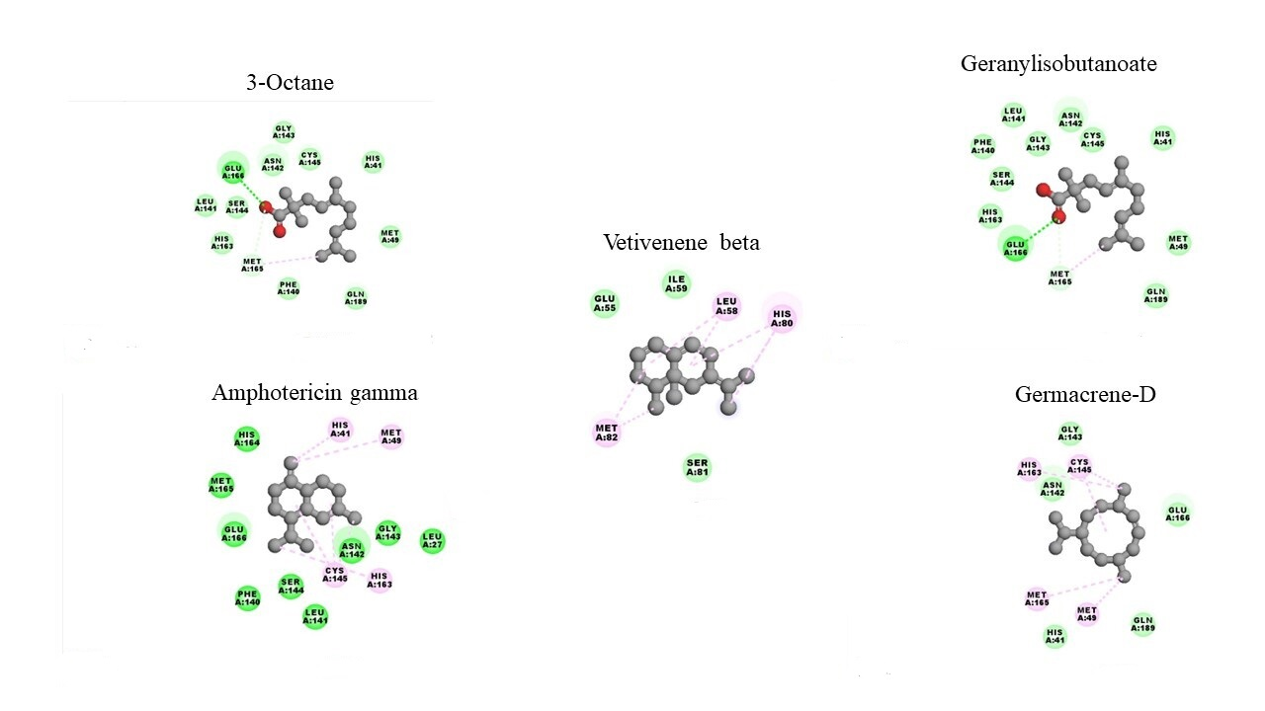
Supplementary Figure 1: Interaction of top hits with amino acids in the substrate binding pocket of SARS-CoV-2 M^{pro}. The ligands showed interaction in the pocket via conventional hydrogen bonds (green) van der Waals interactions (light green), carbon hydrogen bonds (gray) and alkyl interactions (pink).
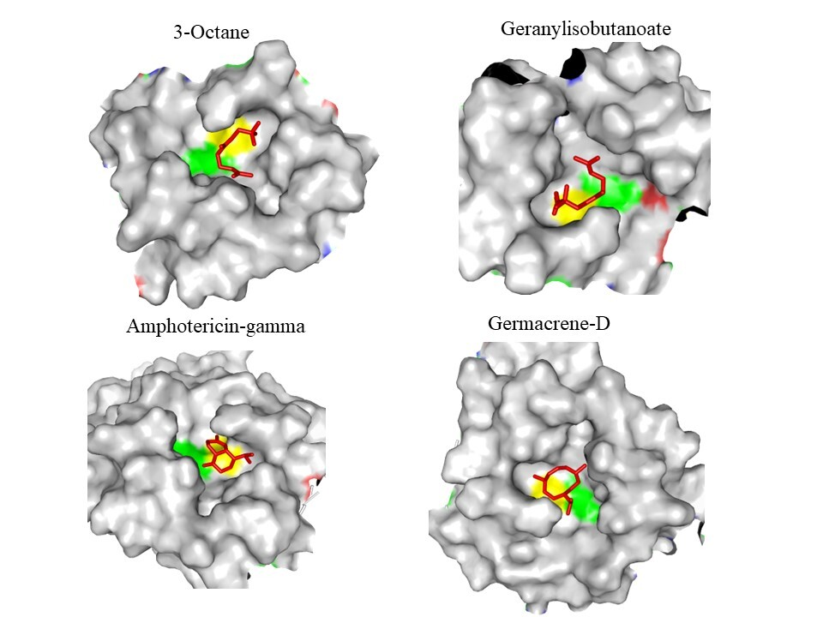
Supplementary Figure 2: Docking of top hits in the catalytic dyad of SARS-CoV-2 M^{pro}. Residues in the catalytic dyad: His⁴¹ is highlighted green and Cys¹⁴⁵ is highlighted yellow.

