Supplementary material

Supplemental Table 1 Patient demographics and clinical characteristics according to currently managing physician (n=1211)
Characteristic | Hepatologist/ Gastroenterologist (n=966) | Diabetologist (n=245) | p-value
Mean age, years (SD) | 55.0 (11.4) | 58.0 (9.0) | 0.0001
Male sex, n | 574 (59.4) | 137 (55.9) | 0.3451
Mean body mass index, kg/m² (SD) | 32.6 (5.5) | 33.6 (8.23) | 0.0189
Body mass index category, kg/m², n (%) |  |  | 0.3759
25–30 | 231 (23.9) | 49 (20.0)
30–35 | 461 (47.7) | 119 (48.6)
≥35 | 274 (28.4) | 77 (31.4)
Concomitant conditions, n (%)ª
Metabolic^{b} | 626 (64.8) | 214 (87.3) | <0.0001
Hypertension | 446 (46.2) | 160 (65.3) | <0.0001
Dyslipidemia | 388 (40.2) | 158 (64.5) | <0.0001
Mean disease duration, years (SD) | 1.5 (2.4) | 1.7 (2.6) | 0.3010
Testing (ever): liver biopsy, n (%)
VCTE cohort (n=583) | 487 (53.9) | 96 (45.5) | 0.0320
FIB-4 cohort (n=267) | 225 (53.2) | 42 (41.6) | 0.0458
ªMost common conditions, occurring in >10% of patients overall.
^{b}Metabolic=presence of any of metabolic syndrome, type 2 diabetes mellitus, insulin resistance, or hyperglycemia.
Abbreviations: FIB-4, Fibrosis-4 Index; SD, standard deviation; VCTE, vibration-controlled transient elastography.

Supplemental Table 2 Patient demographics and clinical characteristics according to whether or not the patient had a liver biopsy (n=1211)
Characteristic | No Liver Biopsy  (n=573) | Liver Biopsy  (n=638) | P-Value
Mean age, years, (SD) | 55.7 (10.8) | 55.5 (11.1) | 0.8013
Male sex | 336 (47.3) | 375 (52.7) | 1.0000
Mean body mass index, kg/m², (SD) | 32.2 (5.4) | 33.3 (6.7) | 0.0029
Body mass index category, kg/m², n (%)
25–30 | 152 (26.5) | 128 (20.1) | 0.0003
30–35 | 285 (49.7) | 295 (46.2)
≥35 | 136 (23.7) | 215 (33.7)
Concomitant conditions, n (%)ª
Metabolic | 370 (64.6) | 470 (73.7) | 0.0007
Hypertension | 252 (44.0) | 354 (55.5) | 0.0001
Dyslipidemia | 251 (43.8) | 295 (46.2) | 0.4182
Sleep disorder | 120 (20.9) | 124 (19.4) | 0.5193
Anxiety | 93 (16.2) | 108 (16.9) | 0.7576
Physician specialty, n (%) |  |  | 0.0723
Hepatologist | 235 (41.0) | 259 (40.6)
Gastroenterologist | 208 (36.3) | 264 (41.4)
Diabetologist | 130 (22.7) | 115 (18.0)
Disease duration, years | 1.2 (1.7) | 1.8 (2.9) | 0.0005
ªMost common conditions, occurring in >10% of patients overall.
Abbreviations: FIB-4, Fibrosis-4 Index; Metabolic, presence of any of metabolic syndrome, type 2 diabetes mellitus, insulin resistance, or hyperglycemia; SD, standard deviation; VCTE, vibration-controlled transient elastography.
A
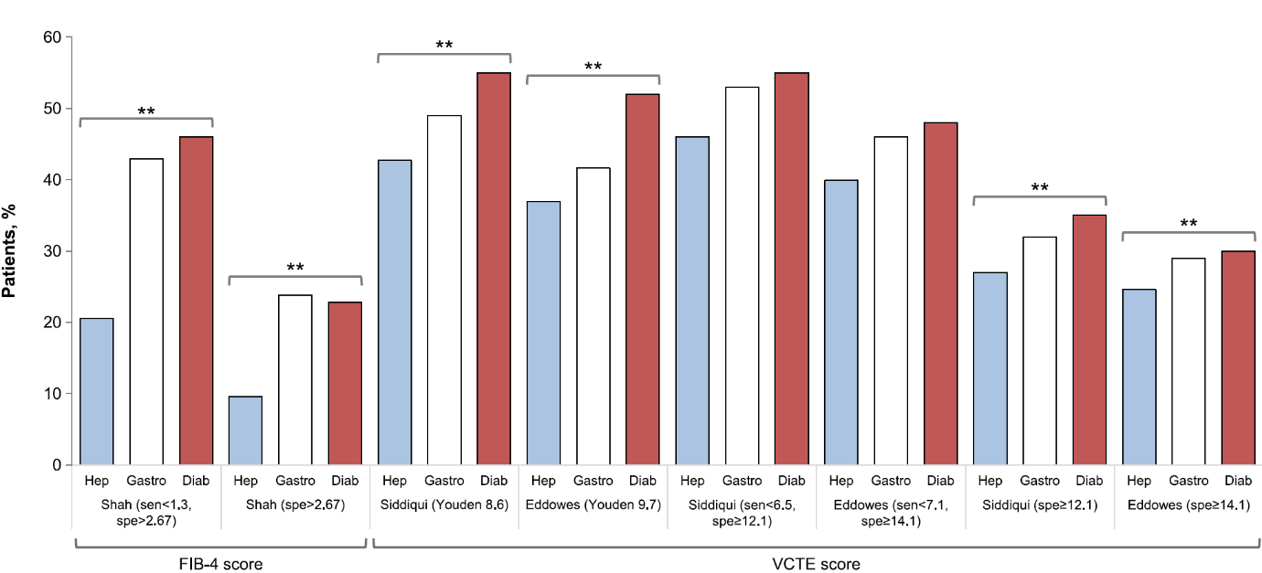
B
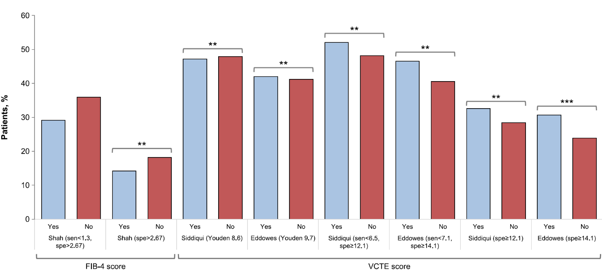

Supplementary Figure S1 Underestimation of fibrosis using PSFS versus CRFS scores according to (A) physician specialty and (B) liver biopsy (yes vs no).
**p<0.001; ***p<0.0001; p-values apply to all four alignment groups (aligned F0–F2; aligned F3/4; physician underestimated; physician overestimated). All values in parentheses are kPa.
CRFS, clinically defined reference fibrosis score; Diab, diabetologist; FIB-4, Fibrosis-4 Index; Gastro, gastroenterologist; Hep, hepatologist; PSFS, physician-stated fibrosis score; Sen, sensitivity; Spe, specificity; VCTE, vibration-controlled transient elastography.

