Supplementary material

Table S1. Comparison of postoperative vital signs between therapeutic intervention groups.
 | Total, n=80 | CA group, n= 40 | ESPB group, n= 40 | p value
Mean Arterial Pressure (mmHg)**
1 hour | 70.5 (61 - 79) | 70 (58 - 76) | 69 (63 - 80) | 0,5632
3 hours | 67 (60 - 74) | 65 (59 - 73) | 67 (62 - 78) | 0,1653
6 hours | 66.5 (60.5 – 73.5) | 67 (58 - 76) | 66 (61 - 73) | 0,9386
12 hours | 64 (58 - 74) | 63 (57 - 74) | 65 (60 - 76) | 0,4240
24 hours | 65 (58 - 76) | 65 (55 - 70) | 69 (59 - 78) | 0,1268
Heart Rate (bpm)**
1 hours | 26.51 (106 - 139) | 125 (107 - 139) | 128 (102 - 139) | 0,9348
3 hours | 127.5 (100 – 144.5) | 127 (101 - 141) | 129 (100 - 145) | 0,2412
6 hours | 120 (100 – 137.5) | 119 (100 - 137) | 120 (100 - 138) | 0,6648
12 hours | 119.5 (98 - 131) | 120 (100 - 134) | 117 (98 - 128) | 0,3005
24 hours | 120.5 (105 – 136.5) | 120 (105 - 137) | 122 (105 - 136) | 0,9157
Oxigen Saturation (%)**
1 hours | 99 (93.5 - 100) | 99 (96 - 100) | 98 (92 - 100) | 0,3507
3 hours | 98 (95 - 99) | 98 (95 - 99) | 98 (95 - 99) | 0,8266
6 hours | 98 (94.5 - 99) | 98 (95 - 99) | 98 (93 - 99) | 0,6928
12 hours | 98 (95 - 99) | 98 (95 - 100) | 98 (94 - 100) | 0,7920
24 hours | 98 (95 - 99) | 98 (95 - 99) | 98 (95 - 100) | 0,845
** Mediana (RIC)
**Mann Whitney
Note: mmHg: milimeters of mercury
Bpm: beats per minute

Figure S1. COX regression model of in-hospital stay

Observations above and over 2 deviance residuals were removed from the model. The model was rebuilt, and no variation was identified in the estimates of the hazard ratios. All data were preserved within the model.

Figure S2. Dependency verification assumptions in the COX regression model for in hospital stay

Figure S3. COX regression model of ICU stay

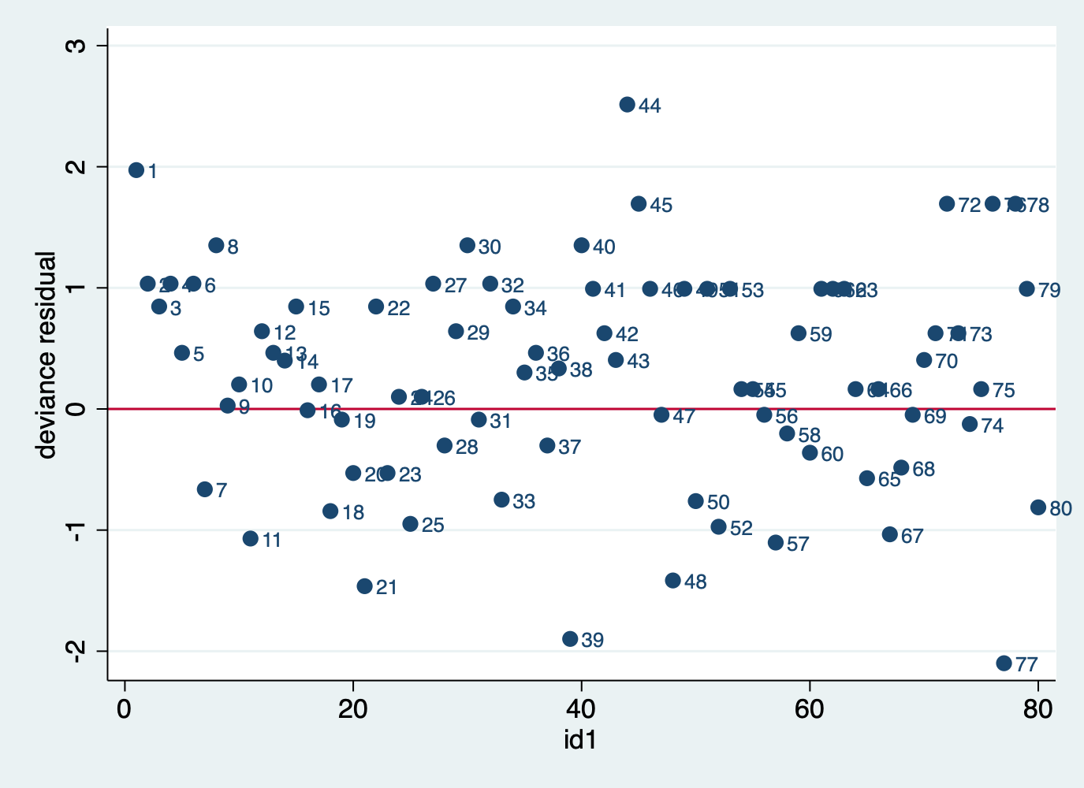

Observations above and over 2 deviance residuals were removed from the model. The model was rebuilt, and no variation was identified in the estimates of the hazard ratios. All data were preserved within the model.

Figure S4. Dependency verification assumptions in the COX regression model for ICU stay

