Durability of Antibody Response Against Hepatitis B Virus for a Decreased Crowd: A Retrospective Polycentric Cohort Study from a 10-Year Follow-up Clinical Study
Pei He^{1,2}, Jie Xia³, Peixin Zhang³, Wensu Yang^{1,2}, Zhaoxin Xia^{1,2}, Ping Liu⁴, Yi Zhu^{1,2}, Yaping Fang⁵, Zhenhua Zhang³, Jilu Shen^{1,2}
1 Department of Laboratory Medicine, The First Affiliated Hospital of Anhui Medical University, Hefei, China.
2 Department of Laboratory Medicine, Anhui Public Health Clinical Center, Hefei, China.
3 Department of Infectious Diseases, The Second Hospital of Anhui Medical University, Hefei, China.
4 Department of Infectious Diseases, Peopleʼs Hospital of Jieshou City, Fuyang, China.
5 Department of Clinical Laboratory, The Second Hospital of Anhui Medical University, Hefei, China.
Corresponding Author: Zhenhua Zhang, E-mail: zzh1974cn@163.com
Jilu Shen, Email: shenjilu@ahmu.edu.cn

Figures & Table legends
Figure S1 Comparisons of the percentage of decline in HBsAb levels between groups. (a) Percentage of decline of HBsAb in the control and case groups. (b) Percentage of decline of HBsAb in each group. Notes: ***P < 0.001, ****P < 0.0001. (b) Three higher values were eliminated in Group 3.
Figure S2. The distribution of the HBeAb levels between groups. (a) The anti-HBe-first levels among the four groups. (b) The anti-HBe-Second levels among the four groups. *P < 0.05, **P < 0.01, ****P < 0.0001. Abbreviations: NS,nonsignificant.
Figure S3. Comparison of the persistence of HBsAb levels in each group. (a–d) The persistence of HBsAb levels between different groups. (e) The persistence of the HBsAb levels between the control and case groups.
Table S1 Clinical performance of the biomarker in diagnosing a declining population

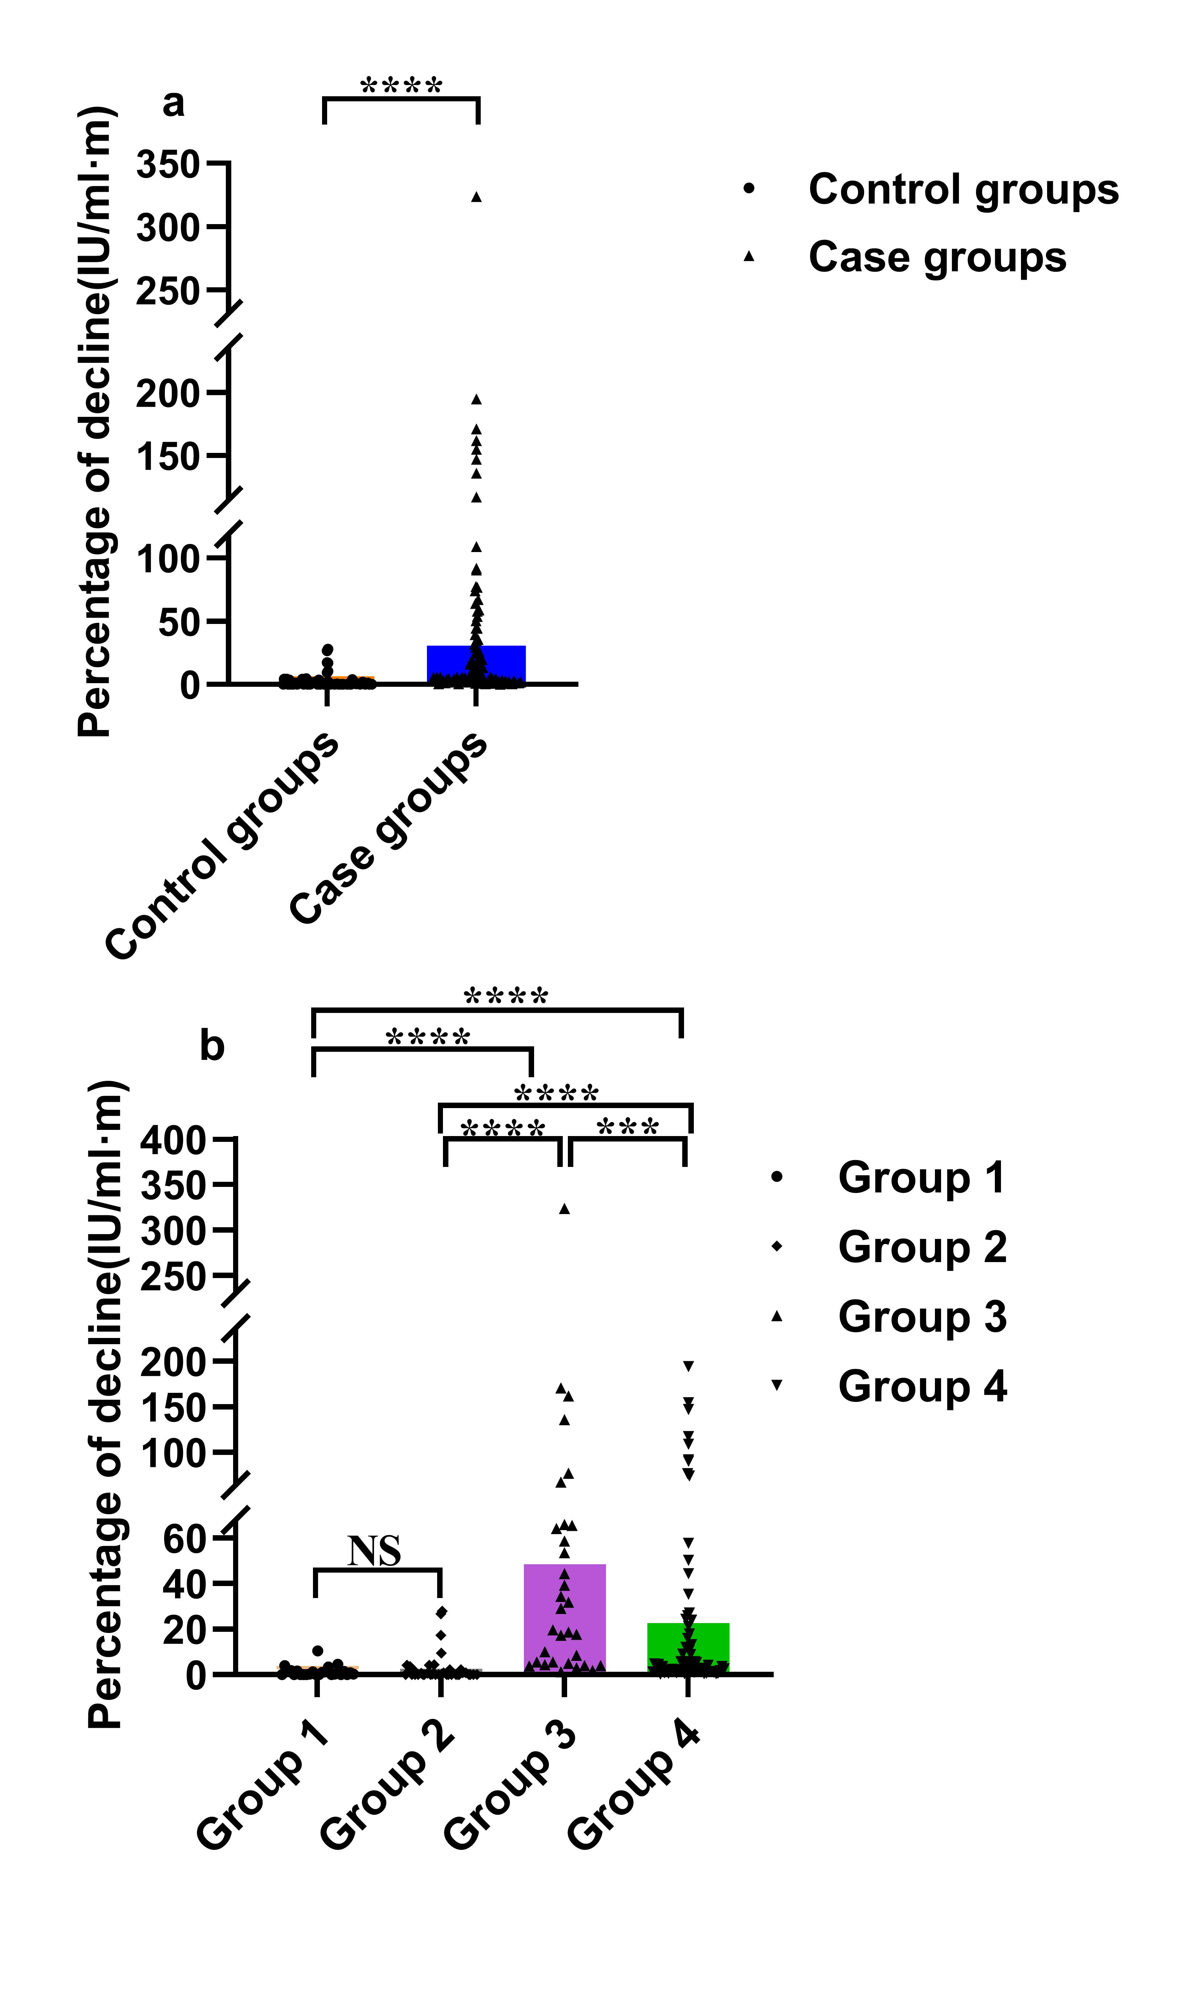
Figure S1 Comparisons of the percentage of decline in HBsAb levels between groups.
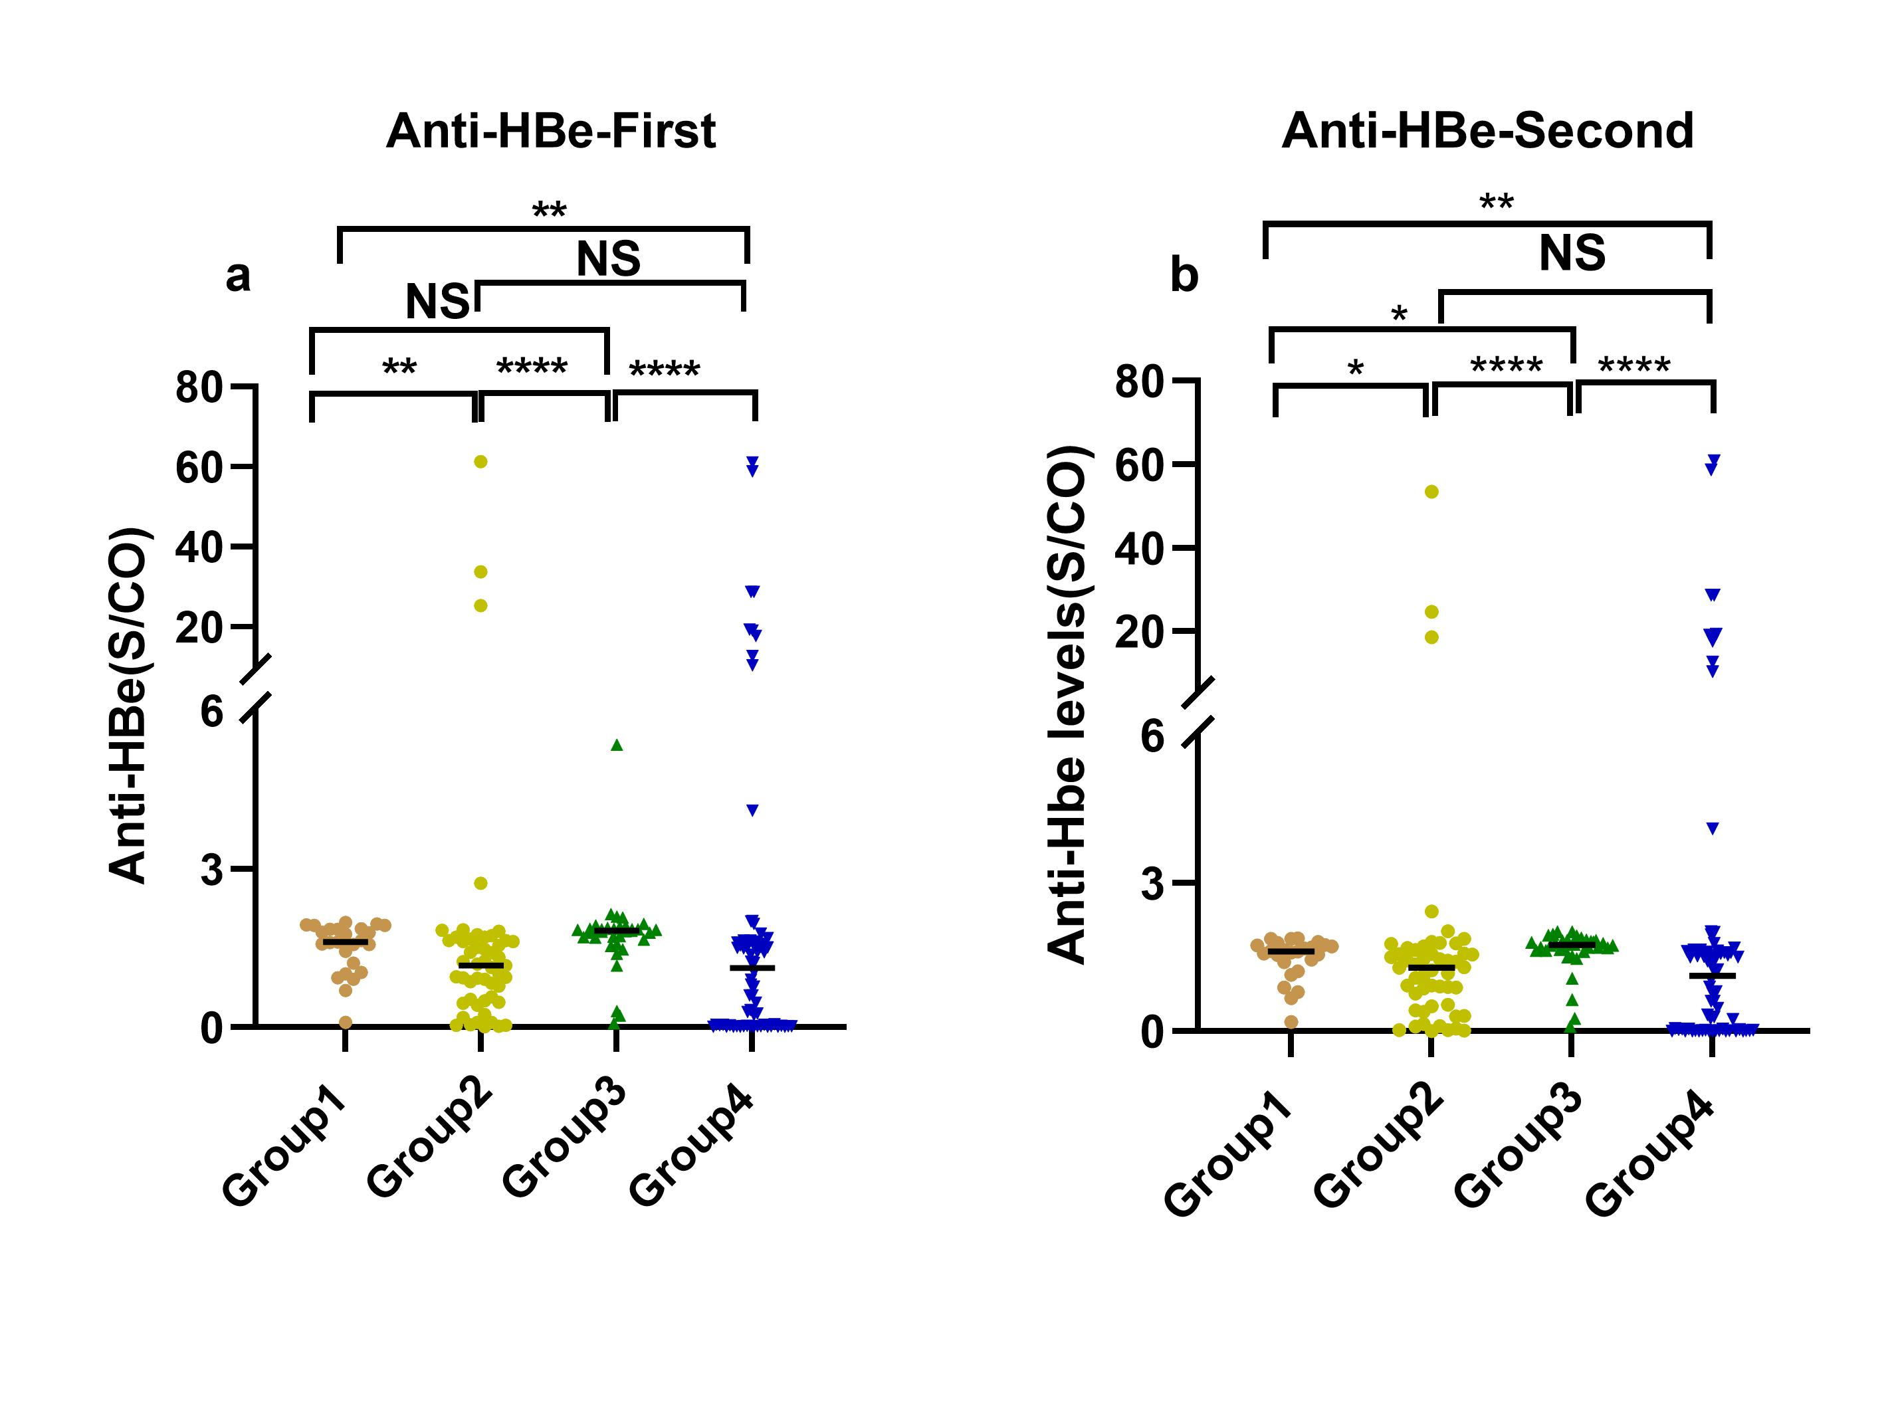
Figure S2. The distribution of the HBeAb levels between groups.

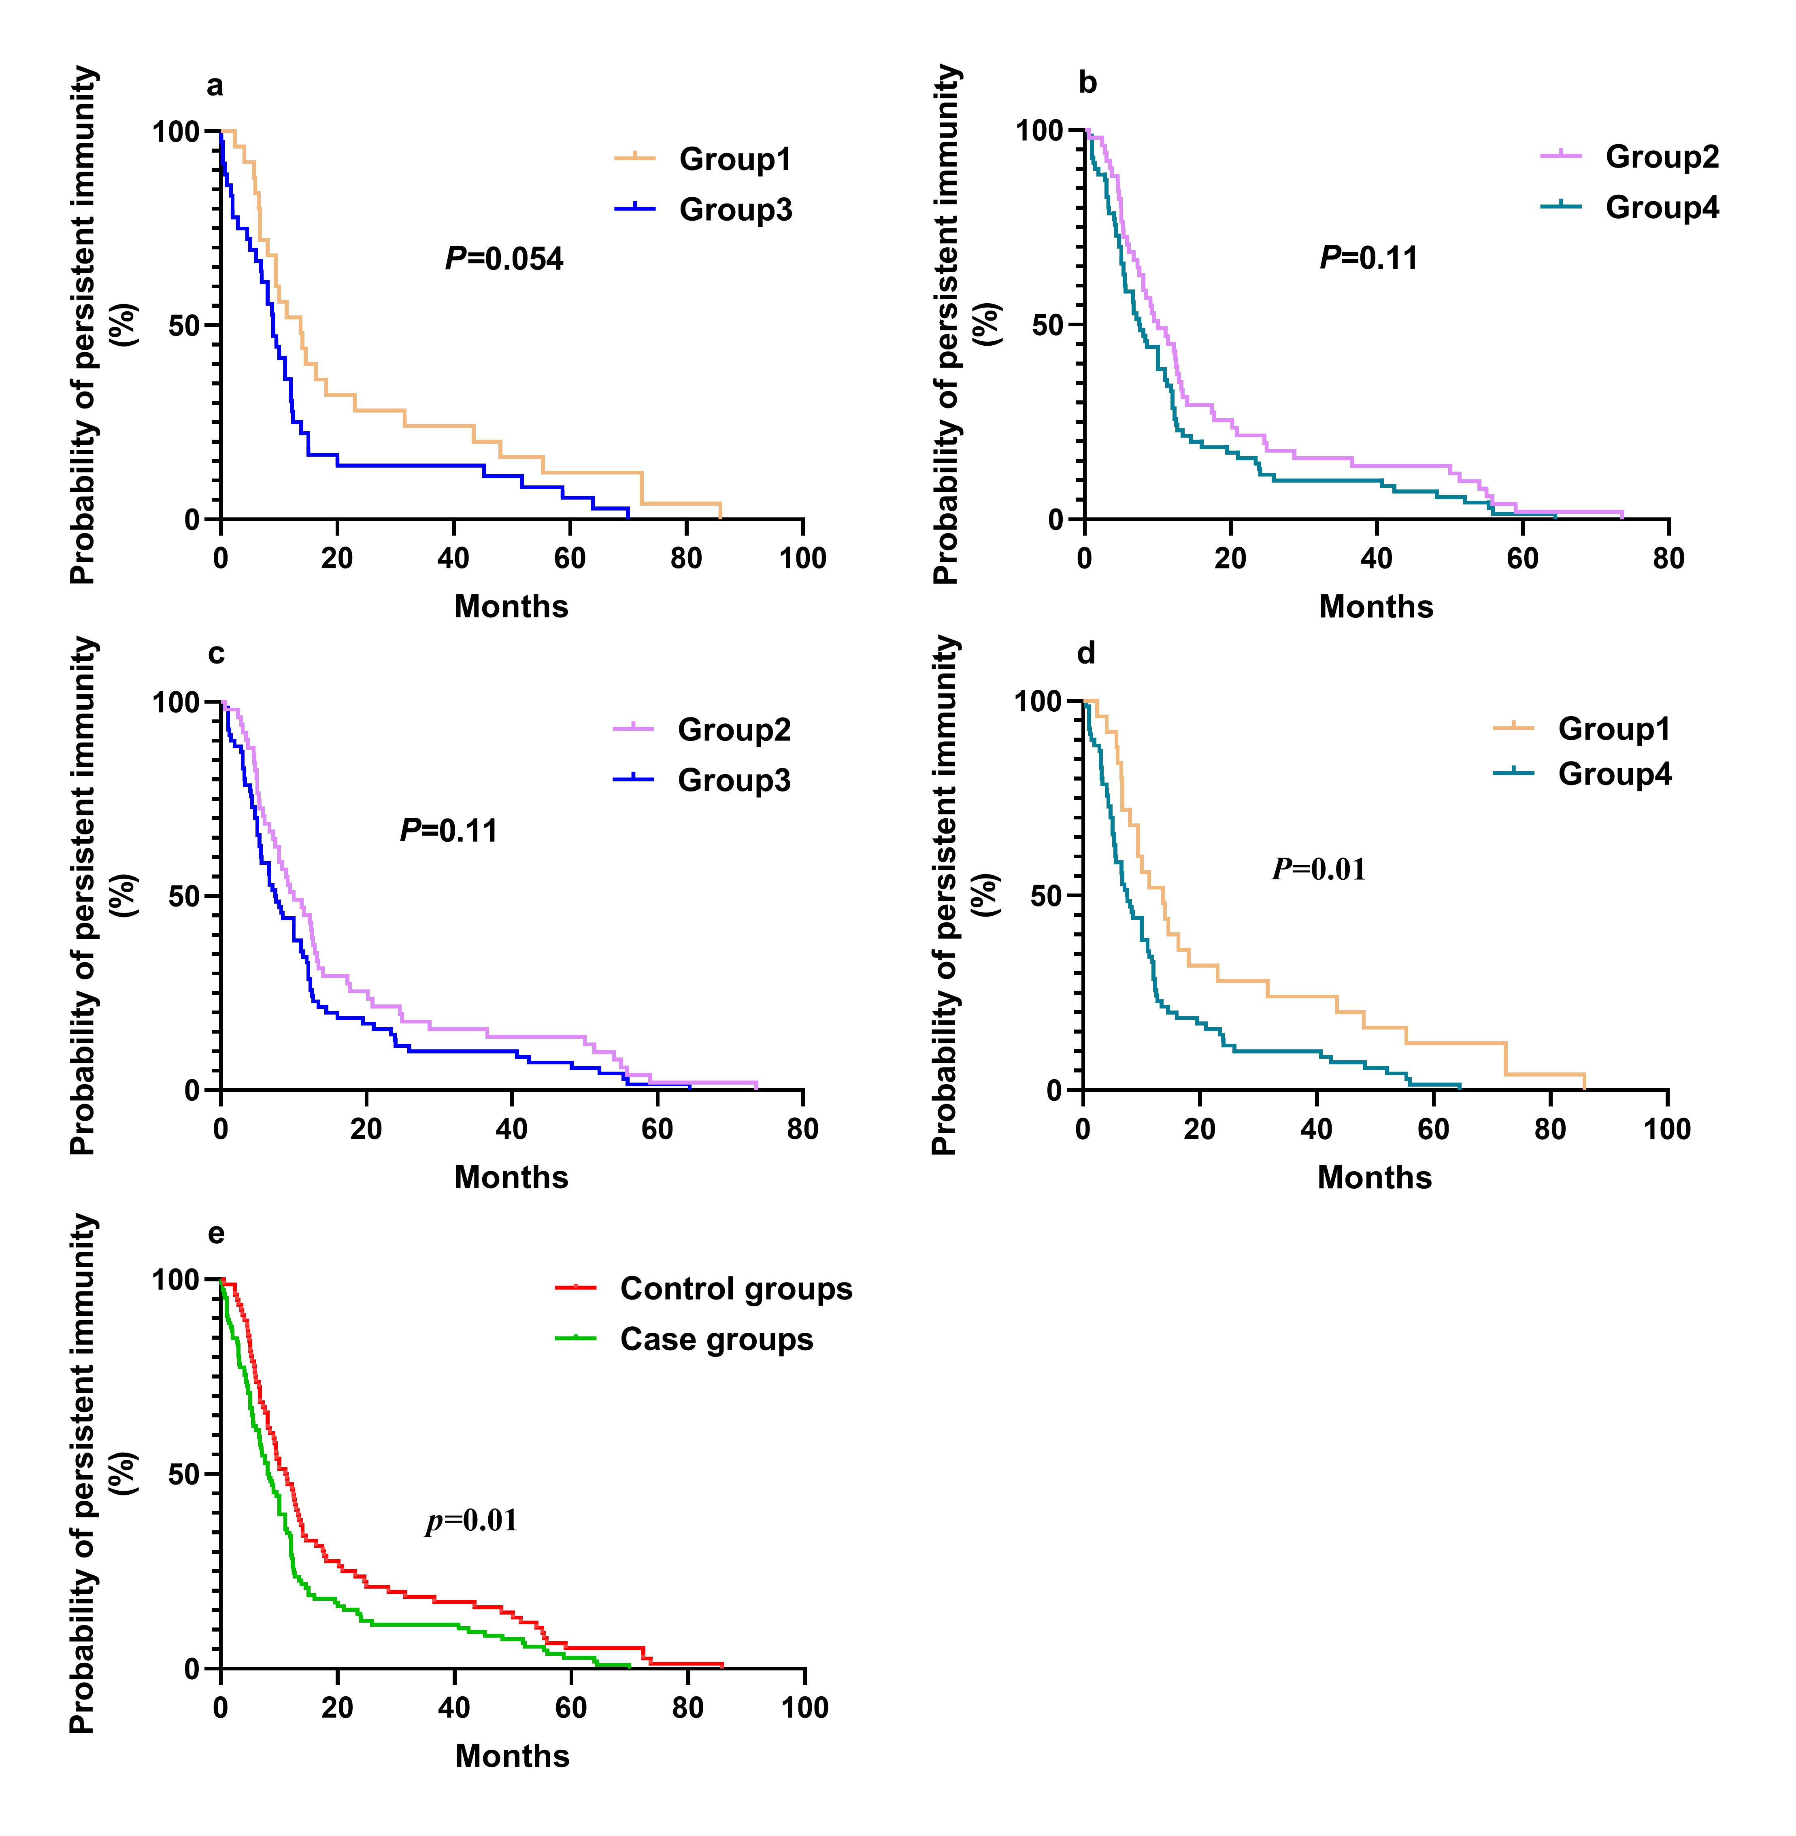Figure S3. Comparison of the persistence of HBsAb levels in each group.

Table S1 Clinical performance of the biomarker in diagnosing a declining population
Biomarker | Cutoff | Sensitivity,% | Specificity,% | PLR | NLR | PPV,% | NPV,%
HBsAb difference value | 8.53 | 94.3 | 69.7 | 3.12 | 0.08 | 0.81 | 0.9

