Supplementary Table 1. ANOSIM results.
Group | R-value | P-value
CLP-GM | 0.30 | 0.036
SC-GM | 0.14 | 0.103
SC-CLP | 0.73 | 0.004

Supplementary Table 2. Adonis results.
Group | Df | SumsOfSqs | MeanSqs | F.Model | R2 | Pr(>F)
SC-CLP | 1(9) | 0.42(0.72) | 0.42(0.08) | 5.17 | 0.36 (0.64) | 0.001
SC-GM | 1(12) | 0.24(1.54) | 0.24(0.13) | 1.85 | 0.13 (0.87) | 0.056
CLP-GM | 1(11) | 0.37(1.45) | 0.39(0.13) | 2.93 | 0.21 (0.79) | 0.015

Supplementary Figure 1. Interaction network of genus within the CLP group. Red, positive correlation; blue, negative correlation.

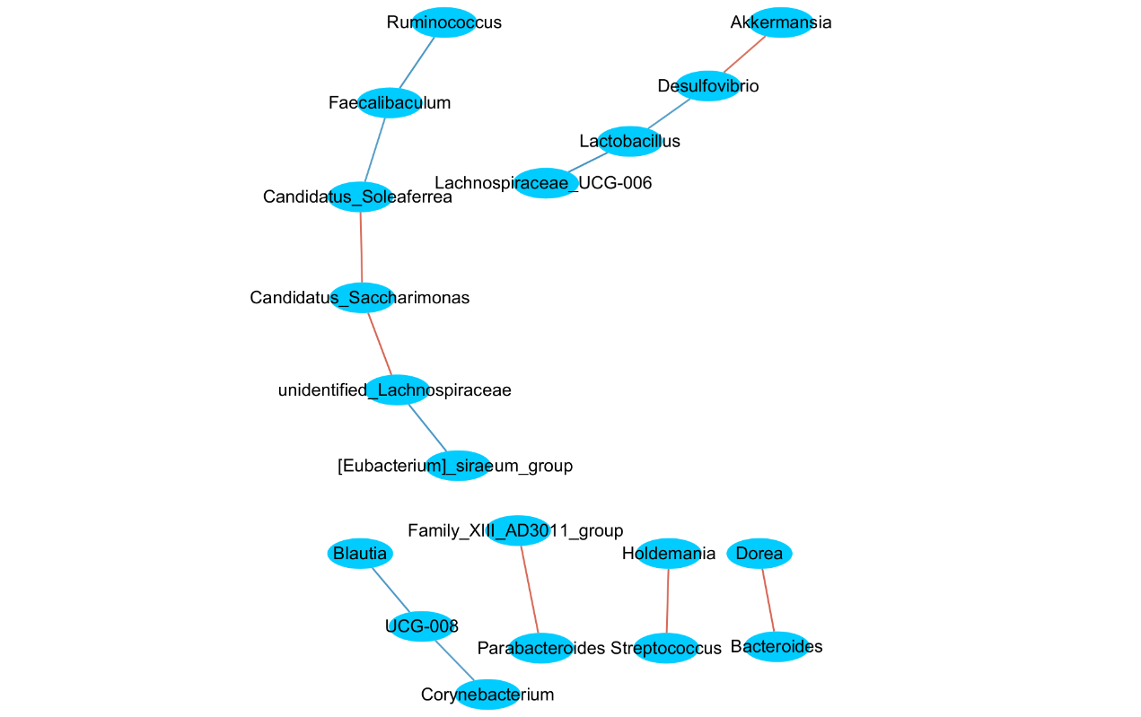

Supplementary Figure 2. Interaction network of genus within the GM group. Red, positive correlation; blue, negative correlation.

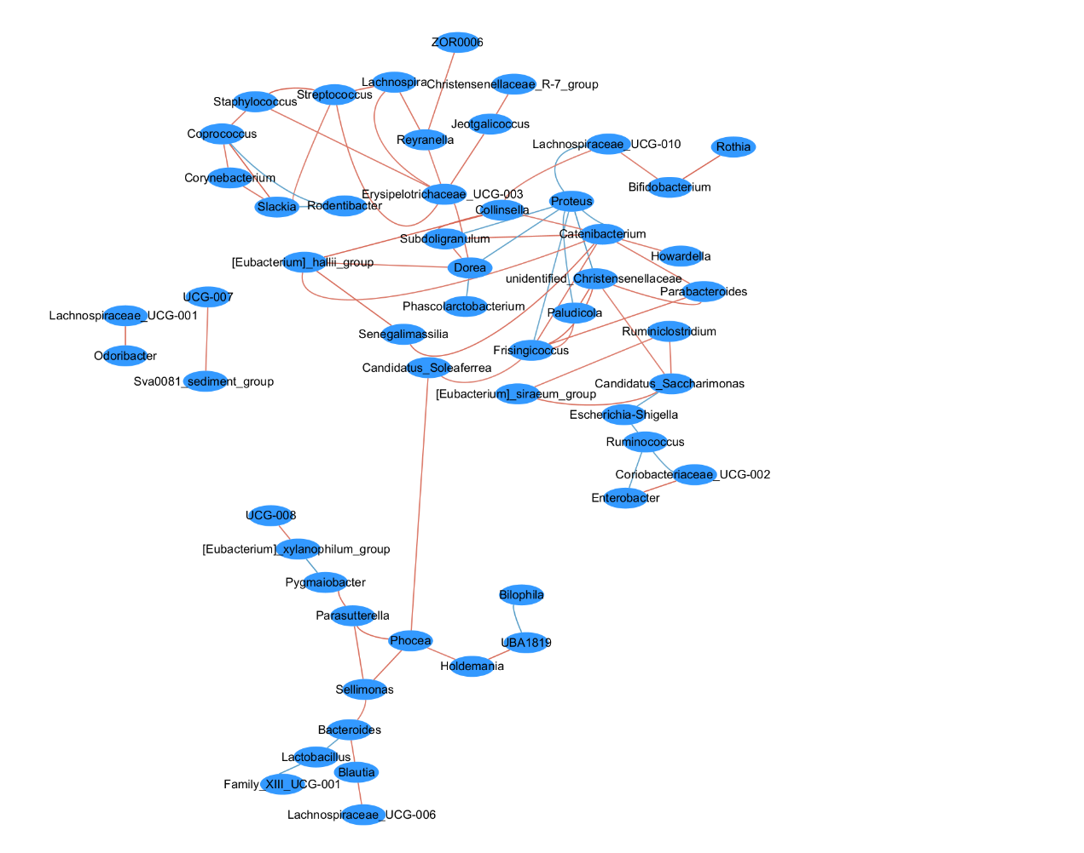

Supplementary Figure 3. Interaction network of genus between the GM and CLP groups. Red, positive correlation; blue, negative correlation.

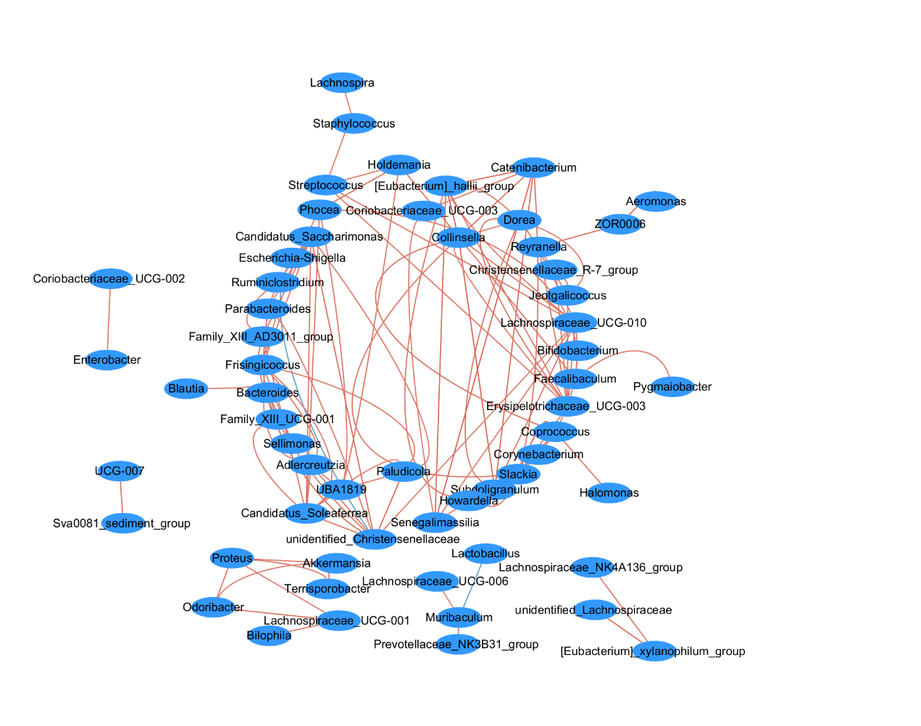

Supplementary Figure 4. Map of differentially enriched KEGG pathway between CLP and GM groups.

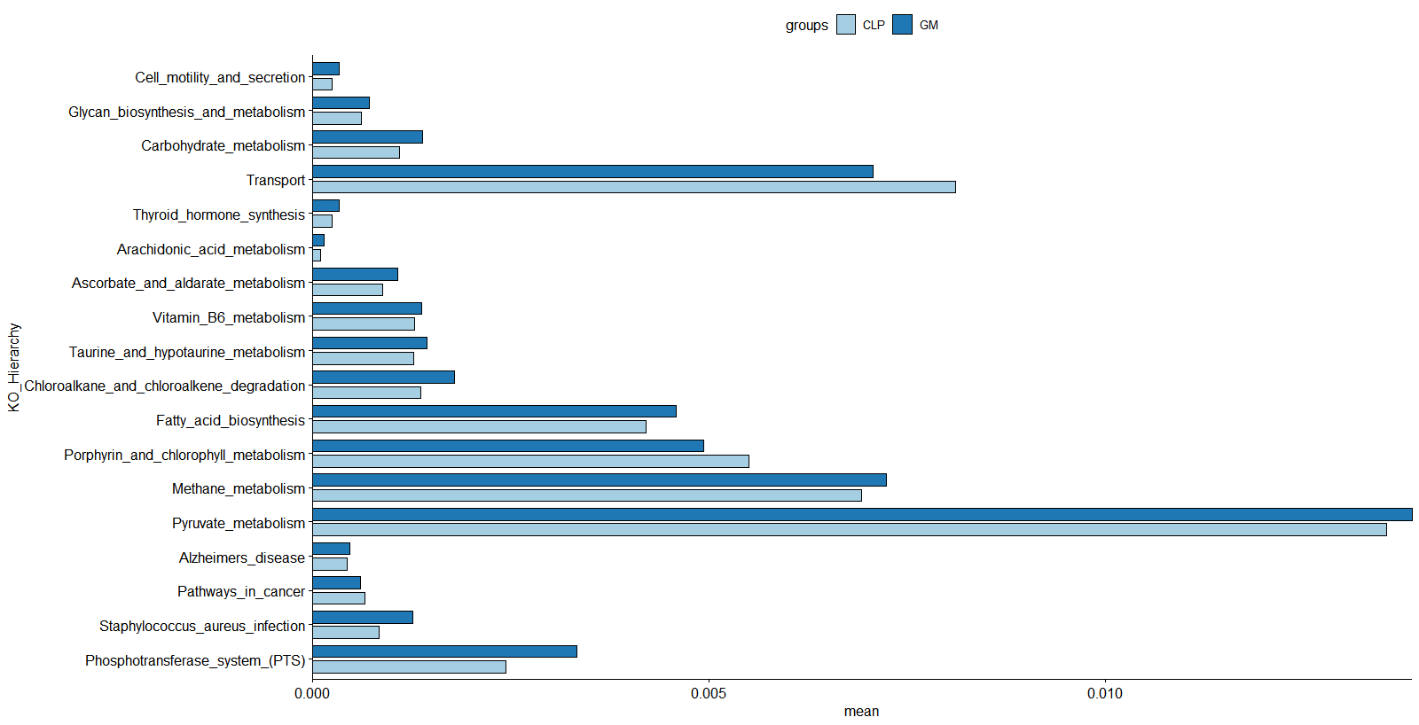

Supplementary Figure 5. Heatmap of correlations between different genera and KEGG pathways. Red, positive correlation; blue, negative correlation; *mean P < 0.05.

Supplementary Figure 6. Network diagram of correlations between different genera and KEGG pathways. Red, positive correlation; blue, negative correlation.

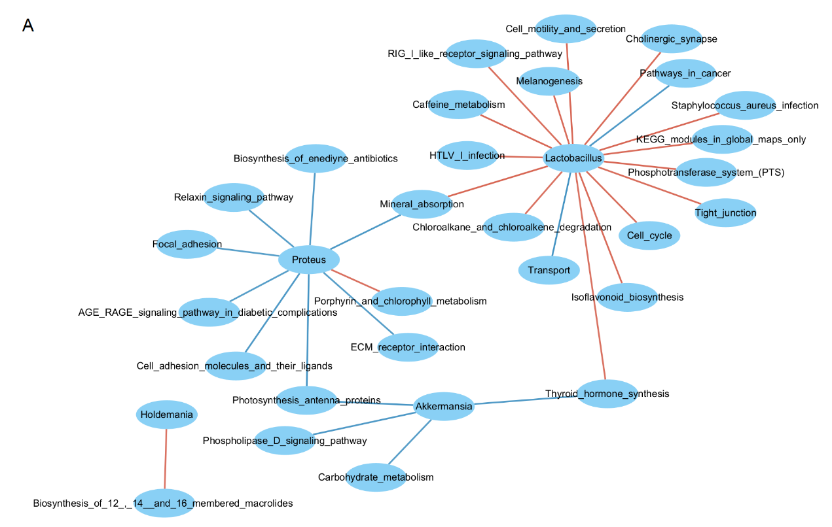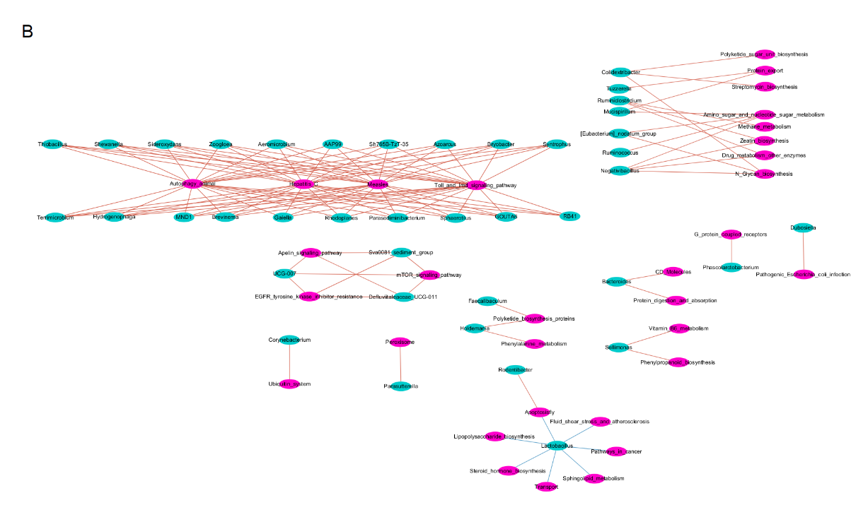

Supplementary Figure 7. A and B are the PCA scores of QC samples in positive and negative ion modes, respectively.

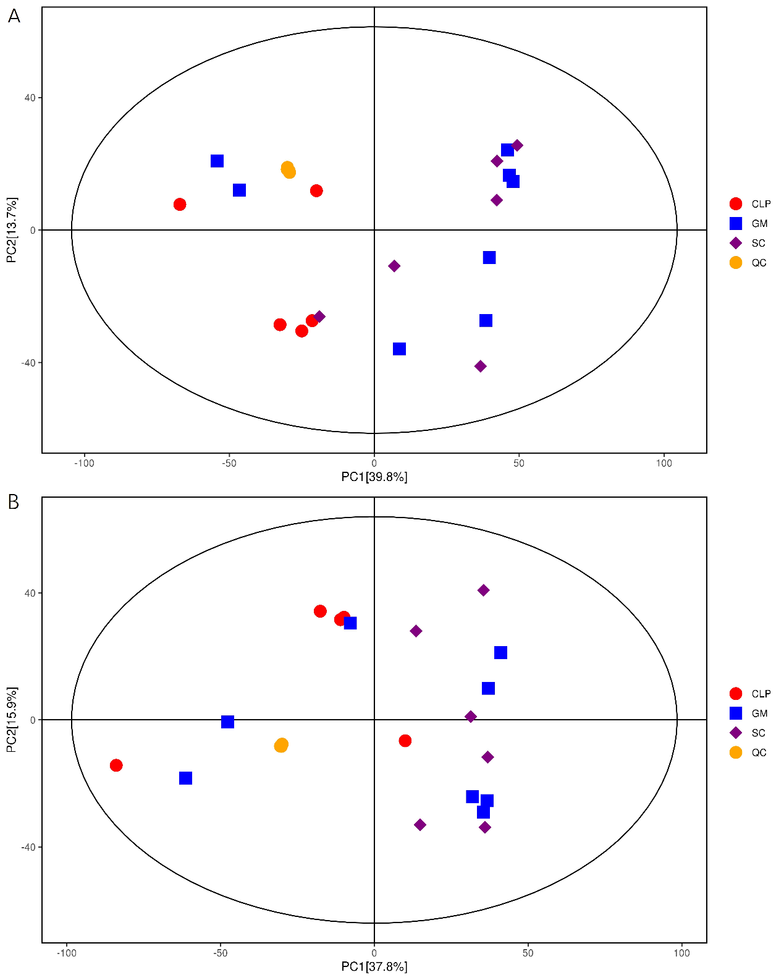

Supplementary Figure 8. A–B represent the total ion chromatograms in the positive and negative ion modes of the SC group, respectively. C–D represent the total ion chromatograms of the CLP group in the positive and negative ion modes, respectively. E–F represent the total ion chromatograms of the GM group in positive and negative ion modes, respectively.

Supplementary Figure 9. Pathway enrichment and statistical analysis of significance of differential metabolites between the GM and CLP groups (P < 0.05, Fisher’s exact test). A. Positive ion mode. B. Negative ion mode.

