Supplementary Material
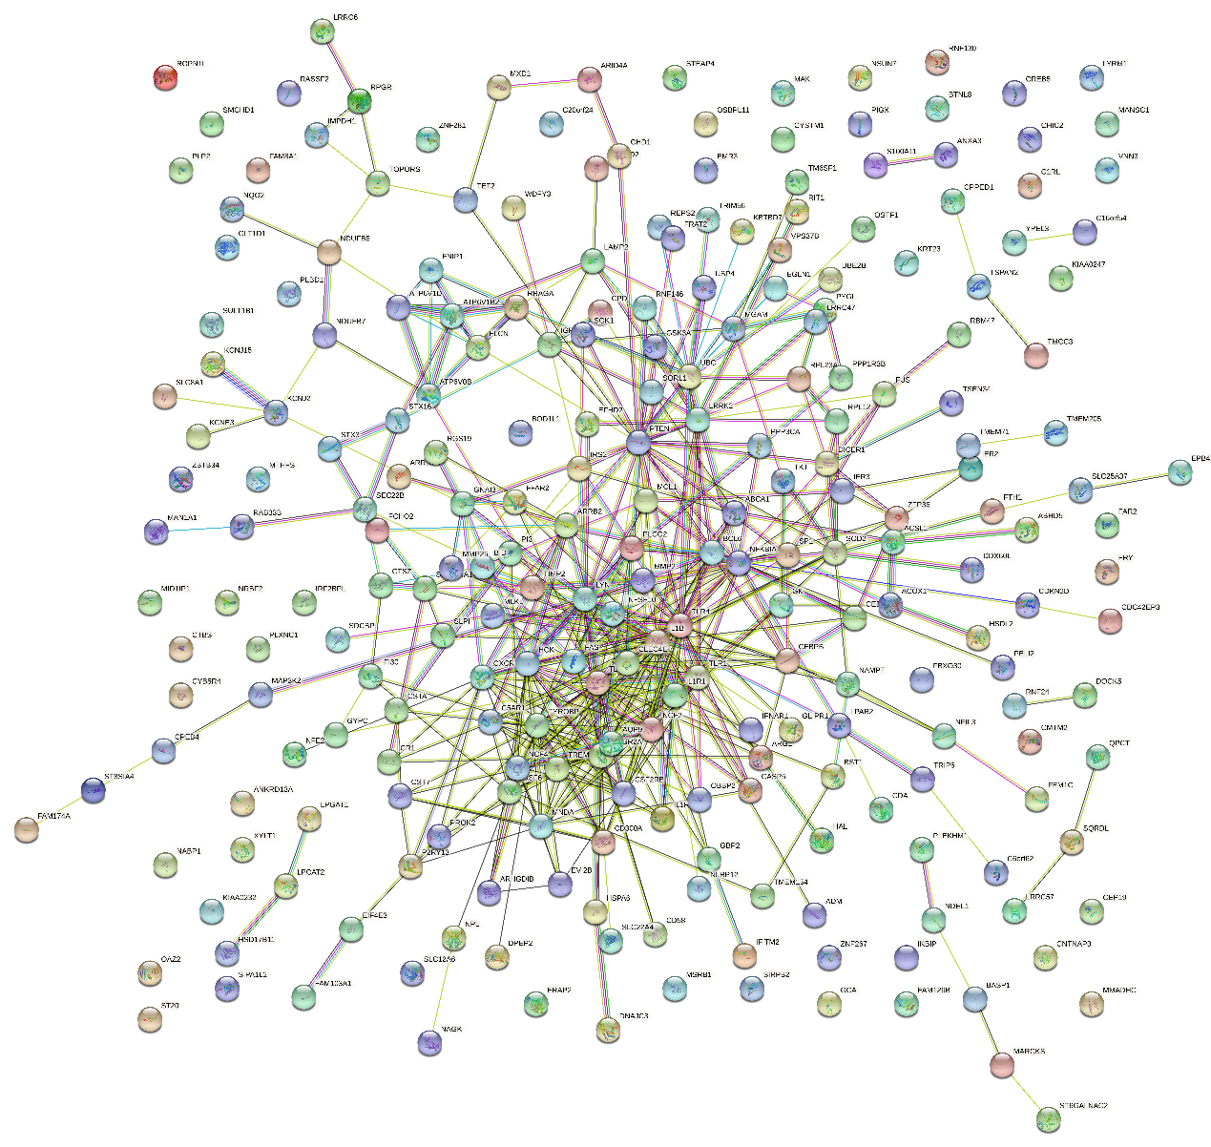

Supplementary Figure 1. Protein-protein interaction network.
In the whole PPI protein interaction network system, the filling nodes in the image indicated that the three-dimensional structure of the protein was known or predicted, while the empty nodes indicated that the three-dimensional structure of the protein was unknown. The connections between proteins represent the functional connections between proteins. There are seven different colored lines :1. The color of evidence supported by database is light blue; 2. The color that has been proved in the experiment is purple; 3. Red is a fusion of two genes. 4. Yellow-green represents the evidence extracted from the article; 5. Green represents two genetic similarities; 6. Blue represents gene cogeneration; And 7. Black indicates gene co-expression. The network diagram of up-regulated genes in patients with restenosis is shown above, and the network diagram of down-regulated genes in patients with restenosis is shown below.

Supplementary Table 1. Basic clinical patient information.
Gender, age, diagnosis, hypertension, diabetes,white blood cell, neutrophil, glucose and prothrombin time were ordered listed in this table.

Characteristic | Restenosis (24) | Non-restenosis (14) | P-value
Age, y | 61.13 ± 2.479 | 49.14 ± 3.083 | 0.005
Gender, M/F | 7/17 | 7/7
Total cholesterol (mmol/L) | 3.686 ± 0.2089 | 4.358 ± 0.2712 | 0.0612
Triglycerides (mmol/L) | 1.554 ± 0.1749 | 1.612 ± 0.1894 | 0.0732
LDL (mmol/L) | 2.108 ± 0.1931 | 2.633 ± 0.1971 | 0.0323
D-dimer (ng/ml) | 99.58 ± 14.82 | 218.4 ± 55.47 | 0.1299
Fibrinogen (g/L) | 2.896 ± 0.1076 | 2.586 ± 0.1398 | 0.0918
APTT (sec) | 39.97 ± 6.141 | 34.46 ± 0.6567 | 0.7124
PT (sec) | 10.92 ± 0.1187 | 12.78 ± 0.9420 | 0.1291
Platelets (×10⁹/L) | 217.4 ± 11.76 | 212.9 ± 13.34 | 0.8123
Leukocytes (×10⁹/L) | 5.265 ± 0.4752 | 4.292 ± 0.3824 | 0.3245
Neutrophils (%) | 68.81 ± 1.956 | 65.03 ± 3.21 | 0.2915
Monocytes (%) | 3.13 ± 0.2548 | 3.815 ± 0.4672 | 0.1684
Lymphocytes (%) | 25.91± 1.563 | 27.36 ± 2.356 | 0.6002
Hypertension (n) | 16 | 3
Diabetes mellitus (n) | 10 | 0
Cigarette smoking (n) | 10 | 4

Supplementary Table2. Primer sequence of qRT-PCR test.

Gene name | Species(Human) | 5’-3’
EEF1D | F | GACGACGCAGAAAGGAGATT
 | R | GCCAGGGATTTCTGGATGTT
RPL36 | F | TCTGACCAAACACACCAAGT
 | R | GTCCTTGGAGACCTTCAGTAAC
RPSA | F | AGGTTTGTGGAACAGTGAGG
 | R | GCCTGGATCTGGTTAGTGAAG
CTLA4 | F | GTGAACCTCACTATCCAAGGAC
 | R | TGCCTATGCCCAGGTAGTA
YTHDF2 | F | CCTCCATTGGCTTCTCCTATTC
 | R | GTTGCTCAGCTGTCCATAAGA
GLS2 | F | TGCCATCGGCTATTATCTCAAG
 | R | CAGAACACAGCTGGAAGTAGAG
β-actin | F | CTCCATCCTGGCCTCGCTGT
 | R | GCTGTCACCTTCACCGTTCC

