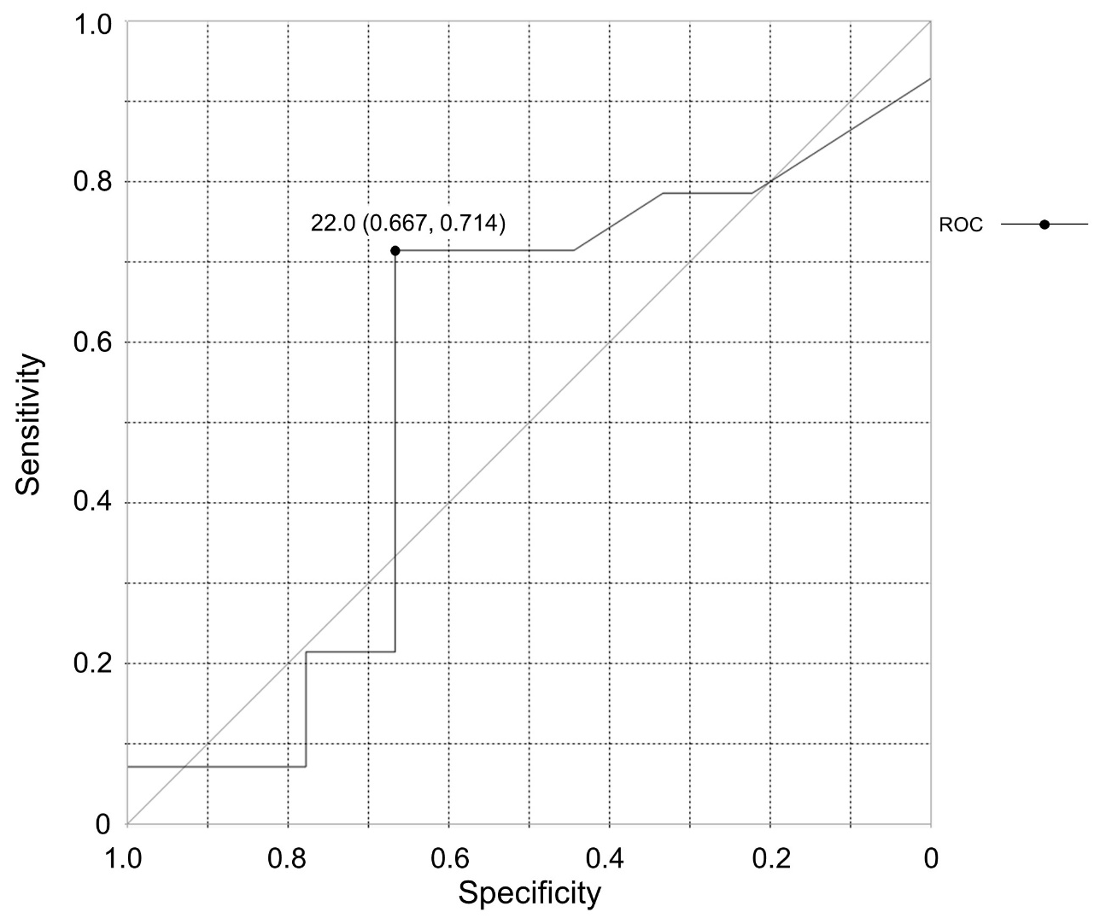
Supplementary Figure 1: ROC curve calculated by blood basophil counts at baseline for achievement of clinical remission
Based on this ROC curve, sensitivity was 71.4% and specificity was 66.7% using blood basophil counts at baseline ≥ 22 (/µl).
Abbreviation: ROC; receiver operating characteristic

Supplementary Table 1: Achievement rates of clinical remission and four criteria
 | ACT≥20 | no AEx | no OCS use | %FEV₁≥80 | CR
ALL | 0.78 | 0.70 | 0.74 | 0.61 | 0.22
BEN | 0.77 | 0.62 | 0.77 | 0.62 | 0.15
M-B | 0.80 | 0.80 | 0.70 | 0.60 | 0.30
BMI ≥ 25 (kg/m²) | 0.86 | 0.57 | 1.00 | 0.57 | 0.29
BMI < 25 (kg/m²) | 0.75 | 0.75 | 0.63 | 0.63 | 0.19
MPR ≥ 80% | 0.81 | 0.69 | 0.75 | 0.56 | 0.25
MPR < 80% | 0.83 | 0.83 | 0.83 | 0.67 | 0.17
duration ≥ 20 (years) | 0.80 | 0.67 | 0.80 | 0.60 | 0.20
duration < 20 (years) | 0.75 | 0.75 | 0.63 | 0.63 | 0.25
ECRS(+) | 0.84 | 0.74 | 0.74 | 0.58 | 0.21
ECRS(-) | 0.50 | 0.50 | 0.75 | 0.75 | 0.25
FeNO ≥50 (ppb) | 0.79 | 0.93* | 0.64 | 0.57 | 0.29
FeNO <50 (ppb) | 0.78 | 0.33* | 0.89 | 0.67 | 0.11
BEC ≥300 (/µl) | 0.83 | 0.67 | 0.83 | 0.67 | 0.25
BEC <300 (/µl) | 0.73 | 0.73 | 0.64 | 0.55 | 0.18
BBC ≥22 (/µl) | 0.77 | 0.85 | 0.77 | 0.77 | 0.38†
BBC <22 (/µl) | 0.80 | 0.50 | 0.70 | 0.40 | 0.00†
These data were shown in Figure 2 as radar charts, and were analyzed using the Fisher's exact test.
*There was a significant difference in the achievement rate of "no AEx" between FeNO ≥ 50 and < 50 (P=0.0049).
†There was a significant difference in the achievement rate of "CR" between BBC ≥ 22 and < 22 (P=0.046).
Abbreviations: ACT; Asthma Control Test, AEx; acute exacerbation, BBC; blood basophil counts,
BEC; blood eosinophil counts, BEN; benralizumab. BMI; body mass index, CR; clinical remission,
ECRS; eosinophilic chronic rhinosinusitis, FeNO; fractional exhaled nitric oxide,
FEV₁; forced expiratory volume in one second, M-B; from mepolizumab to benralizumab treatment,
MPR; medication possession ratio, OCS; oral corticosteroid

