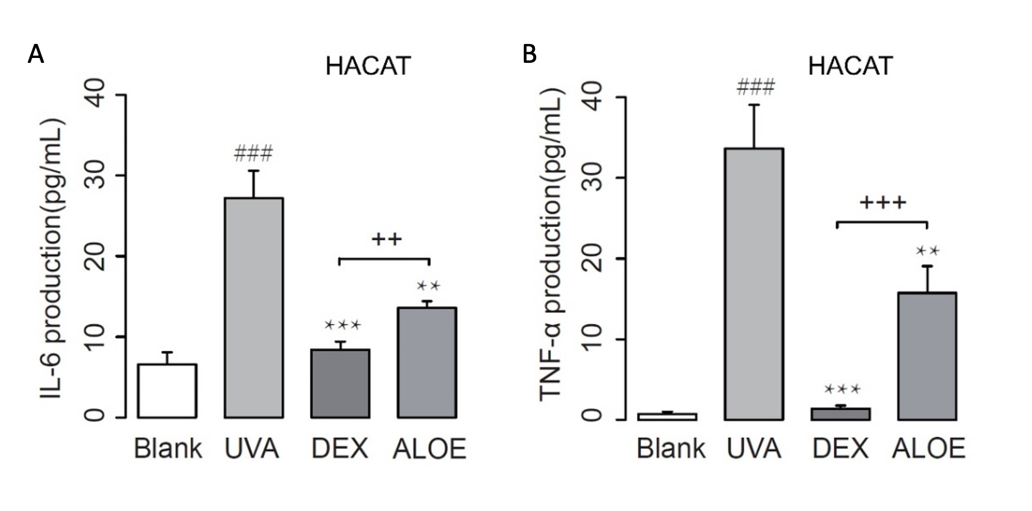
Supplementary Figure 1. (A) IL-6 and (B) TNF-α in ultraviolet (UVA)-induced HaCaT model (n = 5). UVA, UVA irradiation as model groups; DEX, treatment with UVA irradiation (7 J/cm2) and dexamethasone (DEX, 0.05 mg/mL) as positive controls; ALOE, treatment with UVA and ALOE (3 mg/mL) as experimental group. ### p < 0.001 compared to the blank group; *** p < 0.001, ** p < 0.01 compared to the UVA group. ++ p < 0.01, +++ p < 0.001 compared to the DEX group. These data were presented as means ± SD.
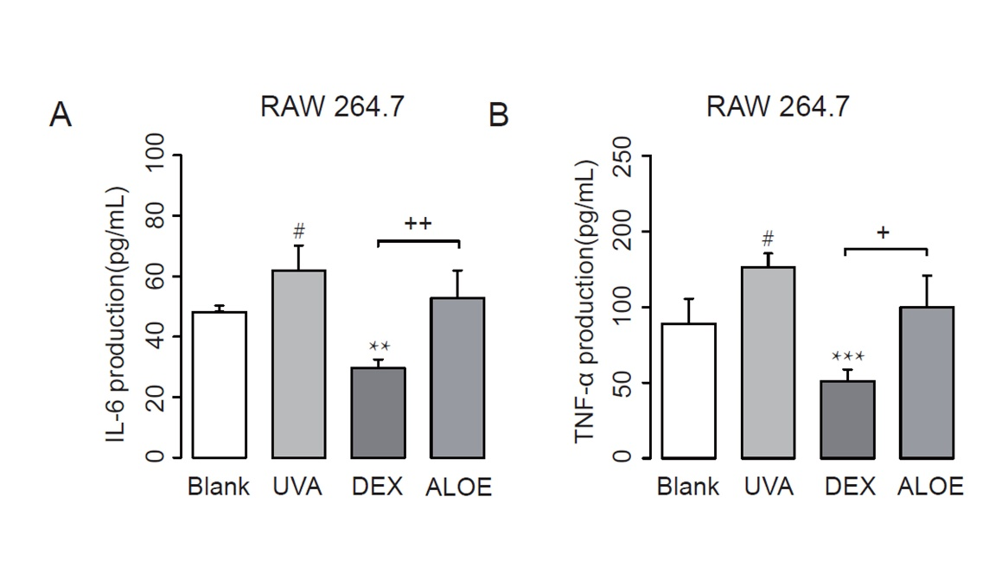
Supplementary Figure 2. (A) IL-6 and (B) TNF-α in ultraviolet (UVA)-induced RAW.264.7 model (n = 5). UVA, UVA irradiation as model groups; DEX, treatment with UVA irradiation (7 J/cm2) and dexamethasone (DEX, 0.05 mg/mL) as positive controls; ALOE, treatment with UVA and ALOE (3 mg/mL) as experimental group. # p < 0.05 compared to the Blank group; *** p < 0.001, ** p < 0.01 compared to the UVA group. + p < 0.05, ++ p < 0.01 compared to the DEX group. These data were presented as means ± SD.
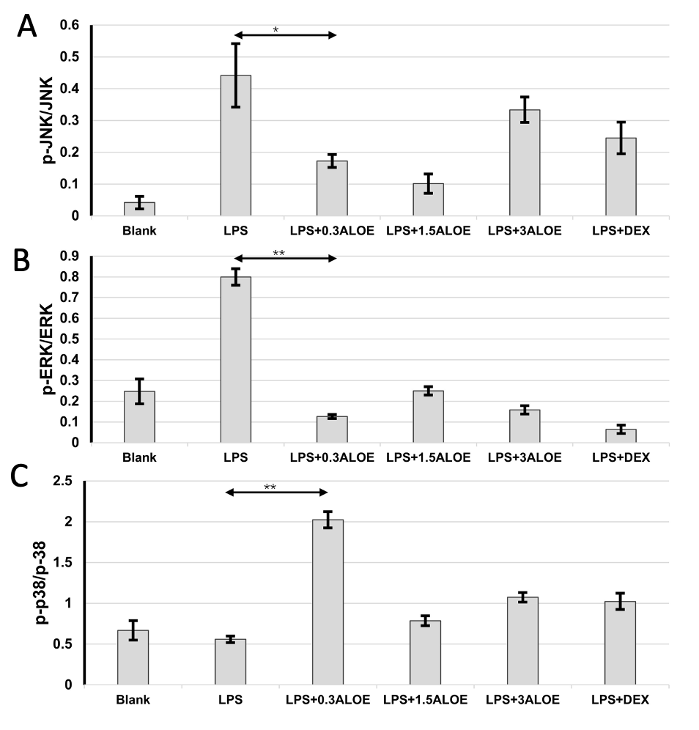
Supplementary Figure 3. Standard quantitative analysis of (A) the ratio of p-JNK/JNK, (B) p-ERK/ERK and (C) p-P38/P38. p-JNK, phosphorylated-JNK; ERK, Extracellular signal-regulated protein kinases; p-ERK, phosphorylated-ERK, p-p38, phosphorylated-p38. ACTIN was used as an internal control. ** p < 0.01, * p < 0.05 compared to the LPS group. These data were presented as means ± SD.

