SUPPLEMENTARY MATERIAL

Supplementary Figure 1: Flowchart of vital status ascertainment.

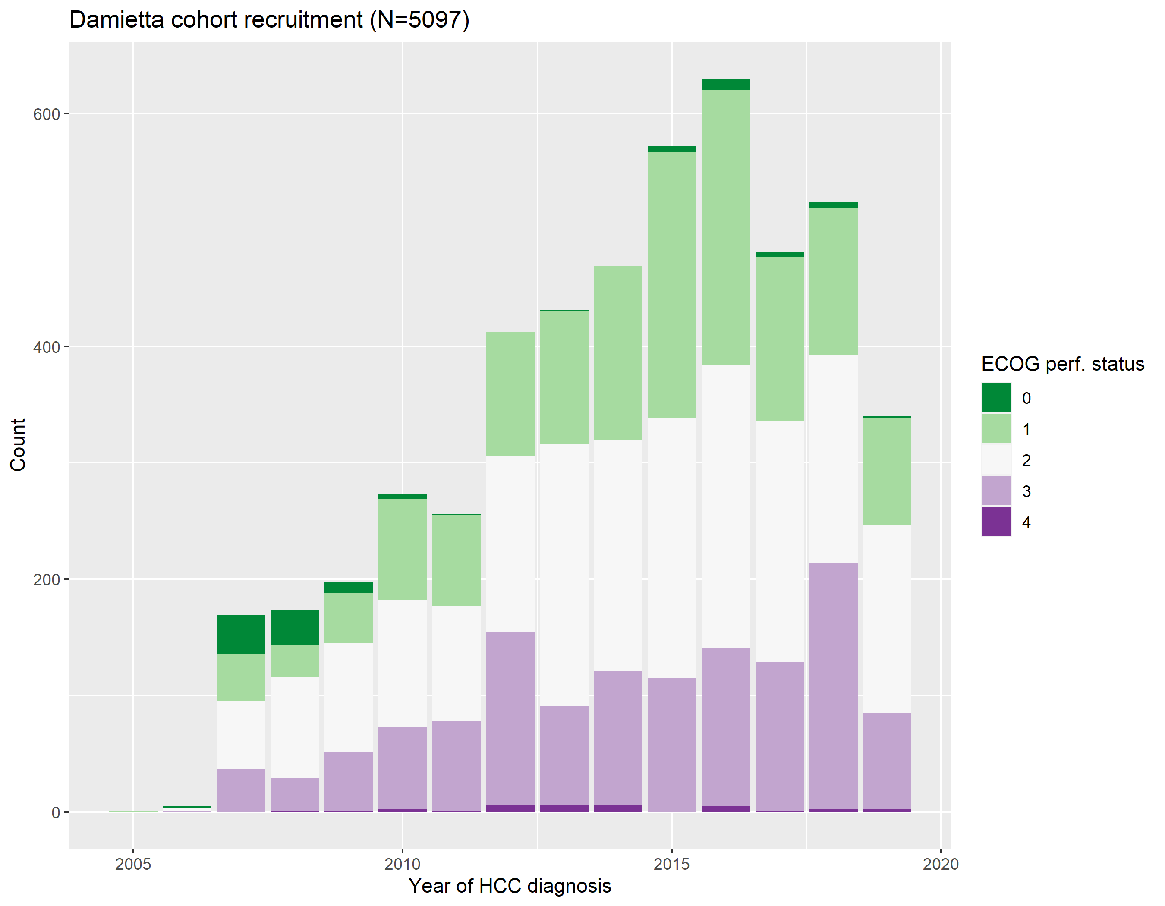

Supplementary Figure 2: Distribution of ECOG performance status at HCC diagnosis, by year of diagnosis.

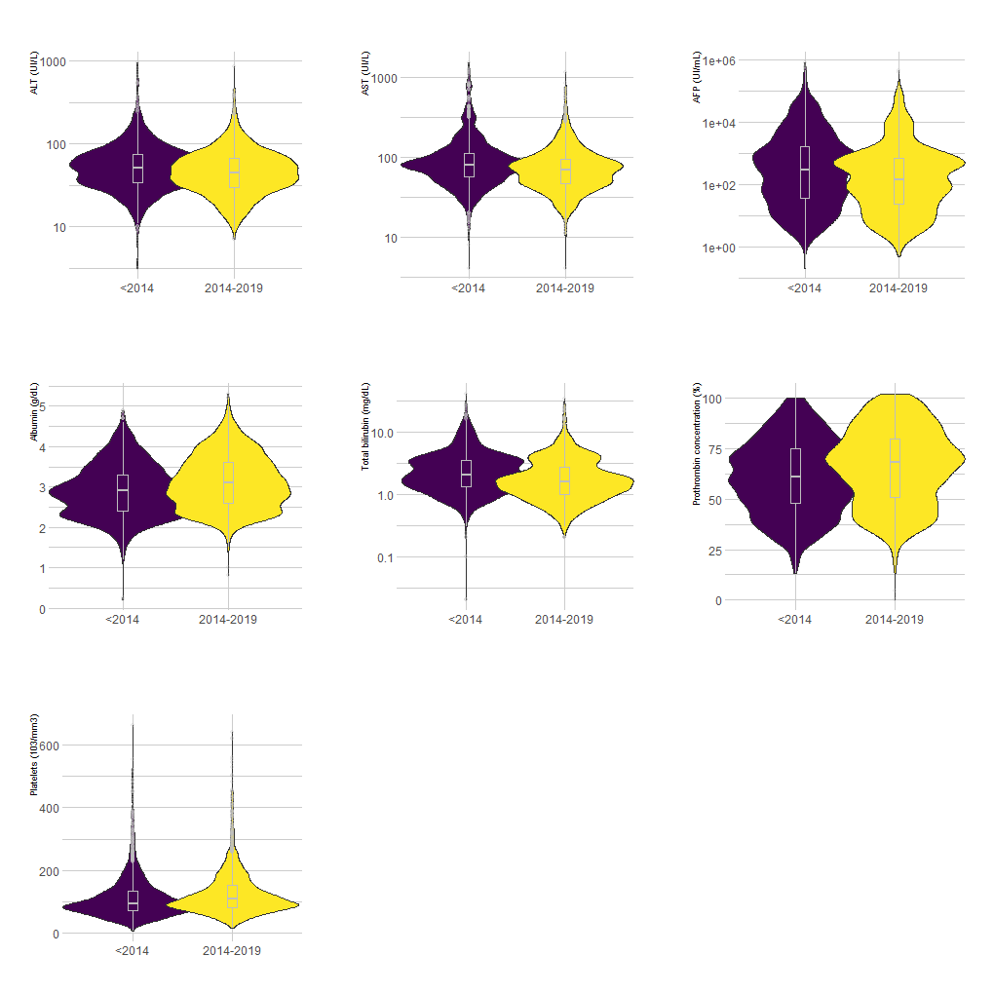

Supplementary figure 3: Temporal changes in laboratory values at time of HCC diagnosis (all Student test p-values <10⁻³).

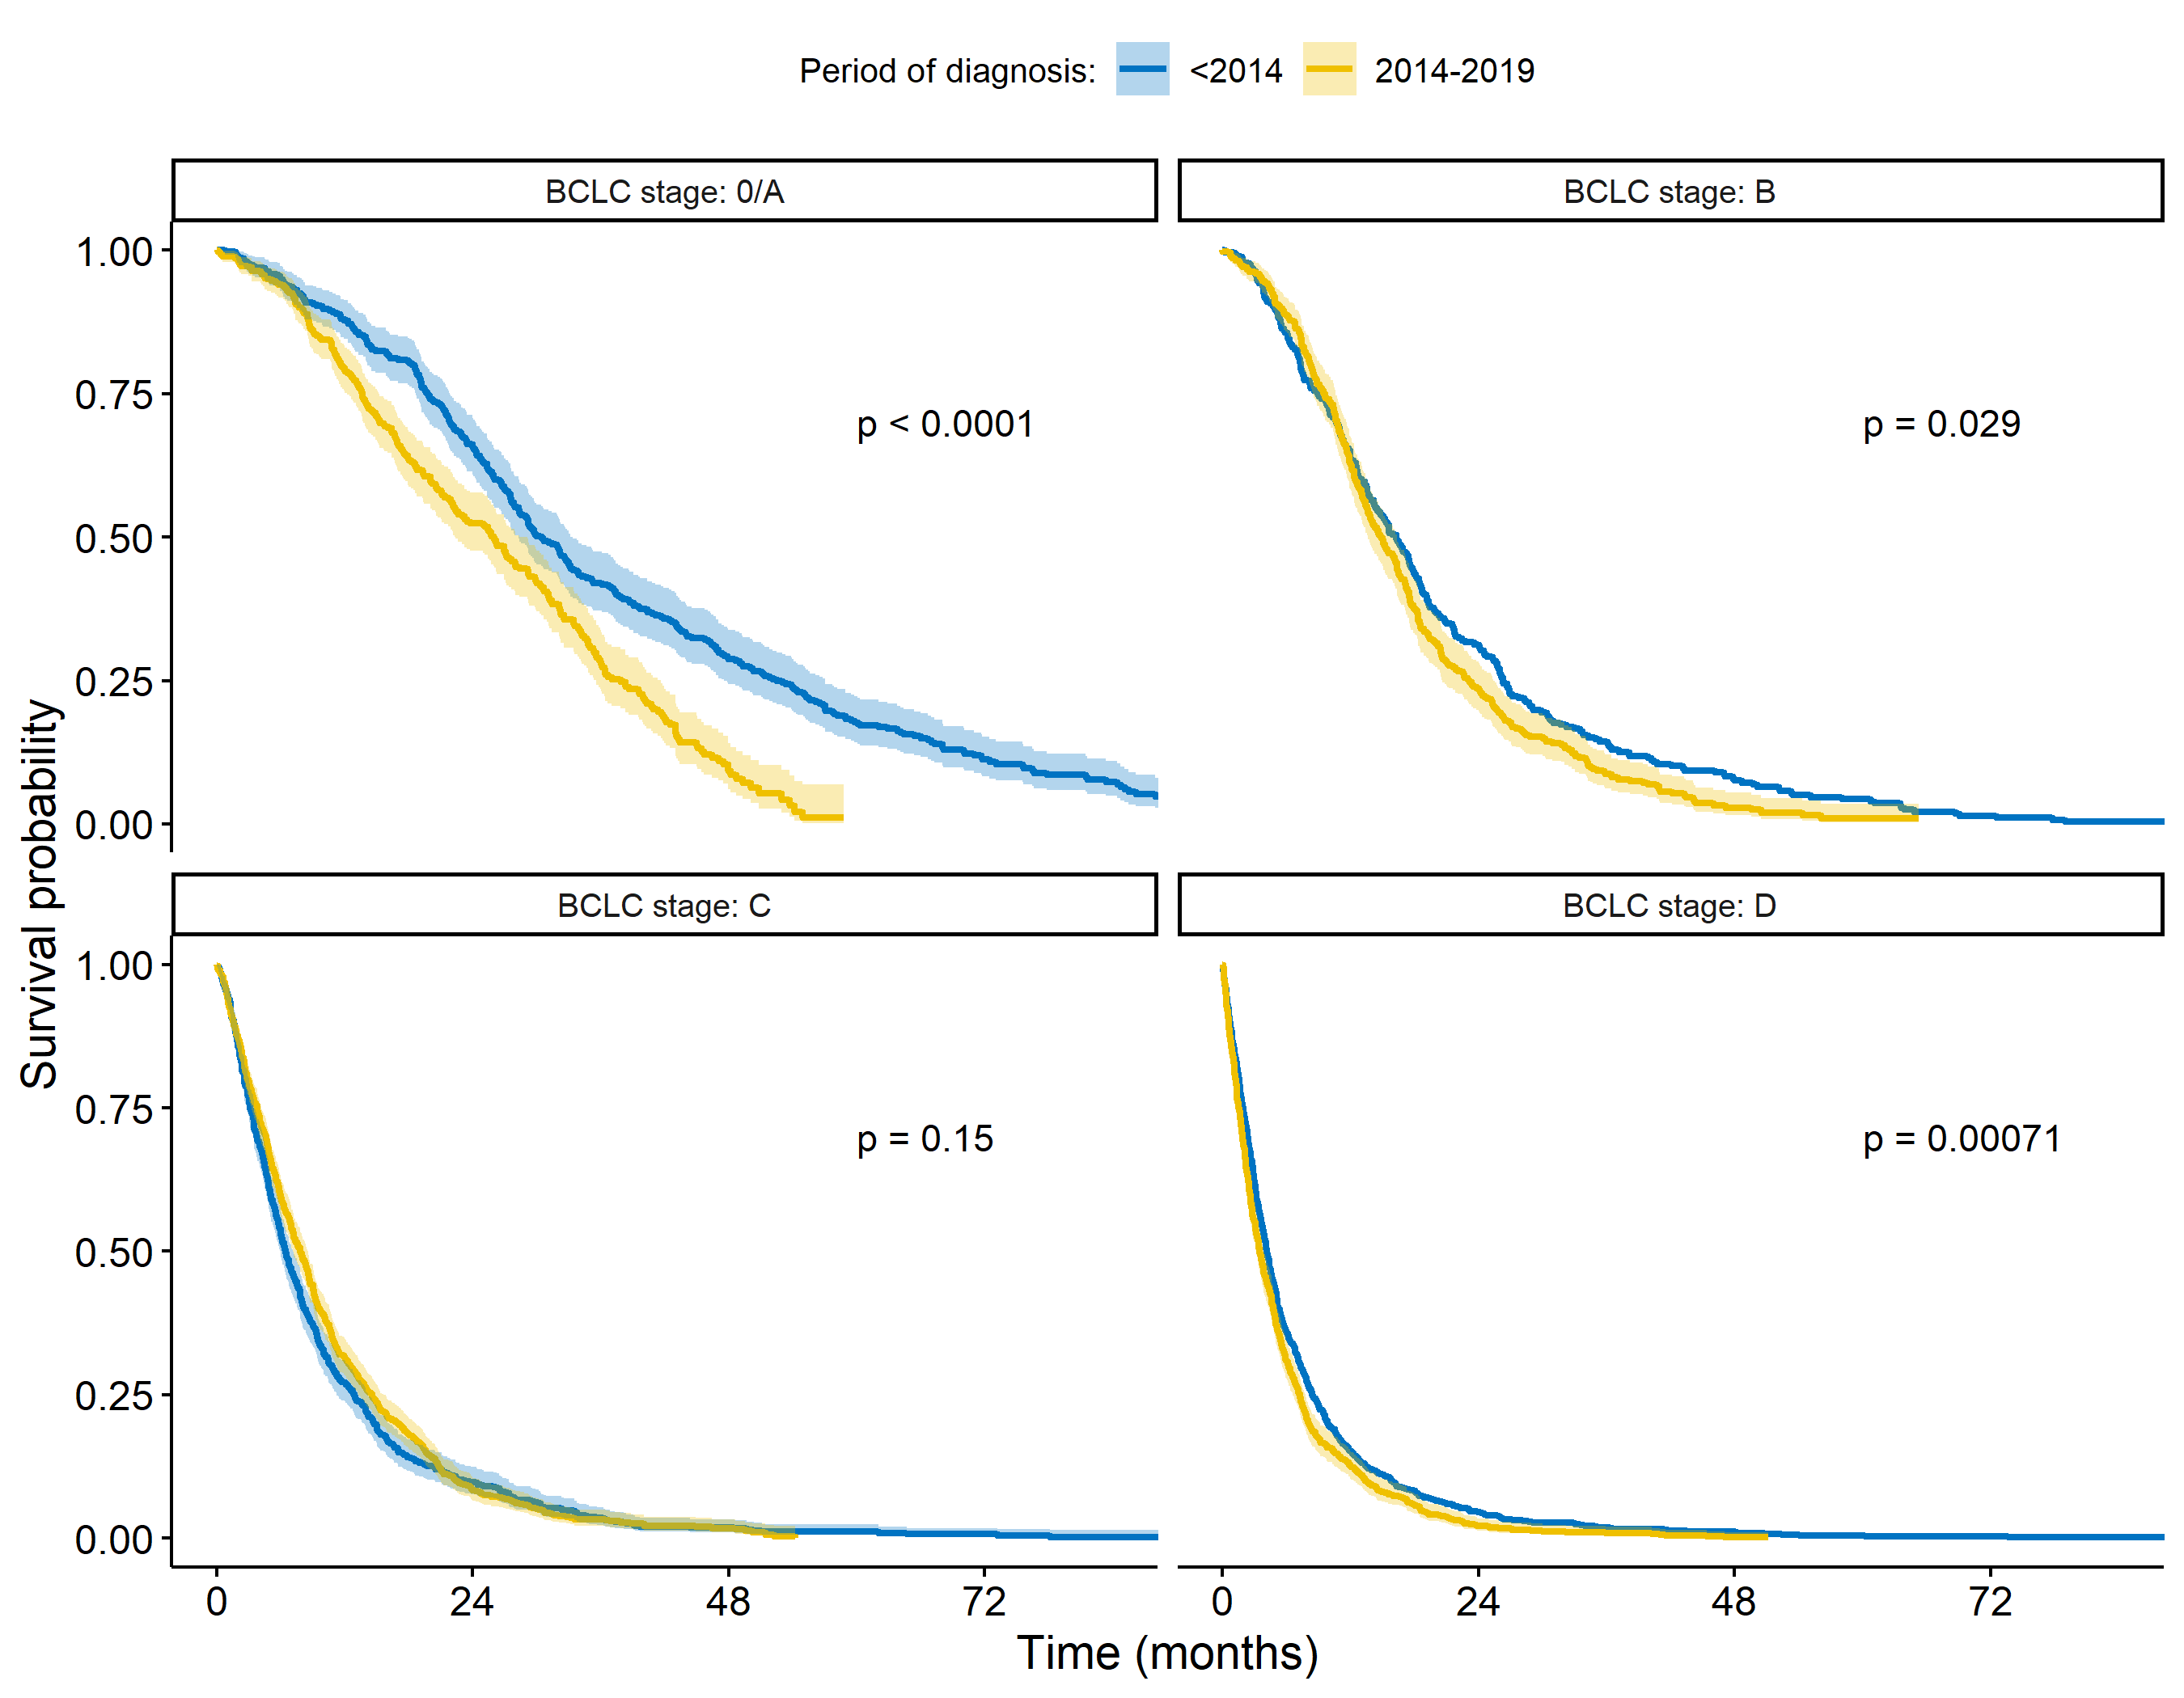 Supplementary Figure 4: Survival per time period and BCLC stage at HCC diagnosis.

Supplementary Table 1 : Temporal changes in patients’ treatment overall and by period of HCC diagnosis.
 |  |  | Year of HCC diagnosis
 |  | Overall | <2014 | 2014-2019
 |  | N = 5,097 | N = 2465 | N= 2632 | P-value
Treatment eventually received | Surgical resection | 104 ( 2.1%) | 34 ( 1.5%) | 70 ( 2.7%) | <10⁻³
 | Curative locoregional therapy | 693 (14.2%) | 326 (14.2%) | 367 (14.2%)
 | Noncurative locoregional therapy | 984 (20.1%) | 342 (14.9%) | 642 (24.9%)
 | Supportive care | 3104 (63.5%) | 1601 (69.5%) | 1503 (58.2%)
 | Missing | 212 | 162 | 50

Supplementary Table 2 : Univariate association between mortality and Child-Pugh score and ECOG stage. RMST : Restricted mean survival time.
 |  | Crude RMST | p
Child-Pugh score | A | ref.
 | B | -9.57 (-10.44; -8.71) | <10⁻³
 | C | -13.68 (-14.55;-12.80) | <10⁻³
ECOG stage | 0-1 | ref.
 | 2 | -9.13 (-10.05; -8.21) | <10⁻³
 | 3-4 | -14.48 (-15.38;-13.57) | <10⁻³

Supplementary Table 3: Association between mortality and general, clinical and tumor characteristics, stratified on the period of HCC diagnosis.
 |  | Multivariate RMST
 |  | Diagnosed <2014 |  |  | Diagnosed ≥2014
 |  | Difference in RMST, months (95% CI) | p |  | Difference in RMST, months (95% CI) | p
Sex | Men | ref. |  |  | ref.
 | Women | -0.54 ( -1.84; 0.76) | 0.4171 |  | 0.01 ( -1.25; 1.26) | 0.9925
Area of residence | Urban | ref. |  |  | ref.
 | Rural | -0.57 ( -1.74; 0.61) | 0.3425 |  | -0.14 ( -1.25; 0.96) | 0.7991
Age at diagnostic | 10y. Increase | -0.87 ( -1.37; -0.36) | 0.0007 |  | -1.04 ( -1.69; -0.40) | 0.0016
Tobacco consumption | No | ref. |  |  | ref.
 | Yes | -1.01 ( -2.06; 0.04) | 0.0587 |  | -2.09 ( -3.18; -1.00) | 0.0002
Hypertension | No | ref. |  |  | ref.
 | Yes | 1.28 ( -0.12; 2.68) | 0.0721 |  | 1.82 ( 0.57; 3.07) | 0.0043
Diabetes | No | ref. |  |  | ref.
 | Yes | 0.26 ( -0.92; 1.43) | 0.6673 |  | -0.22 ( -1.38; 0.95) | 0.7147
Etiology | HCV | ref. |  |  | ref.
 | HBV | -0.34 ( -3.03; 2.34) | 0.8024 |  | 0.01 ( -3.22; 3.24) | 0.9955
 | HBV-HCV | 1.87 ( -2.87; 6.60) | 0.4398 |  | -0.53 ( -5.06; 3.99) | 0.817
 | non-viral | -1.16 ( -3.34; 1.01) | 0.2938 |  | -0.78 ( -3.33; 1.76) | 0.5464
Vascular invasion | No | ref. |  |  | ref.
 | Yes | -1.93 ( -2.85; -1.01) | 0 |  | -2.88 ( -3.91; -1.85) | 0
Distant metastasis | No | ref. |  |  | ref.
 | Yes | -2.01 ( -2.94; -1.08) | 0 |  | -2.12 ( -3.29; -0.94) | 0.0004
BCLC stage at diagnosis | 0/A | ref. |  |  | ref.
 | B | -11.51 (-13.97; -9.06) | 0 |  | -5.84 ( -7.83; -3.85) | 0
 | C | -19.84 (-21.85;-17.82) | 0 |  | -12.16 (-13.92;-10.39) | 0
 | D | -22.49 (-24.38;-20.61) | 0 |  | -15.78 (-17.56;-13.99) | 0

