Supplementary File

Association of oxygen therapy with the natural disease progression of Cystic Fibrosis: A multi-state model of the European Cystic Fibrosis Society Patient Registry.

Simone Gambazza, Annalisa Orenti, Giovanna Pizzamiglio, Anna Zolin, Carla Colombo, Dario Laquintana, Federico Ambrogi, on behalf of the ECFSPR

Supplemental Figure 1. Adjusted probabilities to move from state 1 (alive without LTx) to state 2 (alive with LTx) or state 3 (death) (upper panels) and probabilities for pwCF to move from state 2 to state 3 (lower panels), according to FEV₁ z score, below and equal or above LLN, and oxygen therapy (OT), with other adjusting covariates held constant at the most frequent occurrence.

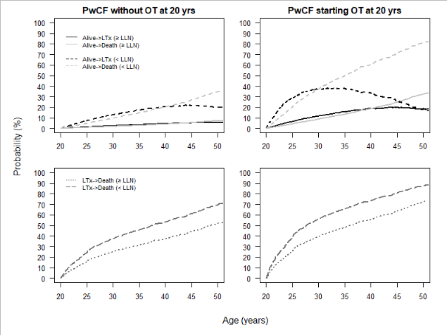

Supplemental Figure 2. Adjusted probabilities to move from state 1 (alive without LTx) to state 2 (alive with LTx) or state 3 (death) (upper panels) and probabilities for pwCF to move from state 2 to state 3 (lower panels), according to sex (F=females, M=males) and oxygen therapy (OT), with other adjusting covariates held constant at the most frequent occurrence.

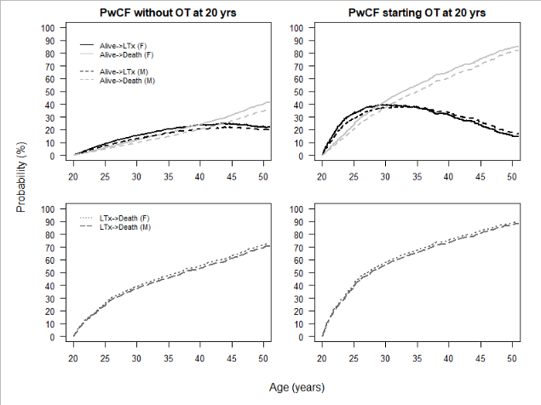

Supplemental Figure 3. Adjusted probabilities to move from state 1 (alive without LTx) to state 2 (alive with LTx) or state 3 (death) (upper panels) and probabilities for pwCF to move from state 2 to state 3 (lower panels), according to BMI, below and equal or above nutritional goal, and oxygen therapy (OT), with other adjusting covariates held constant at the most frequent occurrence.

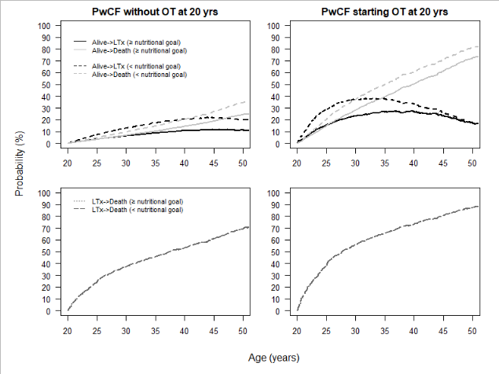

Supplemental Figure 4. Adjusted probabilities to move from state 1 (alive without LTx) to state 2 (alive with LTx) or state 3 (death) (upper panels) and probabilities for pwCF to move from state 2 to state 3 (lower panels), according to Pseudomonas aeruginosa (PSA) infection and oxygen therapy (OT), with other adjusting covariates held constant at the most frequent occurrence.

