Figure S1. Mortality according to CRE isolation bacteria.
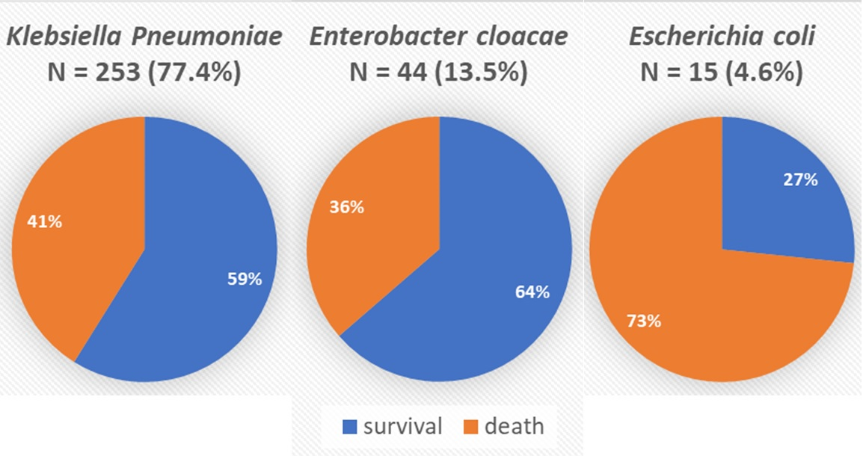
CRE, Carbapenem-resistant Enterobacterales

Figure S2. The prevalence of carbapenemase genotypes according to the intensive care units.
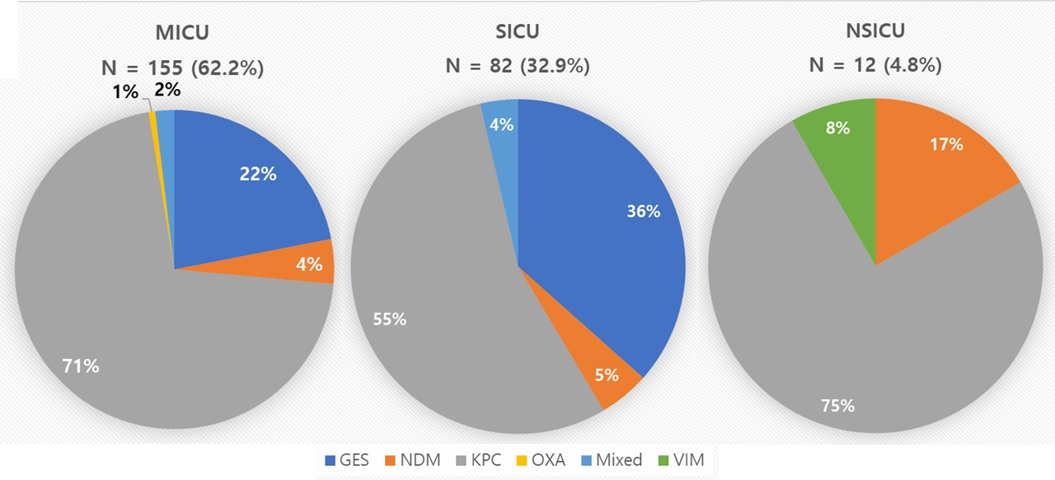
KPC, Klebsiella pneumoniae carbapenemase; GES, Guiana extended-spectrum β-lactamase; NDM, New Delhi metallo-β-lactamase; OXA, oxacillinase; VIM, Verona Paulo metallo-β-lactamase.

Table S1. Clinical characteristics according to types of the intensive care units.
 | MICU  N = 202 | SICU  N = 109 | Neuro ICU  N = 16 | Total  N = 327 | P
Age, years | 74 (62-79) | 66 (59-75) | 65 (59-74) | 69 (60-78) | 0.001*
Number of males | 128 (63.4) | 80 (73.4) | 9 (56.3) | 217 (66.4) | 0.138
Transfer from other hospital or health care facility | 50 (24.8) | 20 (18.3) | 2 (12.5) | 72 (22.0) | 0.275
History of carbapenem usage | 148 (73.3) | 45 (41.3) | 6 (37.5) | 199 (60.9) | <0.001**
Hospital length, days | 47 (28-78) | 68 (42-121) | 77 (37-166) | 54 (32-96) | <0.001*
Length of ICU stay, days | 23 (13-37) | 24 (12-49) | 33 (23-68) | 23 (13-40) | 0.066
Length from ICU admission to 1st detection of CRE, days | 15 (11-25) | 20 (9-38) | 23 (15-75) | 17 (10-29) | 0.050*
APACHE-II | 28 (23-32) | 25 (19-32) | 19 (16-21) | 27 (21-32) | <0.001*
Bedridden state at admission | 90 (44.8) | 27 (24.8) | 2 (12.5) | 119 (36.5) | <0.001**
Mortality | 93 (46.0) | 42 (38.5) | 3 (18.8) | 138 (42.2) | 0.066
CRE as infection | 44 (21.8) | 39 (35.8) | 1 (6.3) | 84 (25.7) | 0.005**
Data are presented as number (%) or median (interquartile range).
*P<0.05 by Kruskal–Wallis test for comparisons between the types of the intensive care units.
** P< 0.05 by Chi-square tests for comparisons between the types of the intensive care units.
CRE = Carbapenem-resistant Enterobacteriaceae; ICU = Intensive care unit; APACHE-II = Acute Physiology and Chronic Health Evaluation II
Table S2. CRE distribution by age and sex.
Age | Male | Female | Total (%)
18-29 | 1 (0.3) | 2 (0.6) | 3 (0.9)
30-39 | 1 (0.3) | 2 (0.6) | 3 (0.9)
40-49 | 10 (3.1) | 2 (0.6) | 12 (3.7)
50-59 | 46 (14.1) | 9 (2.8) | 55 (16.8)
60-69 | 68 (20.8) | 29 (8.9) | 97 (29.7)
70-79 | 56 (17.1) | 39 (11.9) | 95 (29.1)
80-89 | 32 (9.8) | 25 (7.6) | 57 (17.4)
90- | 3 (0.9) | 2 (0.6) | 5 (1.5)
Total | 217 (66.4) | 110 (33.6) | 327 (100.0)
Data are presented as number (% of total cases).

Table S3. Distribution of carbapenem-resistant Enterobacteriaceae isolates and carbapenemase genotypes (N = 249, 76.1% of total CRE cases) (**P < 0.001)
 | K. pneumoniae | E. cloacae | E. coli | No growth | Mixed* | Raoultella planticola | Citrobacter freundii | K. oxytoca | Total
KPC | 161 (64.7) | 0 | 0 | 2 (0.8) | 0 | 1 (0.4) | 0 | 0 | 164 (65.9)
GES | 27 (10.8) | 35 (14.1) | 0 | 0 | 1 (0.4) | 0 | 0 | 1 (0.4) | 64 (25.7)
NDM | 4 (1.6) | 0 | 3 (1.2) | 3 (1.2) | 2 (0.8) | 0 | 1 (0.4) | 0 | 13 (5.2)
NDM & OXA-48 | 1 (0.4) | 0 | 2 (0.8) | 0 | 0 | 0 | 0 | 0 | 3 (1.2)
NDM-5 & OXA-181 | 0 | 0 | 3 (1.2) | 0 | 0 | 0 | 0 | 0 | 3 (1.2)
OXA | 1 (0.4) | 0 | 0 | 0 | 0 | 0 | 0 | 0 | 1 (0.4)
VIM | 0 | 0 | 0 | 1 (0.4) | 0 | 0 | 0 | 0 | 1 (0.4)
Total | 194 (77.9) | 35 (14.1) | 8 (3.2) | 6 (2.4) | 3 (1.2) | 1 (0.4) | 1 (0.4) | 1 (0.4) | 249 (100.0)
Data are presented as number (% of total cases).
*Mixed: E. coli and K. pneumoniae: 1 case, E. cloacae and K. pneumoniae: 2 cases.
** P <0.05 by chi-square tests for comparisons between carbapenem-resistant Enterobacteriaceae isolates and carbapenemase genotypes.
CRE = Carbapenem-resistant Enterobacteriaceae; KPC = Klebsiella pneumoniae carbapenemase; GES = Guiana extended-spectrum β-lactamase; NDM = New Delhi metallo-β-lactamase; OXA = Oxacillinase; VIM = Verona Paulo metallo-ß-Lactamase.

