Supplemental information

Supplementary Table 1. Clinicopathologic characteristics of ESCC patients for small RNA sequencing
Patients | Gender | Age  (year) | Tumor Size  (cm) | T stage | Differentiation | N stage
LNM⁻-1 | Male | 65 | >3 | 3 | Mid-high | 0
LNM⁻-2 | Male | 74 | >3 | 3 | Mid-high | 0
LNM⁻-3 | Male | 58 | >3 | 3 | Mid-high | 0
LNM⁻-4 | Female | 74 | <3 | 3 | Low | 0
LNM⁻-5 | Male | 56 | >3 | 3 | Low | 0
LNM⁺-1 | Male | 58 | >3 | 3 | Mid-high | 1
LNM⁺-2 | Male | 71 | >3 | 3 | Mid-high | 1
LNM⁺-3 | Male | 68 | >3 | 3 | Low | 2
LNM⁺-4 | Male | 69 | >3 | 3 | Low | 2
LNM⁺-5 | Female | 64 | >3 | 3 | Low | 3
Abbreviations: ESCC, esophageal squamous cell carcinoma; LNM⁺, with lymph node metastasis; LNM⁻, without lymph node metastasis.

Supplementary Table 2. Sequences of miR-10527-5p mimic, inhibitor, si-Rab10
Gene | Sequences
miR-10527-5p mimic | 5’-AAAGCAAAUGUUGGGUGAACGGC-3’  5’-GCCGUUCACCCAACAUUUGCUUU-3’
mimic-NC | 5’-UCACAACCUCCUAGAAAGAGUAGA-3’  5’-UCUACUCUUUCUAGGAGGUUGUGA-3’
miR-10527-5p inhibitor | 5’-GCCGUUCACCCAACAUUUGCUUU-3’
inhibitor-NC | 5’-UCUACUCUUUCUAGGAGGUUGUGA-3’
siRab10-1 | F: 5’-GAAUAGACUUCAAGAUCAATT-3’  R: 5’-UUGAUCUUGAAGUCUAUUCTT-3’
siRab10-2 | F: 5’-GCAAAUGGCUUAGAAACAUTT-3’  R: 5’-AUGUUUCUAAGCCAUUUGCTT-3’
Abbreviations: miR-10527-5p, microRNA-10527-5p; NC, negative control; Rab10, ras-related protein Rab-10.

Supplementary Table 3. Primer sequences for qRT‒PCR
Gene | Primer Sequences
U6 | F: 5’-CTCGCTTCGGCAGCACA -3’
miR-10527-5p | F: 5’-AGAAAGCAAATGTTGGGTGA-3’
β-actin | F: 5’-GGACTTCGAGCAAGAGATGG-3’  R: 5’-CCACGTCACACTTCATGATGG-3’
Rab10 | F: 5’-TTCACACCATCACAACCTCC -3’  R: 5’-CCAGTAACATTCTTTCCACATCTTC-3’
SRSF6 | F: 5’-TACGGAAGCCGCAGTGGTG-3’  R: 5’-CCTGCGACTCCTACTTCGTG-3’
MMP16 | F: 5’-ACAGGAACTACTGCTGACCC-3’  R: 5’-AAATACTGCTCCGTTCCGCA-3’
TRIM2 | F: 5’-CAGCATCCCAAGTCCCGTGGT-3’  R: 5’-TCTCGCAGAAAGTGTGCAGACAG-3’
SHOC2 | F: 5’-CTTCTCTTGCCCCGGAACT-3’  R: 5’-GGTGACTCAAGCCTGGACAAA-3’
Abbreviations: F, forward; R, reverse.

Supplementary Table 4. Antibodies used in the present study
Gene | Source |  | No. of Catalogue
anti‑Rab10 |  | Proteintech | 11808-1-AP
anti-GAPDH |  | Proteintech | 60004-1-Ig
anti‑VEGF-C |  | Proteintech | 22601-1-AP
anti-N-cadherin |  | Proteintech | 22018-1-AP
anti-E-cadherin |  | Proteintech | 20874-1-AP
anti-Vimentin |  | Cell Signaling Technology | 5741T
anti-β-catenin |  | Cell Signaling Technology | 8480T
anti-GSK-3β |  | Cell Signaling Technology | 12456
anti- pGSK-3β |  | Cell Signaling Technology | 5558T
anti-GFP |  | Cell Signaling Technology | 2956S
anti‑CD63 |  | Abcam | ab134045
anti‑TSG101 |  | Abcam | ab125011
anti-LYVE-1 |  | Abcam | ab14917
anti-GRP94 |  | Abcam | ab108606
Supplementary Table 5. Differential expression of miRNAs in plasma exosomes between LNM⁺ ESCC patients and LNM⁻ ESCC patients by small RNA sequencing
microRNAs | Log₂FC | P value | LNM⁺ vs LNM⁻
hsa-miR-10527-5p | -1.3767 | 0.023025 | Downregulation
hsa-miR-877-5p | -1.2046 | 0.039114 | Downregulation
hsa-miR-542-3p | -1.1645 | 0.044742 | Downregulation
hsa-miR-493-5p | -1.0198 | 0.034412 | Downregulation
hsa-miR-450a-5p | 1.046 | 0.02762 | Upregulation
hsa-miR-320b | 1.0584 | 0.015241 | Upregulation
hsa-miR-629-5p | 1.0671 | 0.01845 | Upregulation
hsa-miR-320c | 1.228 | 0.025566 | Upregulation
hsa-miR-4647 | 1.4194 | 0.021073 | Upregulation
hsa-let-7b-3p | 1.6762 | 0.0063878 | Upregulation
Abbreviations: ESCC, esophageal squamous cell carcinoma; FC, Fold Change; LNM⁺, with lymph node metastasis; LNM⁻, without lymph node metastasis.

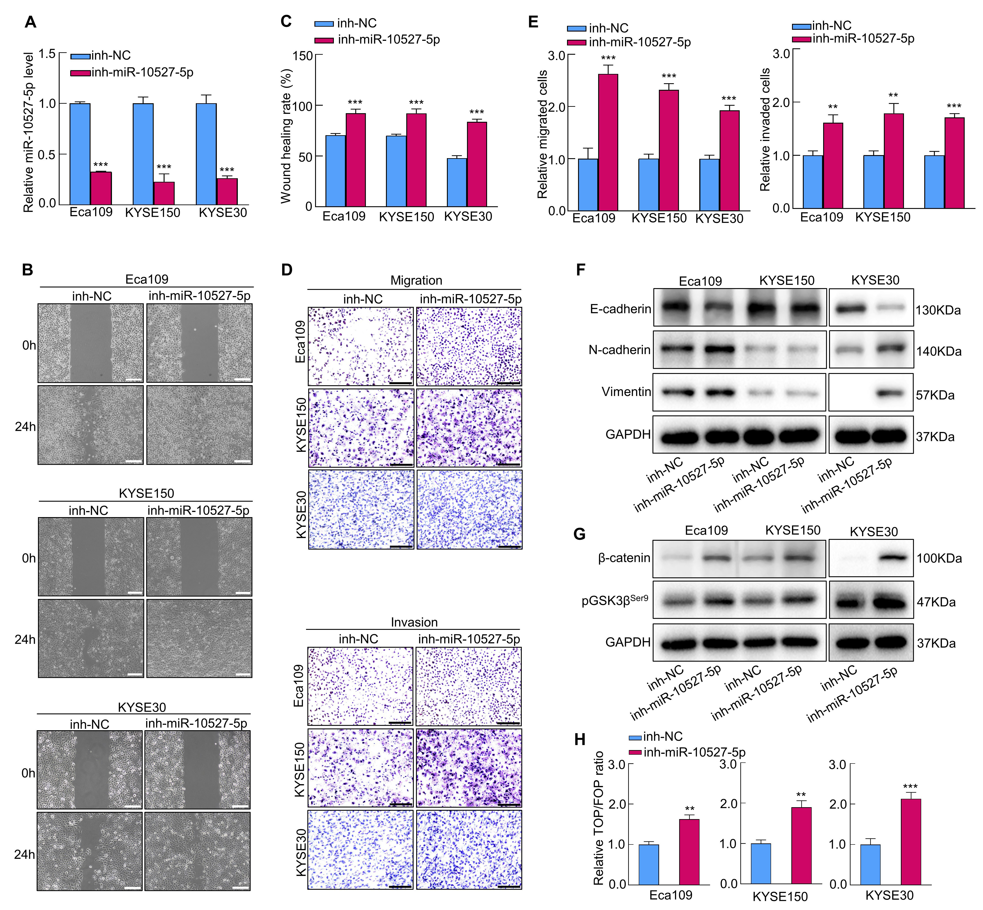
Figure S1. Down-regulation of miR-10527-5p promotes the migration, invasion and EMT progression of ESCC cells.
(A) qRT‒PCR analysis of miR-10527-5p expression in Eca109, KYSE150 and KYSE30 cells after transfection with miR-10527-5p inhibitor. (B-E) The effects of miR-10527-5p inhibitor (inh-miR-10527-5p) on the migration and invasion of Eca109, KYSE150 and KYSE30 cells detected by wound healing assays (scale bar, 200 μm) and Transwell assays (scale bar, 100 μm). (F) Western blot analysis of E-cadherin, N-cadherin and Vimentin proteins in Eca109, KYSE150 and KYSE30 cells after transfection with miR-10527-5p inhibitor. (G) Western blot analysis of β-catenin and pGSK3β^{Ser9} proteins in Eca109, KYSE150 and KYSE30 cells after transfection with miR-10527-5p inhibitor. (H) The effects of miR-10527-5p inhibitor on the transcriptional activity of β-catenin in Eca109, KYSE150 and KYSE30 cells assessed by a TOPFlash/FOPFlash reporter assay. Experiments were performed in triplicate, and the data are represented as the mean ± SD, **P<0.01, ***P<0.001.

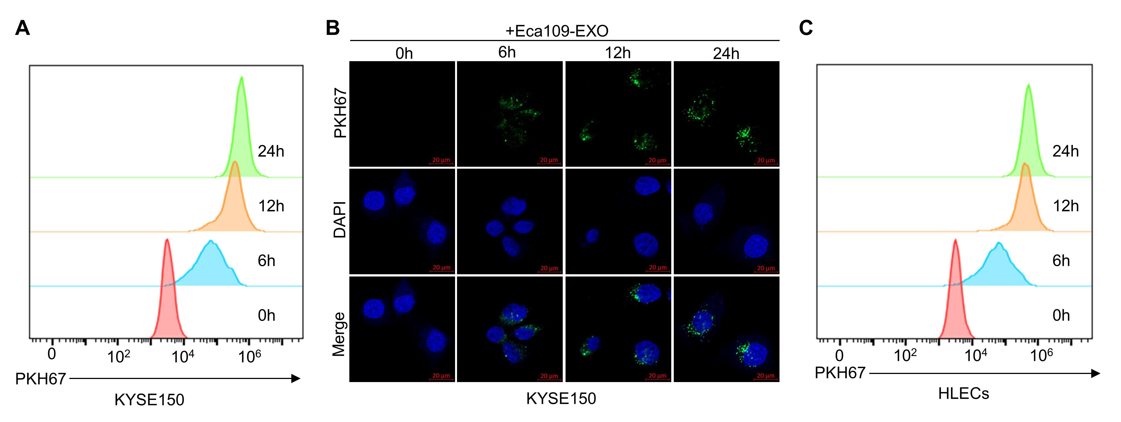
Figure S2. The uptake of Eca109-EXOs by KYSE150 and HLEC cells. (A)The uptake of exosomes by KYSE150 cells after incubation with Eca109-EXOs for 0, 6, 12 and 24 h determined by flow cytometry. (B)The uptake of exosomes by KYSE150 cells after incubation with Eca109-EXOs for 0, 6, 12 and 24 h under a confocal microscope. (C)The uptake of exosomes by HLECs after incubation with Eca109-EXOs for 0, 6, 12 and 24 h determined by flow cytometry.

Figure S3. Prediction of the direct targets of miR-10527-5p.
(A) qRT‒PCR analysis of SRSF6, MMP16, TRIM2, SHOC2 mRNA expressions in Eca109 and KYSE150 cells after miR-10527-5p overexpression (OE). (B) Schematic diagram of the wild-type and mutate-type binding sites between miR-10527-5p and the Rab10 mRNA 3’-UTR region. Experiments were performed in triplicate, and the data are represented as the mean ± SD, ns, no significance, *P<0.05, **P<0.01.

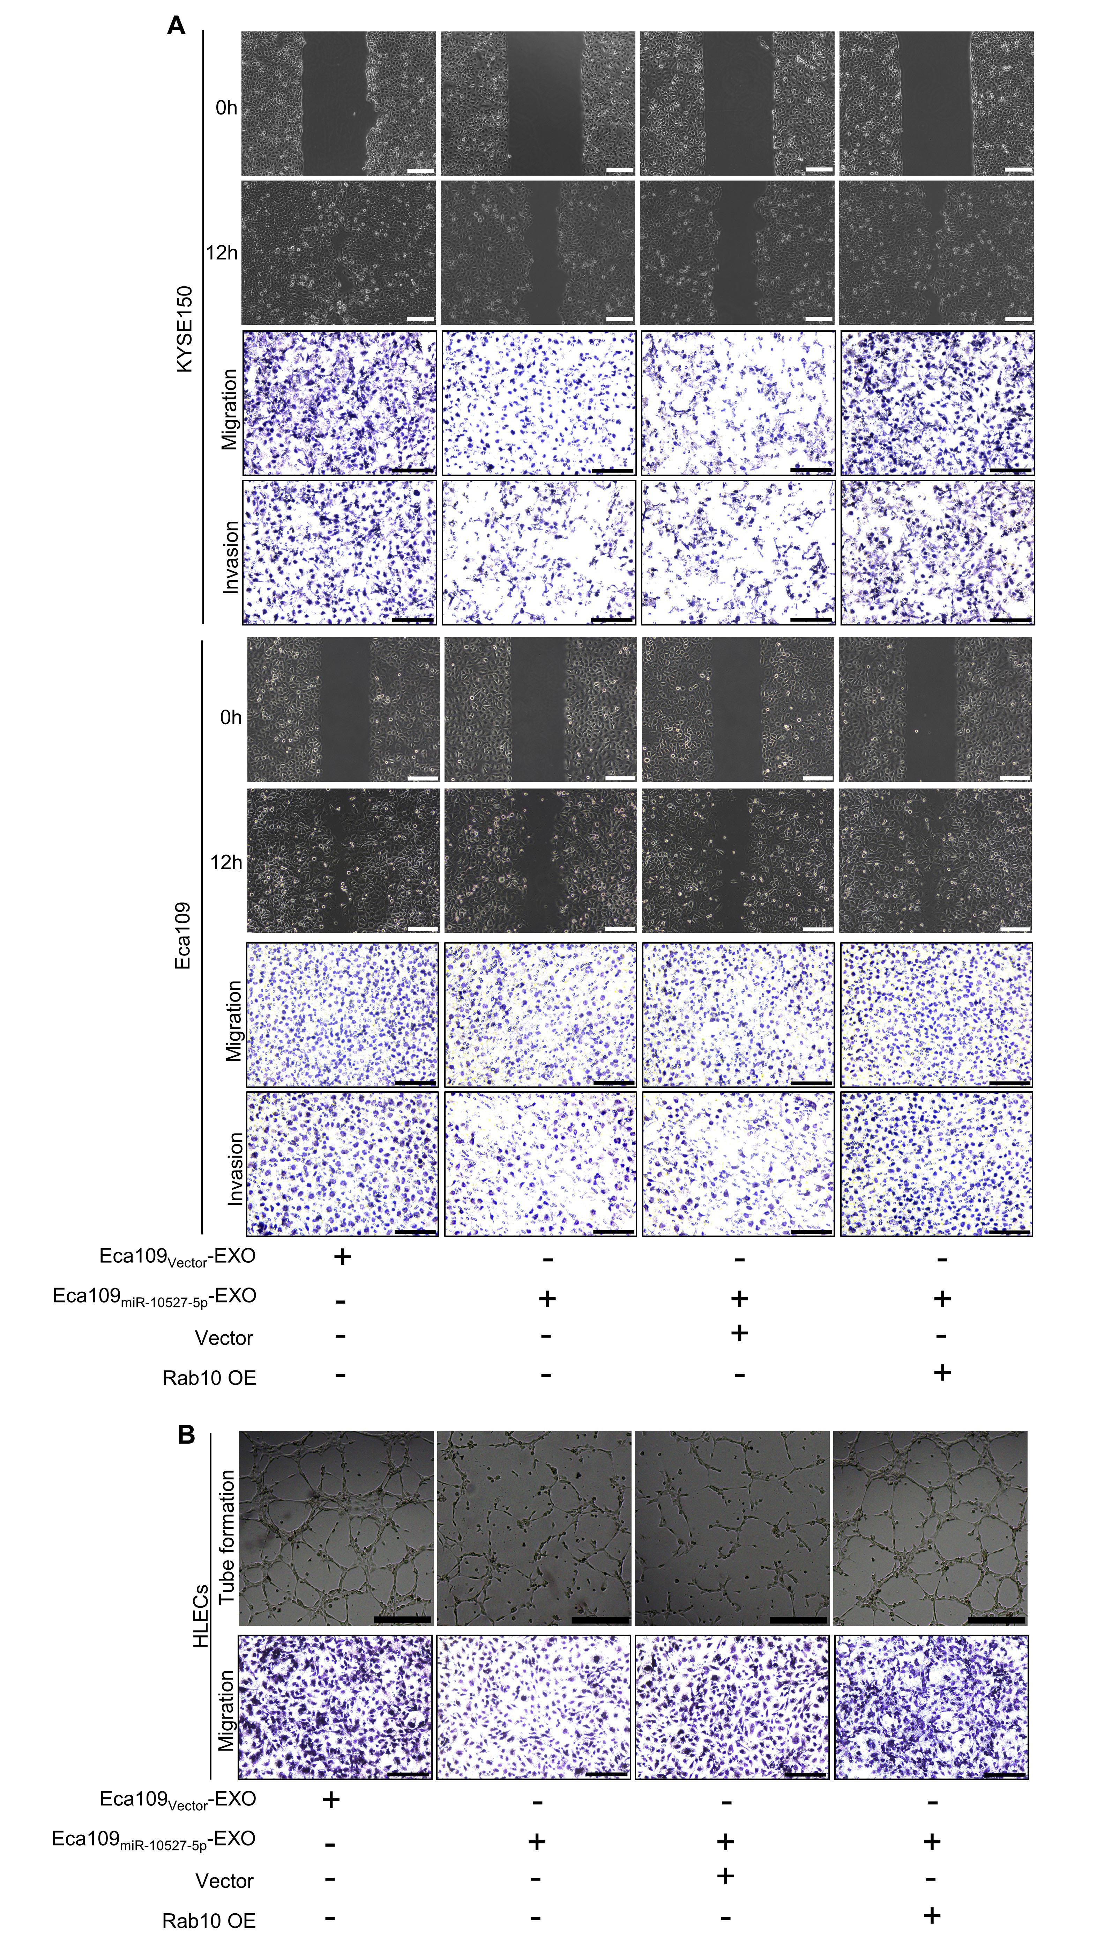
Figure S4. Exosomal miR-10527-5p inhibits the migration, invasion, and EMT of ESCC cells and migration, tube formation of HLECs via Rab10.
(A) Representative images of the migration, invasion of KYSE150 and Eca109 cells rescued by Rab10 overexpression detected by wound healing assays (scale bar, 200 μm) and Transwell assays (scale bar, 100 μm). (B) Representative images of the tube formation and migration of HLECs rescued by Rab10 detected by tube formation (scale bar, 250 μm) and Transwell assays (scale bar, 100 μm). Experiments were performed in triplicate, and the data are represented as the mean ± SD.
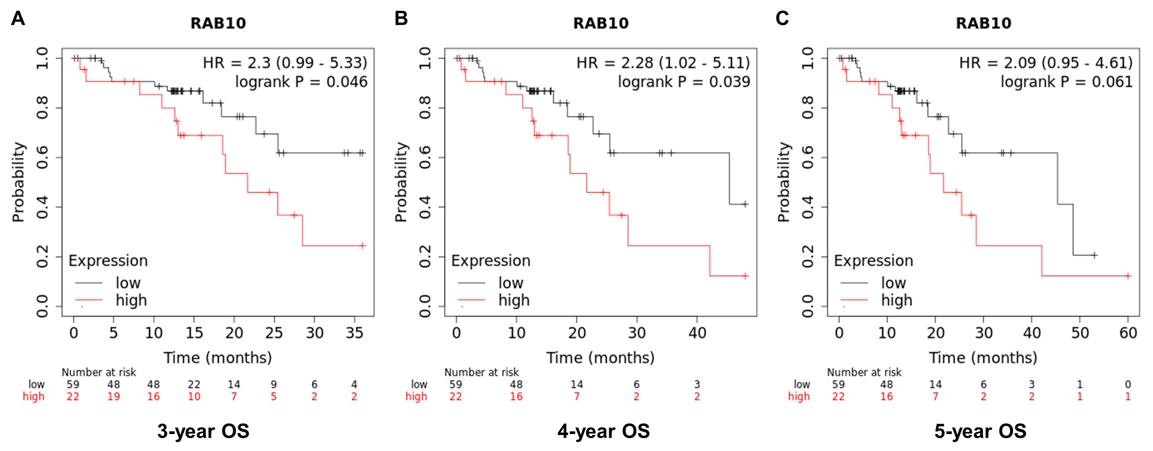
Figure S5. Kaplan-Meier plot of Rab10 for 3-year OS (A), 4-year OS (B) and 5-year OS (C) of ESCC patients.

