Data supplement
Table S1 List of institutional review boards and ethics committees
Country | Institutional Review Board/Ethics Committee
China | Independent Ethics Committee of the Second Xiangya Hospital of Central South University
China | Ethics Committee of the Third Affiliated Hospital, Sun Yansen University
China | Ethics Committee of Tianjin Anding Hospital
China | Ethics Committee of Beijing HuiLongGuan Hospital
China | Ethics Committee of the Second Affiliated Hospital of Zhejiang University College of Medicine
China | Ethics Committee of the First Hospital of Hebei Medical University
China | Ethics Committee of Nanjing Brain Hospital Affiliated with Nanjing Medical University
China | Ethics Committee of the Second People's Hospital of Hunan Province / Brian Hospital of Hunan Province
China | Ethics Committee of Guangdong General Hospital
China | Ethics Committee of Peking University Sixth Hospital
China | Ethics Committee of Xi'an Mental Health Center
China | Ethics Committee of the First Hospital of Xi'an Jiaotong University
China | Independent Ethics Committee of West China Hospital of Sichuan University
China | Ethics Committee of Renmin Hospital of Wuhan University
China | Ethics Committee of Beijing Anding Hospital of Capital Medical University
China | Ethics Committee of First Affiliated Hospital of Kunming Medical University
China | Ethics Committee of Hangzhou Seventh People's Hospital
China | Ethics Committee of Chongqing Mental Health Center
China | Independent Ethics Committee of Urumqi Fourth Hospital
China | Independent Ethics Committee of Huzhou Third People's Hospital
China | Independent Ethics Committee of First Hospital, Zhejiang University Medical College
China | Independent Ethics Committee of Xiamen Xianyue Hospital
China | Independent Ethics Committee of the First Affiliated Hospital of Xinjiang Medical University
China | Independent Ethics Committee of the First Affiliated Hospital of Zhengzhou University
United States of America | Sterling Institutional Review Board

Table S2 Demographic and baseline clinical characteristics by countryª
Characteristic | China |  |  | United States
Characteristic | Esketamine  plus AD  (n=110) | AD  plus placebo  (n=112) | Total  (n=222) | Esketamine  plus AD  (n=14) | AD  plus placebo  (n=14) | Total  (n=28)
Age, years – mean (SD) | 36.0 (11.92) | 36.3 (11.84) | 36.2 (11.85) | 43.6 (11.22) | 49.6 (10.15) | 46.6 (10.92)
Sex – n (%)
Male | 61 (55.5) | 66 (58.9) | 127 (57.2) | 5 (35.7) | 5 (35.7) | 10 (35.7)
Female | 49 (44.5) | 46 (41.1) | 95 (42.8) | 9 (64.3) | 9 (64.3) | 18 (64.3)
Race – n (%)
Asian | 110 (100.0) | 112 (100.0) | 222 (100.0) | 0 | 0 | 0
White | 0 | 0 | 0 | 12 (85.7) | 9 (64.3) | 21 (75.0)
Black or African American | 0 | 0 | 0 | 1 (7.1) | 4 (28.6) | 5 (17.9)
Multiple | 0 | 0 | 0 | 1 (7.1) | 0 | 1 (3.6)
Not reported | 0 | 0 | 0 | 0 | 1 (7.1) | 1 (3.6)
BMI, calculated as kg/m² –  mean (SD) | 23.8 (3.78) | 23.6 (3.65) | 23.7 (3.71) | 32.5 (6.57) | 29.1 (6.10) | 30.8 (6.45)
Employment status – n (%)^{b}
Any type of employment | 76 (69.1) | 70 (62.5) | 146 (65.8) | 10 (71.4) | 9 (64.3) | 19 (67.9)
Any type of unemployment | 24 (21.8) | 34 (30.4) | 58 (26.1) | 3 (21.4) | 4 (28.6) | 7 (25.0)
Other | 10 (9.1) | 8 (7.1) | 18 (8.1) | 1 (7.1) | 1 (7.1) | 2 (7.1)
Age when diagnosed with MDD  years – mean (SD) | 27.3 (11.38) | 28.2 (12.18) | 27.7 (11.77) | 26.8 (13.10) | 27.8 (9.34) | 27.3 (11.18)
Duration of current episode, weeks – mean (SD) | 213.6 (319.67) | 224.2 (285.75) | 219.0 (302.39) | 316.7 (297.19) | 174.1 (152.72) | 245.4 (242.97)
MADRS total score – mean (SD) | 36.2 (5.02) | 35.9 (4.49) | 36.1 (4.75) | 38.5 (6.41) | 35.8 (4.74) | 37.1 (5.70)
CGI-S – mean (SD) | 5.1 (0.61) | 5.2 (0.68) | 5.1 (0.65) | 5.0 (0.55) | 4.9 (0.66) | 4.9 (0.60)
CGI-S category – n (%)
Mildly ill | 1 (0.9) | 1 (0.9) | 2 (0.9) | 0 | 0 | 0
Moderately ill | 13 (11.8) | 12 (10.7) | 25 (11.3) | 2 (14.3) | 4 (28.6) | 6 (21.4)
Markedly ill | 71 (64.5) | 66 (58.9) | 137 (61.7) | 10 (71.4) | 8 (57.1) | 18 (64.3)
Severely ill | 25 (22.7) | 31 (27.7) | 56 (25.2) | 2 (14.3) | 2 (14.3) | 4 (14.3)
Most extremely ill | 0 | 2 (1.8) | 2 (0.9) | 0 | 0 | 0
Class of oral AD – n (%)
SNRI | 61 (55.5) | 61 (54.5) | 122 (55.0) | 7 (50.0) | 8 (57.1) | 15 (53.6)
SSRI | 49 (44.5) | 51 (45.5) | 100 (45.0) | 7 (50.0) | 6 (42.9) | 13 (46.4)
Oral AD – n (%)
Duloxetine | 31 (28.2) | 33 (29.5) | 64 (28.8) | 5 (35.7) | 7 (50.0) | 12 (42.9)
Escitalopram | 25 (22.7) | 29 (25.9) | 54 (24.3) | 5 (35.7) | 5 (35.7) | 10 (35.7)
Venlafaxine extended release | 30 (27.3) | 28 (25.0) | 58 (26.1) | 1 (7.1) | 1 (7.1) | 2 (7.1)
Sertraline | 24 (21.8) | 22 (19.6) | 46 (20.7) | 3 (21.4) | 1 (7.1) | 4 (14.3)
Number of previous treatment failures in current episode –
n (%)^{c}
1 | 36 (32.7) | 31 (27.7) | 67 (30.2) | 2 (14.3) | 7 (50.0) | 9 (32.1)
2 | 39 (35.5) | 42 (37.5) | 81 (36.5) | 7 (50.0) | 5 (35.7) | 12 (42.9)
3 | 25 (22.7) | 29 (25.9) | 54 (24.3) | 4 (28.6) | 2 (14.3) | 6 (21.4)
4 | 6 (5.5) | 8 (7.1) | 14 (6.3) | 1 (7.1) | 0 | 1 (3.6)
5 | 4 (3.6) | 2 (1.8) | 6 (2.7) | 0 | 0 | 0
Notes: ªData generated from the efficacy analysis set. ^{b}Any type of employment includes any category containing “employed”, sheltered work, housewife or dependent husband, and student; any type of unemployment includes any category containing “unemployed”; “other” includes retired or no information available. ^{c}Number of AD medications with nonresponse (defined as ≤25% improvement) taken for at least 6 weeks during the current episode as obtained from MGH-ATRQ at screening.
Abbreviations: AD, antidepressant; BMI, body mass index; CGI-S, Clinical Global Impression of Severity; MADRS, Montgomery-Åsberg Depression Rating Scale; MDD, major depressive disorder; MGH-ATRQ, Massachusetts General Hospital – Antidepressant Treatment Response Questionnaire; SD, standard deviation; SNRI, serotonin-norepinephrine reuptake inhibitor; SSRI, selective serotonin reuptake inhibitor.

Table S3 Change in GAD-7 total scoreª from baseline to the endpoint of the double-blind phase
 | Esketamine  plus AD | AD  plus placebo
Baseline
N | 124 | 126
Mean (SD) | 10.9 (5.32) | 11.0 (5.71)
Median (range) | 11.0 (0, 21) | 11.0 (0, 21)
Endpoint (double-blind phase)
N | 118 | 120
Mean (SD) | 6.6 (4.91) | 8.2 (5.93)
Median (range) | 5.0 (0, 21) | 7.0 (0, 21)
Change from baseline to endpoint
(double-blind phase)
N | 118 | 120
Mean (SD) | -4.3 (5.65) | -2.9 (5.28)
Median (range) | -4.0 (-20, 10) | -2.0 (-21, 9)
ANCOVA^{b}
Difference of LS means (SE) | -1.6 (0.61)
95% CI on difference | -2.78, -0.36
Notes: ªGAD-7 total score ranges from 0 to 21; a higher score indicates more anxiety. Negative change in score indicates improvement. ^{b}Test for treatment effect is based on ANCOVA model on change from baseline as the response variable and factors for treatment (esketamine plus AD, AD plus placebo), country, and class of oral AD (SNRI or SSRI), and baseline value as a covariate.
Abbreviations: AD, antidepressant; ANCOVA, analysis of covariance; CI, confidence interval; GAD-7, 7-Item Generalized Anxiety Disorder Scale; LS, least squares; SD, standard deviation; SE, standard error; SNRI, serotonin-norepinephrine reuptake inhibitor; SSRI, selective serotonin reuptake inhibitor.
Table S4 Plasma esketamine concentrations (ng/mL) on Day 25 following administration of 56 mg or 84 mg intranasal esketamine
Intranasal  esketamine dose | Time | N | Mean | Median | Minimum | Maximum | SD | % CV
56 mg | Predose | 14 | BQL | BQL | BQL | BQL | − | −
56 mg | 40 minutes | 13 | 101 | 92.7 | 43.7 | 190 | 47.4 | 46.8
56 mg | 2 hours | 14 | 55.9 | 53.1 | 31.9 | 132 | 25.0 | 44.8
56 mg | 6 hours | 13 | 12.0 | 10.2 | 7.20 | 23.7 | 5.14 | 42.8
84 mgª | Predose | 78 | BQL | BQL | BQL | 2.83 | − | −
84 mgª | 40 minutes | 75 | 108 | 105 | 28.1 | 248 | 39.9 | 37.2
84 mgª | 2 hours | 79 | 70.1 | 66.0 | 22.7 | 120 | 24.8 | 35.3
84 mgª | 6 hours | 76 | 17.1 | 14.6 | 7.53 | 44.1 | 7.53 | 43.9
Notes: ªFour samples from the 40-minute sampling point and 2 from the 6-hour sampling point were excluded from the summary statistics due to sample collection outside the scheduled sampling window.
Abbreviations: BQL, below quantification limit; CV, coefficient of variation; SD, standard deviation.
Table S5 Proportion of TEAEs of dissociation, dizziness, vertigo, and blood pressure increased that occurred on dosing days and those that occurred on dosing days with same day resolutionª
TEAEs | Esketamine  plus AD  (n=126) | AD  plus placebo  (n=126)
Dissociation
Occurred on dosing days^{b} | 99.6 | 92.3
Occurred on dosing days with same day resolution^{c} | 100 | 100
Dizziness
Occurred on dosing days^{b} | 98.8 | 84
Occurred on dosing days with same day resolution^{c} | 94.1 | 92.9
Vertigo
Occurred on dosing days^{b} | 100 | 100
Occurred on dosing days with same day resolution^{c} | 100 | 100
Blood pressure increased
Occurred on dosing days^{b} | 99.2 | 97.3
Occurred on dosing days with same day resolution^{c} | 89.7 | 77.8
Notes: ªAll data are %. Patients may be counted more than once if they had multiple occurrences of an AE. AEs with imputed start dates were excluded. AEs with the same start time as first dose or with unknown start time were considered post-dose. AEs were coded using MedDRA version 23.1. ^{b}Number of AEs occurring post-dose on a dosing day divided by the total number of occurrences of an AE. ^{c}Number of AEs occurring post-dose on a dosing day with same day resolution divided by the total number of post-dose occurrences of an AE on a dosing day.
Abbreviations: AD, antidepressant; AE, adverse event; MedDRA, Medical Dictionary for Regulatory Activities; TEAE, treatment-emergent adverse event.
Figure S1 Mean MADRS total score over time in the double-blind treatment phase and follow-up phase^{a,b}.

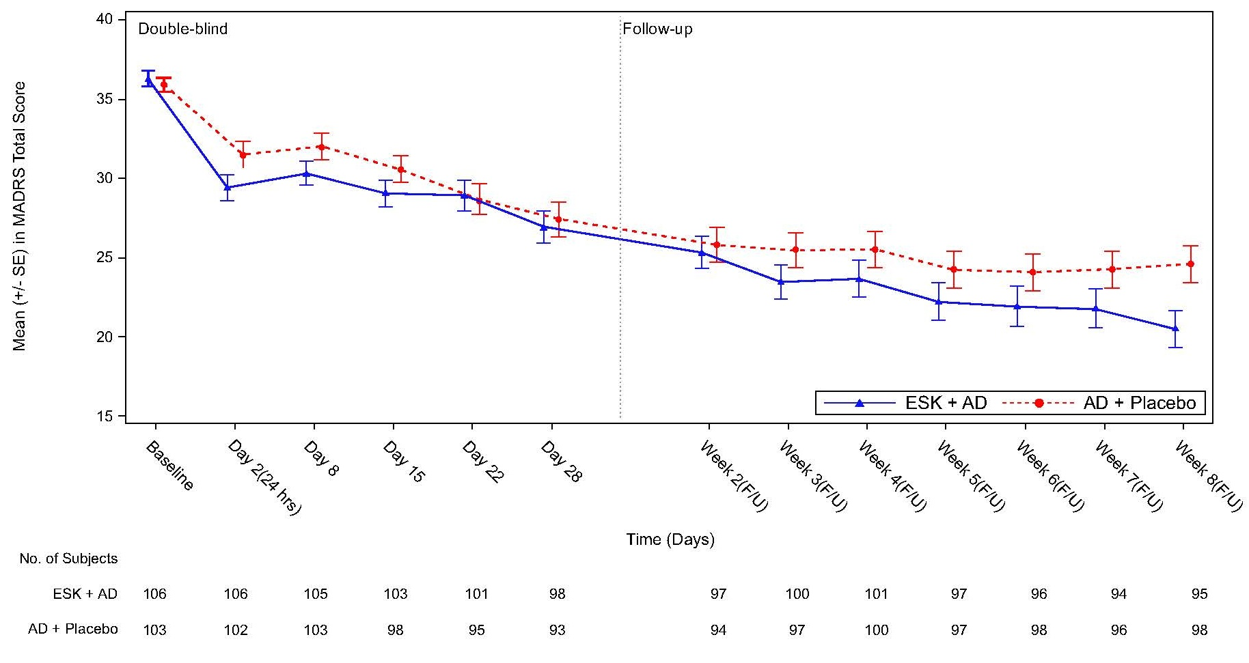
Notes: ªWeek 1 (F/U) was not included because only approximately half of the patients had this visit. For the remaining patients, Week 1 (F/U) and Day 28 visits occurred on the same day; MADRS was assessed once and was captured under Day 28. ^{b}After Day 28, esketamine and placebo were not used.
Abbreviations: AD, antidepressant; ESK, esketamine; F/U, follow-up; MADRS, Montgomery-Åsberg Depression Rating Scale; SE, standard error.

Figure S2 CGI-S frequency distribution at baseline and Day 28 during the double-blind treatment phase.
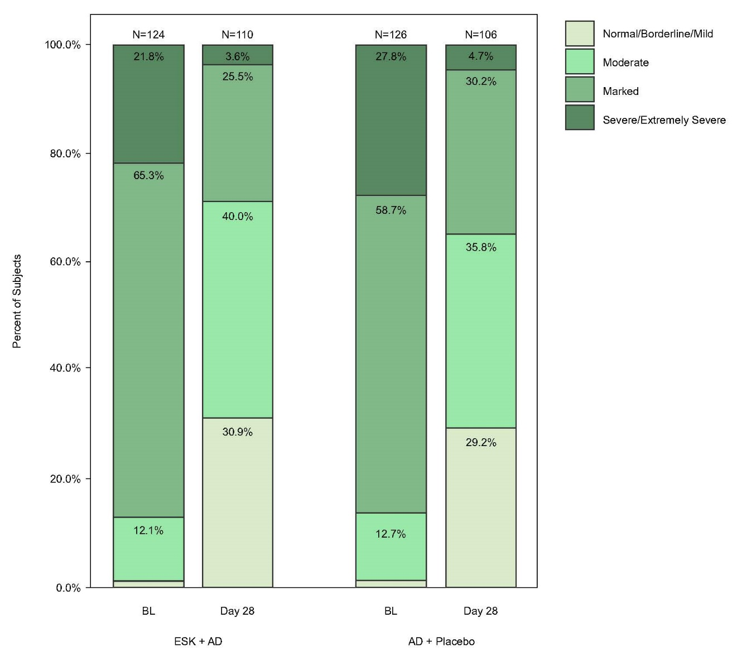
Abbreviations: AD, antidepressant; BL, baseline; CGI-S, Clinical Global Impressions of Severity; ESK, esketamine.
Figure S3 EQ-5D-5L individual dimensions: percent of patients reporting problems (Levels 2–5)ª over time during the double-blind treatment phase.
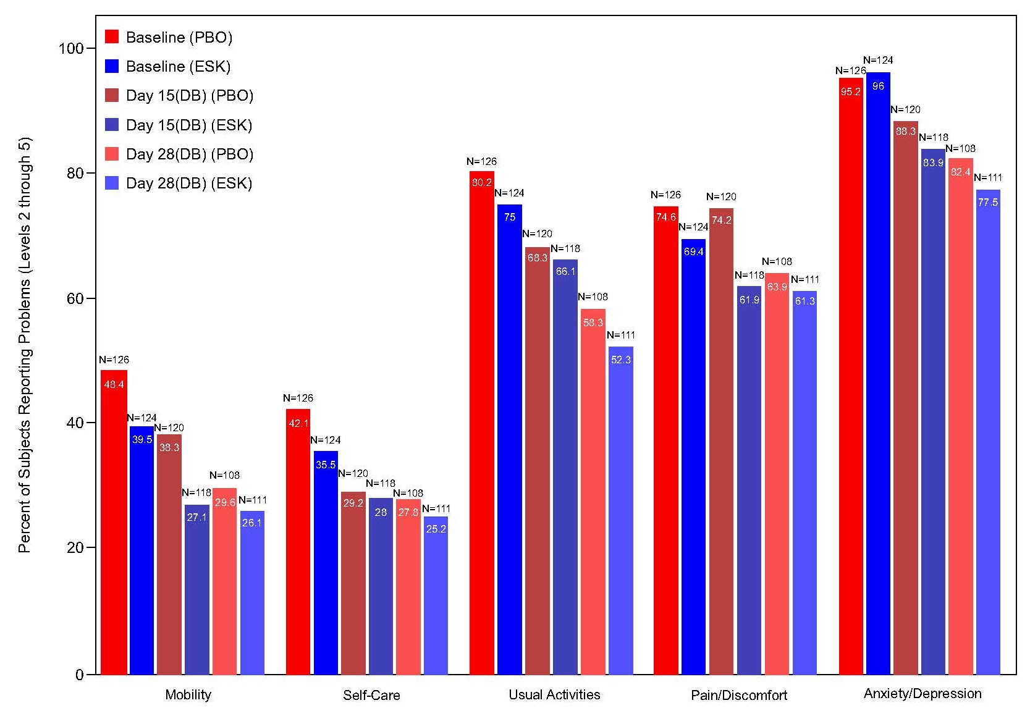
Notes: ªEach dimension is divided into 5 levels of perceived problems: Level 1 indicates no problem, Level 2, indicates slight problems, Level 3 indicates moderate problems, Level 4 indicates severe problems, and Level 5 indicates extreme problems. Percentages of patients reporting Levels 2–5 are shown.
Abbreviations: DB, double-blind; EQ-5D-5L, European Quality of Life – 5 Dimension – 5 Level; ESK, esketamine; PBO, placebo.

Figure S4 Mean systolic (A) and diastolic (B) blood pressure over time in the double-blind treatment phase.
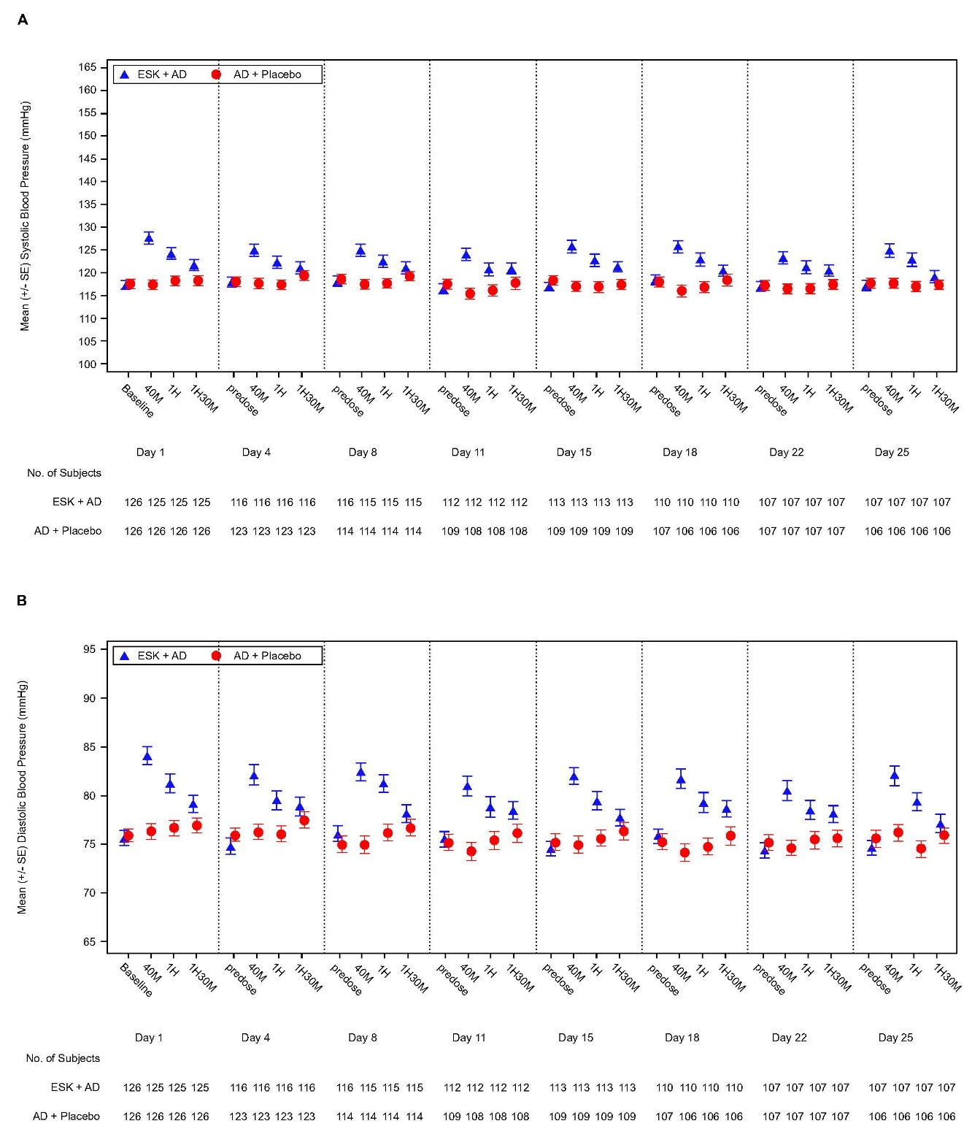
Abbreviations: AD, antidepressant; ESK, esketamine.
Figure S5 Incidence of C-SSRS scores at baseline, Day 4, and study endpoint during the double-blind treatment phase.
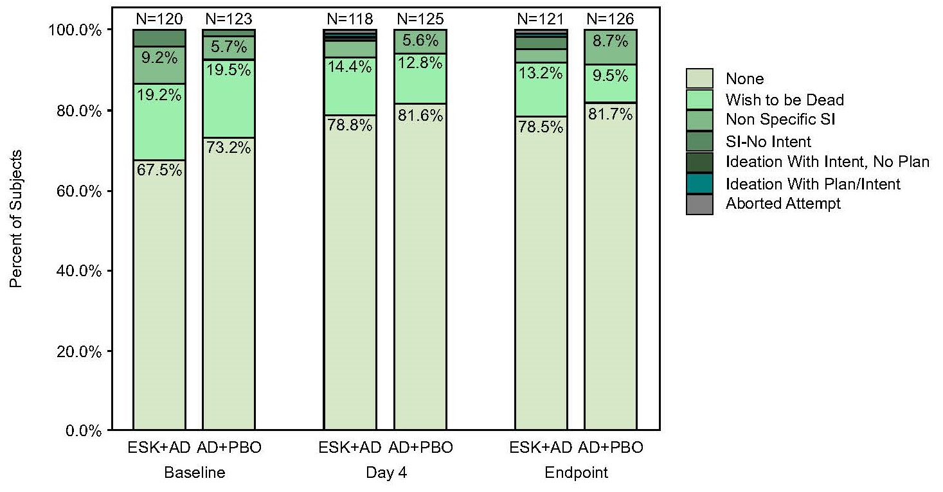

Abbreviations: AD, antidepressant; C-SSRS; Columbia Suicide Severity Rating Scale; ESK, esketamine; PBO, placebo; SI, suicidal ideation.
Figure S6 Mean CADSS total score over time during the double-blind treatment phase.
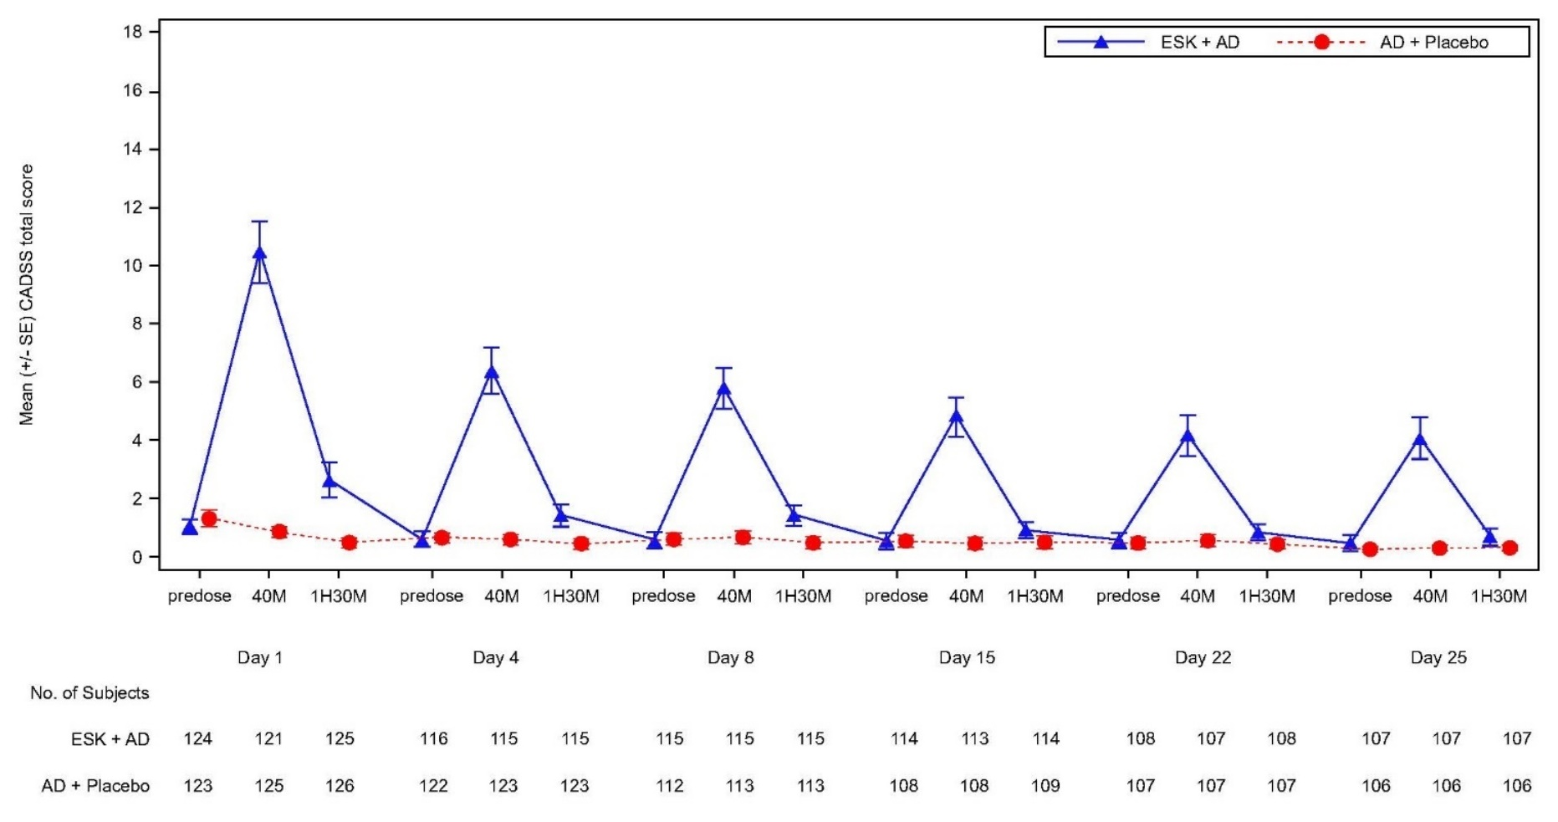

Abbreviations: AD, antidepressant; CADSS, Clinician-Administered Dissociative States Scale; ESK, esketamine.

Figure S7 Post-hoc analysis of percentage of patients with clinically meaningful improvementª in MADRS and PROs (GAD-7, EQ-5D-5L, and EQ-VAS) in the China population at Day 28.
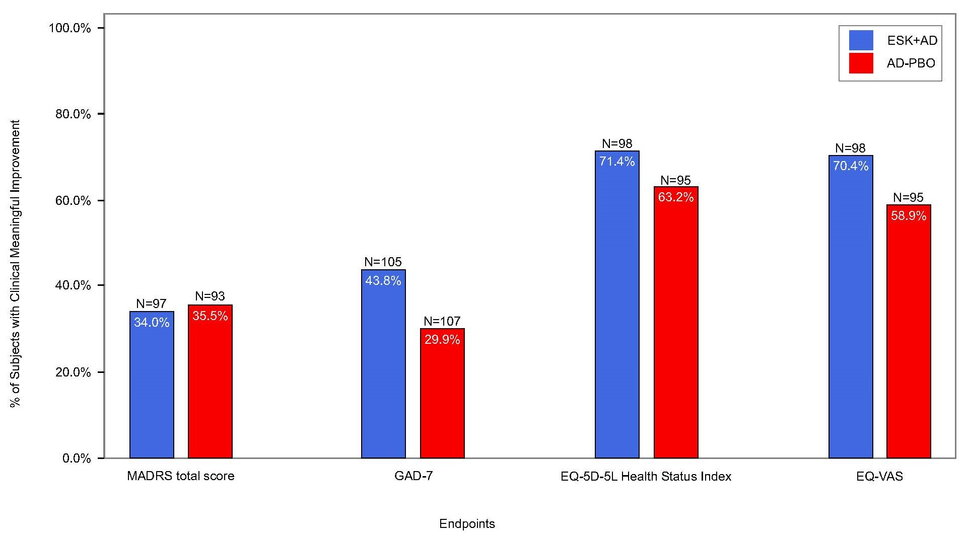
Notes: ªClinically meaningful improvement was defined as follows: MADRS total score, ≥30% reduction from baseline; GAD-7, ≥5 points improvement from baseline; EQ-5D-5L Health Status Index, ≥0.03 points improvement from baseline; and EQ-VAS, ≥7 points improvement from baseline.
Abbreviations: AD, antidepressant; EQ-5D-5L, European Quality of Life – 5 Dimension – 5 Level; EQ-VAS, European Quality of Life Visual Analogue Scale; ESK, esketamine; GAD-7, 7-Item Generalized Anxiety Disorder Scale; MADRS, Montgomery-Åsberg Depression Rating Scale; PBO, placebo; PRO, patient-reported outcome.
Figure S8 Post-hoc analysis of LS mean change in MADRS total score over timeª based on LOCF data in the double-blind treatment phase in the China population in higher enrolling sites (>6 patients per site; 14 sites total) (A) and lower enrolling sites (≤6 patients per site; 8 sites total) (B).
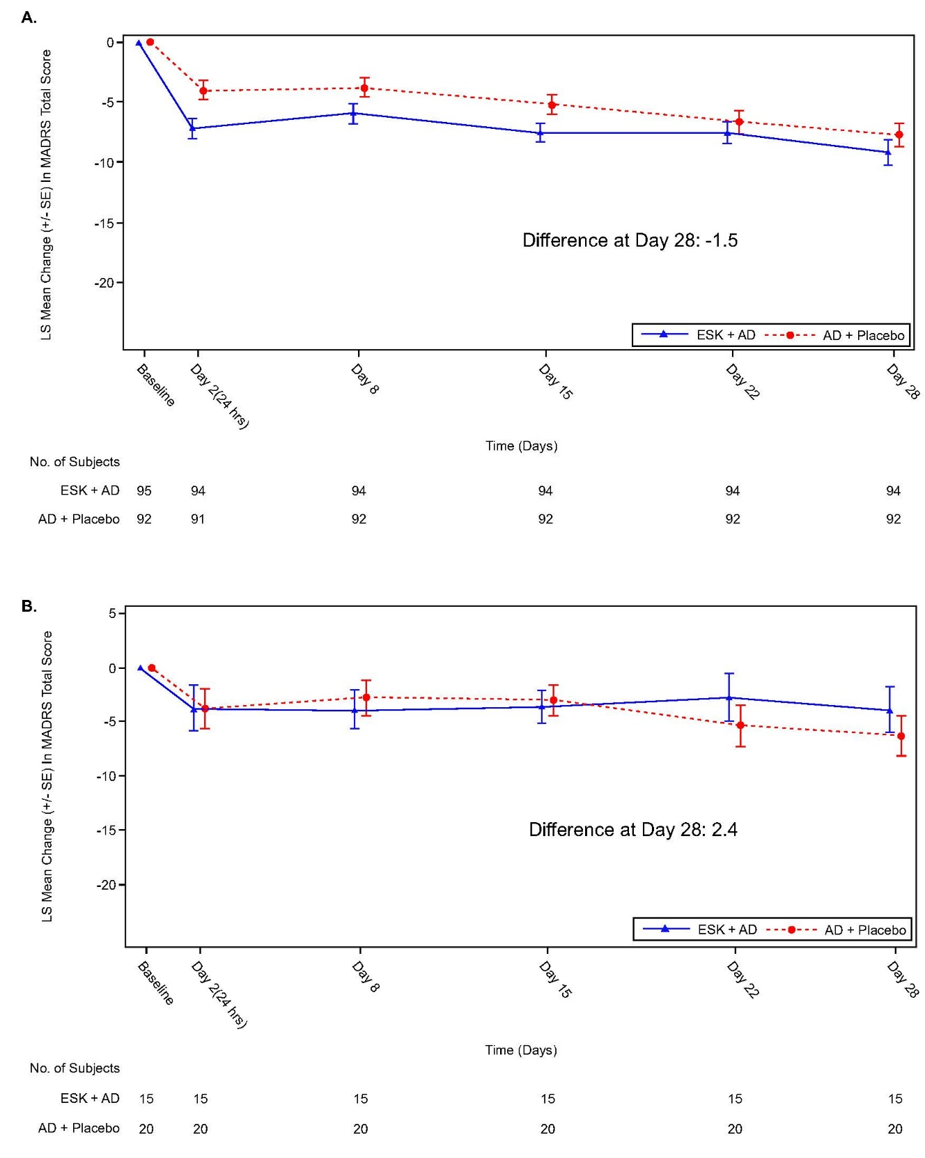
Notes: ªLS mean and SE were based on ANCOVA model with change from baseline as the response variable and factors for treatment (intranasal ESK + oral AD, oral AD + intranasal placebo), and class of oral AD (SNRI or SSRI), and baseline value as a covariate. Negative change in score indicates improvement.
Abbreviations: AD, antidepressant; ANCOVA, analysis of covariance; ESK, esketamine; LOCF, last observation carried forward; LS, least squares; MADRS, Montgomery-Åsberg Depression Rating Scale; SE, standard error; SNRI, serotonin-norepinephrine reuptake inhibitor; SSRI, selective serotonin reuptake inhibitor.

