Supplementary Material

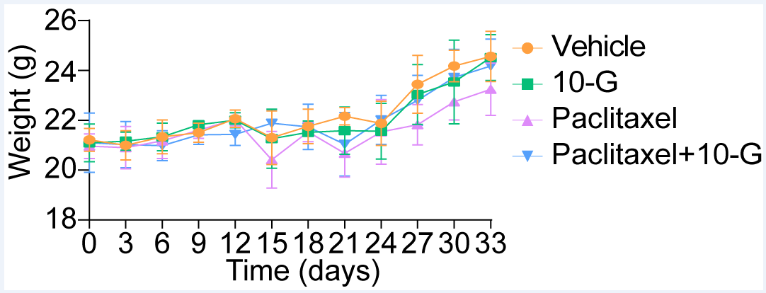
Figure S1. The body weight of mice.

