Supporting Information for
Mucoadhesive nanoparticles enhance the therapeutic effect of dexamethasone on experimental ulcerative colitis by the local administration as an enema

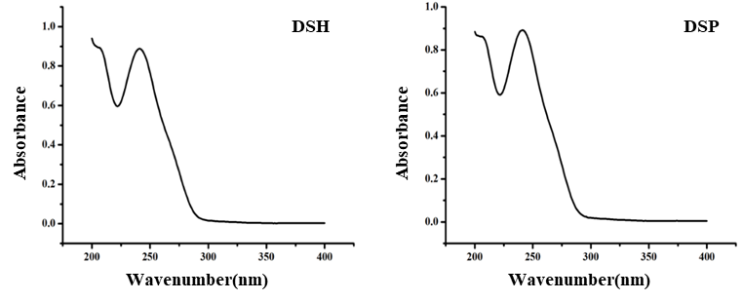
Figure S1 UV-Vis absorption spectra of dexamethasone derivatives

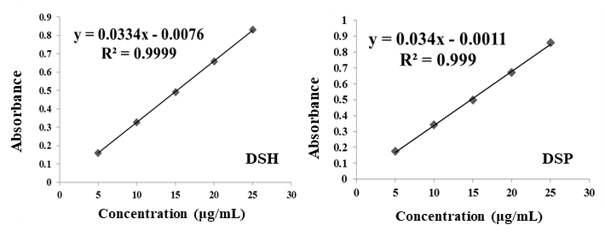
Figure S2 Standard curve for dexamethasone derivatives

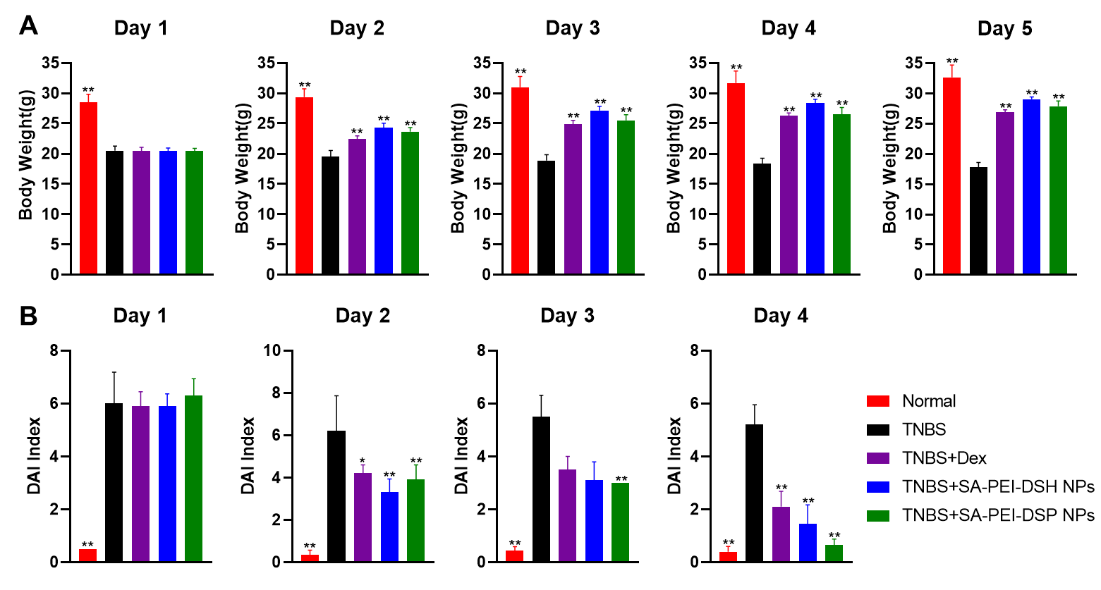
Figure S3 The daily changes in body weights (A) and DAI indexes (B). **p < 0.01, *p < 0.05: significantly different from the TNPS-treated group, mean ± SD, n = 10.
Table S1 Recovery and precision for DSH determination by UV spectroscopy
Concentration  (mg/mL) | Recovery  (%) | RSD within-day  (%) | RSD between-day (%)
0.005 | 100.59 ± 0.52 | 0.005 | 0.65
0.015 | 100.20 ± 0.63 | 0.015 | 0.56
0.025 | 99.64 ± 0.55 | 0.025 | 0.74

Table S2 Recovery and precision for DSP determination by UV spectroscopy
Concentration  (mg/mL) | Recovery  (%) | RSD within-day  (%) | RSD between-day  (%)
0.005 | 100.32 ± 0.31 | 0.46 | 0.29
0.015 | 99.76 ± 0.27 | 0.58 | 0.63
0.025 | 100.35 ± 0.58 | 0.37 | 0.51

Table S3 Effects of concentration changes of DSH and DSP on the particle sizes, Zeta potential, and PDI of different PEI-DDs NPs (Mean ± SD, n=3)
Concentration (mg/mL) | Particle Size  (nm) | Zeta Potential  (mV) | PDT
PEI-DSH NPs
5 | 319.23±6.65 | 47.52±1.52 | 0.46±0.010
10 | 238.13±4.95 | 35.83±1.14 | 0.34±0.010
15 | 211.47±4.76 | 34.57±2.11 | 0.26±0.020
20 | 142.33±1.98 | 28.030±0.95 | 0.21±0.010
PEI-DSP NPs
5 | 44.97±6.05 | 49.80±1.32 | 0.42±0.030
10 | 43.65±3.52 | 44.10±0.59 | 0.38±0.010
15 | 32.50±0.36 | 41.37±1.31 | 0.31±0.070
20 | 18.54±0.040 | 37.47±0.68 | 0.17±0.020

Table S4 Effects of pH values on particle size, potential, and PDI of different PEI-DDs NPs
(Mean ± SD, n=3)
pH values | Particle Size  (nm) | Zeta Potential  (mV) | PDT
PEI-DSH NPs
pH5 | 280.67±3.07 | 50.17±1.34 | 0.37±0.010
pH7 | 86.010±1.63 | 36.90±0.43 | 0.23±0.010
pH9 | 184.10±1.16 | 30.23±1.82 | 0.18±0.010
PEI-DSP NPs
pH5 | 62.51±0.24 | 56.97±1.06 | 0.36±0.080
pH7 | 43.030±5.42 | 54.70±1.00 | 0.28±0.010
pH9 | 43.64±3.52 | 49.80±1.32 | 0.17±0.10

Table S5 Effects of PEI molecular weight on the preparation of different PEI-DDs NPs
(Mean ± SD, n=3)
PEI-DDs NPs | PEI molecular weight | Particle Size  (nm) | Zeta Potential  (mV) | PDI
PEI-DSH-NPs | 1800 | 27600 ± 4200 | 16.24 ± 0.39 | 0.75 ± 0.23
PEI-DSH-NPs | 25000 | 156.86 ± 5.91 | 42.29± 0.74 | 0.27 ± 0.0020
PEI-DSP-NPs | 1800 | 2534 ± 376.92 | 29.93 ± 0.56 | 0.91 ± 0.030
PEI-DSP-NPs | 25000 | 48.92 ± 0.65 | 44.37 ± 0.43 | 0.14 ± 0.0020

Table S6 Effects of SA concentration on the preparation of different SA-PEI-DDs NPs
(Mean ± SD, n=3)
SA-PEI-DDs NPs | SA concentration  (mg/mL) | Particle Size  (nm) | Zeta Potential  (mV) | PDI
SA-PEI-DSH NPs | 0.5 | 192.78 ± 18.46 | -40.56 ± 0.27 | 0.26 ± 0.005
SA-PEI-DSH NPs | 1 | 236.14 ± 5.93 | -44.21 ± 0.73 | 0.33 ± 0.002
SA-PEI-DSH NPs | 2 | 266.58 ± 22.06 | -47.82 ± 0.92 | 0.45 ± 0.006
SA-PEI-DSP NPs | 0.5 | 102.42 ± 5.67 | -43.68 ± 0.25 | 0.23 ± 0.026
SA-PEI-DSP NPs | 1 | 185.72 ± 4.58 | -45.16 ± 0.82 | 0.38 ± 0.017
SA-PEI-DSP NPs | 2 | - | - | Precipitation

Table S7 Effect of PEI and SA feed concentration ratio on the preparation of different
SA-PEI-DDs NPs (Mean ± SD, n=3)
SA-PEI-DDs NPs | CSA : CPEI | Particle Size  (nm) | Zeta Potential  (mV) | PDI
SA-PEI-DSH NPs | 0.5:1 | - | - | Precipitation
SA-PEI-DSH NPs | 1:1 | 192.83 ± 0.75 | -35.76 ± 0.36 | 0.28 ± 0.0020
SA-PEI-DSH NPs | 2:1 | 245.87 ± 7.92 | -38.34 ± 0.47 | 0.47 ± 0.0030
SA-PEI-DSP NPs | 0.5:1 | 89.18 ± 0.25 | -39.10 ± 0.15 | 0.20 ± 0.0010
SA-PEI-DSP NPs | 1:1 | 104.29 ± 0.68 | -35.67 ± 0.82 | 0.24 ± 0.0070
SA-PEI-DSP NPs | 2:1 | 303.63 ± 1.49 | -39.70± 0.34 | 0.22 ± 0.0050

