Supplementary materials.
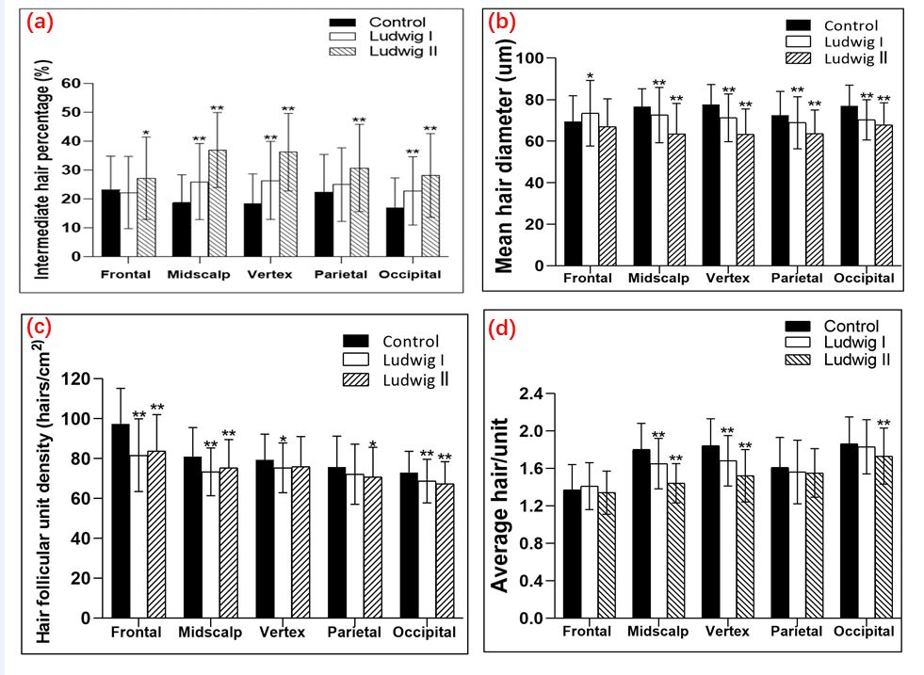
Supplementary 1. The intermediate hair percentage, mean hair diameter, hair follicular unit density and average hair/unit of FPHL subjects and healthy controls across different scalp areas. (a). Compared with healthy controls, the midscalp, vertex, occipital as well as parietal sites showed a tendency of increasing intermediate hair percentage when Ludwig staging was advanced. The frontal area had the lowest middle hair rate in Ludwig I patients. (b). Mean hair diameter across all areas of the scalp (except for frontal) tended to decrease when severity of Ludwig increased compared with normal controls. (c). As for hair follicular unit density, the frontal, midscalp as well as occipital areas had statistically significant decreases for Ludwig I and Ludwig II (p<0.01). Vertex and parietal areas only demonstrated significant statistically significant differences in Ludwig I (P=0.01) and Ludwig II (P=0.03), respectively. (d). The average hair/unit of FPHL subjects and healthy controls across different scalp areas. Compared with healthy controls, vertex and midscalp areas showed statistically significant differences in Ludwig I and Ludwig II (P<0.01) groups, decreasing with severity of Ludwig stage. On the occipital site, significant differences were found only in Ludwig II (P=0.003) group. Parietal and frontal areas had no statistically significant differences neither in Ludwig I nor Ludwig II patients. (** represented P < 0.01, *represented P < 0.05, Ludwig I or Ludwig II VS normal controls at the same scalp area).
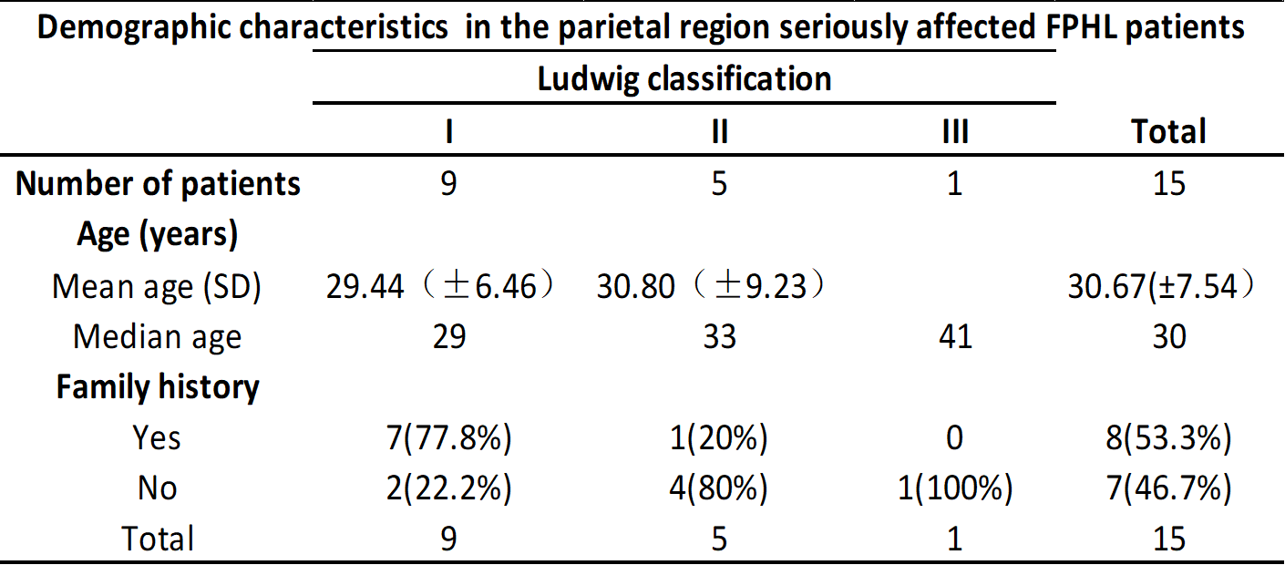
Supplementary 2. FPHL female pattern hair loss; SD standard deviation

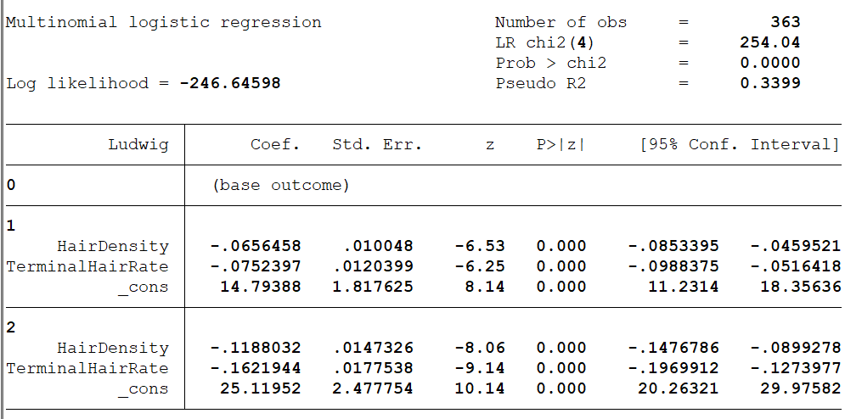
Supplementary 3. multi-logistic regression results in Ludwig classification of FPHL.
( Hair density and terminal hair rate means parameters in the midscalp area）.

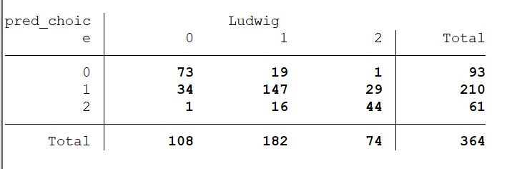
Supplementary 4. Confusion matrix for the multi-logistic regression in the Ludwig classification of FPHL.

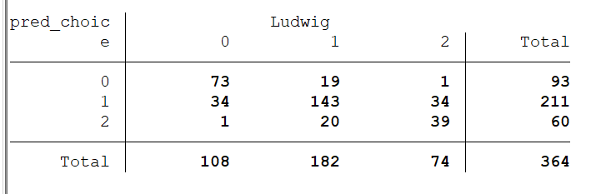
Supplementary 5. Confusion matrix for the multi-logistic regression with 10-fold cross-validation
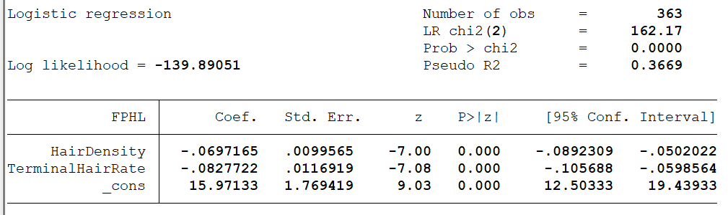
Supplementary 6. Logistic regression results in binary classification of FPHL.

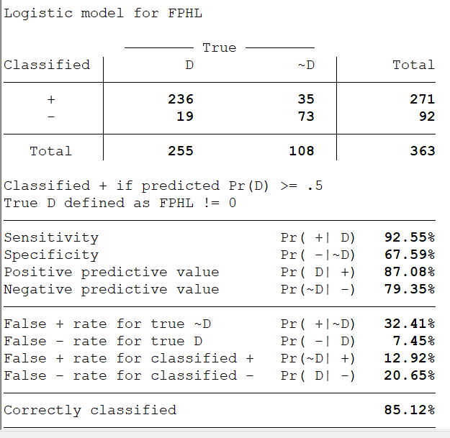
Supplementary 7. Confusion and relevant metrics for logistic regression in binary classification of FPHL.

