Materials and Methods
In vitro drug sensitivity assay
The Bleomycin, Simvastatin and Zoledronate were transfected into Huh-1 and Hep3b cells. Briefly, 5*10³ cell were seeded into 96-well plate and medium containing drugs
was added into each well. Then, the cells were treated with Bleomycin (0, 0.5, 1, 2, 4, 8, 16, 32, 64 and 128 μM/L), Simvastatin (0, 1, 2, 4, 8, 16, 32, 64 and 128 μM/L) or Zoledronate (0, 1, 2, 4, 8, 16, 32, 64 and 128 μM/L). Finally, the Cell Counting Kit-8 (CCK8) assay was performed. The inhibition rates and IC50 values were then calculated.
Supplementary Figures

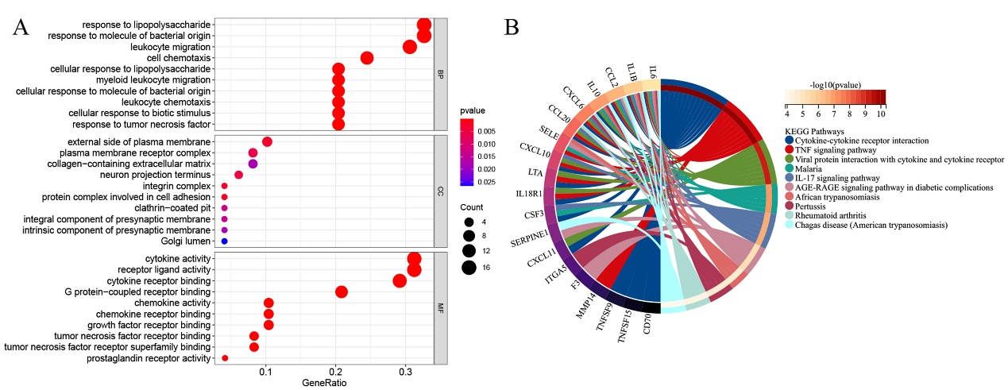
Figure S1. Kyoto Encyclopedia of Genes and Genomes (KEGG) and Gene Ontology (GO) analysis for 49 overlapped differentially expressed genes in TCGA. (A). GO data. (B). KEGG pathways.

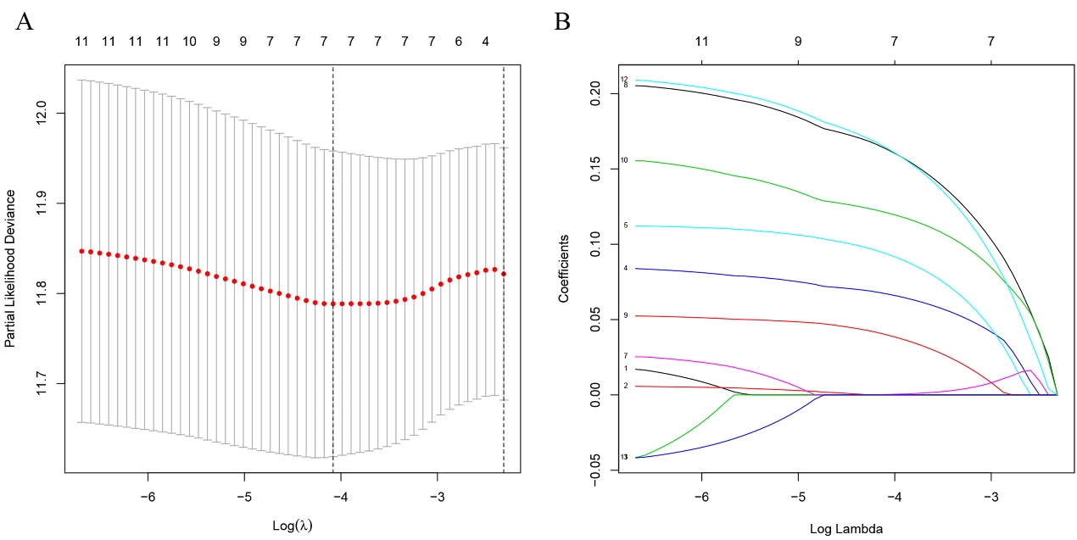
Figure S2. Constructed a seven-gene model from the TCGA cohort. (A) LASSO coefficient expression profiles of 11 candidate genes. (B)The penalty parameter (λ) in the LASSO model was selected through ten cross-validation.
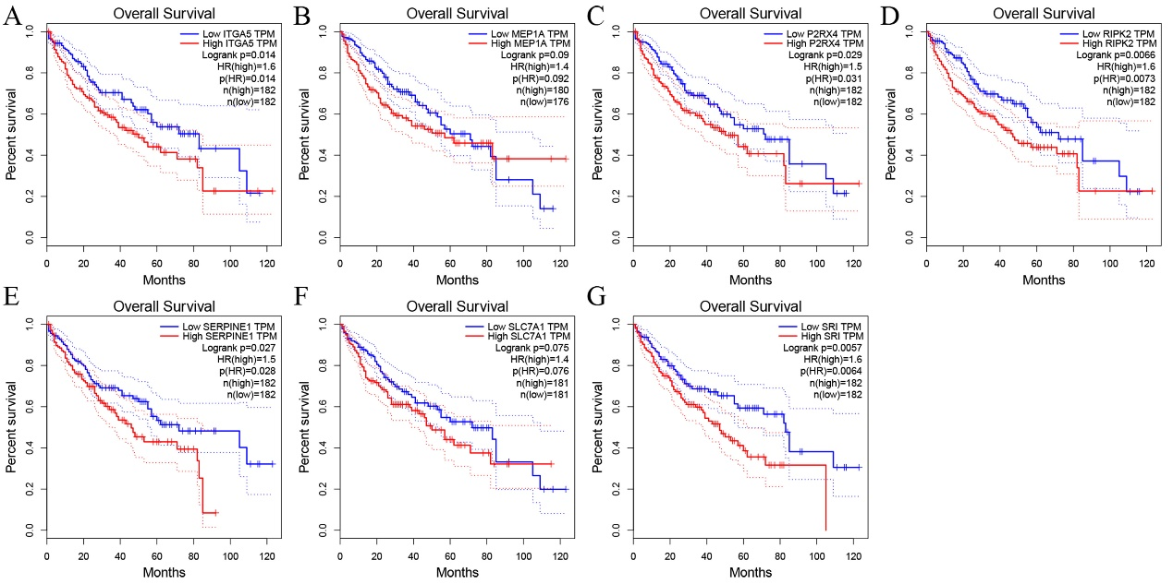
Figure S3. Kaplan-Meier analysis of the ITGA5(A), MEP1A(B), P2RX4(C), RIPK2(D), SERPINE1(E), SLC7A1(F) and SRI(G) gene different expression levels for overall survival with HCC patients (red: high, blue: low) in TCGA.
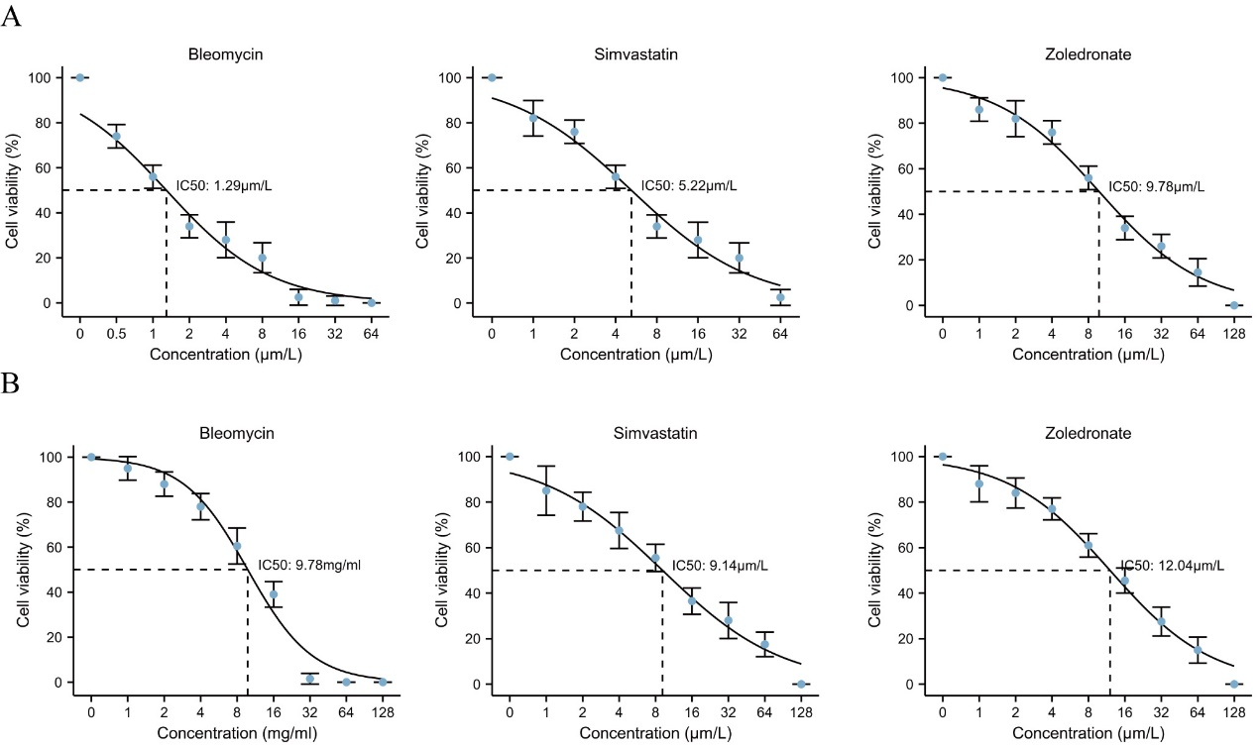
Figure S4. Bleomycin, Simvastatin and Zoledronate regulates drug sensitivity of HCC cell lines. (A) The IC50 value of Huh-1 cell after 3 drugs treatment was 1.29, 5.22 and 9.78μm/L. (B) The IC50 value of Hep3b cell after 3 drugs treatment was 9.78, 9.14, 12.04 μm/L.
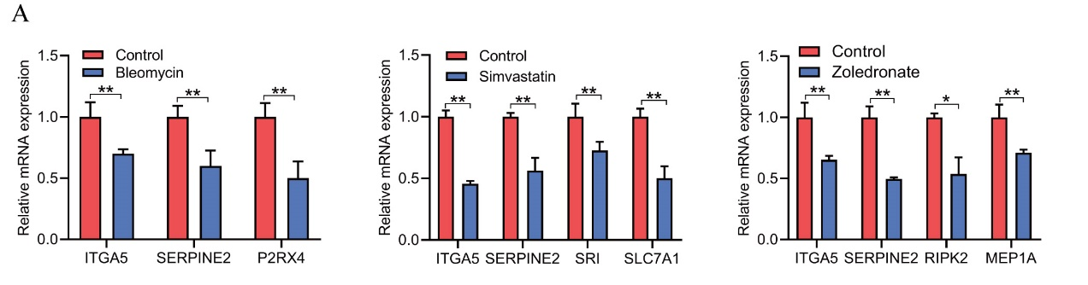
Figure S5. Bleomycin, Simvastatin and Zoledronate regulated 7 genes expression in HCC cells. (A). The expression levels of ITGA5, SERPINE2 and P2RX4 were examined after Bleomycin treatment. (B). The expression levels of ITGA5, SERPINE2 SRI and SLC7A1 were examined after Bleomycin treatment. (C). The expression levels of ITGA5, SERPINE2, RIPK2 and MEP1A were detected after Zoledronate. *P < 0.05, **P < 0.01.

Supplementary Table 1. Potential drugs involved in HCC from TCGA.
Gene | Drug | cor | pvalue
ITGA5 | Bleomycin | -0.496035 | 5.57E-05
SERPINE1 | Tamoxifen | 0.48479 | 9.98E-05
SERPINE1 | Vorinostat | 0.47973 | 0.000121
SERPINE1 | Bleomycin | -0.461649 | 0.000205
ITGA5 | Zoledronate | -0.449141 | 0.000405
SERPINE1 | Lenvatinib | -0.433004 | 0.000858
SERPINE1 | Nilotinib | 0.42014 | 0.000924
RIPK2 | Pipobroman | 0.41603 | 0.000946
MEP1A | Zoledronate | -0.436305 | 0.001538
ITGA5 | Idelalisib | -0.401234 | 0.001799
SRI | Mithramycin | 0.38228 | 0.002576
SERPINE1 | Midostaurin | -0.380173 | 0.002733
SERPINE1 | Dasatinib | -0.381913 | 0.002838
RIPK2 | Lomustine | 0.38045 | 0.002955
ITGA5 | Simvastatin | -0.448673 | 0.003258
RIPK2 | DECITABINE | 0.41948 | 0.003335
RIPK2 | Nelarabine | 0.38077 | 0.003791
ITGA5 | RAPAMYCIN | -0.364466 | 0.004197
SERPINE1 | Estramustine | 0.36666 | 0.004285
SRI | Paclitaxel | 0.3608 | 0.004626
ITGA5 | Tamoxifen | 0.36369 | 0.004633
SERPINE1 | Paclitaxel | 0.35844 | 0.004922
SERPINE1 | Pazopanib | -0.360919 | 0.004981
RIPK2 | Carmustine | 0.35593 | 0.005253
SERPINE1 | Simvastatin | -0.425929 | 0.005494
SLC7A1 | Simvatatin | -0.354594 | 0.005859
ITGA5 | Gemcitabine | -0.351419 | 0.005901
ITGA5 | LDK-378 | 0.35703 | 0.005938
SRI | Fluorouracil | 0.35092 | 0.005976
SLC7A1 | Erlotinib | 0.35376 | 0.005984
RIPK2 | Melphalan | 0.35037 | 0.006061
P2RX4 | Eribulin mesilate | 0.34816 | 0.006411
SRI | Tegafur | 0.34681 | 0.007652
MEP1A | Tegafur | -0.345502 | 0.0079
ITGA5 | Cabozantinib | -0.345482 | 0.007904
ITGA5 | Rapamycin | -0.347334 | 0.008116
P2RX4 | Cladribine | -0.340588 | 0.008301
SERPINE1 | VINORELBINE | 0.34615 | 0.008351
P2RX4 | Ponatinib | 0.33935 | 0.008556
RIPK2 | Etoposide | 0.33603 | 0.008667
ITGA5 | IPI-145 | -0.341558 | 0.00869
SERPINE1 | Zoledronate | -0.340159 | 0.008986
ITGA5 | Temsirolimus | -0.336961 | 0.009696
RIPK2 | Tamoxifen | 0.32968 | 0.010777
P2RX4 | brigatinib | 0.32911 | 0.010921
ITGA5 | Cisplatin | -0.325033 | 0.011279
SERPINE1 | RAPAMYCIN | -0.323551 | 0.011678
RIPK2 | DACARBAZINE | 0.32142 | 0.012274
RIPK2 | Teniposide | 0.31707 | 0.013572
RIPK2 | Asparaginase | 0.31435 | 0.014441
P2RX4 | Vorinostat | -0.31344 | 0.015635
RIPK2 | Cyclophosphamide | 0.35009 | 0.015848
SERPINE1 | Vemurafenib | 0.31251 | 0.015963
SRI | Simvastatin | -0.371478 | 0.016787
RIPK2 | Thiotepa | 0.30589 | 0.017459
RIPK2 | Bendamustine | 0.31777 | 0.01807
SERPINE1 | Selumetinib | 0.30528 | 0.018715
P2RX4 | Carfilzomib | 0.3046 | 0.018996
P2RX4 | Vinorelbine | 0.30967 | 0.019072
SERPINE1 | Abiraterone | -0.368409 | 0.019331
P2RX4 | Dasatinib | 0.30327 | 0.019549
ITGA5 | JNJ-42756493 | -0.307509 | 0.019971
P2RX4 | Gemcitabine | -0.299282 | 0.02018
P2RX4 | Bleomycin | -0.301198 | 0.02044
ITGA5 | Everolimus | -0.301058 | 0.020502
SERPINE1 | JNJ-42756493 | -0.305809 | 0.020702
ITGA5 | Midostaurin | -0.296269 | 0.021534
RIPK2 | DAUNORUBICIN | 0.29795 | 0.021906
SERPINE1 | Dabrafenib | 0.31915 | 0.022446
RIPK2 | Dexamethasone Decadron | 0.33556 | 0.024229
P2RX4 | Depsipeptide | 0.28814 | 0.025576
P2RX4 | Fulvestrant | -0.292155 | 0.026058
MEP1A | Paclitaxel | -0.286965 | 0.026212
RIPK2 | Triethylenemelamine | 0.28673 | 0.026343
SERPINE1 | MITOXANTRONE | -0.285961 | 0.026765
SRI | Isotretinoin | 0.28789 | 0.02703
ITGA5 | MITOXANTRONE | -0.285115 | 0.027238
ITGA5 | Palbociclib | 0.28591 | 0.02815
SERPINE1 | Homoharringtonine | 0.32002 | 0.028314
SERPINE1 | Tegafur | 0.28807 | 0.02832
MEP1A | Megestrol acetate | -0.28802 | 0.028348
SERPINE1 | Raloxifene | 0.28534 | 0.028479
SERPINE1 | Crizotinib | 0.28501 | 0.028673
RIPK2 | Uracil mustard | 0.28238 | 0.028818
SRI | pralatrexate | -0.289223 | 0.029104
SLC7A1 | Gefitinib | 0.28403 | 0.029251
ITGA5 | Pazopanib | -0.283967 | 0.029286
RIPK2 | Irinotecan | 0.28119 | 0.029526
SRI | Actinomycin D | 0.28064 | 0.029861
RIPK2 | Paclitaxel | 0.27828 | 0.031322
SLC7A1 | Pipamperone | -0.280077 | 0.031675
MEP1A | Dasatinib | 0.28001 | 0.031716
ITGA5 | NMS-E628 | 0.28132 | 0.032417
SERPINE1 | Everolimus | -0.276889 | 0.033752
RIPK2 | Zoledronate | -0.279237 | 0.033776
RIPK2 | Raltitrexed | 0.29483 | 0.033858
P2RX4 | Mithramycin | 0.2724 | 0.035235
SRI | Digoxin | 0.28191 | 0.035295
RIPK2 | Doxorubicin | 0.27176 | 0.035685
RIPK2 | Sonidegib | -0.273091 | 0.036373
SLC7A1 | Fludarabine | -0.277858 | 0.036375
RIPK2 | Chlorambucil | 0.2706 | 0.036516
SERPINE1 | Panobinostat | 0.27262 | 0.036711
SERPINE1 | Cobimetinib (isomer 1) | 0.27497 | 0.036712
RIPK2 | Carboplatin | 0.26908 | 0.037624
SERPINE1 | Ixabepilone | 0.28562 | 0.038157
RIPK2 | BMN-673 | 0.2725 | 0.038505
SLC7A1 | Sonidegib | 0.26972 | 0.038839
P2RX4 | 7-Ethyl-10-hydroxycamptothecin | -0.266411 | 0.039634
SLC7A1 | Acalabrutinib | 0.27077 | 0.039799
RIPK2 | Nitrogen mustard | 0.26254 | 0.042707
RIPK2 | Arsenic trioxide | 0.26213 | 0.044897
ITGA5 | Tegafur | 0.26414 | 0.045117
ITGA5 | Olaparib | -0.270042 | 0.046164
RIPK2 | TYROTHRICIN | 0.26053 | 0.046274
ITGA5 | Abiraterone | -0.31687 | 0.046351
SERPINE1 | Fulvestrant | 0.26241 | 0.046595
SERPINE1 | Belinostat | 0.25891 | 0.047695
MEP1A | Cabozantinib | 0.26113 | 0.047716
RIPK2 | Epirubicin | 0.26307 | 0.048033
SRI | Docetaxel | 0.28158 | 0.049996

Supplementary Table 2. Primers for Real-Time PCR
Name | Sequences
ITGA5 sense: | 5'- AGAGCTACGGGCCA AGCTAA -3'
ITGA5 antisense: | 5'- TTCCCCATAAAGTTTGGTCCAC -3'
MEP1A sense: | 5'- TTTACCTTGCTTTTTGCCCACA -3'
MEP1A antisense: | 5'- TGTCCCCTTGAAAGAGGTCCA -3'
P2RX4 sense: | 5'- ACAACGTGTCTCCTGGCTACAAT -3'
P2RX4 antisense: | 5'- GTCAAACTTGCCAGCCTTTCC -3'
RIPK2 sense: | 5'- TCAAGGGCCAGTATCAAGCACGA -3'
RIPK2 antisense: | 5'- ATCATACGTGCTCGGTGAGGT -3'
SERPINE1 sense: | 5'-TGCTGGTGAATGCCCTCTACT-3'
SERPINE1 antisense: | 5'-CGGTCATTCCCAGGTTCTCTA-3'
SLC7A1 sense: | 5'-TCTCCAAAGGAGGTTACCTGC-3'
SLC7A1 antisense: | 5'-AGACTCCCCTCAGTAAAGTGAC-3'
SRI sense: | 5'-GCACCAGCGGGAAGATCA -3'
SRI antisense: | 5'-TGAGAGCCCTCAGTTTGACACA-3'
ACTB sense: | 5'-TCCCTGGAGAAGAGCTACGA-3'
ACTB antisense: | 5'-AGCACTGTGTTGGCGTACAG-3'

Supplementary Table 3. Potential drugs involved in HCC from TCGA.
Gene Symbol | Gene Description
ABCA1 | ATP binding cassette subfamily A member 1
ABI1 | abl interactor 1
ACVR1B | activin A receptor type 1B
ACVR2A | activin A receptor type 2A
ADM | adrenomedullin
ADORA2B | adenosine A2b receptor
ADRM1 | adhesion regulating molecule 1
AHR | aryl hydrocarbon receptor
APLNR | apelin receptor
AQP9 | aquaporin 9
ATP2A2 | ATPase sarcoplasmic/endoplasmic reticulum Ca2+ transporting 2
ATP2B1 | ATPase plasma membrane Ca2+ transporting 1
ATP2C1 | ATPase secretory pathway Ca2+ transporting 1
AXL | AXL receptor tyrosine kinase
BDKRB1 | bradykinin receptor B1
BEST1 | bestrophin 1
BST2 | bone marrow stromal cell antigen 2
BTG2 | BTG anti-proliferation factor 2
C3AR1 | complement C3a receptor 1
C5AR1 | complement C5a receptor 1
CALCRL | calcitonin receptor like receptor
CCL17 | C-C motif chemokine ligand 17
CCL2 | C-C motif chemokine ligand 2
CCL20 | C-C motif chemokine ligand 20
CCL22 | C-C motif chemokine ligand 22
CCL24 | C-C motif chemokine ligand 24
CCL5 | C-C motif chemokine ligand 5
CCL7 | C-C motif chemokine ligand 7
CCR7 | C-C motif chemokine receptor 7
CCRL2 | C-C motif chemokine receptor like 2
CD14 | CD14 molecule
CD40 | CD40 molecule
CD48 | CD48 molecule
CD55 | CD55 molecule (Cromer blood group)
CD69 | CD69 molecule
CD70 | CD70 molecule
CD82 | CD82 molecule
CDKN1A | cyclin dependent kinase inhibitor 1A
CHST2 | carbohydrate sulfotransferase 2
CLEC5A | C-type lectin domain containing 5A
CMKLR1 | chemerin chemokine-like receptor 1
CSF1 | colony stimulating factor 1
CSF3 | colony stimulating factor 3
CSF3R | colony stimulating factor 3 receptor
CX3CL1 | C-X3-C motif chemokine ligand 1
CXCL10 | C-X-C motif chemokine ligand 10
CXCL11 | C-X-C motif chemokine ligand 11
CXCL6 | C-X-C motif chemokine ligand 6
CXCL9 | C-X-C motif chemokine ligand 9
CXCR6 | C-X-C motif chemokine receptor 6
CYBB | cytochrome b-245 beta chain
DCBLD2 | discoidin, CUB and LCCL domain containing 2
EBI3 | Epstein-Barr virus induced 3
EDN1 | endothelin 1
EIF2AK2 | eukaryotic translation initiation factor 2 alpha kinase 2
EMP3 | epithelial membrane protein 3
ADGRE1 | adhesion G protein-coupled receptor E1
EREG | epiregulin
F3 | coagulation factor III, tissue factor
FFAR2 | free fatty acid receptor 2
FPR1 | formyl peptide receptor 1
FZD5 | frizzled class receptor 5
GABBR1 | gamma-aminobutyric acid type B receptor subunit 1
GCH1 | GTP cyclohydrolase 1
GNA15 | G protein subunit alpha 15
GNAI3 | G protein subunit alpha i3
GP1BA | glycoprotein Ib platelet subunit alpha
GPC3 | glypican 3
GPR132 | G protein-coupled receptor 132
GPR183 | G protein-coupled receptor 183
HAS2 | hyaluronan synthase 2
HBEGF | heparin binding EGF like growth factor
HIF1A | hypoxia inducible factor 1 subunit alpha
HPN | hepsin
HRH1 | histamine receptor H1
ICAM1 | intercellular adhesion molecule 1
ICAM4 | intercellular adhesion molecule 4
ICOSLG | inducible T cell costimulator ligand
IFITM1 | interferon induced transmembrane protein...
IFNAR1 | interferon alpha and beta receptor subun...
IFNGR2 | interferon gamma receptor 2
IL10 | interleukin 10
IL10RA | interleukin 10 receptor subunit alpha
IL12B | interleukin 12B
IL15 | interleukin 15
IL15RA | interleukin 15 receptor subunit alpha
IL18 | interleukin 18
IL18R1 | interleukin 18 receptor 1
IL18RAP | interleukin 18 receptor accessory protein
IL1A | interleukin 1 alpha
IL1B | interleukin 1 beta
IL1R1 | interleukin 1 receptor type 1
IL2RB | interleukin 2 receptor subunit beta
IL4R | interleukin 4 receptor
IL6 | interleukin 6
IL7R | interleukin 7 receptor
CXCL8 | C-X-C motif chemokine ligand 8
INHBA | inhibin subunit beta A
IRAK2 | interleukin 1 receptor associated kinase 2
IRF1 | interferon regulatory factor 1
IRF7 | interferon regulatory factor 7
ITGA5 | integrin subunit alpha 5
ITGB3 | integrin subunit beta 3
ITGB8 | integrin subunit beta 8
KCNA3 | potassium voltage-gated channel subfamily A member 3
KCNJ2 | potassium inwardly rectifying channel subfamily J member 2
KCNMB2 | potassium calcium-activated channel subfamily M regulatory beta subunit 2
KIF1B | kinesin family member 1B
KLF6 | Kruppel like factor 6
LAMP3 | lysosomal associated membrane protein 3
LCK | LCK proto-oncogene, Src family tyrosine kinase
LCP2 | lymphocyte cytosolic protein 2
LDLR | low density lipoprotein receptor
LIF | LIF interleukin 6 family cytokine
LPAR1 | lysophosphatidic acid receptor 1
LTA | lymphotoxin alpha
LY6E | lymphocyte antigen 6 family member E
LYN | LYN proto-oncogene, Src family tyrosine kinase
MARCO | macrophage receptor with collagenous structure
MEFV | MEFV innate immuity regulator, pyrin
MEP1A | meprin A subunit alpha
MET | MET proto-oncogene, receptor tyrosine kinase
MMP14 | matrix metallopeptidase 14
MSR1 | macrophage scavenger receptor 1
MXD1 | MAX dimerization protein 1
MYC | MYC proto-oncogene, bHLH transcription factor
NAMPT | nicotinamide phosphoribosyltransferase
NDP | norrin cystine knot growth factor NDP
NFKB1 | nuclear factor kappa B subunit 1
NFKBIA | NFKB inhibitor alpha
NLRP3 | NLR family pyrin domain containing 3
NMI | N-myc and STAT interactor
NMUR1 | neuromedin U receptor 1
NOD2 | nucleotide binding oligomerization domain containing 2
NPFFR2 | neuropeptide FF receptor 2
OLR1 | oxidized low density lipoprotein receptor 1
OPRK1 | opioid receptor kappa 1
OSM | oncostatin M
OSMR | oncostatin M receptor
P2RX4 | purinergic receptor P2X 4
P2RX7 | purinergic receptor P2X 7
P2RY2 | purinergic receptor P2Y2
PCDH7 | protocadherin 7
PDE4B | phosphodiesterase 4B
PDPN | podoplanin
PIK3R5 | phosphoinositide-3-kinase regulatory subunit 5
PLAUR | plasminogen activator, urokinase receptor
PROK2 | prokineticin 2
PSEN1 | presenilin 1
PTAFR | platelet activating factor receptor
PTGER2 | prostaglandin E receptor 2
PTGER4 | prostaglandin E receptor 4
PTGIR | prostaglandin I2 receptor
PTPRE | protein tyrosine phosphatase receptor type E
PVR | PVR cell adhesion molecule
RAF1 | Raf-1 proto-oncogene, serine/threonine kinase
RASGRP1 | RAS guanyl releasing protein 1
RELA | RELA proto-oncogene, NF-kB subunit
RGS1 | regulator of G protein signaling 1
RGS16 | regulator of G protein signaling 16
RHOG | ras homolog family member G
RIPK2 | receptor interacting serine/threonine kinase 2
RNF144B | ring finger protein 144B
ROS1 | ROS proto-oncogene 1, receptor tyrosine kinase
RTP4 | receptor transporter protein 4
SCARF1 | scavenger receptor class F member 1
SCN1B | sodium voltage-gated channel beta subunit 1
SELE | selectin E
SELL | selectin L
SELENOS | selenoprotein S
SEMA4D | semaphorin 4D
SERPINE1 | serpin family E member 1
SGMS2 | sphingomyelin synthase 2
SLAMF1 | signaling lymphocytic activation molecule family member 1
SLC11A2 | solute carrier family 11 member 2
SLC1A2 | solute carrier family 1 member 2
SLC28A2 | solute carrier family 28 member 2
SLC31A1 | solute carrier family 31 member 1
SLC31A2 | solute carrier family 31 member 2
SLC4A4 | solute carrier family 4 member 4
SLC7A1 | solute carrier family 7 member 1
SLC7A2 | solute carrier family 7 member 2
SPHK1 | sphingosine kinase 1
SRI | sorcin
STAB1 | stabilin 1
TACR1 | tachykinin receptor 1
TACR3 | tachykinin receptor 3
TAPBP | TAP binding protein
TIMP1 | TIMP metallopeptidase inhibitor 1
TLR1 | toll like receptor 1
TLR2 | toll like receptor 2
TLR3 | toll like receptor 3
TNFAIP6 | TNF alpha induced protein 6
TNFRSF1B | TNF receptor superfamily member 1B
TNFRSF9 | TNF receptor superfamily member 9
TNFSF10 | TNF superfamily member 10
TNFSF15 | TNF superfamily member 15
TNFSF9 | TNF superfamily member 9
TPBG | trophoblast glycoprotein
VIP | vasoactive intestinal peptide

