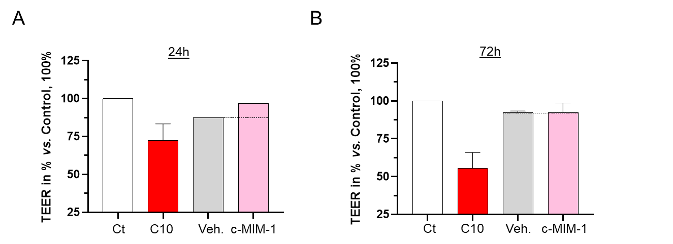Supplementary Figure S1. c-MIM-1 does not affect the intestinal permeability in a cellular intestinal model of HCoEpiC cells. (A-B) Effect of a 30 min Veh./c-MIM-1 treatment on the TEER of HCoEpiC cells, measured 24- or 72-hours later. The raw data were provided as the measures of the Ω/cm² for each triplicate and were then expressed as percentages of the untreated control conditions (Ct), set as 100%. Each dot represents the percentage values of one independent experiment, each histogram illustrating the mean ± SD obtained for each assessed condition, in 3 independent experiments (only one experiment for the Veh. and the c-MIM-1 conditions at 24 hours). The black dotted lines highlight the effect of c-MIM-1 compared with Veh.

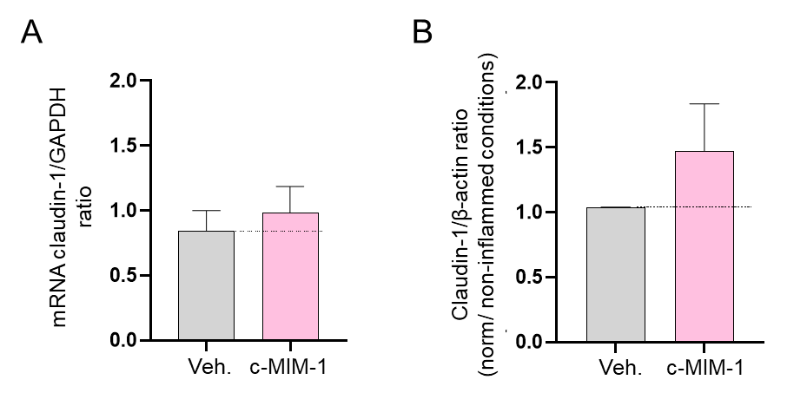Supplementary Figure S2. c-MIM-1 slightly increases the expression of claudin-1 in a cellular intestinal model of HCoEpiC cells. The expression of claudin-1 was assessed by RT-qPCR in HCoEpiC cells, after 24 hours of treatment with either the Veh. or c-MIM-1. (A) Relative expression of claudin-1 at mRNA level. The claudin-1 expression has been normalized by using the expression of the housekeeping gene GAPDH as a reference, and the histograms are standardized on the untreated control conditions, arbitrarily set at 1. The experiment has been done once; each condition was performed in triplicate. (B) The relative expression of claudin-1 at the protein level has been assessed by Western Blot in the same conditions as described above. The expression of β-actin has been used as a housekeeping gene for protein expression. The claudin-1/β-actin ratios are presented, after quantization of the Blot’s pictures performed with the use of ImageJ software. The Western Blots were run twice and the mean ratios ± SD obtained from each Blot are shown. The black dotted lines highlight the effect of c-MIM-1 compared with Veh.

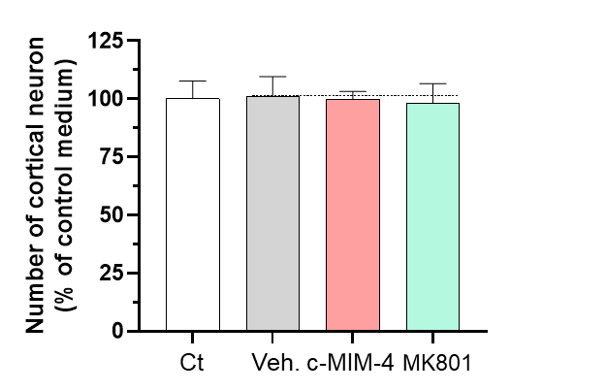
Supplementary Figure S3. c-MIM-4 does not affect the viability of rat primary cortical neurons. Effect of a 96 hours treatment with either the Veh., c-MIM-4, or MK801, on rat primary cortical neurons survival, expressed in percentage of control medium (Ct). The results are presented as the mean ± SD of n = 6 technical replicates. The black dotted line highlights the effect of c-MIM-4 compared with the Veh.

