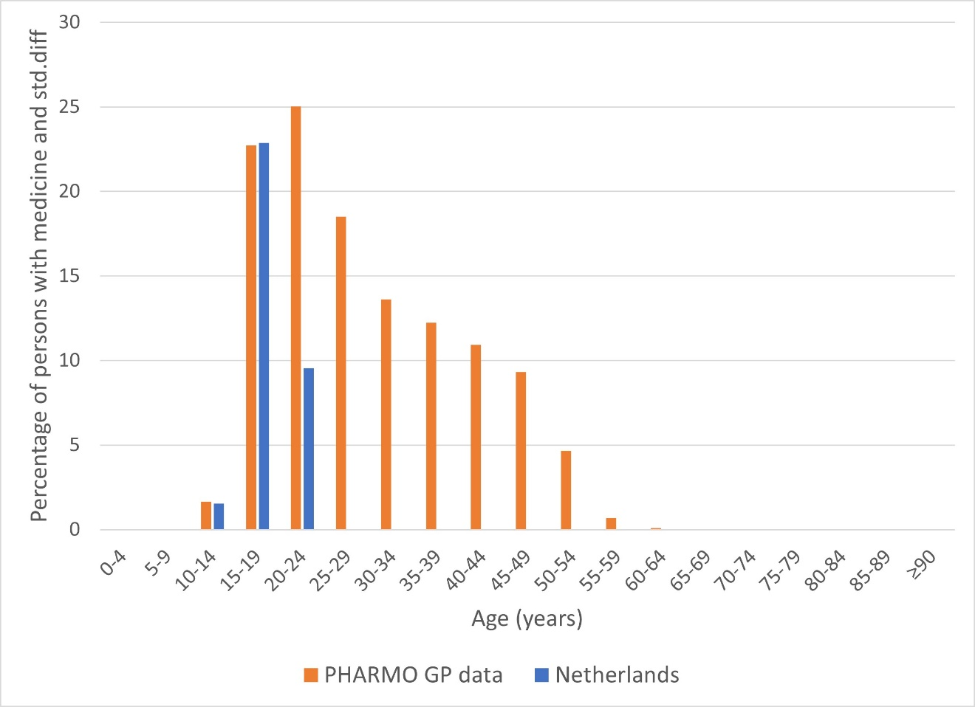Figure S1 Hormonal contraceptives for systemic use by age in the PHARMO GP data and the Netherlands in 2018

Table S1 Demographic characteristics of the population in PHARMO GP data, the Netherlands and Nivel at January 1st, 2006
 | PHARMO GP data  N = 1,410,073 | The Netherlands  N = 16,334,210 | Nivel  N = n.a. | Std.diff
 | % | % | % | GP vs NL | GP vs Nivel
Sex
males | 49.6 | 49.5 | n.a. | 0.00 | -
females | 50.4 | 50.5 | n.a. | 0.00 | -
unknown | <0.5 | 0.0 | n.a. | 0.01 | -
Age (years)
0-4 | 5.1 | 6.0 | n.a. | -0.04 | -
5-17 | 38.3 | 37.3 | n.a. | 0.02 | -
18-44 | 26.9 | 26.5 | n.a. | 0.01 | -
45-64 | 18.4 | 15.9 | n.a. | 0.07 | -
65-74 | 6.9 | 7.8 | n.a. | -0.04 | -
75-84 | 3.5 | 4.9 | n.a. | -0.07 | -
≥85 | 1.0 | 1.5 | n.a. | -0.05 | -
unknown | <0.5 | 0.0 | n.a. | 0.02 | -
Degree of urbanization
extremely urbanized | 21.8 | 19.2 | n.a. | 0.06 | -
strongly urbanized | 26.4 | 22.9 | n.a. | 0.08 | -
moderately urbanized | 20.6 | 18 | n.a. | 0.07 | -
hardly urbanized | 20.3 | 19.5 | n.a. | 0.02 | -
not urbanized | 8 | 20.4 | n.a. | -0.36 | -
unknown | 2.9 | 0.0 | n.a. | 0.24 | -
Deceased | 0.18 | 0.83 | n.a. | -0.09 | -
n.a. = not available. No information was available regarding demographic characteristics in Nivel in 2006.
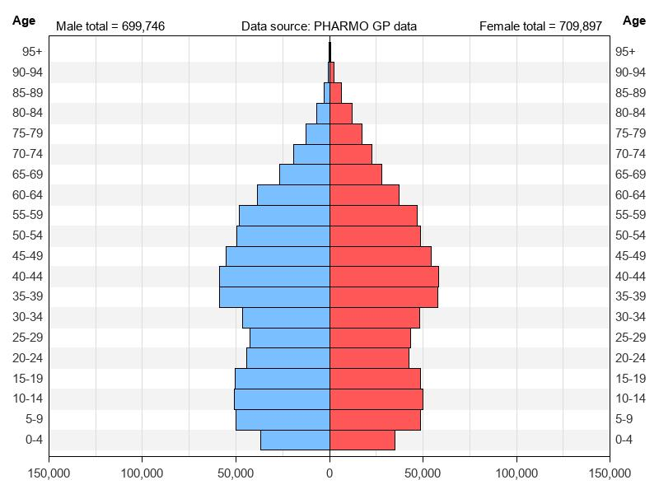
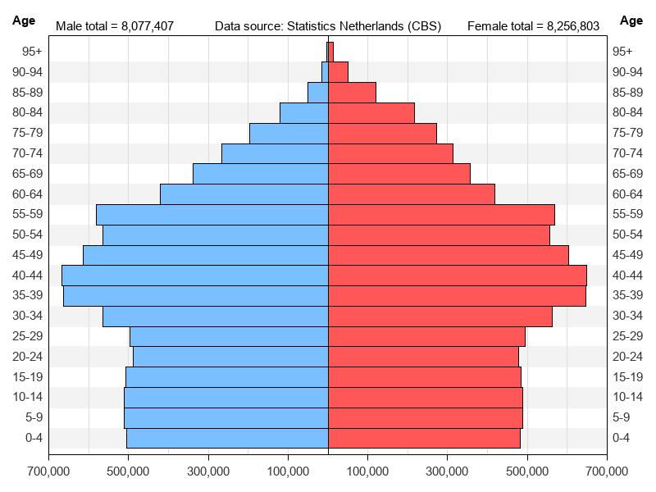
Figure S2 Population pyramid of the PHARMO GP population and the Dutch population at January 1st, 2006.

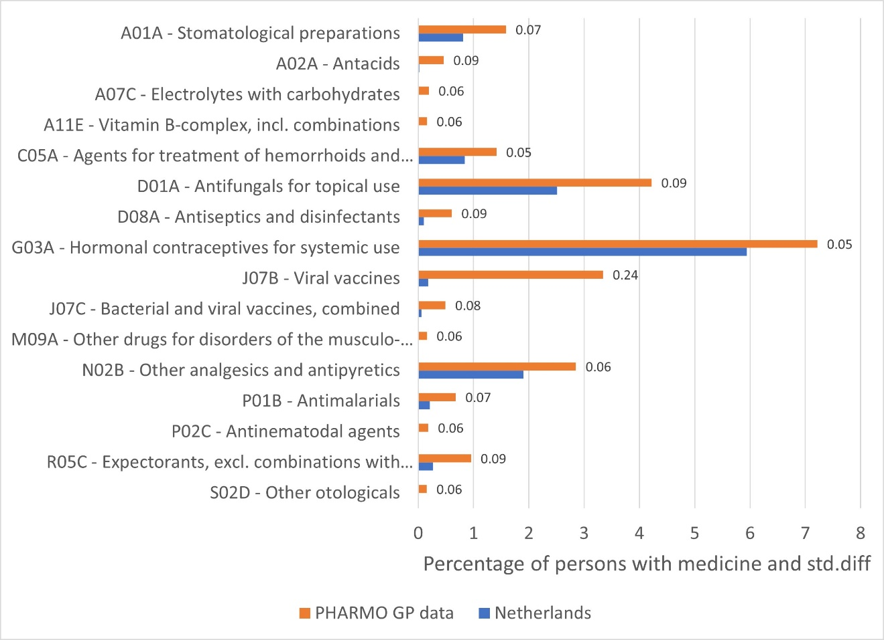 Figure S3 Medication use per pharmacological subgroup (ATC 3rd level) in the PHARMO GP data and the Netherlands in 2006 with absolute std.diff ≥0.05.

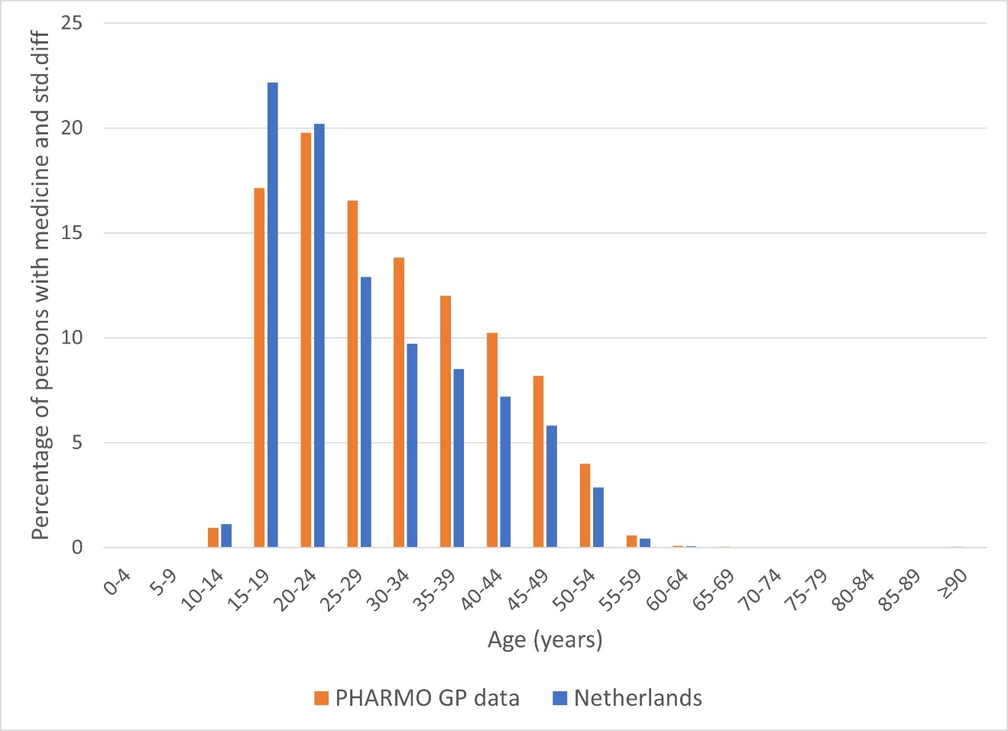Figure S4 Hormonal contraceptives for systemic use by age in the PHARMO GP data and the Netherlands in 2006

Table S2 Demographic characteristics of the population in PHARMO GP data, the Netherlands and Nivel at January 1st, 2012
 | PHARMO GP data  N = 3,182,707 | The Netherlands  N = 16,730,348 | Nivel  N = 858,788 | Std.diff
 | % | % | % | GP vs NL | GP vs Nivel
Sex
males | 49.7 | 49.5 | 49.5 | 0.00 | 0.00
females | 50.3 | 50.5 | 50.5 | 0.00 | 0.00
unknown | <0.5 | 0.0 | 0.0 | 0.01 | 0.01
Age (years)
0-4 | 4.4 | 5.5 | 5.1 | -0.05 | -0.03
5-17 | 16.4 | 15.3 | 15.5 | 0.03 | 0.02
18-44 | 36.2 | 34.9 | 34.4 | 0.03 | 0.04
45-64 | 27.9 | 28.0 | 28.0 | 0.00 | 0.00
65-74 | 9.0 | 9.1 | 10.0 | 0.00 | -0.03
75-84 | 4.6 | 5.2 | 5.5 | -0.03 | -0.04
≥85 | 1.5 | 1.9 | 2.3 | -0.03 | -0.06
unknown | <0.5 | 0.0 | 0.0 | 0.01 | 0.01
Degree of urbanization
extremely urbanized | 24.3 | 20.5 | n.a. | 0.09 | -
strongly urbanized | 23.6 | 24 | n.a. | -0.01 | -
moderately urbanized | 18.9 | 18.1 | n.a. | 0.02 | -
hardly urbanized | 20.7 | 18.6 | n.a. | 0.05 | -
not urbanized | 10.0 | 18.8 | n.a. | -0.25 | -
unknown | 2.5 | 0.0 | n.a. | 0.22 | -
Deceased | 0.28 | 0.84 | n.a. | -0.07 | -

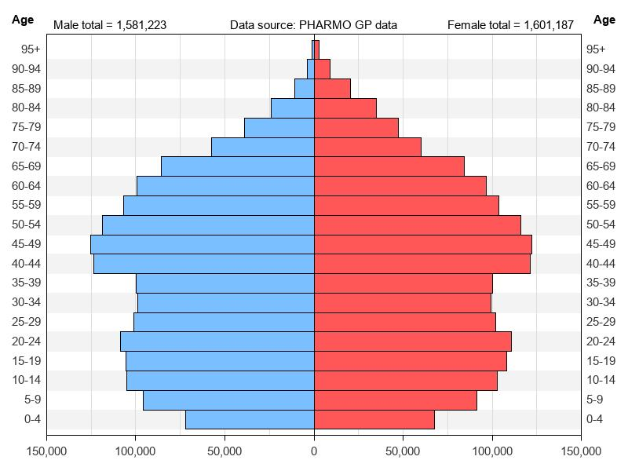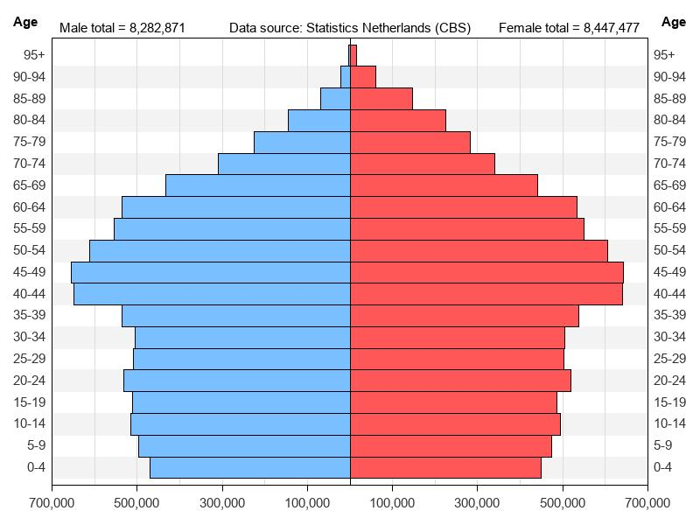
Figure S5 Population pyramid of the PHARMO GP population and the Dutch population at January 1st, 2012.

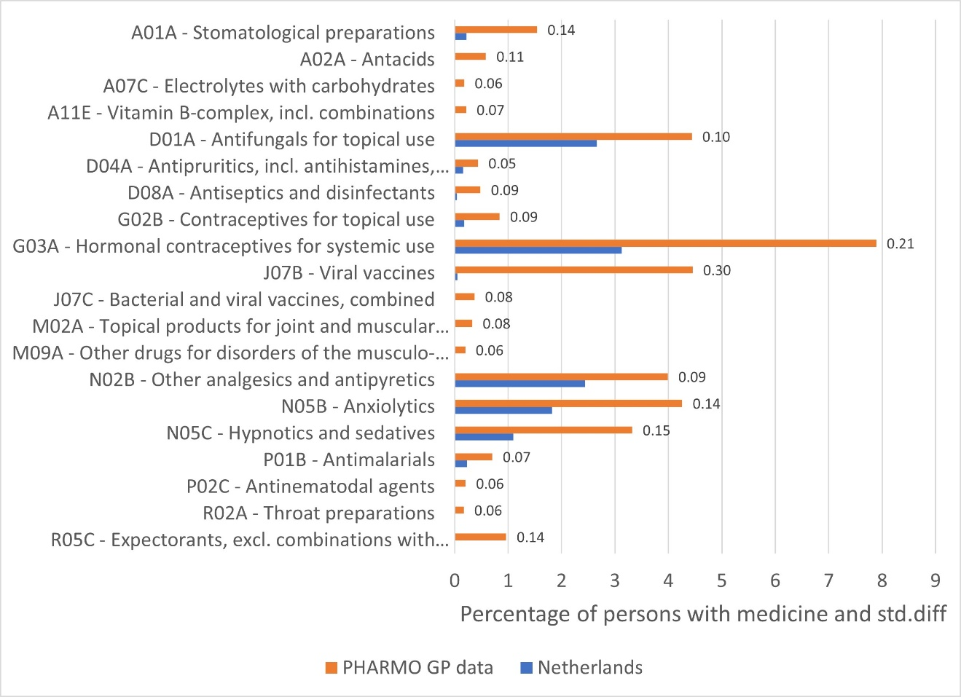
Figure S6 Medication use per pharmacological subgroup (ATC 3rd level) in the PHARMO GP data and the Netherlands in 2012 with absolute std.diff ≥0.05.

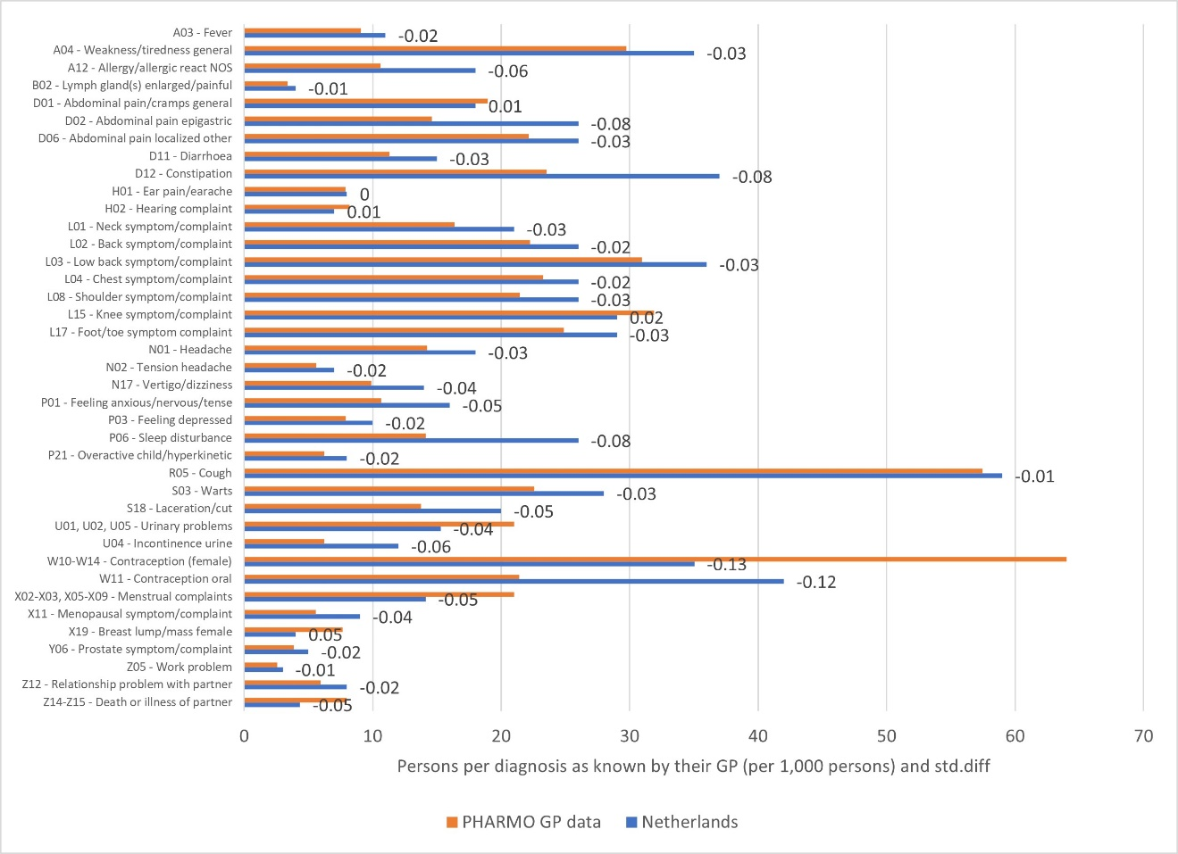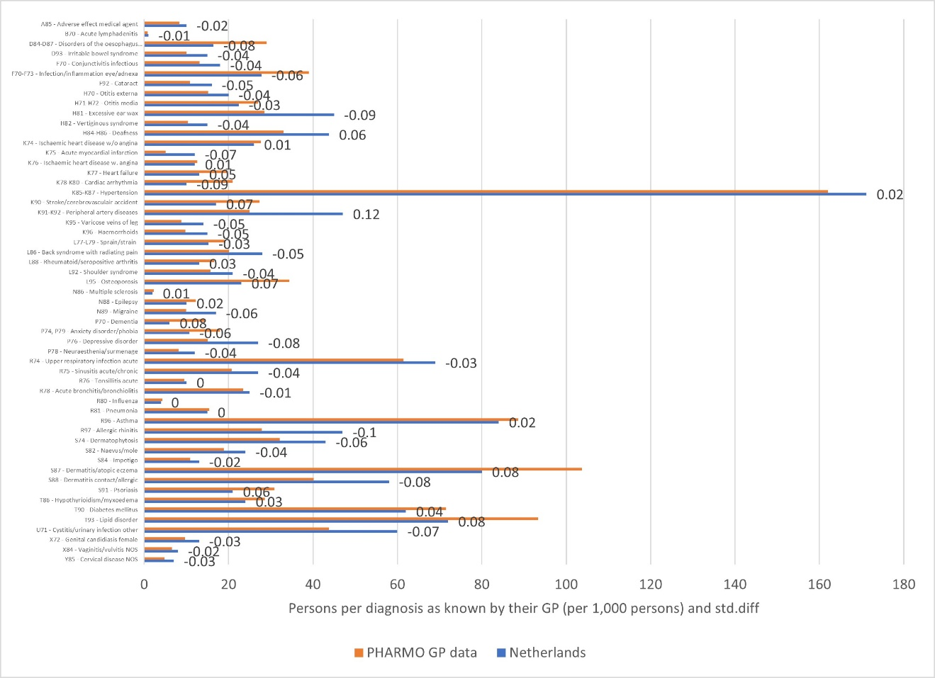Figure S7 Symptoms and complaints (a) and diagnoses (b) per ICPC level in the PHARMO GP data and the Netherlands in 2012.
b)
a)
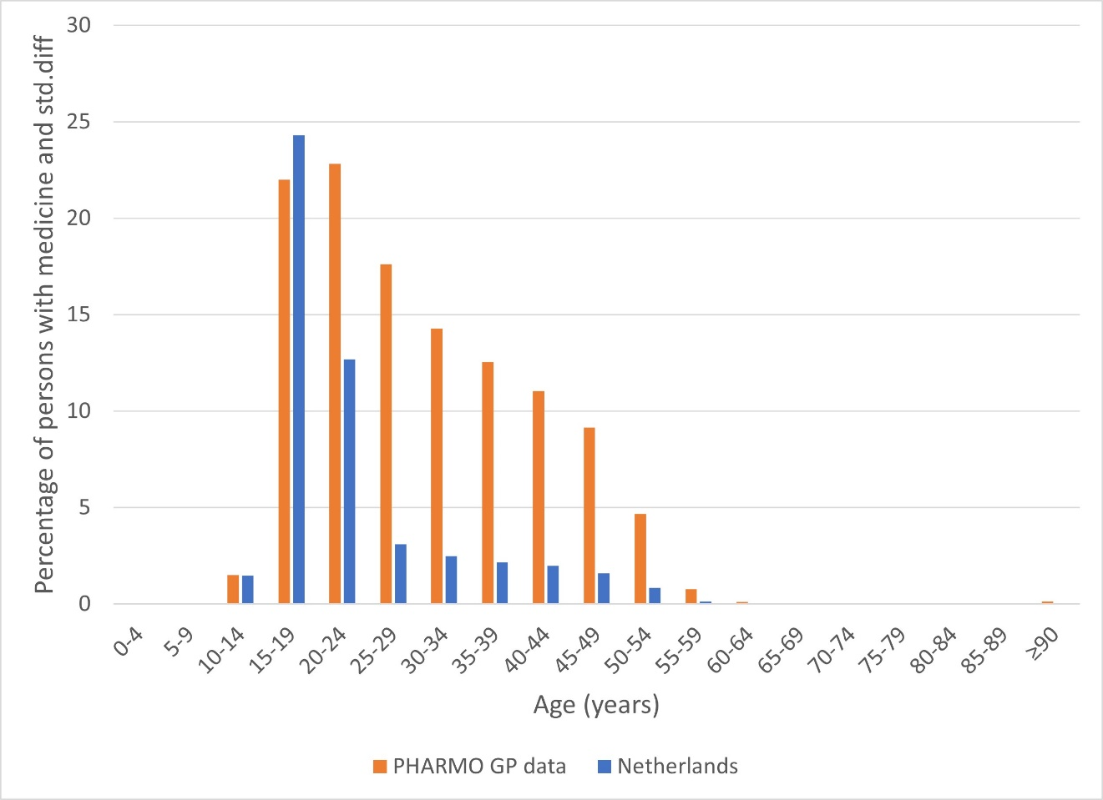
Figure S8 Hormonal contraceptives for systemic use by age in the PHARMO GP data in 2012

