Supplementary material 1
Collection of water sample and determination of MC-LR concentration
Water Collection
The brown glass bottle is marked with the water sample number, and the sample number, sampling point (village), well water, river water, pond water, and sampling date are registered on the sampling registration form. Before collecting the water samples, using the water samples to wash the sampling container, glass bottle and bottle cap 2-3 times before the water samples are formally collected. After mining, placed in 4℃ for light avoidance preservation and precipitation, filtration, extraction, concentration and concentration to 1ml within 24 h, and then tested by high-performance liquid chromatography(HPLC).
Water sample treatment
Firstly, activate the solid-phase extraction column, use 10 ml of 100% methanol and 10 ml of ultra-pure water; further enrichment and purification and concentration. After 500 ml water samples are filtered under 0.45 µm filter membrane, flow through a C18 solid-phase extraction column, the flow rate is 4.0 ml/min, then the fixed phase was successively rinsed with 10 ml of ultra-pure water and 20 ml of 20% methanol solution. Finally, use 80% (add 0.05% trifluoroacetic acid) 15 ml of the fixed phase was collected in a 15 ml centrifuge tube, pour the collected eluate into a glass dish in a 60℃ water bath in a normal constant temperature, vaporate the water and blow it dry, flush glass dishes using 1ml of ultra-pure water blow, the fluid collected in a 1.5ml centrifuge tube is the extracellular MC-LR (water sample), then save for analysis at -20℃, ultra-pure water was used to reach 1 ml before sample entry analysis.
Membrane-like treatment treatment
After 0.45 µm filter membrane pressure, filter 500 ml water samples, filter film into 50 ml centrifuge tube, add 10 ml ultra-pure water for three times, 10 ml membrane water bath, use 1ml methanol, and collect the liquid in 1.5 ml centrifuge tube to 1 ml before sample entry analysis.The total MC-LR (TMC) content in water is the sum of the extracellular MC-LR (EMC) and membrane-like intracellular MC-LR (IMC) content dissolved in water.
Selection of detergent, eluate, mobile phase, and mobile phase phosphoric acid content
In this experiment, 20% methanol shower solution, 80% methanol solution eluate (including 0.05% trifluoroacetic acid) were used, and the mobile phase was 0.1% water-phosphate acid solution-acetonitrile (67:33). The above conditions have been established and improved by our research group.
Determination conditions of HPLC chromatography
column: InerSustain ODS(4.6mm, 250mm, 5 µm); UV wavelength 238nm; column temperature 45℃; mobile phase: 0.1% aqueous phosphate solution-acetonitrile (67:33); flow rate 1.0 ml/min; equal degree elution; sample intake 20 L.
Standard curve equation and detection limit of HPLC
MC-LR standard samples and samples were separated by the above detection conditions, and the retention time of MC-LR was 15.291 min, as is shown in Figure S1.
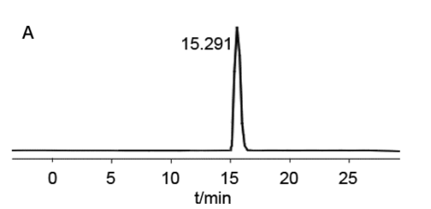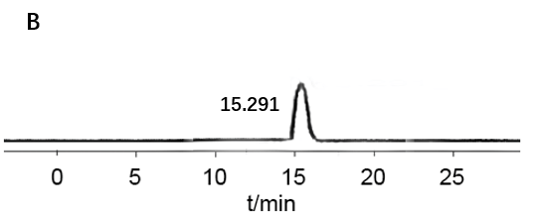
Figure S1 Microcystin-LR standard(A) and sample(B) liquid chromatogram.
The linear regression equation, correlation coefficient (Table S1) and standard curve (Figure S2) were obtained from the peak area to the concentration of the compound, and limit of detection(LOD) of MC-LR was calculated to be 0.028 μg/L according to the requirement of signal-to-noise ratio (S/N) = 3. The MC-LR concentration of water samples collected in this study was calculated according to the curve.
Table S1 Regression equation, correlation coefficient and detection limit
compound  (μg/L) | Regression equation | Correlation coefficient | Linear range  (µg/ml) | LOD
MC-LR | Y=38037X-225.13 | 0.9987 | 0.05~1 | 0.028
Note: Y is the chromatographic peak area ; X is the content of microcystins.
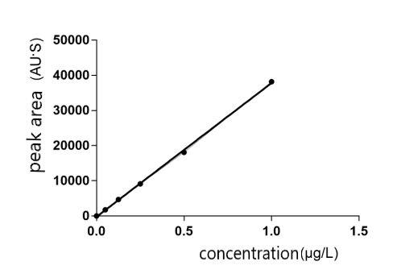
Figure S2 HPLC detection of MC-LR standard curve.
Supplementary material 2
Cell genetic quality identification report
Structure of lentivirus
Figure S3 Schematic diagram of LV5 shuttle plasmid.
The lentivirus used in this study was constructed by Shanghai Shenggong Bioengineering Co., Ltd., and its structure is shown in Figure S3. The shuttle plasmid of lentivirus is LV5, which contains green fluorescent protein (GFP) gene and puromycin and ampicillin resistance genes (needed for subsequent screening). The promoter is CMV and EF-1α, and the restriction site is NotI/NsiI.
Sequencing results of lentivirus

Figure S4 Sanger sequencing map after construction of LV5-HBXΔ32 virus.
Figure S5 Sanger sequencing map after construction of LV5-HBXΔ4 virus.

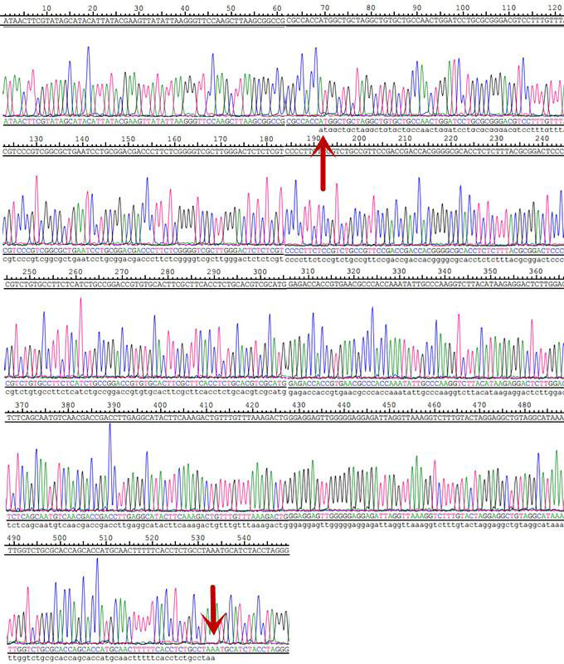
Figure S6 Sanger sequencing map after construction of LV5-HBX virus.

Supplementary material 3
Stable cell line Construction
Cell transfection
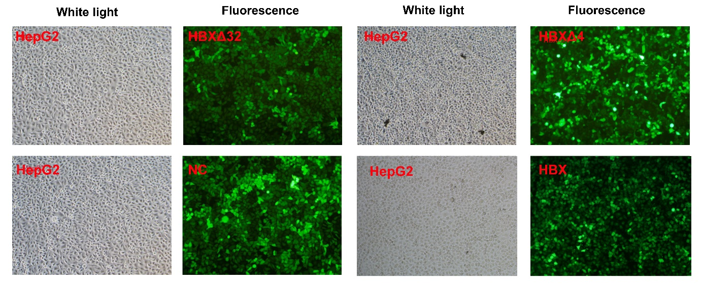
Figure S7 HepG2 cell transfection map (× 100).
HepG2 cells were transfected with virus NC, HBXΔ32, HBXΔ4 and HBX constructed by Shenggong Bioengineering Co., Ltd., China. 72 hours after transfection and screening with puromycin, the same visual field was compared under bright-field and fluorescence, respectively. The transfection efficiency was estimated to be more than 90% according to the number of cells with fluorescence / the total number of cells in the bright-field.

Realtime fluorescence quantitative Polymerase Chain Reaction (qPCR)
Table S2 Relative expression of HBX mRNA in HepG2 cells after transfection
 | HBXΔ32 | HBXΔ4 | HBX | P
Relative expression | 1.053±0.064 | 1.037±0.050 | 1.002±0.0265 | 0.452
Figure S8 Relative expression level of HBX mRNA in HepG2 cells after transfection.

Westernblot (WB)
Table S3 Relative expression of HBX protein levels in HepG2 cells after transfection
 | HBXΔ32 | HBXΔ4 | HBX | P
Relative expression | 1.030±0.010 | 1.010±0.026 | 1.003±0.006 | 0.206

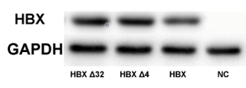
Figure S9 HBX protein expression electrophoresis of HepG2 cells after transfection.

Figure S10 HBX protein expression level in HepG2 cells after transfection.

Supplementary material 4
Table S4 The relationship between liver health status of the residents in high incidence area of liver cancer and drinking water after age stratification
Age (years) |  |  | Well water  n(%) | River water  n(%) | Reservoir water  n(%) | Χ² | P
≤55 | Hepatitis | No | 43(89.6) | 16(50.0) | 6(26.1) | 30.352 | <0.001
≤55 |  | Yes | 5(10.4) | 16(50.0) | 17(73.9) | 30.352 | <0.001
＞55 | Hepatitis | No | 35(89.7) | 8(29.6) | 1(12.5) | 32.124 | <0.001
＞55 |  | Yes | 4(10.3) | 19(70.4) | 7(87.5) | 32.124 | <0.001
Total | Hepatitis | No | 78(89.7) | 24(40.7) | 7(22.6) | 59.810 | <0.001
Total |  | Yes | 9(10.3) | 35(59.3) | 24(77.4) | 59.810 | <0.001
≤55 | Clonorchiasis | No | 46(95.8) | 22(68.8) | 9(39.1) | 27.381 | <0.001
≤55 |  | Yes | 2(4.2) | 10(31.3) | 14(60.9) | 27.381 | <0.001
＞55 | Clonorchiasis | No | 35(89.7) | 23(85.2) | 3(37.5) | 12.734 | 0.002
＞55 |  | Yes | 4(10.3) | 4(14.8) | 5(62.5) | 12.734 | 0.002
Total | Clonorchiasis | No | 81(93.1) | 45(76.3) | 12(38.7) | 39.512 | <0.001
Total |  | Yes | 6(6.9) | 14(23.7) | 19(61.3) | 39.512 | <0.001
≤55 | Family history of liver cance | No | 42(87.5) | 26(81.3) | 16(69.6) | 3.327 | 0.189
≤55 |  | Yes | 6(12.5) | 6(18.8) | 7(30.4) | 3.327 | 0.189
＞55 | Family history of liver cance | No | 34(87.2) | 22(81.5) | 5(62.5) | 2.819 | 0.244
＞55 |  | Yes | 5(12.8) | 5(18.5) | 3(37.5) | 2.819 | 0.244
Total | Family history of liver cance | No | 76(87.4) | 48(81.4) | 21(67.7) | 5.956 | 0.051
Total |  | Yes | 11(12.6) | 11(18.6) | 10(32.3) | 5.956 | 0.051
≤55 | GPT abnormal | No | 38(79.2) | 15(46.9) | 4(17.4) | 25.355 | <0.001
≤55 |  | Yes | 10(20.8) | 17(53.1) | 19(82.6) | 25.355 | <0.001
＞55 | GPT abnormal | No | 37(94.9) | 15(55.6) | 2(25.0) | 22.971 | <0.001
＞55 |  | Yes | 2(5.1) | 12(44.4) | 6(75.0) | 22.971 | <0.001
Total | GPT abnormal | No | 75(86.2) | 30(50.8) | 6(19.4) | 49.010 | <0.001
Total |  | Yes | 12(13.8) | 29(49.2) | 25(80.6) | 49.010 | <0.001
≤55 | HBsAg | Negative | 16(33.3) | 3(9.4) | 9(39.1) | 7.702 | 0.021
≤55 |  | Positive | 32(66.7) | 29(90.6) | 14(60.9) | 7.702 | 0.021
＞55 | HBsAg | Negative | 19(48.7) | 1(3.7) | 0(0.0) | 19.714 | <0.001
＞55 |  | Positive | 20(51.3) | 26(96.3) | 8(100) | 19.714 | <0.001
Total | HBsAg | Negative | 35(40.2) | 4(6.8) | 9(29.0) | 19.973 | <0.001
Total |  | Positive | 52(59.8) | 55(93.2) | 22(71.0) | 19.973 | <0.001
Total | - | - | 87(49.2) | 59(33.3) | 31(17.5) | - | -
Table S5 The relationship between liver health status of the residents in high incidence area of liver cancer and drinking water after Sex stratification
Sex |  |  | Well water  n(%) | River water  n(%) | Reservoir water  n(%) | Χ² | P
Female | Hepatitis | No | 43(89.6) | 9(34.6) | 1(20.0) | 28.439 | <0.001
Female |  | Yes | 5(10.4) | 17(65.4) | 4(80.0) | 28.439 | <0.001
Male | Hepatitis | No | 35(89.7) | 15(45.5) | 6(23.1) | 31.087 | <0.001
Male |  | Yes | 4(10.3) | 18(54.5) | 20(76.9) | 31.087 | <0.001
Total | Hepatitis | No | 78(89.7) | 24(40.7) | 7(22.6) | 59.810 | <0.001
Total |  | Yes | 9(10.3) | 35(59.3) | 24(77.4) | 59.810 | <0.001
Female | Clonorchiasis | No | 48(100) | 25(96.2) | 4(80.0) | 7.612 | <0.001
Female |  | Yes | 0(0.0) | 1(3.8) | 1(20.0) | 7.612 | <0.001
Male | Clonorchiasis | No | 33(84.6) | 20(60.6) | 8(30.8) | 19.303 | <0.001
Male |  | Yes | 6(15.4) | 13(39.4) | 18(69.2) | 19.303 | <0.001
Total | Clonorchiasis | No | 81(93.1) | 45(76.3) | 12(38.7) | 39.512 | <0.001
Total |  | Yes | 6(6.9) | 14(23.7) | 19(61.3) | 39.512 | <0.001
Female | Family history of liver cance | No | 46(95.8) | 20(76.9) | 3(60.0) | 9.064 | 0.011
Female |  | Yes | 2(4.2) | 6(23.1) | 2(40.0) | 9.064 | 0.011
Male | Family history of liver cance | No | 30(76.9) | 28(84.8) | 18(69.2) | 2.052 | 0.358
Male |  | Yes | 9(23.1) | 5(15.2) | 8(30.8) | 2.052 | 0.358
Total | Family history of liver cance | No | 76(87.4) | 48(81.4) | 21(67.7) | 5.956 | 0.051
Total |  | Yes | 11(12.6) | 11(18.6) | 10(32.3) | 5.956 | 0.051
Female | GPT abnormal | No | 41(85.4) | 15(57.7) | 1(20.0) | 13.677 | <0.001
Female |  | Yes | 7(14.6) | 11(42.3) | 4(80.0) | 13.677 | <0.001
Male | GPT abnormal | No | 34(87.2) | 15(45.5) | 5(19.2) | 30.985 | 0.001
Male |  | Yes | 5(12.8) | 18(54.5) | 21(80.8) | 30.985 | 0.001
Total | GPT abnormal | No | 75(86.2) | 30(50.8) | 6(19.4) | 49.010 | <0.001
Total |  | Yes | 12(13.8) | 29(49.2) | 25(80.6) | 49.010 | <0.001
Female | HBsAg | Negative | 17(35.4) | 1(3.8) | 1(20.0) | 9.250 | 0.01
Female |  | Positive | 31(64.6) | 25(96.2) | 4(80.0) | 9.250 | 0.01
Male | HBsAg | Negative | 18(46.2) | 3(9.1) | 8(30.8) | 11.809 | 0.003
Male |  | Positive | 21(53.8) | 30(90.9) | 18(69.2) | 11.809 | 0.003
Total | HBsAg | Negative | 35(40.2) | 4(6.8) | 9(29.0) | 19.973 | <0.001
Total |  | Positive | 52(59.8) | 55(93.2) | 22(71.0) | 19.973 | <0.001
Total | - | - | 87(49.2) | 59(33.3) | 31(17.5) | - | -

