Supplementary materials
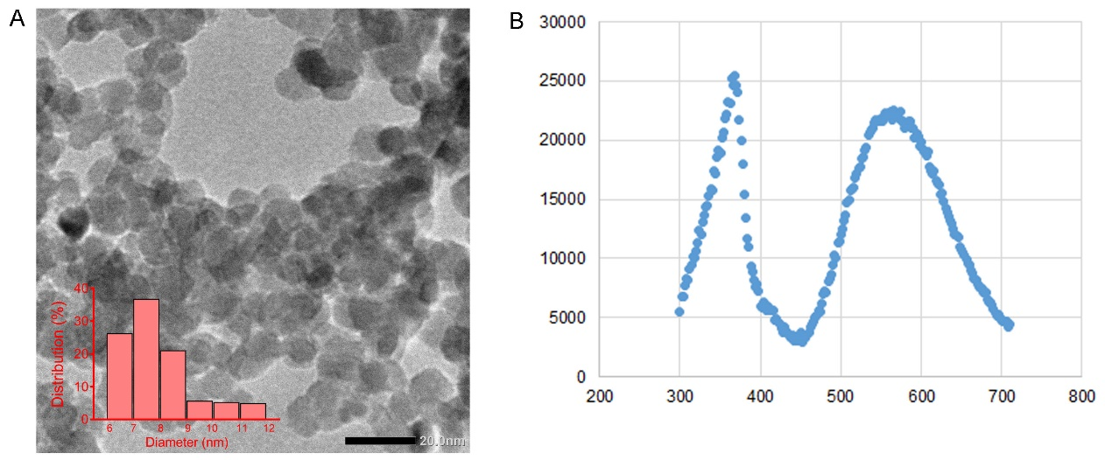
Figure S1 Characterization of ZnO QDs. (A) TEM and (B) photoluminescence (PL) spectra. The insets of the TEM images show the corresponding particle size distribution of ZnO QDs.
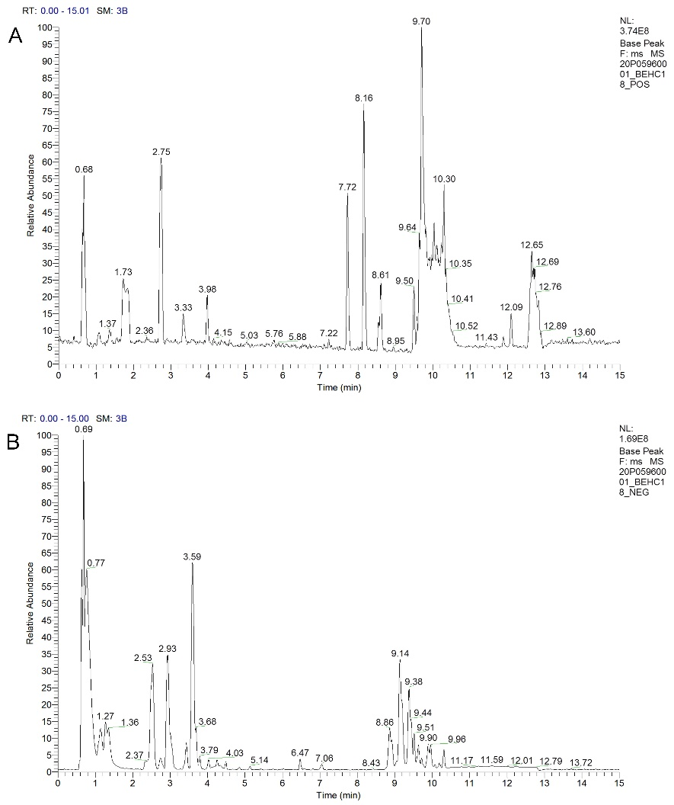
Figure S2. Representative base peak chromatograms (BPC) from untreated SMMC-7721 cells UPLC-MS/MS system: (A) pos, (B) neg.
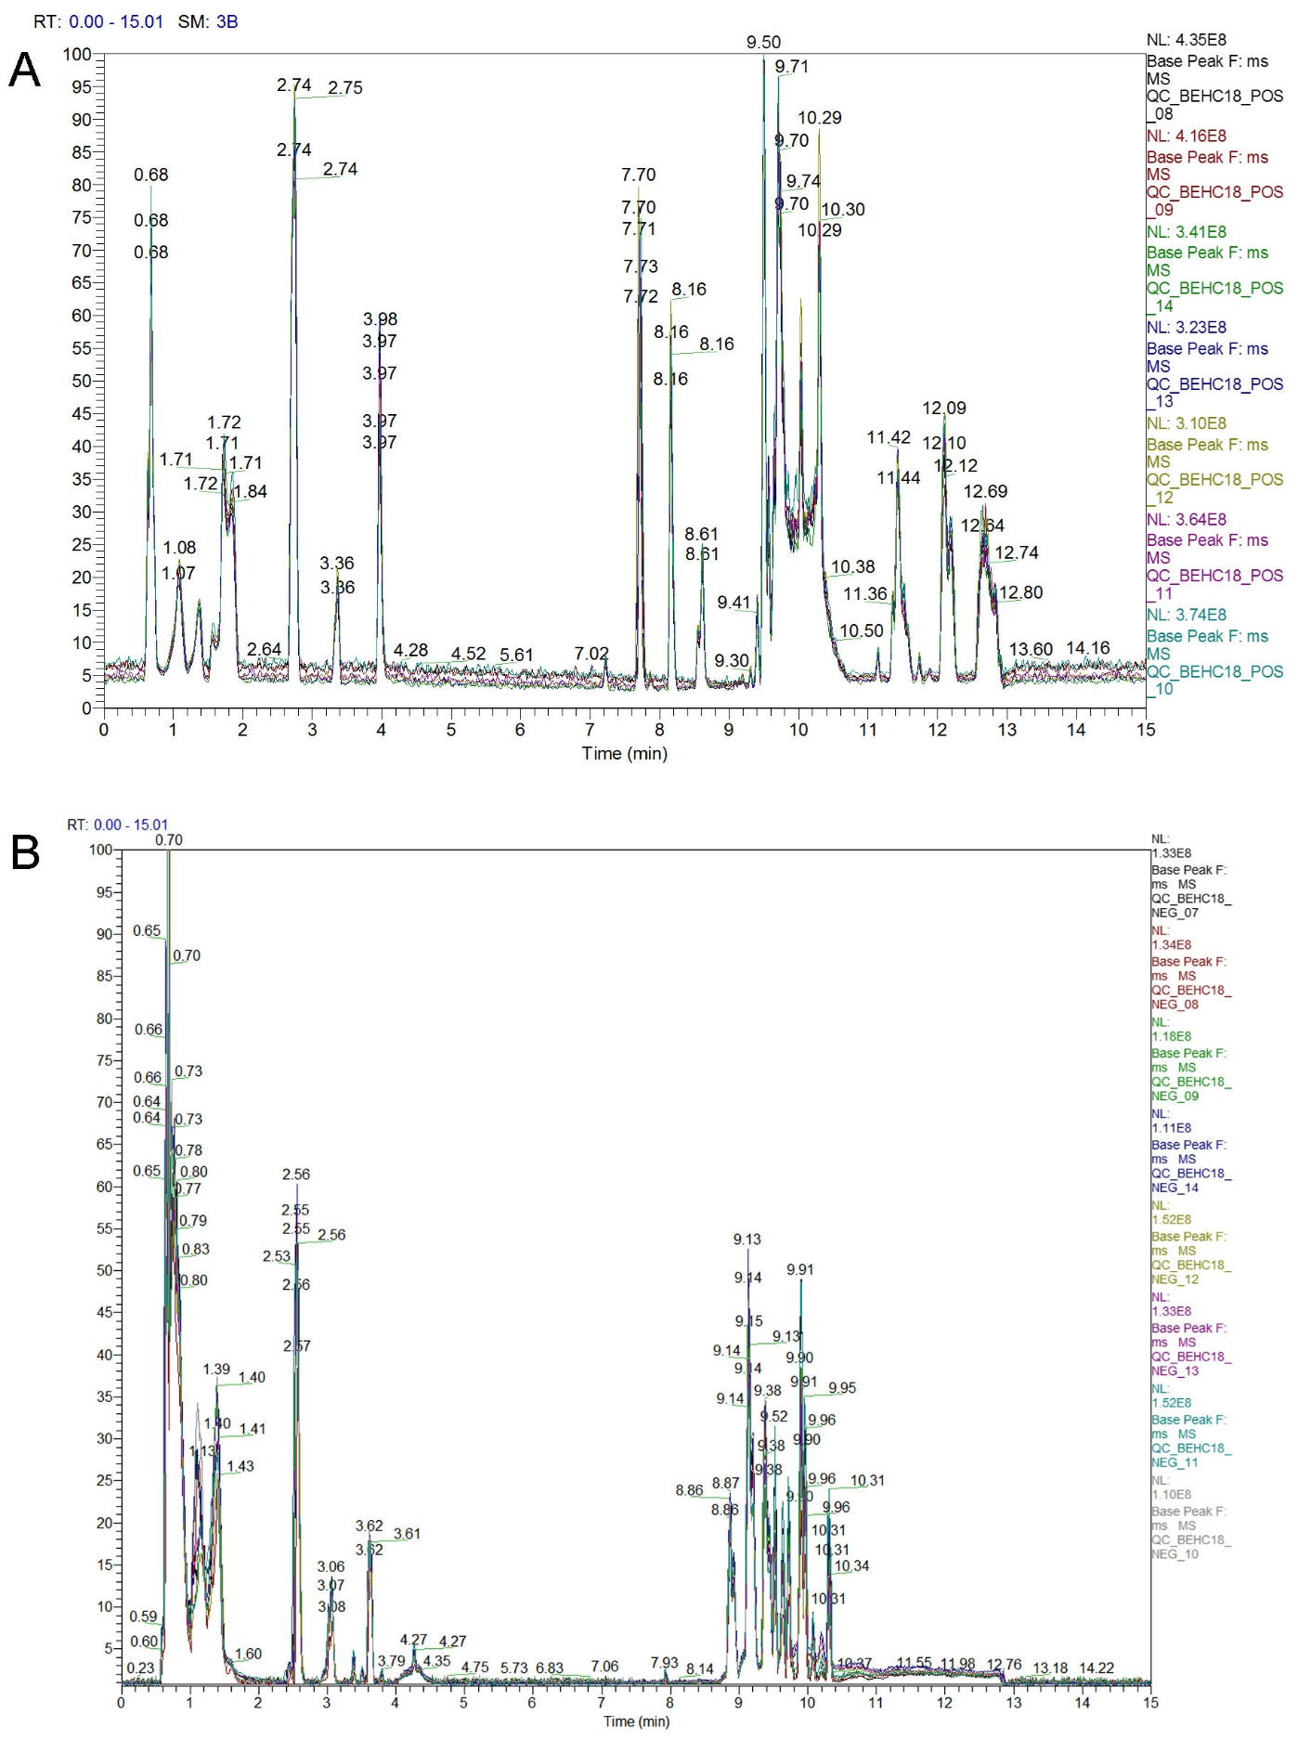
Figure S3. Overlay the base peak chromatograms (BPC) of all QC samples in UPLC-MS/MS system: (A) pos, (B) neg.

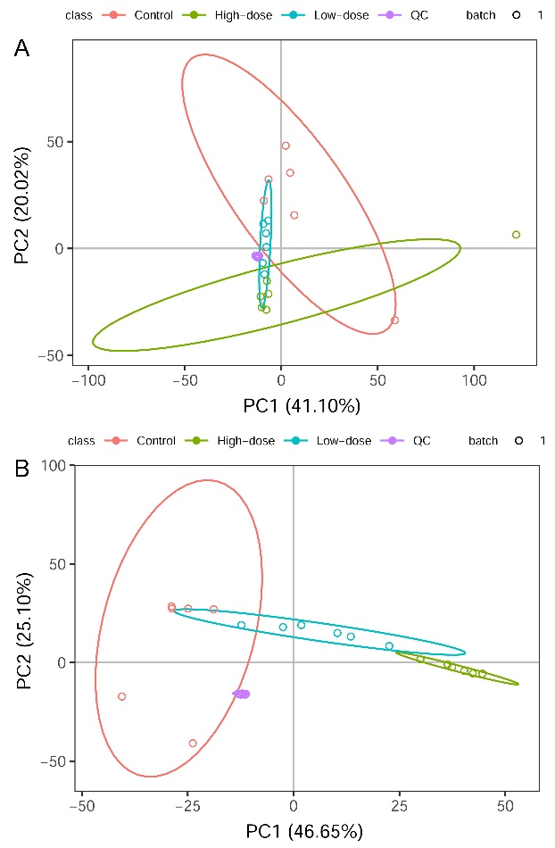
Figure S4. Score plots of the PCA model of all samples and QC: (A) pos, (B) neg.
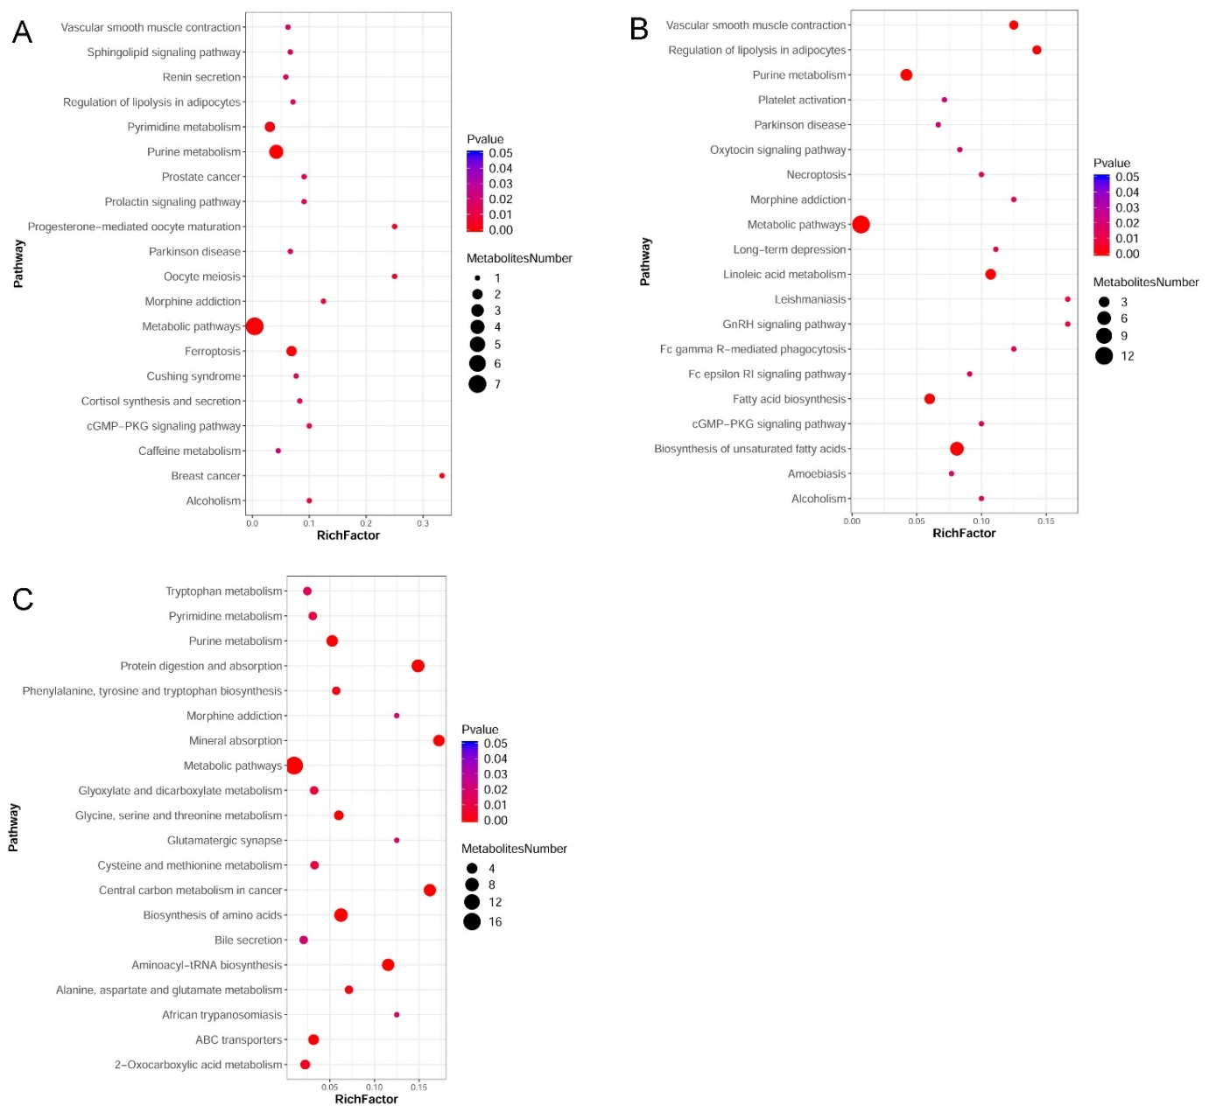
Figure S5. Scatterplot of significantly enriched KEGG pathways of differential metabolites induced by ZnO quantum dots. (A) 50 µg/mL in pos; (B) 20 µg/mL in neg; (C) 50 µg/mL in neg. The size of the dots represents the metabolites number.

