Supplementary Figures
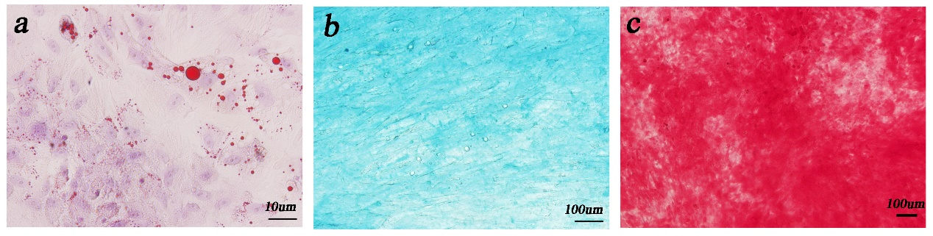
Supplementary Figure 1. hUC-MSCs showed muti-lineage differentiation of (a)adipogenesis, (b)chondrogenesis and (c)osteogenesis.

Supplementary Figure 2. The relationship of PTEN and miR-23a-3p was tested by pull-down assay, ***P < 0.001.
Supplementary Figure 3. HUVECs were cultured with sEVs for 24h, then qPCR was used to measure miR-23a-3p expression level in cells. Three independent replicates have been statistical analysis. *p < 0.05.

Supplementary Figure 4. (b) CCK-8 assay of BMSCs cultured on BG and BG-gel scaffolds.

Supplementary Figure 5. (a) Morphology of sEVs from degraded BG scaffold with Gelma/nanoclay hydrogel coatings was visualized under transmission electron microscopy (TEM). Scale bar:100um. (b)Representative fluorescence micrograph of PKH-26 (red)-labelled sEVs from the composited scaffold were incubated with BMSCs for 24 h. Scale bar:25um.

Supplementary table 1: The sequence of the primers.
Gene | Sequences
OCN | F-5’-CTCACAGATGCCAAGCCCA-3’
OCN | R-5’-CAAGGTAGCGCCGGAGTCT-3’
ALP | F-5’-TCCTGACCAAAAACCTCAAAGG-3’
ALP | R-5’-TGCTTCATGCAGAGCCTGC-3’
BMP-2 | F-5’-ACTACCAGAAACGAGTGGGAA-3’
BMP-2 | R-5’-GCATCTGTTCTCGGAAAACCT-3’
mGAPDH | F-5’-AGGTCGGTGTGAACGGATTTG-3’
mGAPDH | R-5’-TGTAGACCATGTAGTTGAGGTCA-3’

Supplementary table 2: The sequence of antagomir-23a-3p and scramblemir.
Name | Sequences
Antagomir-23a-3p | 5’-GGAAAUCCCGGCAAUGUGAU-3’
Scramblemir | 5’-CAGUACUUUUGUGUAGUACAA-3’

