Supplementary Materials

Table S1: Comparative release of verapamil HCl loaded composite NFs (N6) and (Z5) after 2 and 24 hr.
 | % Drug release from NF formulations |  | p
 | PVA-Z (Z5) | PVA-SA (N6) | p
2 hours |  |  | 0.027*
Mean ± SD | 19.0 ± 1.0 | 29.7 ± 1.15 | 0.027*
24 hours |  |  | 0.026*
Mean ± SD | 68.0 ± 1.0 | 93.7 ± 2.08 | 0.026*
(*) Significant

Figure S1: Comparative verapamil HCl release from loaded composite NFs (N6) and (Z5) after 2 hr and 24 hr.

 | Grp 0  Control | Grp 1  Verapamil HCl conventional gel | Grp 2  Placebo PVA-SA NFs (N2) | Grp 3 Placebo PVA-Z NFs (Z4) | Grp 4  Verapamil loaded PVA-SA NFs (N6) | Grp 5  Verapamil loaded PVA-Z NFs (Z5) | Test of significance  (p)
% Wound healing
Day 7
Mean ± SD | 23±6.08 | 28±3 | 33±3 | 27±8.1 | 54±4 | 33±4.3 | (F=13.8, P<.001*)
Sig. between groups | Sig between Grp 4 Vs {control, Grp (1,2,3,5)}
Day 14
Mean ± SD | 69±5.3 | 73±3 | 90±5 | 67±2 | 100±2 | 100±5 | (F=13.8, P<.001*)
Sig. between groups | Sig between {Grp 0 Vs Gp(2,4,5) }& {Gp1 vs Gr(2,4,5)} &{ Gp2 vs Gr (0,1,3)}& {Grp3 Vs Grp(2,4,5)}&{Grp 4 vs Grp (0,1,3)}&{Grp 5 vs Grp(0,1,3)}
Table S2: Comparative % wound healing results for different treatment groups after 7 and 14 days.

(*) Significant
F; One Way ANOVA based on boot strapping technique

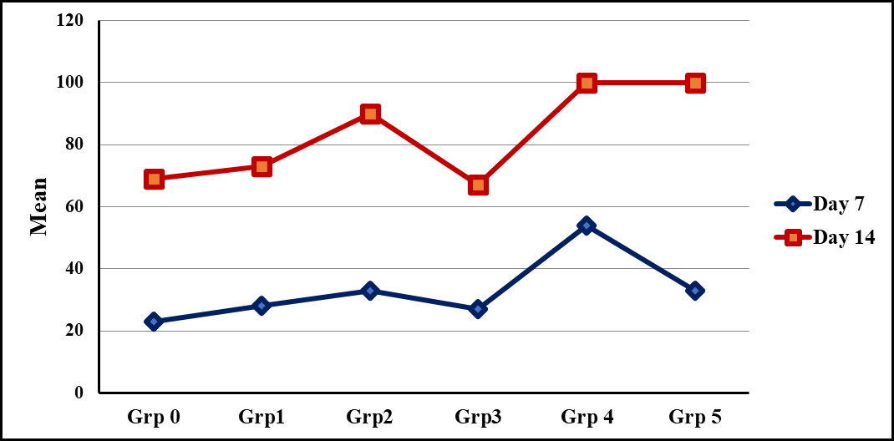

Figure S2: Comparison between % wound healing of different treatment groups after 7 and 14 days.

