Supplementary Figure

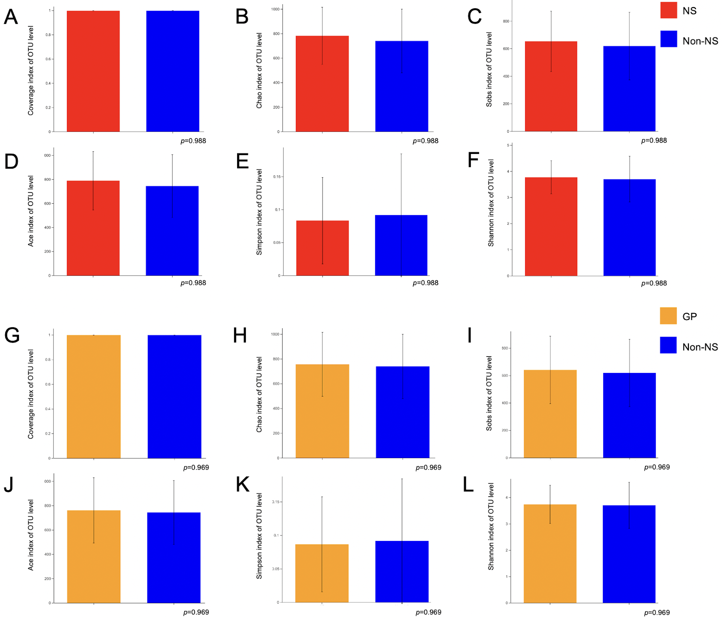
Supplementary Figure 1. Alpha diversity analysis. (A) Coverage index, (B) Chao index, (C) Sobs index, (D) Ace index, (D) Simpson index and (E) Shannon index for NS group and non-NS group. (G) Coverage index, (H) Chao index, (I) Sobs index, (J) Ace index, (K) Simpson index and (L) Shannon index for GP group and non-NS group.

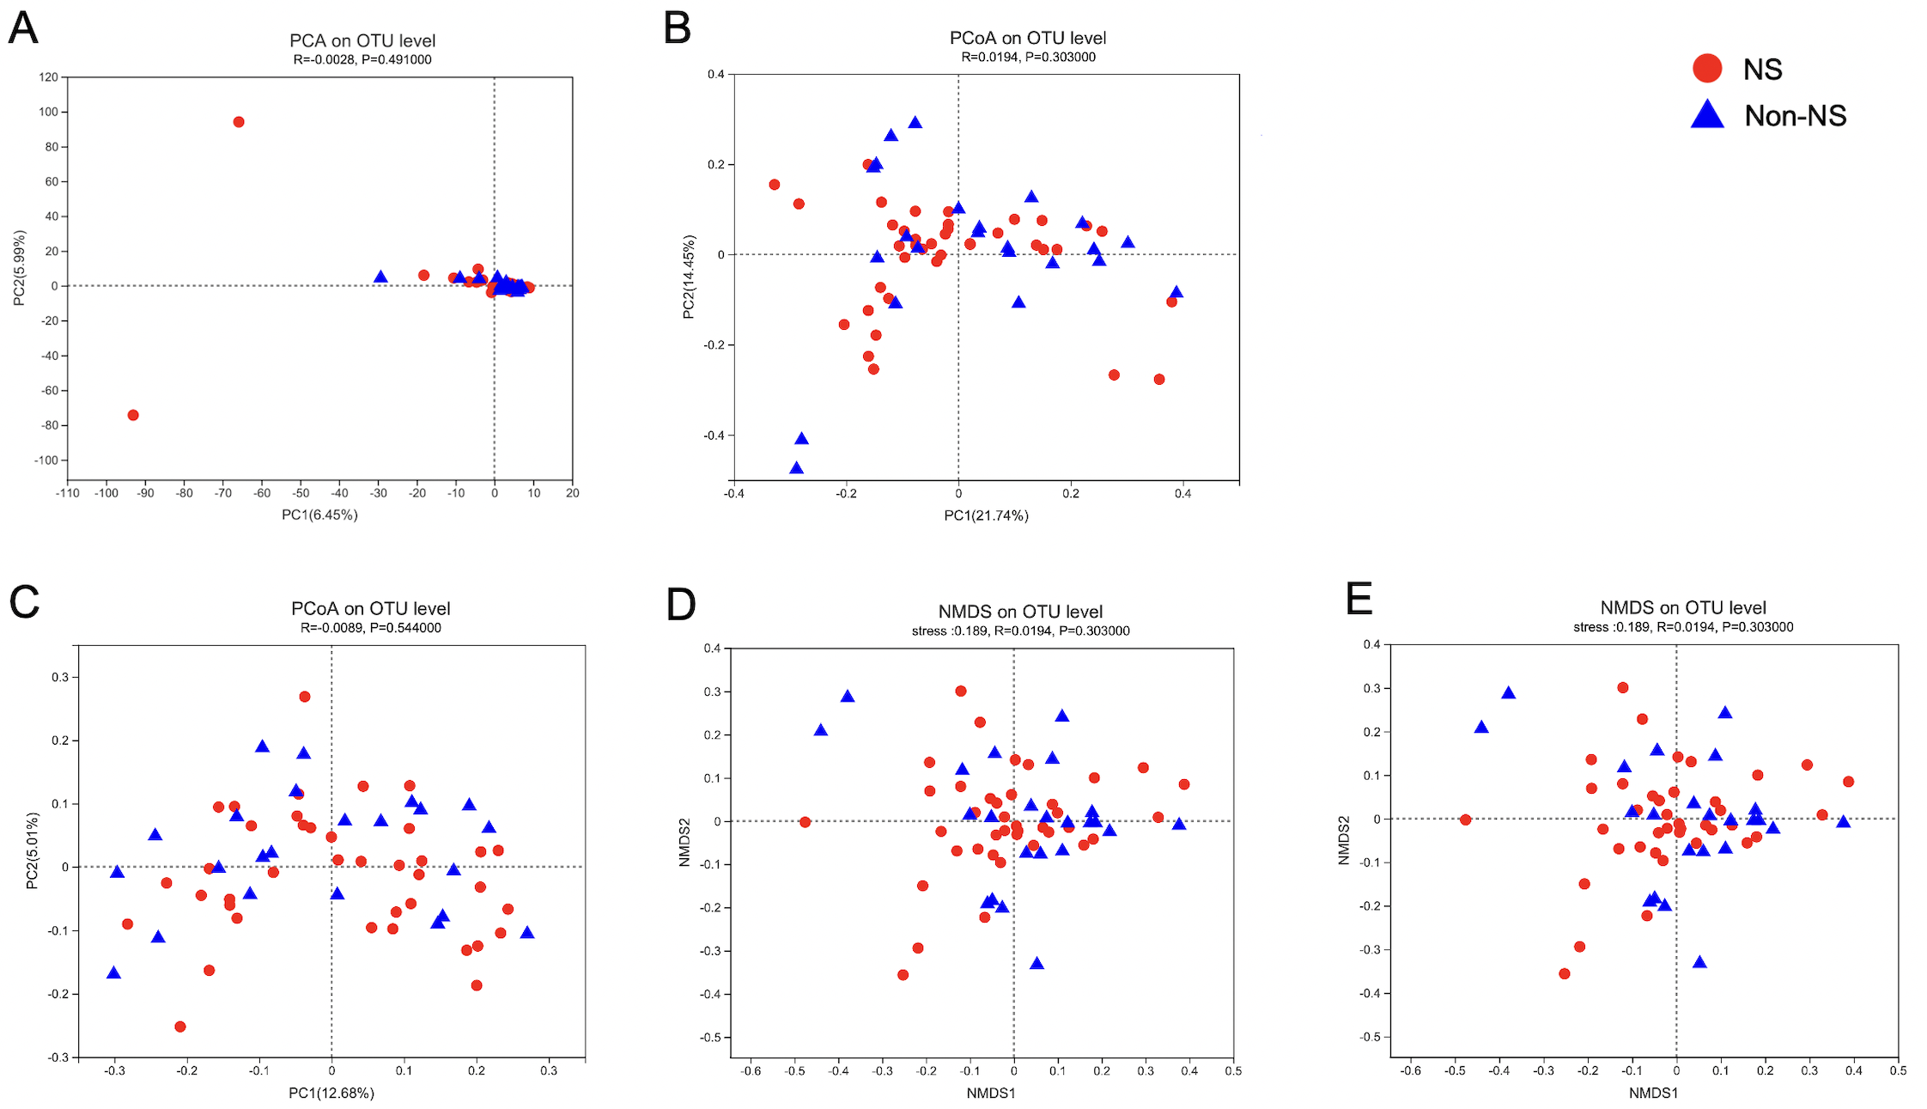
Supplementary Figure 2. Beta diversity analysis for NS and non-NS group. (A) PCA, (B) PCoA weighted unifrac, (C) PCoA unweighted unifrac, (D) NMDS weighted unifrac and (E) NMDS unweighted unifrac analyses of samples from NS and non-NS group.

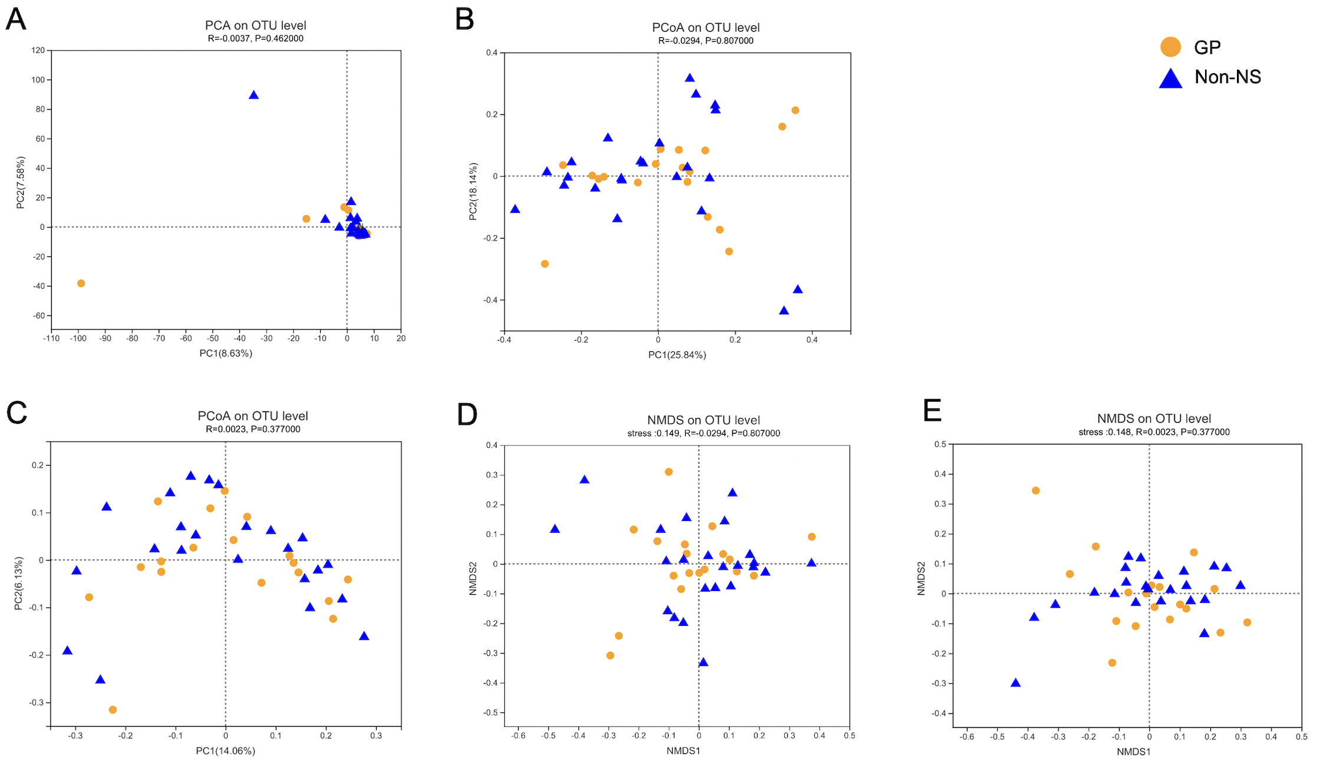
Supplementary Figure 3. Beta diversity analysis for GP and non-NS group. (A) PCA, (B) PCoA weighted unifrac, (C) PCoA unweighted unifrac, (D) NMDS weighted unifrac and (E) NMDS unweighted unifrac analyses of samples from GP and non-NS group.

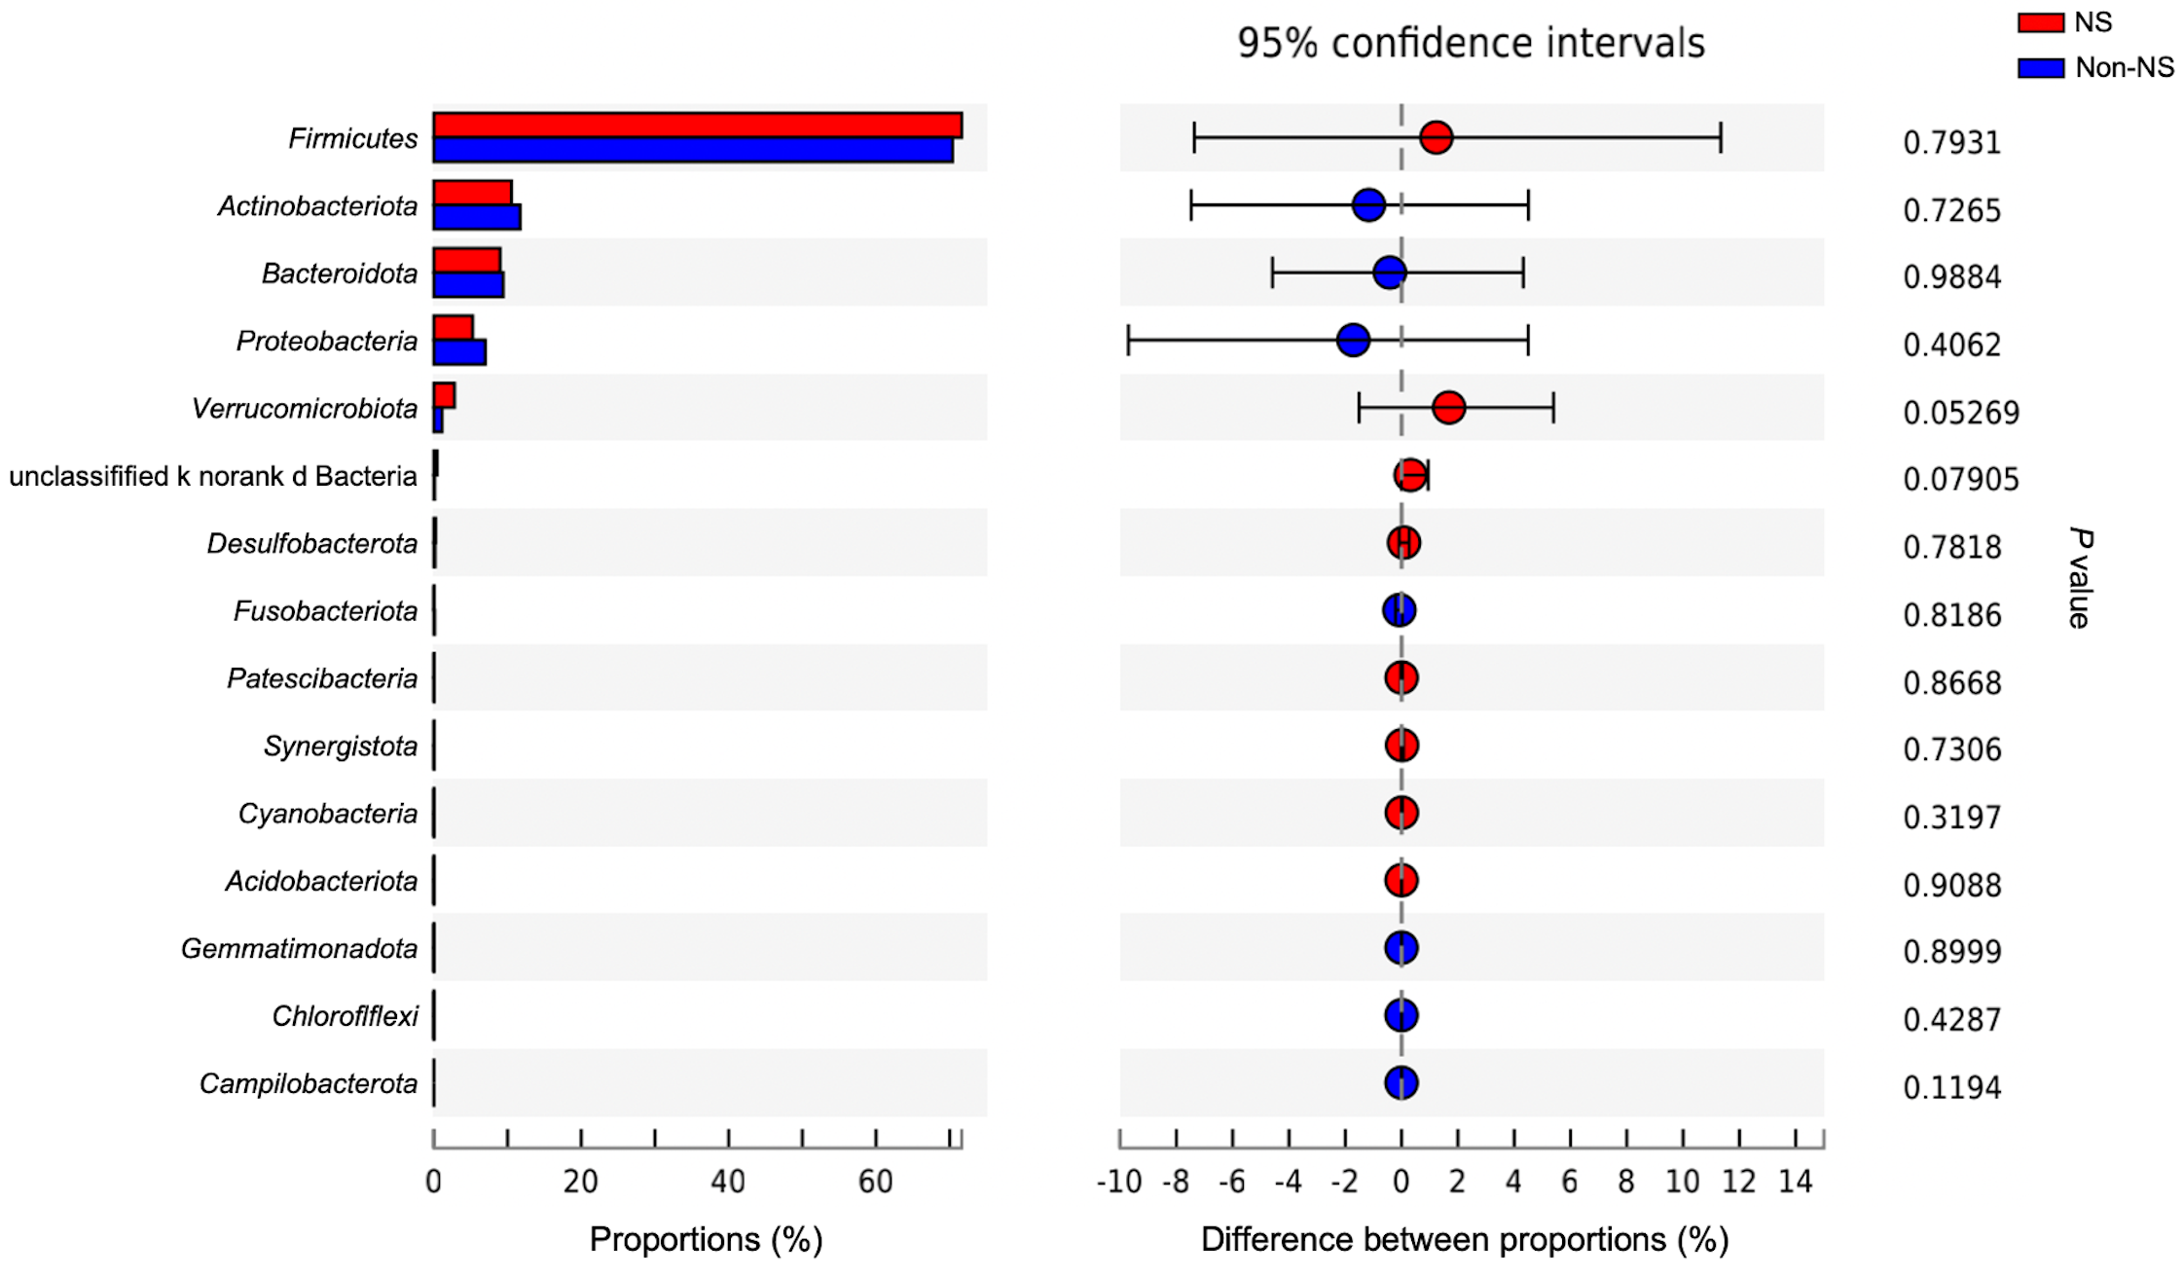
Supplementary Figure 4. Wilcoxon rank-sum test bar plot of NS group and non-NS group at the phylum level.

