Table S1. EVs protein abundant according quantitative proteomic analysis.
Protein | HEK293F |  | MRC5 |  | HKB-11
Protein | Abundances | Normalized with ITGB1 | Abundances | Normalized with ITGB1 | Abundances | Normalized with ITGB1
CD81 | 8.98E+09 | 5.51 | 2.80E+07 | 0.69 | 3.39E+07 | 3.45
CD63 | 2.70E+08 | 0.17 | 5.63E+07 | 1.39 | 3.26E+07 | 3.31
TSG101 | 4.10E+08 | 0.25 | 1.63E+05 | 0.00 | 1.29E+07 | 1.31
Laminin γ-1 | 4.55E+08 | 0.28 | 9.07E+08 | 22.40 | 7.88E+08 | 80.08
Laminin α-1 | 4.27E+08 | 0.26 | 8.20E+08 | 20.25 | 1.75E+08 | 17.79
Laminin β-1 | 3.29E+08 | 0.20 | 8.85E+08 | 21.85 | 5.29E+08 | 53.76
Laminin α-3 | 6.36E+07 | 0.04 | - | - | 1.51E+07 | 1.54
Laminin β-2 | 6.26E+07 | 0.04 | - | - | 3.91E+08 | 39.74
Laminin α-5 | 6.10E+07 | 0.04 | 1.77E+08 | 4.37 | 9.60E+08 | 97.56
Laminin α-4 | 9.58E+06 | 0.01 | 1.78E+08 | 4.40 | 6.22E+07 | 6.32
Laminin γ-2 | 3.55E+06 | 0.00 | 1.95E+07 | 0.48 | - | -
Laminin α-2 | 1.23E+06 | 0.00 | 1.03E+09 | 25.43 | 2.22E+06 | 0.23
Laminin β-4 | - | - | - | - | 1.25E+06 | 0.13
Fibronectin | 2.14E+08 | 0.13 | 2.85E+09 | 70.37 | 6.82E+07 | 6.93
ITGB1 | 1.63E+09 | 1.00 | 4.05E+07 | 1.00 | 9.84E+06 | 1.00
ITGAV | 7.23E+08 | 0.44 | 5.24E+06 | 0.13 | 1.05E+05 | 0.01
ITGA5 | 4.41E+08 | 0.27 | 2.80E+06 | 0.07 | - | -
ITGA4 | 2.53E+08 | 0.16 | - | - | 2.21E+05 | 0.02
ITGA2 | 2.50E+08 | 0.15 | 1.60E+07 | 0.40 | - | -
ITGA6 | 1.94E+08 | 0.12 | - | - | 3.85E+05 | 0.04
ITGA3 | 1.26E+08 | 0.08 | 1.15E+06 | 0.03 | - | -
ITGB5 | 1.24E+08 | 0.08 | - | - | - | -
ITGA9 | 1.12E+08 | 0.07 | - | - | - | -
ITGA7 | 8.77E+07 | 0.05 | - | - | - | -
ITGA1 | 6.71E+07 | 0.04 | 1.85E+07 | 0.46 | - | -
ITGB4 | 1.11E+07 | 0.01 | - | - | - | -
ITGB3 | 0 | - | - | - | - | -
ITGAX | 0 | - | - | - | - | -
ITGA11 | - | - | 4.72E+05 | 0.01 | 5.00E+08 | 50.81
ITGA8 | - | - | 2.62E+05 | 0.01 | - | -
ITGIIb | - | - | - | - | 1.30E+05 | 0.01
-: Not detected

Table S2. The presence of HN3, Nanoluc, mscIL12 on ITGB1⁻mscL12⁺HN3⁺EVs (4.77×10¹⁰ particles).
Protein | Abundances
IL-12A (p35) | 8.99E+07
IL-12B (p40) | 7.34E+08
HN3 | 4.60E+08
Nanoluc | 2.20E+08
CD81 | 1.89E+09
CD9 | 1.65E+08
IL12 is a heterodimeric cytokine consisting of two subunits p35 and p40. We used the recombinant IL12 protein as the quantification standard. When 800ng of the protein standard IL-12 was loaded, the abundance of p35 was 5.56E+09. The abundance of CD9 on the EVs was about twice of the abundance of p35, which suggested that the population of IL12 on the EVs was about half of CD9’s population.

Table S3. The absolute value of proinflammatory cytokines.
Treatment | IL-3 | IL-1β | TNF-a | IL-9 | IFN-γ | IL-2 | IL-13 | IL-6 | IL-4 | MCP-1 | IL-5 | IL-1a
ITGB1⁻Deg EVs | 1.4 | 3.7 | 51.5 | 11.8 | 5.2 | 7.4 | 36.9 | 0.3 | 1.1 | 195.2 | 6.6 | 2.7
ITGB1⁻Deg EVs | 1.4 | 4.5 | 65.5 | 13.8 | 6.0 | 9.4 | 54.6 | 0.3 | 2.3 | 214.9 | 8.2 | 3.3
ITGB1⁻Deg EVs | 0.7 | 1.9 | 28.4 | 4.0 | 2.2 | 4.2 | 20.2 | 0.3 | 0.9 | 131.2 | 3.4 | 1.5
ITGB1⁻Deg EVs | 1.2 | 2.7 | 55.0 | 13.8 | 4.5 | 3.7 | 23.5 | 0.3 | 0.9 | 195.2 | 5.1 | 2.5
ITGB1⁻Deg EVs | 1.5 | 4.8 | 62.0 | 8.7 | 4.2 | 9.6 | 58.3 | 0.3 | 2.3 | 190.1 | 16.9 | 4.7
ITGB1⁻Deg EVs | 1.2 | 3.7 | 65.5 | 11.8 | 6.0 | 6.0 | 36.9 | 0.3 | 1.6 | 164.2 | 5.5 | 2.0
rmIL12-70ng | 0.8 | 1.9 | 22.3 | 5.8 | 2.7 | 3.7 | 23.5 | 0.4 | 0.8 | 131.2 | 3.4 | 1.2
rmIL12-70ng | 1.4 | 4.7 | 44.7 | 11.8 | 6.0 | 9.1 | 40.4 | 1.0 | 2.0 | 205.1 | 11.6 | 2.3
rmIL12-70ng | 84.2 | 1.7 | 596.4 | 4.9 | 3.2 | 14.3 | 136.6 | 11.2 | 0.9 | 131.2 | 4.2 | 1.2
rmIL12-70ng | 0.8 | 1.7 | 22.3 | 5.8 | 2.8 | 3.3 | 23.5 | 0.6 | 0.6 | 125.5 | 7.7 | 1.2
rmIL12-70ng | 0.5 | 2.9 | 19.4 | 1.6 | 2.4 | 2.0 | 14.2 | 0.4 | 0.4 | 901.3 | 5.5 | 1.5
rmIL12-70ng | 0.8 | 1.9 | 34.8 | 9.7 | 3.2 | 4.4 | 30.1 | 0.9 | 0.6 | 142.4 | 8.8 | 1.6
rmIL12-3ug | 0.6 | 1.7 | 23.8 | 8.7 | 16.3 | 2.0 | 18.7 | 0.4 | 0.8 | 164.2 | 6.8 | 1.2
rmIL12-3ug | 3.0 | 3.2 | 62.0 | 12.8 | 28.4 | 5.1 | 30.1 | 0.3 | 1.2 | 300.1 | 8.2 | 1.5
rmIL12-3ug | 3.3 | 2.7 | 51.5 | 9.7 | 20.5 | 5.5 | 35.2 | 1.0 | 1.6 | 624.7 | 9.5 | 5.0
rmIL12-3ug | 34.9 | 2.8 | 245.1 | 4.9 | 19.9 | 9.4 | 54.6 | 1.9 | 1.6 | 233.9 | 10.4 | 2.0
rmIL12-3ug | 2.5 | 4.5 | 108.9 | 21.1 | 33.0 | 7.2 | 51.1 | 4.3 | 2.7 | 374.8 | 8.8 | 7.9
rmIL12-3ug | 1.4 | 3.2 | 51.5 | 13.8 | 30.6 | 7.0 | 33.5 | 2.4 | 1.6 | 304.3 | 7.7 | 2.3
ITGB1⁻mscIL12⁺HN3⁺Deg EVs | 1.5 | 4.0 | 160.6 | 42.5 | 61.9 | 27.9 | 105.7 | 3.3 | 3.9 | 344.4 | 15.0 | 4.5
ITGB1⁻mscIL12⁺HN3⁺Deg EVs | 1.4 | 3.2 | 76.2 | 22.7 | 38.5 | 7.0 | 36.9 | 0.8 | 1.8 | 312.5 | 7.5 | 4.7
ITGB1⁻mscIL12⁺HN3⁺Deg EVs | 0.8 | 4.3 | 76.2 | 33.7 | 65.7 | 10.1 | 65.5 | 0.7 | 2.3 | 328.7 | 13.6 | 2.7
ITGB1⁻mscIL12⁺HN3⁺Deg EVs | 0.7 | 2.2 | 69.1 | 21.1 | 45.8 | 12.5 | 58.3 | 0.4 | 2.0 | 270.2 | 7.7 | 2.0
ITGB1⁻mscIL12⁺HN3⁺Deg EVs | 0.9 | 3.2 | 69.1 | 25.9 | 43.4 | 11.8 | 65.5 | 0.8 | 2.1 | 270.2 | 7.7 | 3.7
Treatment | IL-3 | IL-1β | TNF-a | IL-9 | IFN-γ | IL-2 | IL-13 | IL-6 | IL-4 | MCP-1 | IL-5 | IL-1a
ITGB1⁻mscIL12⁺HN3⁺Deg EVs | 1.4 | 3.2 | 127.3 | 31.6 | 47.0 | 10.6 | 47.5 | 2.7 | 2.9 | 324.7 | 7.3 | 3.3

Treatment | G-CSF | RANTES | IL-10 | KC | IL-17A | GM-CSF | Eotaxin | MIP-1β | IL-12p40 | MIP-1a | IL-12p70
ITGB1⁻Deg EVs | 122.7 | 95.8 | 18.1 | 30.2 | 28.4 | 28.0 | 3381.0 | 22.4 | 372.7 | 1.7 | 36.7
ITGB1⁻Deg EVs | 43.0 | 111.7 | 25.0 | 33.1 | 14.0 | 39.1 | 4391.0 | 28.0 | 358.0 | 1.7 | 30.7
ITGB1⁻Deg EVs | 66.3 | 74.3 | 14.7 | 28.1 | 20.2 | 20.6 | 5113.0 | 21.4 | 368.2 | 1.1 | 23.3
ITGB1⁻Deg EVs | 47.9 | 87.6 | 12.8 | 33.9 | 30.8 | 25.6 | 4548.0 | 39.0 | 335.4 | 1.5 | 45.6
ITGB1⁻Deg EVs | 54.6 | 116.0 | 29.2 | 29.8 | 16.3 | 41.1 | 3302.0 | 20.5 | 331.0 | 1.8 | 24.9
ITGB1⁻Deg EVs | 36.9 | 88.5 | 20.8 | 29.8 | 33.3 | 30.3 | 3675.0 | 30.8 | 390.8 | 1.5 | 42.0
rmIL12-70ng | 87.4 | 147.8 | 16.7 | 24.8 | 20.7 | 12.5 | 4832.0 | 23.3 | 746.7 | 1.0 | 10.3
rmIL12-70ng | 88.7 | 129.4 | 26.4 | 28.1 | 22.2 | 39.1 | 5299.0 | 48.0 | 699.1 | 1.7 | 36.7
rmIL12-70ng | 375.4 | 169.9 | 11.5 | 44.5 | 25.5 | 78.2 | 6831.0 | 33.5 | 790.1 | 1.0 | 5.6
rmIL12-70ng | 57.1 | 148.6 | 15.4 | 21.3 | 20.4 | 18.0 | 4227.0 | 27.1 | 613.2 | 1.1 | 2.8
rmIL12-70ng | 57.7 | 145.5 | 11.5 | 22.2 | 17.1 | 9.6 | 4141.0 | 24.2 | 604.4 | 0.7 | 5.1
rmIL12-70ng | 63.3 | 142.3 | 19.4 | 38.3 | 39.9 | 13.9 | 5044.0 | 32.6 | 774.6 | 1.1 | 45.6
rmIL12-3ug | 33.3 | 215.8 | 26.4 | 53.9 | 26.2 | 12.5 | 4293.0 | 61.0 | 932.6 | 1.6 | 51.1
rmIL12-3ug | 70.7 | 265.3 | 33.5 | 50.6 | 28.7 | 25.6 | 6522.0 | 76.7 | 971.9 | 2.5 | 70.1
rmIL12-3ug | 74.4 | 219.2 | 39.2 | 48.0 | 32.9 | 25.6 | 6147.0 | 73.5 | 834.3 | 3.1 | 82.8
rmIL12-3ug | 141.8 | 208.4 | 49.3 | 46.5 | 17.8 | 19.3 | 3423.0 | 49.7 | 846.3 | 2.2 | 38.5
rmIL12-3ug | 140.6 | 273.3 | 50.7 | 59.7 | 49.7 | 45.1 | 6279.0 | 103.1 | 868.1 | 3.3 | 154.7
rmIL12-3ug | 92.4 | 249.7 | 45.7 | 50.2 | 30.0 | 30.3 | 6054.0 | 79.9 | 979.5 | 2.6 | 98.7
ITGB1⁻mscIL12⁺HN3⁺Deg EVs | 102.3 | 749.6 | 68.7 | 73.0 | 91.2 | 45.1 | 6338.0 | 177.1 | 573.6 | 6.6 | 421.3
ITGB1⁻mscIL12⁺HN3⁺Deg EVs | 183.3 | 515.9 | 40.7 | 47.2 | 53.5 | 33.7 | 5663.0 | 112.7 | 384.2 | 4.5 | 184.6
ITGB1⁻mscIL12⁺HN3⁺Deg EVs | 107.9 | 662.7 | 42.8 | 69.2 | 38.5 | 43.1 | 11157.0 | 169.7 | 302.0 | 5.8 | 337.9
ITGB1⁻mscIL12⁺HN3⁺Deg EVs | 196.6 | 661.0 | 39.2 | 44.5 | 61.9 | 21.9 | 6613.0 | 123.4 | 533.6 | 4.1 | 207.4
ITGB1⁻mscIL12⁺HN3⁺Deg EVs | 89.3 | 569.1 | 34.9 | 50.2 | 51.5 | 41.1 | 6320.0 | 114.8 | 473.3 | 4.6 | 220.9
ITGB1⁻mscIL12⁺HN3⁺Deg EVs | 160.7 | 625.6 | 27.8 | 72.7 | 106.2 | 25.6 | 4418.0 | 150.5 | 547.7 | 6.3 | 317.3

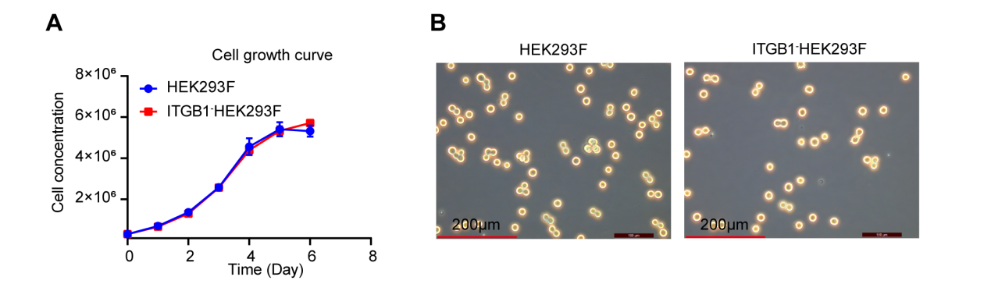
Figure S1. The growth curve and morphology of HEK293F cells. (A) HEK293F cells and ITGB1 knock-out HEK293F cells growth curve. (B) HEK293F cells and ITGB1 knock-out HEK293F cells morphology.

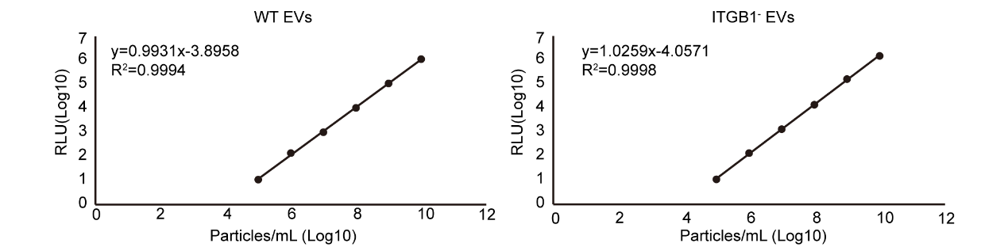
Figure S2. Nanoluc standard curve.

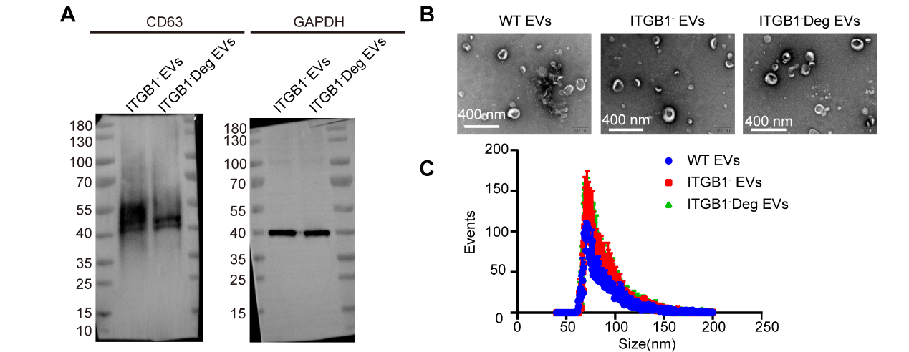
Figure S3. Multiple engineering steps did not change the EVs morphology and size. (A) Western blot analyses of EVs for CD63 and GAPDH. (B) The TEM photos of WT, ITGB1⁻, ITGB1⁻Deg EVs. (C) The size of WT, ITGB1⁻, ITGB1⁻Deg EVs detection by nanoFCM.

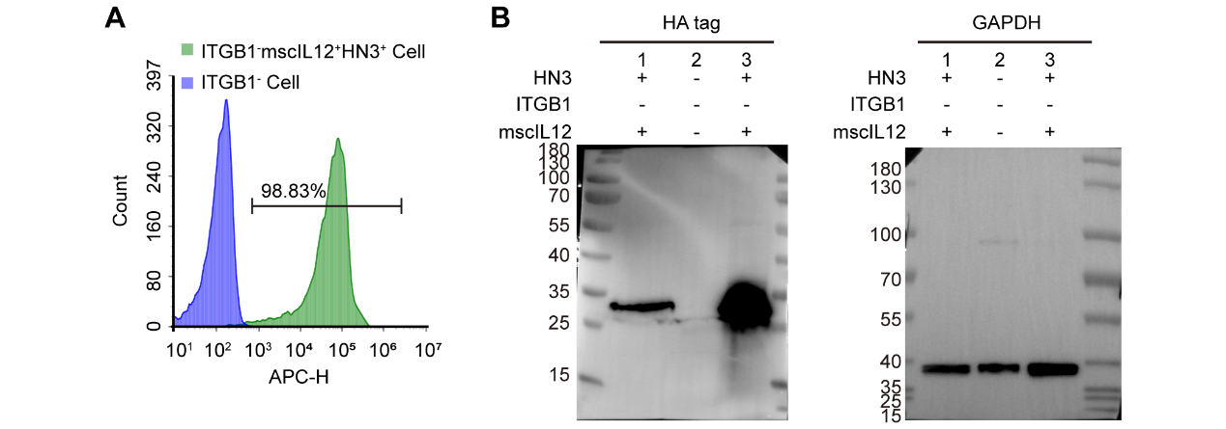
Figure S4. HN3 expression on ITGB1⁻mscIL12⁺HN3⁺ HEK293F cells and EVs. (A) FCM analysis of ITGB1⁻ and ITGB1⁻mscIL12⁺HN3⁺ HEK293F cells with hGPC3-Fc, showed that only the latter cell line can be labeled by APC-labeled anti-IgG antibody, which meant only the HN3⁺ cells can bind the GPC3-Fc fusion protein. (B) Western Blot analysis confirmed HN3 expression on ITGB1⁻mscIL12⁺HN3⁺ HEK293F EVs. 1: ITGB1⁻mscIL12⁺HN3⁺ EVs. 2: ITGB1⁻ EVs. 3: ITGB1⁻mscIL12⁺HN3⁺ cells.

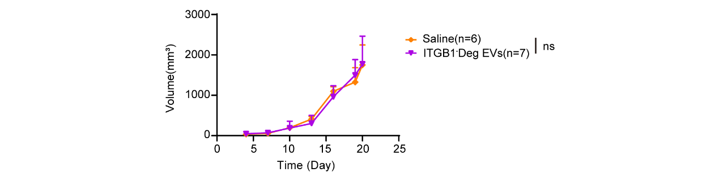
Figure S5. The tumor growth curves of the Saline group and the ITGB1⁻Deg EVs group.

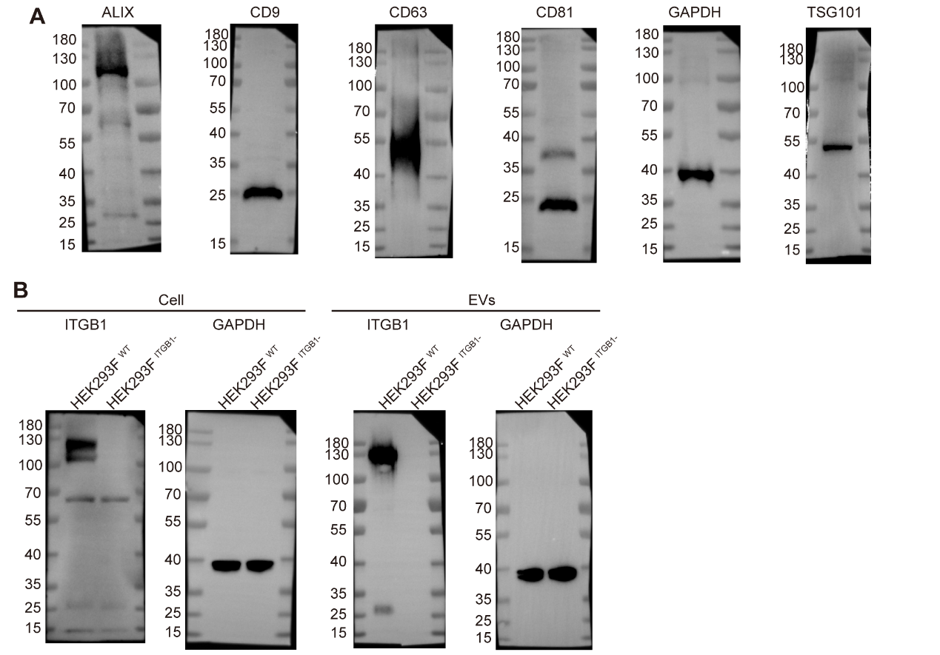

Figure S6. The uncut image of WB. (A) The uncut image of Fig.1A. (B) The uncut image of Fig.1E.

