Table S1. Descriptive statistics for the variables used in analysis

Variable |  | n | Percentage/Mean | Number of obs/SD | min | max
Dependent variables
risk10 | 10-year CVD risk score  (%) | 2,710 | 3.916 | 5.661 | 0.044 | 61.36
h_cvdrisk | 1=low CVD risk | 2,710 | 34.28 | 929 | 1 | 3
h_cvdrisk | 2=medium CVD risk | 2,710 | 41.29 | 1119 | 1 | 3
h_cvdrisk | 3=high CVD risk | 2,710 | 24.43 | 662 | 1 | 3
Independent variables
age | Age | 2,752 | 54.35 | 8.486 | 40.01 | 70.00
female | 1=female | 2,752 | 57.3 | 1,577 | 0 | 1
uni* | 1= incomplete tertiary or tertiary education | 2,752 | 39.1 | 1,076 | 0 | 1
incsec | 1= incomplete secondary or basic education | 2,752 | 3.1 | 85 | 0 | 1
sec | 1= secondary education | 2,752 | 12.2 | 336 | 0 | 1
vocat | 1= secondary vocational education | 2,752 | 45.5 | 1252 | 0 | 1
mard* | 1= married | 2,752 | 70.4 | 1811 | 0 | 1
div | 1=divorced/separated | 2,752 | 13.9 | 358 | 0 | 1
wid | 1=widowed | 2,752 | 8.3 | 213 | 0 | 1
sing | 1=single | 2,752 | 7.4 | 190 | 0 | 1
fin_const | 1= has financial constraints (includes the categories ‘no money for food’ and ‘can afford food but not clothes) | 2,701 | 17.5 | 473 | 0 | 1
fin_inter | 1=has some financial constrains (‘difficult to buy home appliances’ and ‘difficult to buy a car’) | 2,701 | 76.2 | 2,058 | 0 | 1
fin_uncon* | 1=no financial constraints  (‘difficult to buy a flat/house’ и ‘can afford flat or house’) | 2,701 | 6.3 | 170 | 0 | 1
smoke | 1=smoker | 2,751 | 25.7 | 707 | 0 | 1
ad_diet | 1=doctor advised to change diet | 1,937 | 42.2 | 817 | 0 | 1
ad_exer | 1=doctor advised to take up exercise/sport | 1,937 | 33.8 | 916 | 0 | 1
dispan | 1=aware of the check-up program | 2,749 | 0.800 | 2,199 | 0 | 1
retr | 1=retired | 2,750 | 29.1 | 800 | 0 | 1
other | 1=other employment status  (student, housewife, carer) | 2,750 | 6.4 | 176 | 0 | 1
work* | 1=employed | 2,752 | 64.4 | 1772 | 0 | 1
disab | 1=registered disability | 2,752 | 4.9 | 135 | 0 | 1
knowl_b | By living healthily, I can prevent serious diseases’ (0 – strongly agree, 7 – strongly disagree)  1= scored 0-2 on the scale | 2,735 | 62.6 | 1712 | 0 | 1
phys | 1=vigorous physical activity | 2,714 | 47.3 | 1284 | 0 | 1
sah_b | 1=poor self-reported health | 2,752 | 46.2 | 1271 | 0 | 1
condit | Number of comorbid chronic conditions | 2,594 | 1.701 | 1.475 | 0 | 9
pain | 1=pain interfered with normal work | 2,752 | 7.5 | 193 | 0 | 1
gpvis | GP visits in the last 12 months | 2,751 | 1.119 | 1.521 | 0 | 5
nogp | 1= did not visit a GP in the last 12 months | 2,751 | 50.2 | 1381 | 0 | 1
pcard | Visits to cardiologist in the  outpatient care in the last 12 months | 2,752 | 0.214 | 0.580 | 0 | 5
hcard | Visits to cardiologist in the outpatient care in the last 12 months | 2,752 | 0.059 | 0.341 | 0 | 5
hosp | Hospitalizations in the last 12 months | 2,752 | 0.151 | 0.479 | 0 | 8
fincris | 1= faced a major financial crisis in the last 6 months | 2,743 | 12.3 | 337 | 0 | 1
alcoften | 1=drinks every day or almost every day | 2,749 | 2.7 | 74 | 0 | 1
alcmorem | 1=drinks 1-3 times a month | 2,749 | 26.7 | 734 | 0 | 1
alcwk | 1=drinks 1-4 times a week | 2,749 | 20.9 | 575 | 0 | 1
alcno* | 1=drinks never, almost never or few times a year | 2,749 | 49.8 | 1369 | 0 | 1
stopalc | 1=felt he/she should cut down on drinking | 2,344 | 18.6 | 436 | 0 | 1
Note: For categorical variables, percentage and number of observations are presented; for continuous and count variables, statistics presented are means with standard deviations
*denotes the reference category

Table S2. Akaike and Bayesian information criteria for the latent class models

Model | n | ll(null) | ll(model) | df | AIC | BIC
twoclass | 2,701 | . | -9120.05 | 17 | 18274.09 | 18374.42
threeclass | 2,701 | . | -9051.1 | 28 | 18158.19 | 18323.43

Table S3. Latent class marginal probabilities

 | Margin | Delta Method | 95% CI Upper bound | 95% CI Lower bound
Class 1 | 0.553 | 0.024 | 0.506 | 0.598
Class 2 | 0.101 | 0.018 | 0.071 | 0.143
Class 3 | 0.346 | 0.026 | 0.297 | 0.399
Note: n=2,701

Figure S1. Class-specific item probability profile plot for latent class analysis

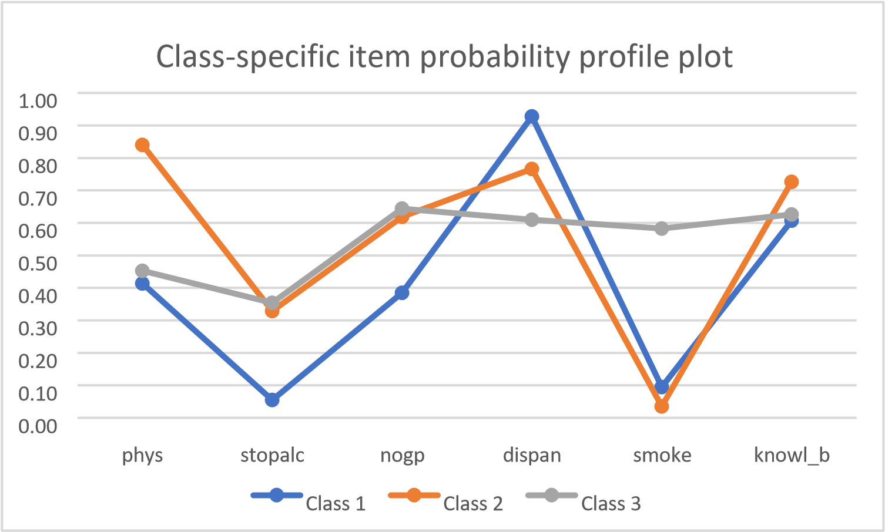

Table S4. LCA structural equation model and measurement models
 | (1) | (2) | (3) | (4) | (5) | (6) | (7) | (8) | (9)
VARIABLES | 1b.C | 2.C | 3.C | phys | stopalc | nogp | dispan | smoke | knowl_b
o.female | -
o.age | -
o.uni | -
o.fin_const | -
o._cons | 0.000  (0.000)
female |  | -4.562*** | -3.361***
 |  | (0.594) | (0.265)
age |  | -0.222*** | -0.095***
 |  | (0.035) | (0.014)
uni |  | 1.460*** | -1.019***
 |  | (0.528) | (0.219)
fin_const |  | -0.625 | 0.753***
 |  | (0.733) | (0.241)
1bn.C |  |  |  | -0.346*** | -2.843*** | -0.467*** | 2.551*** | -2.257*** | 0.435***
 |  |  |  | (0.064) | (0.197) | (0.064) | (0.151) | (0.148) | (0.060)
2.C |  |  |  | 1.660*** | -0.713*** | 0.484*** | 1.188*** | -3.296** | 0.977***
 |  |  |  | (0.362) | (0.193) | (0.181) | (0.217) | (1.347) | (0.205)
3.C |  |  |  | -0.189** | -0.602*** | 0.592*** | 0.447*** | 0.334** | 0.515***
 |  |  |  | (0.093) | (0.099) | (0.094) | (0.093) | (0.135) | (0.084)
Constant |  | 11.196*** | 6.829***
 |  | (1.644) | (0.919)
Observations | 2,701 | 2,701 | 2,701 | 2,701 | 2,701 | 2,701 | 2,701 | 2,701 | 2,701

Note: For measurement models: family- Bernoulli, link - logit; standard errors in parentheses *** p<0.01, ** p<0.05, * p<0.1

Figure S2. Mediation analysis with GSEM for CVD risk score and GP visits as a mediator
