Supplementary materials: Funnel plots

Figure S1 – S10: Comparison-adjusted funnel plot for each outcome in this network meta-analysis.

Figure S1 Comparison-adjusted funnel plot for each outcome in this network meta-analysis for TST.
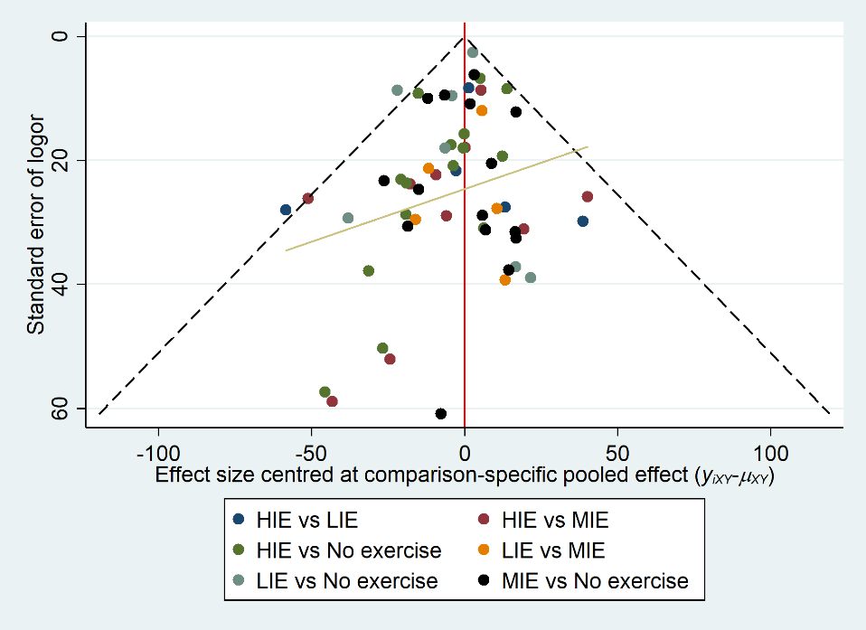
Abbreviations: TST, total sleep time. LIE, low-intensity exercise. MIE, moderate-intensity exercise. HIE, high-intensity exercise.

Figure S2 Comparison-adjusted funnel plot for each outcome in this network meta-analysis for SOL.
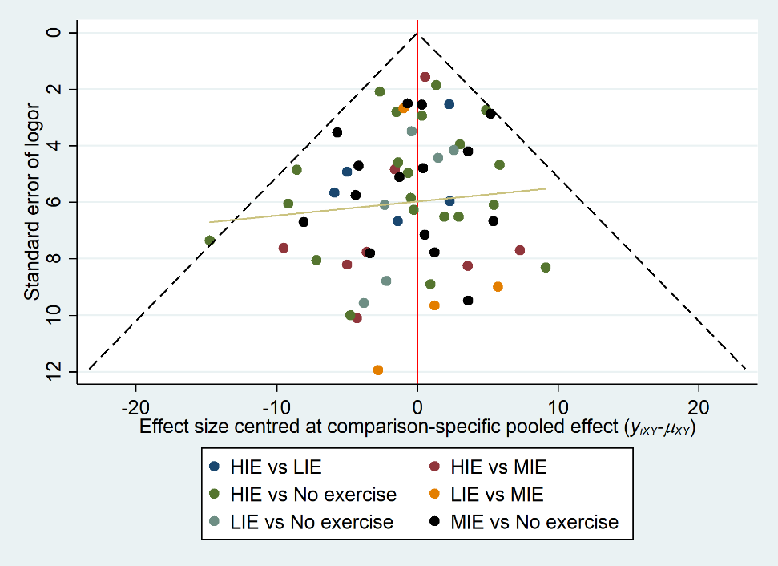
Abbreviations: SOL, sleep onset latency. LIE, low-intensity exercise. MIE, moderate-intensity exercise. HIE, high-intensity exercise.

Figure S3 Comparison-adjusted funnel plot for each outcome in this network meta-analysis for WASO.
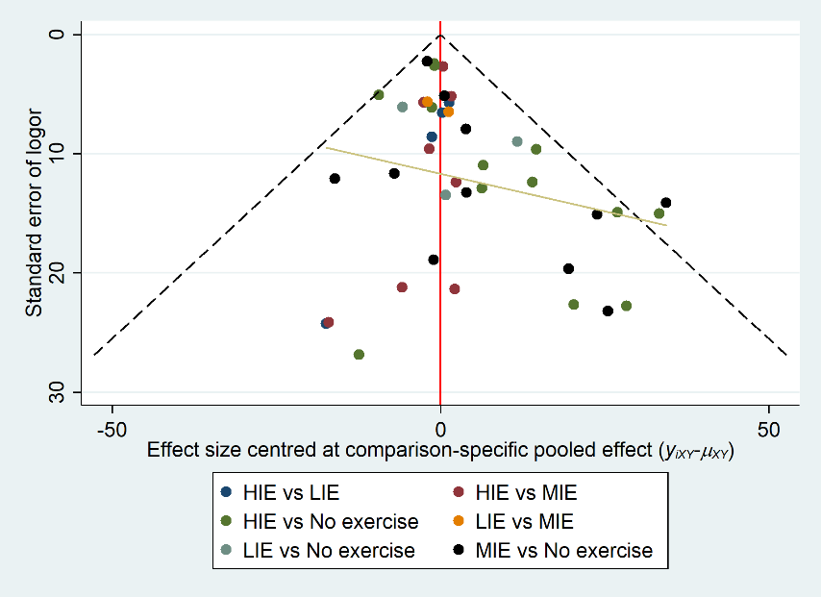
Abbreviations: WASO, wake time after sleep onset. LIE, low-intensity exercise. MIE, moderate-intensity exercise. HIE, high-intensity exercise.

Figure S4 Comparison-adjusted funnel plot for each outcome in this network meta-analysis for SE.
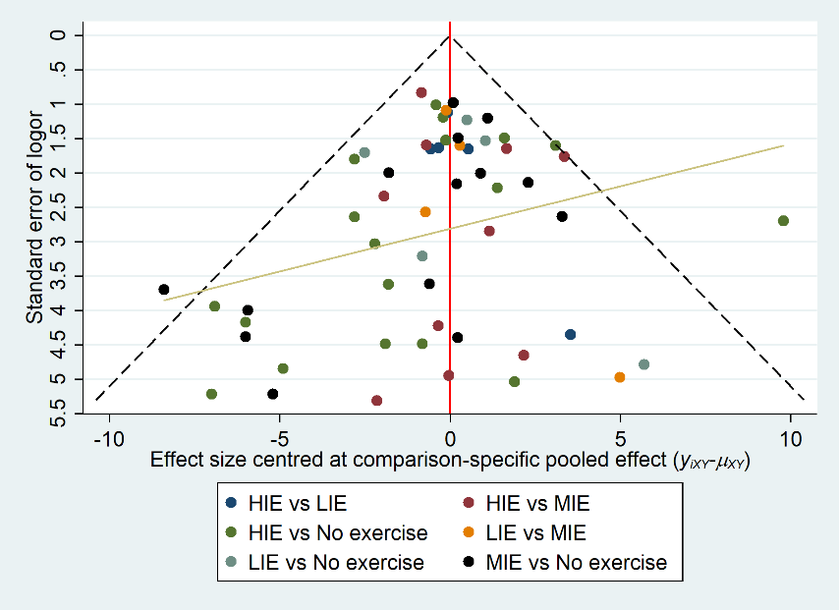
Abbreviations: SE, sleep efficiency. LIE, low-intensity exercise. MIE, moderate-intensity exercise. HIE, high-intensity exercise.

Figure S5 Comparison-adjusted funnel plot for each outcome in this network meta-analysis for REM-L.
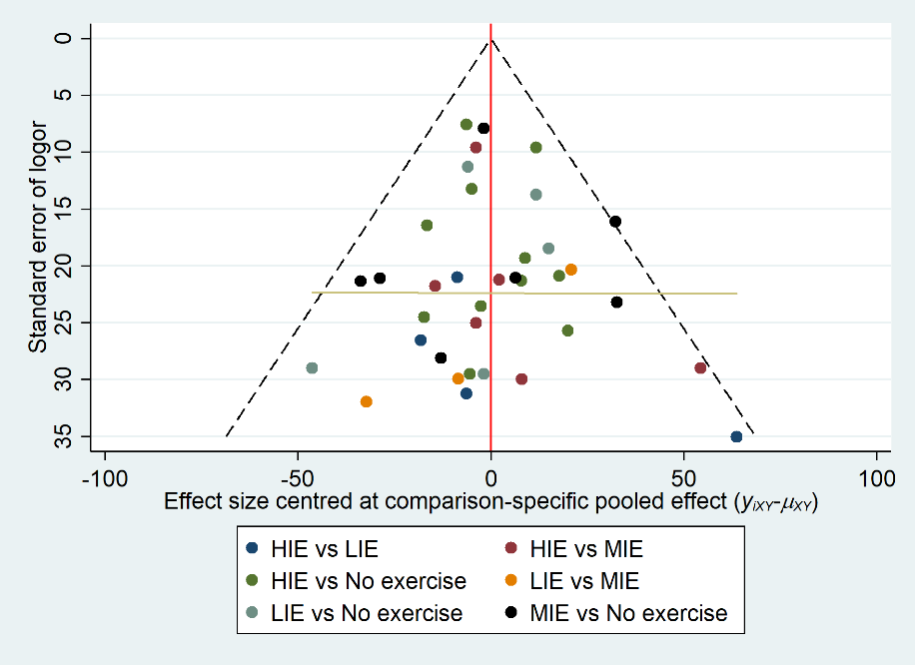
Abbreviations: REM-L, rapid eye movement latency. LIE, low-intensity exercise. MIE, moderate-intensity exercise. HIE, high-intensity exercise.

Figure S6 Comparison-adjusted funnel plot for each outcome in this network meta-analysis for stage N1 sleep.
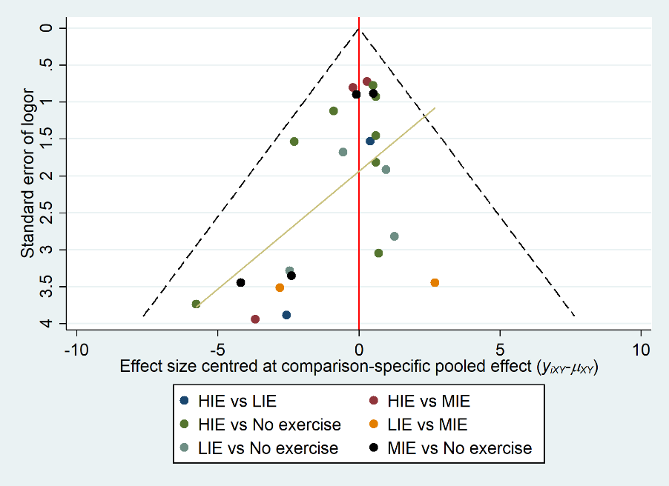
Abbreviations: LIE, low-intensity exercise. MIE, moderate-intensity exercise. HIE, high-intensity exercise.

Figure S7 Comparison-adjusted funnel plot for each outcome in this network meta-analysis for stage N2 sleep.
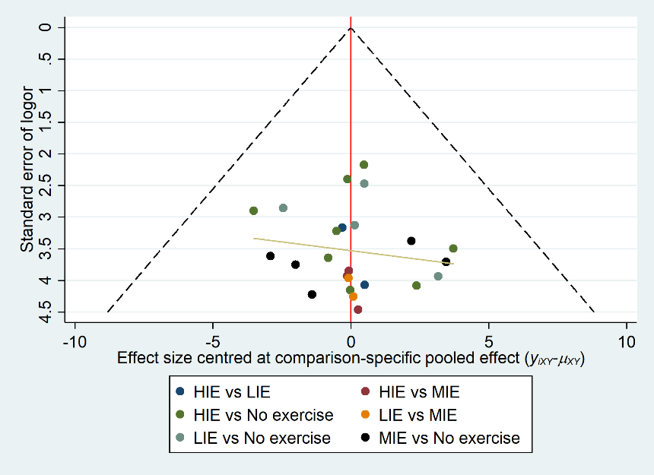
Abbreviations: LIE, low-intensity exercise. MIE, moderate-intensity exercise. HIE, high-intensity exercise.

Figure S8 Comparison-adjusted funnel plot for each outcome in this network meta-analysis for stage N3 sleep (SWS).
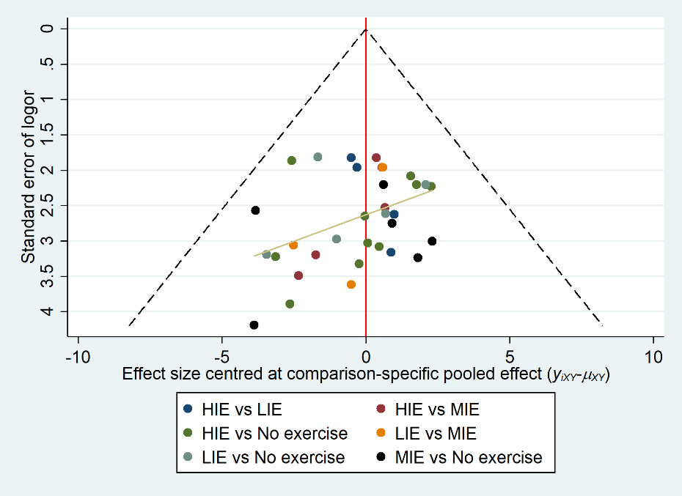
Abbreviations: SWS, slow-wave sleep. LIE, low-intensity exercise. MIE, moderate-intensity exercise. HIE, high-intensity exercise.

Figure S9 Comparison-adjusted funnel plot for each outcome in this network meta-analysis for REM.
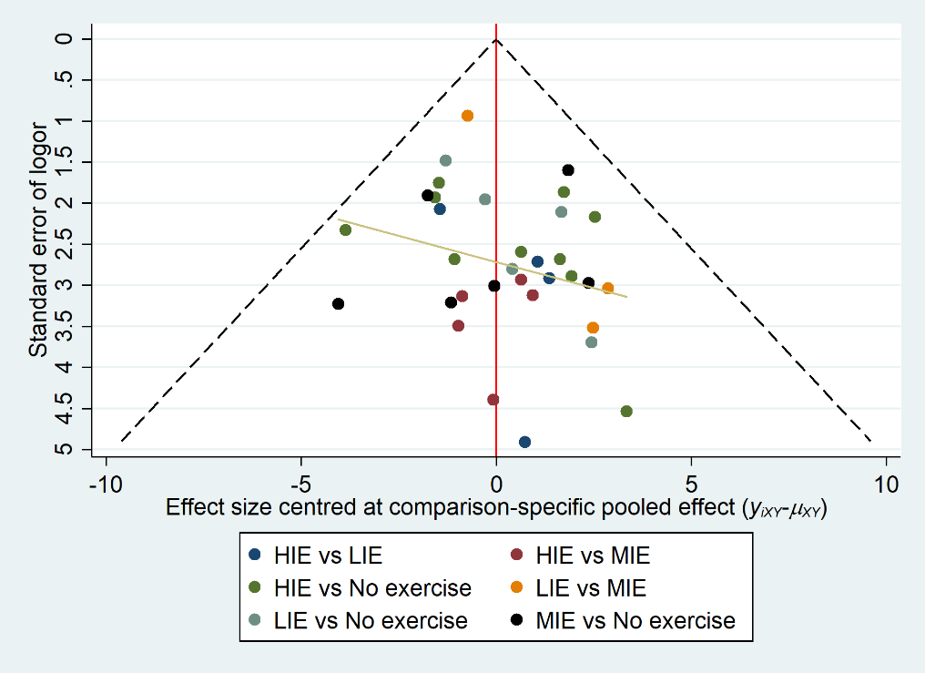
Abbreviations: REM, rapid eye movement. LIE, low-intensity exercise. MIE, moderate-intensity exercise. HIE, high-intensity exercise.

Figure S10 Comparison-adjusted funnel plot for each outcome in this network meta-analysis for SSQ
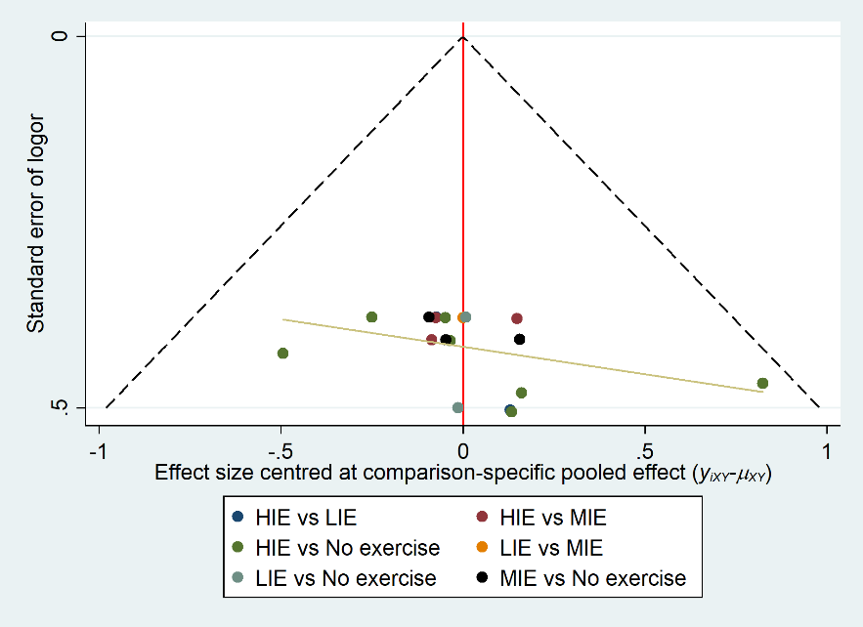
Abbreviations: SSQ, subjective sleep quality. LIE, low-intensity exercise. MIE, moderate-intensity exercise. HIE, high-intensity exercise.

Supplementary materials: Supplementary tables

Table S1: Risk of bias assessment of the included studies.

Table S2 – S11: League tables with network (lower diagonal) and direct (upper diagonal) evidence.

Table S12: Evaluation of the inconsistency by node-splitting method.

Table S13: Subgroup analyses

Table S1 Risk of bias assessment of the included studies with the revised Cochrane risk of bias tool (RoB 2).
Study ID | Randomization process | Deviations from the intended interventions | Missing outcome data | Measurement of the outcome | Selection of the reported result | Overall
Arias et al 2016 ²⁸ | 
Aloulou et al 2020 ²⁹
Browman & Tepas 1976 ¹⁶ | 
Bulckaert et al 2011 ³⁰
Driver et al 1988 ³¹
Flausino et al 2012 ⁴⁴
Hayashi et al 2014 ⁴⁸
Kern et al 1995 ⁴⁵
Larsen et al 2019 ³²
Miller et al 2020 ¹²
Miura et al 2016 ³³
Myllymäki et al 2011 ³⁴
Myllymäki et al 2012 ²⁰
O’Connor et al 1998 ⁴⁶
Oda & Shirakawa 2014 ¹⁵
Park et al 2021 ³⁵
Ramos-Campo et al 2019 ¹⁷
Robey et al 2013 ³⁶
Saidi et al 2020 ³⁷
Thomas et al 2020 ¹⁹
Ucar et al 2017 ³⁸
Vincent et al 2020 ³⁹
Vitale et al 2017 ⁴⁰
Vlahoyiannis et al 2021 ¹⁸
Wong et al 2013 ⁴⁷
Yamanaka et al 2015 ⁴³
Yoshida et al 1998 ⁴¹
Youngstedt et al 1999 ⁴²
Notes: Green (+) circles represent low risk of bias, red (-) circles high risk of bias, and (?) Some concerns.

Table S2 League table with network (lower diagonal) and direct (upper diagonal) evidence for different intensities of acute evening exercise on TST.
No exercise | -3.65 (-11.00, 8.19) I² = 18.0% | -2.49 (-10.40, 5.71) I² = 0 % | -0.79 (-9.85, 8.70) I² = 0 %
3.04 (-7.34, 10.19) I² = 24.7 % | LIE | -1.01 (-26.30, 24.50) I² = 0 % | -1.10 (-19.20, 19.00) I² = 0 %
1.62 (-6.00, 9.17) I² = 0 % | -1.27 (-11.06, 10.59) I² = 0 % | MIE | -4.38 (-20.40, 12.20) I² = 0 %
2.11 (-6.24, 10.01) I² = 0 % | -0.69 (-10.48, 10.59) I² = 0 % | 0.53 (-9.41, 9.86) I² = 0 % | HIE
Notes: Effect estimates were presented as mean differences with 95% credible intervals.
Abbreviations: LIE, low-intensity exercise. MIE, moderate-intensity exercise. HIE, high-intensity exercise. TST, total sleep time

Table S3 League table with network (lower diagonal) and direct (upper diagonal) evidence for different intensities of acute evening exercise on SOL.
No exercise | -3.14 (-8.23, 1.83) I² = 0 % | -0.13 (-2.54, 2.24) I² = 0 % | -0.60 (-2.61, 1.29) I² = 0 %
1.02 (-2.50, 4.39) I² = 0 % | LIE | -3.22 (-10.90, 4.40) I² = 0 % | -0.63 (-5.44, 4.50) I² = 0 %
0.76 (-1.28, 2.87) I² = 0 % | -0.23 (-3.85, 3.43) I² = 0 % | MIE | 0.85 (-2.56, 4.49) I² = 0 %
0.54 (-1.31, 2.31) I² = 0 % | -0.48 (-3.95, 3.01) I² = 0 % | -0.22 (-2.64, 2.08) I² = 0 % | HIE
Notes: Effect estimates were presented as mean differences with 95% credible intervals.
Abbreviations: LIE, low-intensity exercise. MIE, moderate-intensity exercise. HIE, high-intensity exercise. SOL, sleep onset latency.

Table S4 League table with network (lower diagonal) and direct (upper diagonal) evidence for different intensities of acute evening exercise on WASO.
No exercise | -5.88 (-18.70, 7.18) I² = 0 % | -2.25 (-7.69, 2.43) I² = 0 % | -0.02 (-4.70, 3.95) I² = 3.0 %
1.87 (-4.78, 9.51) I² = 0 % | LIE | -1.84 (-11.00, 7.43) I² = 0 % | -0.23 (-10.50, 9.81) I² = 0 %
2.50 (-1.62, 8.17) I² = 0 % | 0.67 (-6.16, 7.61) I² = 0 % | MIE | 1.26 (-4.38, 7.06) I² = 0 %
0.64 (-2.91, 5.85) I² = 5.2 % | -1.16 (-7.96, 5.68) I² = 0 % | -1.85 (-6.54, 2.67) I² = 0 % | HIE
Notes: Effect estimates were presented as mean differences with 95% credible intervals.
Abbreviations: LIE, low-intensity exercise. MIE, moderate-intensity exercise. HIE, high-intensity exercise. WASO, wake time after sleep onset.

Table S5 League table with network (lower diagonal) and direct (upper diagonal) evidence for different intensities of acute evening exercise on SE.
No exercise | 0.89 (-1.48, 3.15) I² = 0 % | 0.15 (-1.08, 1.42) I² = 0 % | -1.61 (-1.38, 1.08) I² = 33.0 %
-0.29 (-1.91, 1.27) I² = 0 % | LIE | -0.02 (-2.36, 2.23) I² = 0 % | 0.11 (-1.89, 2.13) I² = 0 %
-0.41 (-1.66, 0.71) I² = 0 % | -0.12 (-1.79, 1.47) I² = 0 % | MIE | -0.72 (-2.36, 0.75) I² = 0 %
0.17 (-0.94, 1.25) I² = 29.1 % | 0.45 (-1.07, 2.05) I² = 0 % | 0.58 (-0.61, 1.90) I² = 0 % | HIE
Notes: Effect estimates were presented as mean differences with 95% credible intervals.
Abbreviations: LIE, low-intensity exercise. MIE, moderate-intensity exercise. HIE, high-intensity exercise. SE, sleep efficiency.

Table S6 League table with network (lower diagonal) and direct (upper diagonal) evidence for different intensities of acute evening exercise on REM-L.
No exercise | 12.6 (-4.41, 29.9) I² = 0 % | 3.12 (-11.50, 17.60) I² = 14.8 % | 8.28 (-2.35, 19.20) I² = 0 %
-8.99 (-24.14, 6.10) I2 = 0 % | LIE | 16.9 (-21.4, 55.00) I² = 0 % | -0.52 (-38.30, 39.20) I² = 0 %
-4.84 (-17.74, 7.57) I² = 15.6 % | 4.15 (-14.21 22.13) I² = 0 % | MIE | 5.27 (-17.50, 27.70) I² = 0 %
-8.57 (-18.58, 1.80) I² = 0 % | 0.50 (-16.66, 17.58) I² = 0 % | -3.79 (-17.67, 10.97)  I² = 0 % | HIE
Notes: Effect estimates were presented as mean differences with 95% credible intervals.
Abbreviations: LIE, low-intensity exercise. MIE, moderate-intensity exercise. HIE, high-intensity exercise. REM-L, rapid eye movement latency.

Table S7 League table with network (lower diagonal) and direct (upper diagonal) evidence for different intensities of acute evening exercise on the proportion of stage N1 sleep.
No exercise | 0.03 (-2.54, 2.59) I² = 0 % | -1.07 (-2.88, 0.82) I² = 0 % | -0.67 (-1.78, 0.46) I² = 0 %
0.39 (-1.59, 2.49) I² = 0 % | LIE | 1.79 (-4.69, 8.30) I² = 0 % | -0.18 (-3.50, 3.39) I² = 0 %
0.72 (-0.71, 2.08) I² = 0 % | 0.33 (-2.02, 2.57) I² = 0 % | MIE | -0.01 (-1.48, 1.50) I² = 0 %
0.66 (-0.44, 1.69) I² = 0 % | 0.26 (-1.87, 2.31) I² = 0 % | -0.06 (-1.39, 1.25) I² = 0 % | HIE

Notes: Effect estimates were presented as mean differences with 95% credible intervals.
Abbreviations: LIE, low-intensity exercise. MIE, moderate-intensity exercise. HIE, high-intensity exercise.

Table S8 League table with network (lower diagonal) and direct (upper diagonal) evidence for different intensities of acute evening exercise on the proportion of stage N2 sleep.
No exercise | 1.52 (-2.03, 5.02) I² = 0 % | 2.13 (-1.81, 6.04) I² = 0 % | 2.12 (-0.33, 4.52) I² = 0 %
-1.62 (-4.68, 1.45) I² = 0 % | LIE | 0.23 (-8.45, 9.16) I² = 0 % | 0.55 (-6.21, 7.34) I² = 0 %
-2.13 (-5.30, 1.19) I² = 0 % | -0.47 (-4.61, 3.66) I² = 0 % | MIE | -0.24 (-6.71, 5.98) I² = 0 %
-2.09 (-4.34, 0.12) I² = 0 % | -0.46 (-4.05, 3.08) I² = 0 % | 0.02 (-3.51, 3.64) I² = 0 % | HIE
Notes: Effect estimates were presented as mean differences with 95% credible intervals.
Abbreviations: LIE, low-intensity exercise. MIE, moderate-intensity exercise.

Table S9 League table with network (lower diagonal) and direct (upper diagonal) evidence for different intensities of acute evening exercise on the proportion of stage N3 sleep (slow-wave sleep).
No exercise | -0.45 (-2.98, 1.95) I² = 0 % | 0.36 (-2.34, 3.12) I² = 0 % | -0.30 (-2.23, 1.66) I² = 0 %
0.64 (-1.27, 2.55) I2 = 0 % | LIE | 2.00 (-1.37, 5.25) I² = 0 % | 0.19 (-2.65, 3.18) I² = 0 %
-0.84 (-2.78, 1.17) I² = 0 % | -1.50 (-3.65, 0.74) I² = 0 % | MIE | -1.39 (-4.30, 1.52) I² = 0 %
0.41 (-1.24, 2.04) I² = 0 % | -0.24 (-2.27, 1.78) I² = 0 % | 1.25 (-0.83, 3.24) I² = 0 % | HIE
Notes: Effect estimates were presented as mean differences with 95% credible intervals.
Abbreviations: LIE, low-intensity exercise. MIE, moderate-intensity exercise.

Table S10 League table with network (lower diagonal) and direct (upper diagonal) evidence for different intensities of acute evening exercise on the proportion of rapid eye movement sleep.
No exercise | -0.87 (-3.11, 1.36) I² = 0 % | -0.68 (-3.12, 1.73) I² = 0 % | -1.85 (-3.49, -0.18) I² = 0 %
0.10 (-1.75, 2.14) I² = 0 % | LIE | -2.91 (-5.07, -0.40) I² = 0 % | -1.06 (-4.93, 2.71) I² = 0 %
1.56 (-0.48, 3.45) I² = 0 % | 1.48 (-1.03, 3.43) I² = 0 % | MIE | -1.75 (-5.68, 2.47) I² = 0 %
1.95 (0.35, 3.58) I² = 0 % | 1.83 (-0.42, 3.94) I² = 0 % | 0.36 (-1.81, 2.76) I² = 0 % | HIE
Notes: Effect estimates were presented as mean differences with 95% credible intervals.
Abbreviations: LIE, low-intensity exercise. MIE, moderate-intensity exercise.

Table S11 League table with network (lower diagonal) and direct (upper diagonal) evidence for different intensities of acute evening exercise on SSQ.
No exercise | -0.13 (-0.73, 0.46) I² = 0 % | 0.05 (-0.40, 0.50) I² = 0 % | -0.33 (-0.65, -0.02) I² = 0 %
0.16 (-0.37, 0.67) I² = 0 % | LIE | 0.29 (-0.46, 1.03) I² = 0 % | -0.22 (-0.81, 0.38) I² = 0 %
0.01 (-0.42, 0.44) I² = 0 % | -0.15 (-0.73, 0.43) I² = 0 % | MIE | -0.28 (-0.72, 0.16) I² = 0 %
0.34 (0.00, 0.67) I² = 0 % | 0.18 (-0.34, 0.73) I² = 0 % | 0.33 (-0.11, 0.77) I² = 0 % | HIE
Notes: Effect estimates were presented as standardized mean differences with 95% credible intervals.
Abbreviations: LIE, low-intensity exercise. MIE, moderate-intensity exercise. SSQ, subjective sleep quality

Table S12 Evaluation of the inconsistency by node-splitting method for outcomes.
Outcomes | Comparison | Direct | Indirect | p value
TST (min) | LIE vs. No exercise | -3.65 (-11.00, 8.19) | - | -
TST (min) | MIE vs. No exercise | -2.49 (-10.4, 5.71) | 4.84 (-18.60, 28.30) | 0.12
TST (min) | HIE vs. No exercise | -0.79 (-9.85, 8.70) | -7.92 (-27.00, 11.20) | 0.08
TST (min) | MIE vs. LIE | -1.01 (-26.3, 24.50) | 1.46 (-10.50, 13.40) | 0.84
TST (min) | HIE vs. LIE | -1.10 (-19.20, 19.00) | 1.17 (-11.60, 14.00) | 0.83
TST (min) | HIE vs. MIE | -4.38 (-20.40, 12.2) | 1.77 (-10.40, 13.90) | 0.70
SOL (min) | LIE vs. No exercise | -3.14 (-8.23, 1.83) | - | -
SOL (min) | MIE vs. No exercise | -0.13 (-2.54, 2.24) | - | -
SOL (min) | HIE vs. No exercise | -0.60 (-2.61, 1.29) | - | -
SOL (min) | MIE vs. LIE | -3.22 (-10.90, 4.40) | 1.30 (-2.93, 5.53) | 0.08
SOL (min) | HIE vs. LIE | -0.63 (-5.44, 4.50) | 1.41 (-3.16, 5.97) | 0.92
SOL (min) | HIE vs. MIE | 0.85 (-2.56, 4.49) | -0.16 (-3.26, 2.95) | 0.54
REM-L (min) | LIE vs. No exercise | 12.60 (-4.41, 29.9) | - | -
REM-L (min) | MIE vs. No exercise | 3.12 (-11.50, 17.60) | - | -
REM-L (min) | HIE vs. No exercise | 8.28 (-2.35, 19.2) | - | -
REM-L (min) | MIE vs. LIE | 16.90 (-21.4, 55.00) | -10.70 (-31.60, 10.20) | 0.14
REM-L (min) | HIE vs. LIE | -0.52 (-38.30, 39.20) | -0.61 (-20.10, 18.80) | 0.56
REM-L (min) | HIE vs. MIE | 5.27 (-17.5, 27.7) | 2.81 (-15.30. 20.90) | 0.82
WASO (min) | LIE vs. No exercise | -5.88 (-18.70, 7.18) | - | -
WASO (min) | MIE vs. No exercise | -2.25 (-7.69, 2.43) | - | -
WASO (min) | HIE vs. No exercise | -0.02 (-4.70, 3.95) | - | -
WASO (min) | MIE vs. LIE | -1.84 (-11.00, 7.43) | 0.76 (-9.61, 11.10) | 0.36
WASO (min) | HIE vs. LIE | -0.23 (-10.50, 9.81) | - | -
WASO (min) | HIE vs. MIE | 1.26 (-4.38, 7.06) | 3.21 (-4.79, 11.20) | 0.98
SE (%) | LIE vs. No exercise | 0.89 (-1.48, 3.15) | - | -
SE (%) | MIE vs. No exercise | 0.15 (-1.08, 1.42) | 2.58 (-1.07, 6.22) | 0.16
SE (%) | HIE vs. No exercise | -1.61 (-1.38, 1.08) | -0.15 (-2.53, 2.22) | 0.10
SE (%) | MIE vs. LIE | -0.02 (-2.36, 2.23) | 0.27 (-2.08, 2.63) | 0.76
SE (%) | HIE vs. LIE | 0.11 (-1.89, 2.13) | -1.33 (-3.89, 1.23) | 0.46
SE (%) | HIE vs. MIE | -0.72 (-2.36, 0.75) | -0.25 (-2.41, 1.91) | 0.87
N1 (%) | LIE vs. No exercise | 0.03 (-2.54, 2.59) | - | -
N1 (%) | MIE vs. No exercise | -1.07 (-2.88, 0.82) | - | -
N1 (%) | HIE vs. No exercise | -0.67 (-1.78, 0.46) | - | -
N1 (%) | MIE vs. LIE | 1.79 (-4.69, 8.30) | -0.65 (-3.14, 1.84) | 0.34
N1 (%) | HIE vs. LIE | -0.18 (-3.50, 3.39) | -0.34 (-3.07, 2.38) | 0.90
N1 (%) | HIE vs. MIE | -0.01 (-1.48, 1.50) | 0.26 (-2.65, 3.17) | 0.24
N2 (%) | LIE vs. No exercise | 1.52 (-2.03, 5.02) | - | -
N2 (%) | MIE vs. No exercise | 2.13 (-1.81, 6.04) | - | -
N2 (%) | HIE vs. No exercise | 2.12 (-0.33, 4.52) | - | -
N2 (%) | MIE vs. LIE | 0.23 (-8.45, 9.16) | 0.56 (-4.09, 5.21) | 0.79
N2 (%) | HIE vs. LIE | 0.55 (-6.21, 7.34) | 0.44 (-3.73, 4.60) | 0.94
N2 (%) | HIE vs. MIE | -0.24 (-6.71, 5.98) | 0.09 (-4.44, 4.61) | 0.79
N3 (%) | LIE vs. No exercise | -0.45 (-2.98, 1.95) | - | -
N3 (%) | MIE vs. No exercise | 0.36 (-2.34, 3.12) | - | -
N3 (%) | HIE vs. No exercise | -0.30 (-2.23, 1.66) | - | -
N3 (%) | MIE vs. LIE | 2.00 (-1.37, 5.25) | 1.08 (-1.92, 4.09) | 0.33
N3 (%) | HIE vs. LIE | 0.19 (-2.65, 3.18) | 0.32 (-2.47, 3.11) | 0.71
N3 (%) | HIE vs. MIE | -1.39 (-4.30, 1.52) | -1.10 (-3.85, 1.65) | 0.87
REM (%) | LIE vs. No exercise | -0.87 (-3.11, 1.36) | - | -
REM (%) | MIE vs. No exercise | -0.68 (-3.12, 1.73) | - | -
REM (%) | HIE vs. No exercise | -1.85 (-3.49, -0.18) | - | -
REM (%) | MIE vs. LIE | -2.91 (-5.07, -0.40) | 2.19 (-2.19, 6.55) | 0.09
REM (%) | HIE vs. LIE | -1.06 (-4.93, 2.71) | -2.22 (-4.92, -.487) | 0.62
REM (%) | HIE vs. MIE | -1.75 (-5.68, 2.47) | 0.22 (-2.52, 2.96) | 0.30
SSQ | LIE vs. No exercise | -0.13 (-0.73, 0.46) | -0.19 (-1.30, 0.92) | 0.93
SSQ | MIE vs. No exercise | 0.05 (-0.40, 0.50) | -0.11 (-0.97, 0.65) | 0.73
SSQ | HIE vs. No exercise | -0.33 (-0.65, -0.02) | -0.10 (-1.20, 0.99) | 0.69
SSQ | MIE vs. LIE | 0.29 (-0.46, 1.03) | -0.03 (-0.90, 0.85) | 0.60
SSQ | HIE vs. LIE | -0.22 (-0.81, 0.38) | -0.01 (-1.12, 1.10) | 0.75
SSQ | HIE vs. MIE | -0.28 (-0.72, 0.16) | -0.47 (-1.26, 0.32) | 0.68
Notes: Effect estimates of outcomes were presented as mean differences with 95% credible intervals except SSQ was presented as standardized mean differences with 95% credible intervals.
Abbreviations: LIE, low-intensity exercise. MIE, moderate-intensity exercise. HIE, high-intensity exercise. TST, total sleep time. SOL, sleep onset latency. WASO, wake time after sleep onset. SE, sleep efficiency. REM, rapid eye movement. REM-L, rapid eye movement latency. N1, stage N1 sleep. N2, stage N2 sleep. N3, stage N3 sleep. SSQ, subjective sleep quality.

 | Table S13. Subgroup analyses
 | Sleep measures | Comparisons | Time of evening exercise |  |  | Hours from cessation of exercise to bedtime |  |  |  |  | Exercise modality |  |  | Physical activity level |  |  | Duration
 | Sleep measures | Comparisons | Early evening: 16:00 to 20:00 | Late evening: after 20:00 |  | 0.5-1.5 h | 2h | ＞2-4 h |  | Cycling |  | Running |  | Physically fit | Sedentary |  | 25-30min | > 30-60min
 | TST (min) | LIE vs No exercise | 7.23 (-6.05, 20.70) | -8.24 (-24.16, 6.48) |  | -18.46 (-89.58, 51.26) | -9.52 (-39.33, 12.09) | 6.83 (-6.32, 21.23) |  |  | -8.48 (-21.92, 1.92) | 11.67 (-3.98, 28.31) |  | -4.06 (-11.84, 6.81) | 12.80 (-19.42, 45.11) |  | 0.31 (-31.48, 32.99) | -1.36 (-11.53, 12.01)
 | TST (min) | MIE vs No exercise | -0.94 (-13.57, 11.19) | -1.14 (-11.42, 10.98) |  | -4.22 (-17.66, 9.57) | 3.34 (-23.35, 29.52) | 0.62 (-11.49, 12.97) |  |  | -6.30 (-18.37, 5.32) | 3.00 (-8.07, 14.99) |  | -3.55 (-12.47, 5.34) | 6.69 (-11.83, 25.43) |  | -3.49 (-13.94, 7.43) | -0.14 (-12.33, 11.57)
 | TST (min) | HIE vs No exercise | 0.81 (-11.17, 13.36) | -5.69 (-18.24, 7.71) |  | -11.34 (-30.17, 8.88) | 11.17 (-9.46, 33.75) | -0.90 (-13.18, 11.44) |  |  | 0.41 (-11.73, 15.46) | 0.41 (-11.08, 12.60) |  | -4.21 (-13.04, 5.13) | 9.71 (-11.12, 31.43) |  | -6.08 (-16.63, 5.38) | 1.59 (-11.12, 14.86)
 | TST (min) | MIE VS LIE | -8.05 (-24.80, 7.84) | 7.05 (-9.54, 27.60) |  | 14.25 (-55.67, 85.77) | 13.63 (-18.38, 49.21) | -6.30 (-22.73, 9.86) |  |  | 2.34 (-12.33, 18.12) | -8.71 (-26.28, 8.87) |  | 0.28 (-12.75, 11.38) | -6.08 (-38.16, 25.92) |  | -3.83 (-37.04, 28.27) | 0.89 (-15.22, 15.69)
 | TST (min) | HIE VS LIE | -6.31 (-21.47, 8.81) | 2.43 (-15.53, 23.58) |  | 7.17 (-64.27, 80.69) | 21.17 (-5.77, 56.55) | -7.74 (-23.44, 7.06) |  |  | 8.89 (-6.41, 30.18) | -11.25 (-27.75, 4.96) |  | -0.38 (-12.86, 10.65) | -3.01 (-34.63, 28.97) |  | -6.32 (-40.13, 26.19) | 2.90 (-13.16, 17.06)
 | TST (min) | HIE VS MIE | 1.68 (-13.88, 18.68) | -4.63 (-18.69, 9.22) |  | -7.11 (-27.45, 14.31) | 7.83 (-17.88, 35.00) | -1.58 (-17.29, 13.97) |  |  | 6.73 (-9.46, 26.17) | -2.61 (-15.75, 10.48) |  | -0.62 (-11.83, 10.97) | 2.98 (-18.24, 24.80) |  | -2.57 (-15.77, 11.04) | 1.88 (-13.46, 17.51)
 | SOL (min) | LIE vs No exercise | -3.63 (-8.14, 0.95) | 0.41 (-16.63, 17.03) |  | 0.64 (-19.27, 20.44) | 0.59 (-7.81, 8.86) | -3.37 (-7.77, 1.06) |  |  | 1.05 (-5.27, 6.84) | -2.76 (-7.39, 1.84) |  | -3.62 (-8.82, 1.53) | 0.22 (-5.08, 5.17) |  | - | -1.14 (-4.72, 2.41)
 | SOL (min) | MIE vs No exercise | -0.66 (-3.60, 2.19) | 0.90 (-3.53, 5.38) |  | 1.43 (-7.53, 10.19) | -1.98 (-6.93, 3.35) | -0.71 (-3.45, 2.06) |  |  | -1.50 (-5.27, 2.20) | -0.28 (-3.13, 2.61) |  | 0.01 (-3.53, 3.64) | -1.66 (-4.56, 1.32) |  | -0.21 (-7.32, 6.94) | -0.88 (-3.14, 1.37)
 | SOL (min) | HIE vs No exercise | -1.64 (-4.29, 0.93) | 1.94 (-1.22, 5.47) |  | 4.38 (-4.31, 17.08) | -2.29 (-7.16, 2.85) | -1.19 (-3.66, 1.26) |  |  | -1.84 (-5.20, 0.95) | 1.08 (-1.63, 3.97) |  | 0.56 (-1.62, 3.00) | -2.51 (-6.06, 0.74) |  | 1.17 (-3.41, 6.73) | -0.86 (-3.05, 1.25)
 | SOL (min) | MIE VS LIE | 2.97 (-2.39, 8.20) | 0.52 (-16.30, 17.64) |  | 0.74 (-19.48, 20.68) | -2.56 (-10.54, 6.01) | 2.64 (-2.44, 7.81) |  |  | -2.53 (-8.58, 3.85) | 2.49 (-2.84, 7.68) |  | 3.66 (-2.58, 9.89) | -1.87 (-6.82, 3.38) |  | - | 0.26 (-3.61, 4.14)
 | SOL (min) | HIE VS LIE | 1.99 (-2.87, 6.67) | 1.61 (-15.39, 19.01) |  | 4.06 (-17.11, 27.37) | -2.91 (-10.80, 5.59) | 2.17 (-2.36, 6.80) |  |  | -2.92 (-8.96, 3.15) | 3.86 (-0.95, 8.88) |  | 4.20 (-1.04, 9.56) | -2.74 (-7.63, 2.17) |  | - | 0.27 (-3.34, 3.86)
 | SOL (min) | HIE VS MIE | -0.99 (-4.60, 2.75) | 1.05 (-4.11, 6.55) |  | 3.15 (-8.16, 17.75) | -0.31 (-5.98, 5.28) | -0.48 (-4.01, 3.02) |  |  | -0.36 (-4.56, 3.38) | 1.35 (-2.36, 5.21) |  | 0.54 (-3.40 4.68) | -0.86 (-4.48, 2.52) |  | 1.42 (-6.10, 9.71) | 0.01 (-2.64, 2.66)
 | REM-L (min) | LIE vs No exercise | -2.49 (-23.46, 19.48) | 18.84 (-13.59, 50.91) |  | - | 27.62 (-9.69, 74.25) | -2.92 (-24.37, 19.67) |  |  | 17.33 (-5.50, 46.57) | 3.74 (-22.55, 29.88) |  | 6.75 (-13.84, 26.77) | 15.67 (-16.89, 49.67) |  | - | 10.34 (-6.93, 27.83)
 | REM-L (min) | MIE vs No exercise | 1.64 (-20.66, 25.20) | 1.98 (-21.12, 21.28) |  | 6.45 (-16.74, 29.94) | 5.24 (-30.30, 39.76) | 1.16 (-22.21, 25.76) |  |  | 38.78 (3.99, 73.80) | -1.27 (-16.99, 13.10) |  | 12.85 (-8.02, 38.89) | -1.25 (-20.01, 19.12) |  | -1.60 (-30.40, 20.79) | 9.93 (-8.09, 29.48)
 | REM-L (min) | HIE vs No exercise | 5.04 (-10.43, 22.01) | 12.45 (-7.30, 29.71) |  | 14.84 (-8.12, 37.78) | 5.11 (-28.56, 33.89) | 2.61 (-15.16, 22.63) |  |  | 1.74 (-20.92, 23.33) | 10.66 (-3.97, 24.28) |  | 15.56 (-2.59, 33.94) | 2.94 (-13.38, 19.39) |  | 5.93 (-14.05, 23.59) | 10.56 (-6.72, 27.00)
 | REM-L (min) | MIE VS LIE | 4.08 (-22.53, 30.81) | -16.77 (-57.02, 19.82) |  | - | -22.72 (-77.81, 23.71) | 4.11 (-22.38, 31.91) |  |  | 21.22 (-18.23, 56.54) | -5.01 (-33.53, 22.89) |  | 6.17 (-19.90, 37.22) | -17.04 (-51.18, 17.15) |  | - | -0.34 (-22.42, 22.67)
 | REM-L (min) | HIE VS LIE | 7.56 (-16.70, 31.52) | -6.42 (-44.69, 29.52) |  | - | -22.71 (-79.09, 20.21) | 5.71 (-19.28, 31.15) |  |  | -15.71 (-52.37, 14.08) | 6.90 (-19.73, 33.67) |  | 8.79 (-16.16, 34.46) | -12.64 (-46.88, 20.15) |  | - | 0.16 (-22.06, 21.27)
 | REM-L (min) | HIE VS MIE | 3.50 (-22.22, 28.85) | 10.47 (-10.49, 32.56) |  | 8.38 (-17.06, 33.80) | -0.29 (-38.85, 35.05) | 1.66 (-26.05, 28.57) |  |  | -37.13 (-77.00, 1.72) | 11.96 (-4.61, 28.54) |  | 2.72 (-25.44, 26.22) | 4.18 (-17.70, 24.89) |  | 7.55 (-16.34, 35.25) | 0.56 (-22.63, 21.81)
 | WASO (min) | LIE vs No exercise | -4.81 (-18.88, 6.78) | - |  | - | -2.47 (-29.89, 19.01) | -4.80 (-18.75, 6.72) |  |  | 0.83 (-18.82, 18.19) | -4.48 (-16.13, 4.43) |  | -8.00 (-26.35, 8.78) | -4.71 (-16.22, 4.90) |  | - | -2.90 (-11.08, 4.73)
 | WASO (min) | MIE vs No exercise | -3.62 (-15.76, 6.84) | -3.93 (-18.36, 3.13) |  | -1.19 (-9.49, 5.86) | -8.60 (-28.50, 4.55) | -3.55 (-15.53, 6.78) |  |  | -3.06 (-15.64, 7.80) | -3.52 (-13.07, 1.94) |  | -1.36 (-10.96, 5.26) | -7.32 (-17.17, 0.98) |  | -5.79 (-26.53, 6.01) | -3.53 (-10.56, 3.14)
 | WASO (min) | HIE vs No exercise | -2.53 (-14.45, 6.70) | -1.97 (-15.69, 4.28) |  | -0.21 (-8.96, 7.26) | -3.96 (-24.22, 6.60) | -2.54 (-14.38, 6.81) |  |  | 0.07 (-13.05, 9.20) | -2.15 (-11.31, 2.69) |  | 0.22 (-8.05, 5.48) | -6.56 (-17.01, 2.08) |  | -2.61 (-22.18, 8.14) | -2.05 (-8.84, 3.17)
 | WASO (min) | MIE VS LIE | 1.22 (-11.06, 13.90) | - |  | - | -5.97 (-31.66, 17.41) | 1.28 (-11.00, 13.94) |  |  | -3.86 (-22.75, 15.29) | 0.74 (-8.70, 9.88) |  | 6.49 (-12.47, 25.37) | -2.53 (-11.25, 6.15) |  | - | -0.60 (-8.07, 6.94)
 | WASO (min) | HIE VS LIE | 2.25 (-10.28, 14.53) | - |  | - | -1.64 (-28.23, 20.70) | 2.19 (-10.17, 14.51) |  |  | -0.75 (-20.87, 17.23) | 2.13 (-7.07, 11.32) |  | 8.12 (-9.43, 25.49) | -1.74 (-11.36, 7.55) |  | - | 0.73 (-6.87, 8.13)
 | WASO (min) | HIE VS MIE | 1.017 (-11.01, 12.58) | 1.87 (-8.44, 12.62) |  | 1.0 (-7.66, 9.66) | 4.30 (-12.78, 19.73) | 0.95 (-10.95, 12.31) |  |  | 3.13 (-11.61, 15.42) | 1.35 (-5.11, 8.04) |  | 1.52 (-7.22, 10.58) | 0.82 (-7.36, 8.67) |  | 3.12 (-13.63, 19.99) | 1.38 (-5.77, 8.04)
 | SE (%) | LIE vs No exercise | 1.06 (-0.76, 3.03) | -4.65 (-15.06, 5.99) |  | -5.11 (-15.26, 4.95) | 0.56 (-4.07, 6.13) | 1.10 (-0.81, 3.21) |  |  | -0.78 (-4.36, 2.51) | 0.78 (-1.44, 3.25) |  | 0.13 (-2.59, 2.74) | 1.04 (-1.49, 3.89) |  | -0.04 (-6.20, 6.69) | 0.54 (-1.39, 2.55)
 | SE (%) | MIE vs No exercise | 0.47 (-1.08, 2.13) | 0.88 (-1.71, 4.06) |  | -0.63 (-3.67, 2.62) | 1.80 (-1.32, 6.07) | 0.86 (-0.70, 2.67) |  |  | -0.21 (-2.44, 2.13) | 0.87 (-0.76, 2.88) |  | 0.27 (-1.38, 2.24) | 1.17 (-0.86, 3.43) |  | 0.43 (-2.72, 4.54) | 0.62 (-0.76, 2.12)
 | SE (%) | HIE vs No exercise | 0.89 (-0.56, 2.53) | -1.26 (-3.64, 1.60) |  | -2.96 (-7.83, 2.04) | 1.19 (-1.36, 4.84) | 0.66 (-0.86, 2.35) |  |  | 0.31 (-1.76, 2.85) | -0.23 (-1.85, 1.43) |  | -0.74 (-2.31, 0.78) | 1.56 (-0.69, 4.02) |  | -0.58 (-3.41, 2.74) | 0.07 (-1.36, 1.63)
 | SE (%) | MIE VS LIE | -0.59 (-2.60, 1.34) | 5.59 (-5.09, 16.17) |  | 4.49 (-5.69, 14.77) | 1.22 (-3.77, 6.73) | -0.23 (-2.30, 1.82) |  |  | 0.54 (-2.85, 4.38) | 0.08 (-2.26, 2.59) |  | 0.13 (-2.52, 3.26) | 0.11 (-2.50, 2.68) |  | 0.43 (-5.89, 7.27) | 0.07 (-1.96, 2.16)
 | SE (%) | HIE VS LIE | -0.15 (-2.01, 1.62) | 3.41 (-7.33, 14.15) |  | 2.15 (-8.84, 13.19) | 0.60 (-4.35, 5.93) | -0.44 (-2.38, 1.48) |  |  | 1.10 (-2.30, 5.20) | -1.01 (-3.42, 1.19) |  | -0.88 (-3.54, 1.85) | 0.51 (-2.08, 3.06) |  | -0.55 (-7.06, 5.94) | -0.48 (-2.42, 1.53)
 | SE (%) | HIE VS MIE | 0.43 (-1.25, 2.20) | -2.15 (-5.27, 0.87) |  | -2.32 (-7.33, 2.59) | -0.59 (-4.35, 3.00) | -0.20 (-1.93, 1.47) |  |  | 0.53 (-2.14, 3.47) | -1.09 (-3.17, 0.60) |  | -1.01 (-3.16, 0.76) | 0.39 (-1.95, 2.73) |  | -1.01 (-5.02, 2.53) | -0.54 (-2.20, 1.08)
 | N1 (%) | LIE vs No exercise | -0.72 (-4.43, 2.76) | 0.58 (-3.04, 4.16) |  | - | 0.44 (-2.90, 3.86) | -0.74 (-4.38, 2.74) |  |  | 0.05 (-3.33, 3.26) | -0.65 (-3.83, 2.58) |  | -0.04 (-2.78, 2.52) | 0.08 (-5.88, 6.23) |  | - | -0.21 (-2.64 2.27)
 | N1 (%) | MIE vs No exercise | 3.42 (-3.75, 10.38) | -1.03 (-2.63, 0.59) |  | - | -0.91 (-2.71, 1.23) | 3.40 (-3.55, 10.44) |  |  | 1.38 (-3.50, 6.26) | -1.04 (-2.60, 0.54) |  | 3.65 (-3.09, 10.27) | -1.17 (-2.94, 0.77) |  | -1.33 (-3.51, 0.84) | -0.02 (-2.38, 2.95)
 | N1 (%) | HIE vs No exercise | -0.77 (-3.37, 1.67) | -0.91 (-2.28, 0.59) |  | - | -0.68 (-2.17, 1.39) | -0.75 (-3.32, 1.68) |  |  | -0.14 (-2.53, 2.63) | -0.93 (-2.23, 0.47) |  | 0.02 (-2.16, 2.03) | -1.14 (-2.64, 0.79) |  | -0.91 (-2.44, 0.63) | -0.21 (-2.04, 2.33)
 | N1 (%) | MIE VS LIE | 4.18 (-2.91, 11.19) | -1.61 (-5.55, 2.36) |  | - | -1.34 (-5.01, 2.47) | 4.17 (-2.83, 11.16) |  |  | 1.34 (-3.65, 6.33) | -0.38 (-3.79, 2.94) |  | 3.70 (-3.02, 10.40) | -1.24 (-7.40, 4.79) |  | - | 0.19 (-2.82, 3.64)
 | N1 (%) | HIE VS LIE | -0.03 (-3.72, 3.73) | -1.48 (-5.31, 2.45) |  | - | -1.11 (-4.66, 2.74) | -0.01 (-3.71, 3.69) |  |  | -0.17 (-3.99, 4.05) | -0.27 (-3.36, 2.85) |  | 0.05 (-2.88, 3.08) | -1.20 (-7.33, 4.86) |  | - | 0.02 (-2.56, 3.07)
 | N1 (%) | HIE VS MIE | -4.21 (-11.46, 3.15) | 0.12 (-1.34, 1.71) |  | - | 0.20 (-1.56, 2.35) | -4.17 (-11.48, 3.02) |  |  | -1.47 (-6.65, 3.87) | 0.10 (-1.31, 1.63) |  | -3.63 (-10.56, 3.34) | 0.02 (-1.65, 1.98) |  | 0.41 (-1.70, 2.56) | -0.19 (-2.81, 2.52)
 | N2 (%) | LIE vs No exercise | 2.55 (-2.19, 7.20) | 0.85 (-5.88, 7.67) |  | - | 0.59 (-4.37, 5.57) | 2.55 (-2.20, 7.27) |  |  | 1.73 (-2.02, 5.53) | 1.53 (-5.75, 8.82) |  | 2.06(-1.57, 5.62) | -0.25 (-7.74, 7.36) |  | - | 1.71 (-1.55, 5.00)
 | N2 (%) | MIE vs No exercise | 3.32 (-4.51, 11.01) | 2.77 (-2.00, 7.51) |  | 4.73 (-4.17, 13.63) | 1.05 (-3.46, 5.67) | 3.24 (-4.48, 11.25) |  |  | 2.55 (-1.83, 6.93) | 1.82 (-3.95, 7.68) |  | 3.88 (-1.69, 9.40) | 0.64 (-3.80, 5.13) |  | 0.59 (-5.78, 6.96) | 2.76 (-1.13, 6.67)
 | N2 (%) | HIE vs No exercise | 2.05 (-1.34, 5.54) | 3.09 (-1.16, 7.18) |  | - | 1.98 (-1.65, 5.46) | 2.06 (-1.35, 5.53) |  |  | 1.46 (-1.89, 4.80) | 2.69 (-1.22, 6.52) |  | 2.63 (-0.50, 5.78) | 0.95 (-2.90, 4.76) |  | 1.50 (-1.80, 4.82) | 2.61 (-0.60, 5.85)
 | N2 (%) | MIE VS LIE | 0.74 (-7.34, 8.70) | 1.93 (-6.34, 10.14) |  | - | 0.44 (-5.81, 6.76) | 0.65 (-7.32, 8.84) |  |  | 0.82 (-4.31, 5.94) | 0.30 (-8.64, 9.37) |  | 1.84 (-4.36, 7.98) | 0.88 (-7.07, 8.70) |  | - | 1.07 (-3.60, 5.56)
 | N2 (%) | HIE VS LIE | -0.50 (-5.75, 4.92) | 2.21 (-5.87, 10.05) |  | - | 1.38 (-4.34, 7.02) | -0.48 (-5.74, 4.92) |  |  | -0.27 (-5.17, 4.55) | 1.14 (-6.16, 8.44) |  | 0.59 (-3.85, 5.05) | 1.20 (-6.54, 8.75) |  | - | 0.89 (-3.22, 5.01)
 | N2 (%) | HIE VS MIE | -1.23 (-9.49, 7.17) | 0.28 (-5.22, 5.68) |  | - | 0.93 (-3.95, 5.67) | -1.15 (-9.70, 7.23) |  |  | -1.11 (-6.25, 4.06) | 0.85 (-5.27, 6.77) |  | -1.31 (-7.42, 5.21) | 0.29 (-4.39, 4.975) |  | 0.94 (-5.66, 7.46) | -0.16 (-4.71, 4.43)
 | N3 (%) | LIE vs No exercise | -1.69 (-4.17, 0.91) | 0.83 (-5.18, 6.93) |  | - | 0.92 (-3.09, 4.87) | -1.69 (-4.15, 0.87) |  |  | 0.82 (-2.44, 4.10) | -2.26 (-4.85, 0.37) |  | 0.14 (-2.98, 3.35) | -1.30 (-4.07, 1.44) |  | - | -0.73 (-2.68, 1.22)
 | N3 (%) | MIE vs No exercise | 0.14 (-2.60, 2.88) | 4.24 (-5.33, 13.65) |  | 4.19 (-5.32, 13.74) | 0.65 (-2.93, 4.25) | 0.16 (-2.59, 2.88) |  |  | 1.97 (-1.89, 5.79) | -0.31 (-2.69, 2.10) |  | 0.52 (-4.54, 5.65) | 0.85 (-1.57, 3.18) |  | -0.10 (-5.60, 5.45) | 0.88 (-1.24, 3.05)
 | N3 (%) | HIE vs No exercise | -1.12 (-3.44, 1.23) | -1.25 (-6.31, 4.19) |  | - | 0.01 (-2.79, 2.76) | -1.12 (-3.46, 1.22) |  |  | 1.17 (-1.92, 4.20) | -1.66 (-3.65, 0.30) |  | -0.99 (-4.02, 2.21) | -0.22 (-2.40, 1.92) |  | 0.78 (-2.77, 4.33) | -0.73 (-2.64, 1.12)
 | N3 (%) | MIE VS LIE | 1.83 (-0.98, 4.52) | 3.40 (-7.90, 14.55) |  | - | -0.29 (-5.30, 4.83) | 1.84 (-0.90, 4.46) |  |  | 1.15 (-3.20, 5.54) | 1.96 (-0.76, 4.60) |  | 0.34 (-5.04, 5.82) | 2.16 (-0.68, 4.91) |  | - | 1.63 (-0.73, 3.93)
 | N3 (%) | HIE VS LIE | 0.56 (-1.89, 3.02) | -2.11 (-9.88, 6.10) |  | - | -0.94 (-5.45, 3.69) | 0.53 (-1.90, 2.99) |  |  | 0.36 (-3.87, 4.51) | 0.58 (-1.79, 3.03) |  | -1.16 (-5.12, 2.93) | 1.10 (-1.57, 3.73) |  | - | 0.01 (-2.20, 2.08)
 | N3 (%) | HIE VS MIE | -1.28 (-3.99, 1.46) | -5.44 (-16.14, 5.49) |  | - | -0.64 (-4.37, 3.06) | -1.29 (-3.98, 1.44) |  |  | -0.80 (-5.22, 3.65) | -1.36 (-3.65, 0.98) |  | -1.48 (-7.34, 4.36) | -1.05 (-3.35, 1.29) |  | 0.90 (-4.93, 6.61) | -1.63 (-3.84, 0.61)
 | REM (%) | LIE vs No exercise | -0.05 (-3.01, 2.78) | -2.45 (-8.27, 3.38) |  | - | -2.12 (-6.63, 2.56) | 0.03 (-2.45, 2.25) |  |  | -0.15 (-3.72, 2.7) | -0.54 (-3.50, 2.41) |  | -0.14 (-3.27, 2.52) | -0.75 (-4.25, 2.75) |  | - | -0.35 (-2.48, 1.51)
 | REM (%) | MIE vs No exercise | -2.34 (-5.49, 1.31) | 0.48 (-3.21, 4.24) |  | 0.93 (-2.76, 4.67) | -0.85 (-4.79, 3.16) | -2.33 (-4.97, 0.60) |  |  | -2.24 (-5.20, 1.02) | 0.00 (-3.14, 3.18) |  | -2.25 (-5.48, 1.37) | -0.73 (-3.63, 2.21) |  | 1.21 (-5.57, 8.07) | -1.90 (-3.91, 0.28)
 | REM (%) | HIE vs No exercise | -1.97 (-4.36, 0.24) | -1.47 (-4.49, 1.63) |  | - | -1.91 (-4.89, 0.99) | -1.95 (-4.15, 0.12) |  |  | -2.27 (-5.38, 0.73) | -1.61 (-3.92, 0.56) |  | -1.52 (-4.36, 1.15) | -2.23 (-4.60, 0.17) |  | -1.17 (-3.98, 1.69) | -2.50 (-4.74, -0.35)
 | REM (%) | MIE VS LIE | -2.32 (-4.67, 0.96) | 2.94 (-3.93, 9.86) |  | - | 1.27 (-4.30, 6.81) | -2.39 (-4.67, 0.65) |  |  | -2.13 (-5.09, 1.97) | 0.53 (-3.09, 4.27) |  | -2.14 (-5.32, 2.07) | 0.02 (-3.62, 3.69) |  | - | -1.59 (-3.55, 1.02)
 | REM (%) | HIE VS LIE | -1.93 (-4.88, 1.01) | 0.95 (-5.49, 7.57) |  | - | 0.22 (-5.13, 5.31) | -1.96 (-4.56, 0.69) |  |  | -2.12 (-6.20, 2.41) | -1.07 (-4.11, 1.88) |  | -1.36 (-4.89, 2.39) | -1.49 (-5.03, 2.08) |  | - | -2.14 (-4.61, 0.44)
 | REM (%) | HIE VS MIE | 0.35 (-3.41, 3.56) | -1.95 (-6.20, 2.29) |  | - | -1.09 (-5.37, 3.13) | 0.39 (-2.96, 3.30) |  |  | -0.04 (-4.45, 3.98) | -1.63 (-4.83, 1.52) |  | 0.72 (-3.83, 4.73) | -1.51 (-4.52, 1.45) |  | -2.36 (-9.22, 4.35) | -0.60 (-3.38, 1.96)
 | Notes: Effect estimates of outcomes were presented as mean differences with 95% credible intervals
 | Abbreviations: LIE: low-intensity exercise. MIE: moderate-intensity exercise. HIE: high-intensity exercise. TST: total sleep time. SOL: sleep onset latency. WASO: wake time after sleep onset. SE: sleep efficiency. REM: rapid eye movement. REM-L: rapid eye movement latency. N1: stage N1 sleep. N2: stage N2 sleep. N3: stage N3 sleep. SSQ: subjective sleep quality.

