ORIGINAL RESEARCH
Sousa de Almeida, M. et al

Supplementary information

Cellular uptake of silica particles influences EGFR dynamics and is affected in response to EGF
Mauro Sousa de Almeida¹, Arya Roshanfekr¹, Sandor Balog¹, Alke Petri-Fink^{1,2} and Barbara Rothen-Rutishauser¹

¹Adolphe Merkle Institute, University of Fribourg, Chemin des Verdiers 4, 1700 Fribourg, Switzerland; ²Department of Chemistry, University of Fribourg, Chemin du Musée 9, 1700 Fribourg, Switzerland

Correspondence: Barbara Rothen-Rutishauser
Adolphe Merkle Institute, University of Fribourg, Chemin des Verdiers 4, 1700 Fribourg
Email: barbara.rothen@unifr.ch
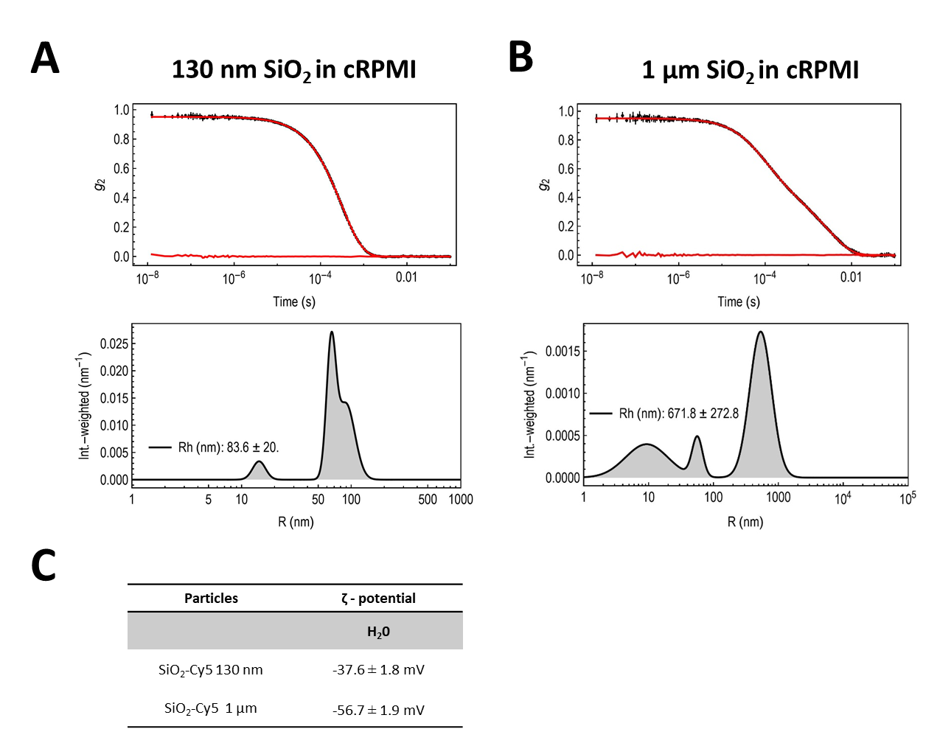
Figure S1. Stability of SiO₂ particles in cell culture medium. Graphs and histograms depicting the correlation curve and intensity distribution of 130 nm (A) and 1 µm SiO₂ particles (B) after 24 h in complete RPMI 1640 (cRPMI). (C) ζ-potential determined by electrophoretic light scattering in H₂O showing the large negative zeta potential values for both particles.
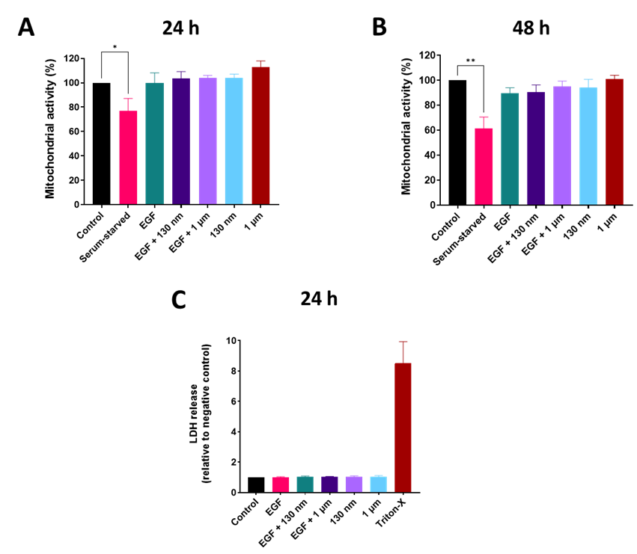
Figure S2. Effect of SiO₂ particles and epidermal growth factor (EGF) on lung epithelial cells (A549) mitochondrial activity and cytotoxicity. A549 mitochondrial activity upon 24 h (A) and 48 h (B) exposure to 50 µg/mL SiO₂ particles in the presence and absence of EGF (100 ng/mL). Data is presented as mean ± standard error of mean (n = 3). Statistically significant differences among the groups (One-way ANOVA Dunnett's post-hoc test for multiple comparisons): *p ≤ 0.05; **p ≤ 0.01. (C) Cytotoxicity of EGF and SiO₂ particles upon 24 h exposure. Data are presented as mean ± standard error of mean (n = 3).
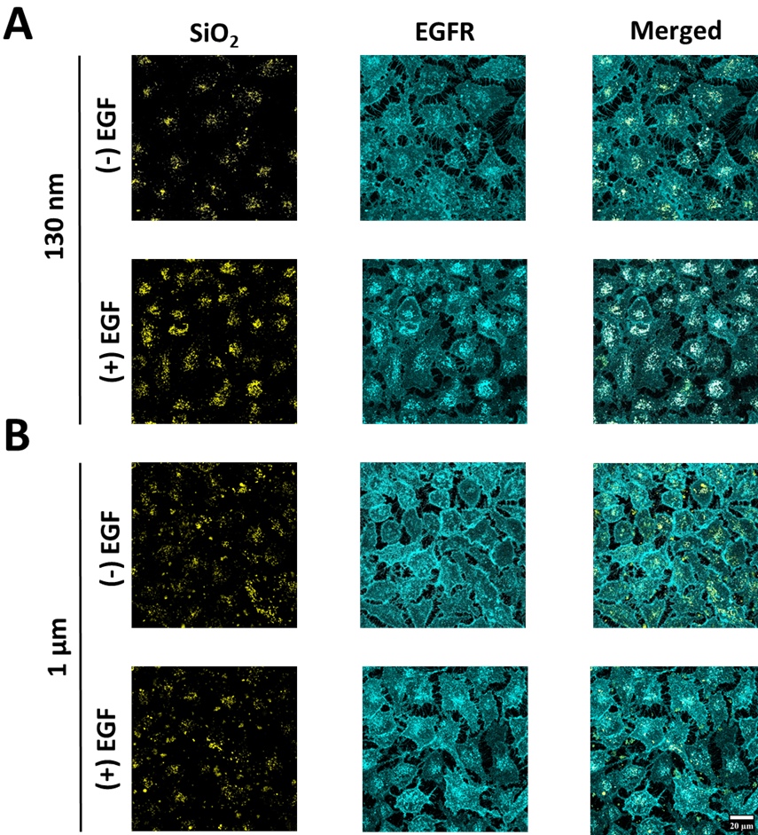
Figure S3. Cellular uptake of SiO₂ particles in the presence or absence of epidermal growth factor. Maximum projection intensities revealing the interaction and internalization of 130 nm (A) and 1 µm (B) SiO₂ particles within lung epithelial cells (A549) after 24 h of exposure. Scale bar = 20 µm. Particles in yellow and EGFR-GFP in cyan.
Figure S4. Interference analysis of SiO₂ particles in WST-1 assay. Spike-in controls containing the same administered dose (50 µg/mL) were included with no evidence of quenching or auto-absorption. Blank – cell culture medium only. Data were obtained from one biological experiment with three technical replicates.

