Appendix
The table below shows Table 7 from the SECURE study (Calodney et al) and two randomized trials of lateral transiliac SI joint fusion (iMIA and INSITE).
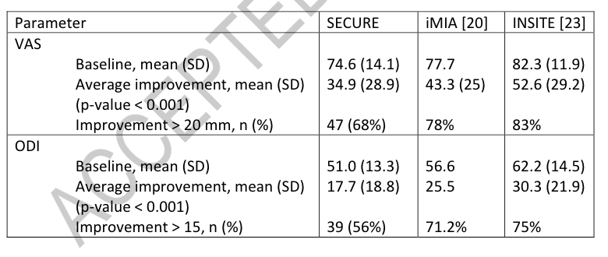
Data are summarized as:

 | Improvement  in VAS pain  score | SD of  change score | N
iMIA and INSITE | 49.5* | 27* | 153
SECURE | 34.9 | 28.9 | 69
 | Improvement  in Oswestry Disability Index | SD of  change score | N
iFuse | 28.7* | 28* | 153
DA | 17.7 | 18.8 | 69
*weighted average of iMIA and INSITE improvement and SD of change score

Using student’s t test: $t=({\overline{x}}_{1}-{\overline{x}}_{2})/\sqrt{\left[\frac{{s^{2}}_{1}}{n_{1}}+\frac{{s^{2}}_{2}}{n_{2}}\right]}$ with degrees of freedom: $df=n_{1}+n_{2}-2$, the t-value for the difference in mean pain score improvement is 3.55 (p=.0005). The t-value for the difference in mean Oswestry Disability Index improvement was 3.44 (p=.0007).

