Appendix 1. Database search strategies

Table. Database search strategies
PubMed via National Library of medicine (NML), April 7, 2020
Search terms | Items found
Intervention:
1. “clinical frailty scale” [Title/Abstract] | 193
“ ” = Citation marks; searches for an exact phrase
CINAHL via ebscohost.com, April 7, 2020
Search terms | Items found
Intervention :
1. TI ”clinical frailty scale” OR AB “clinical frailty scale” | 92
TI= Title
AB= Abstract
“ ” = Citations marks; searches for an exact phrase
EMBASE via embase.com, April 8, 2020
Search terms | Items found
Intervention:
1. (“clinical frailty scale”/exp OR “clinical frailty scale”) and [embase]/lim | 392
/exp= Includes terms found below this term in the EMTREE hierarchy
“ ” = Citations marks; searches for an exact phrase
SCOPUS via scopus.com, April 8, 2020
Search terms | Items found
Intervention:
1. TITLE-ABS-KEY (“clinical frailty scale”) | 79

ABS= Abstract

KEY= Keywords
“ ” = Citation marks; searches for an exact phrase

Appendix 2. Protocol for study selection

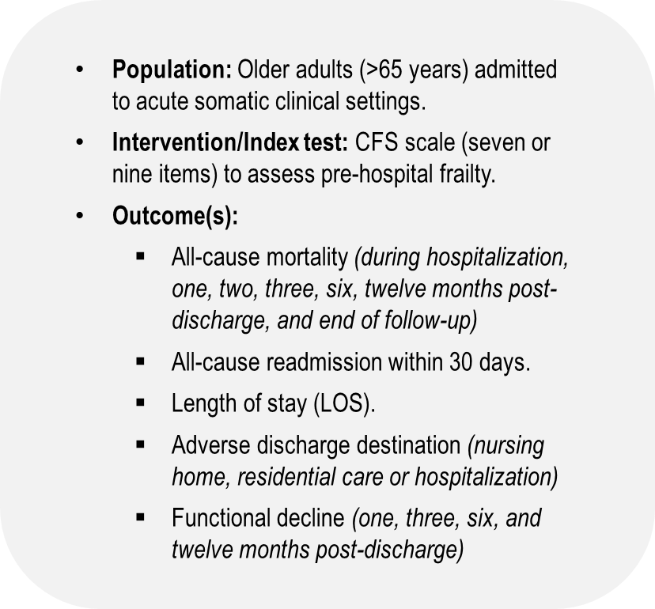

Appendix 3. PRISMA flowchart
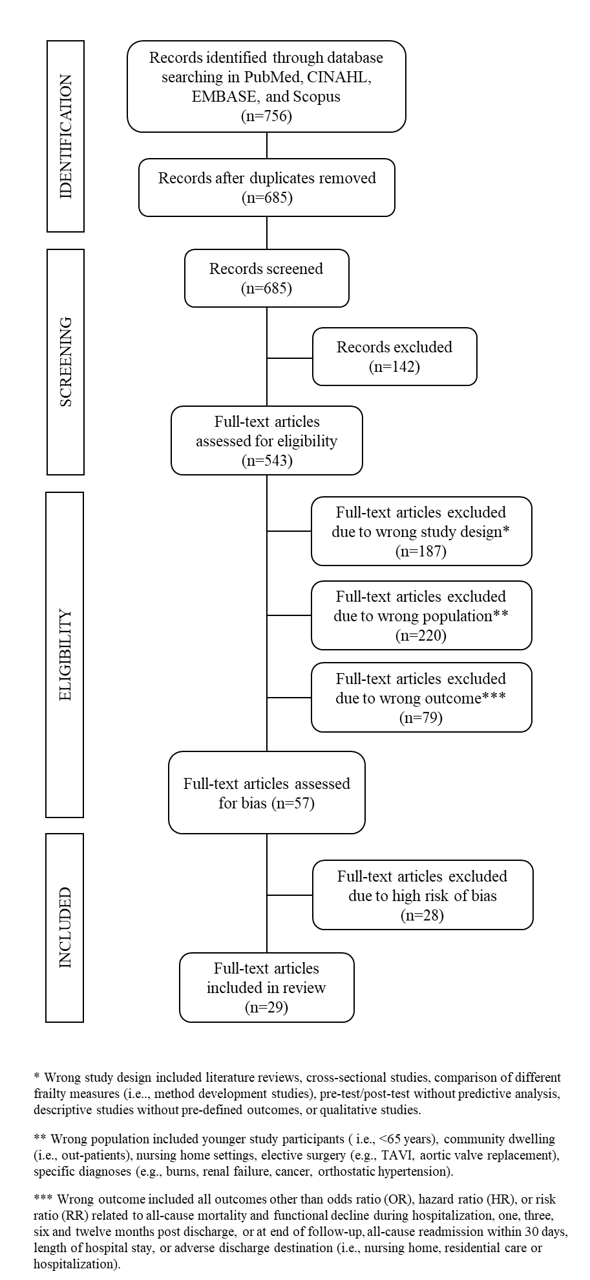

Appendix 4. Studies that were excluded due to an overall high risk of bias (RoB) according to the Quality in Prognosis Studies (QUIPS).

Author and year | Title | Reason for RoB
Arteaga et al (2020) | Impact of frailty in surgical emergencies. A comparison of four frailty scales. | ≥ 4 domains assessed as moderate risk and a high risk of confounding bias.
Belga et al (2016) | Comparing three different measures of frailty in medical inpatients: Multicenter prospective cohort study examining 30-day risk of readmission or death. | High risk of confounding bias.
Cardona et al (2019) | Prospective validation of a checklist to predict short-term death in older patients after emergency department admission in Australia and Ireland. | ≥ 4 domains assessed as moderate risk.
Chen et al (2019) | Frailty is associated with an increased risk of major adverse outcomes in elderly patients following surgical treatment of hip fracture. | ≥ 4 domains assessed as moderate risk and high risk of attrition and measurement related to CFS bias.
Chong et al (2019) | Validating a standardized approach in administration of the clinical frailty scale in hospitalized older adults. | ≥ 4 domains assessed as moderate risk and High risk of measurement related to CFS bias.
Conroy & Dowsing (2013) | The ability of frailty to predict outcomes in older people attending an acute medical unit. | High risk of selection, confounding, and analysis/presentation bias.
Costa et al (2018) | Frailty is independently associated with 1-year mortality after hospitalization for acute heart failure. | High risk of attrition, measurement related to CFS and outcomes, confounding, and analysis/presentation bias.
Eamer et al (2019) | Frailty predicts increased costs in emergent general surgery patients: A prospective cohort cost analysis | ≥ 4 domains assessed as moderate risk and high risk of attrition bias.
Eamer et al (2017) | Analysis of post-discharge costs following emergent general surgery in elderly patients. | ≥ 4 domains assessed as moderate risk and high risk of attrition bias.
Fisher et al (2015) | Predicting intensive care and hospital outcome with the Dalhousie clinical frailty scale: A pilot assessment. | High risk of attrition, measurement related to CFS, confounding, and analysis/presentation bias.
Gregorevic et al (2016) | The clinical frailty scale predicts functional decline and mortality when used by junior medical staff: A prospective cohort study. | ≥ 4 domains assessed as moderate risk, high risk of attrition, and analysis/presentation bias.
Hope et al (2019) | Frailty, acute organ dysfunction, and increased disability after hospitalization in older adults who survive critical illness: A prospective cohort study. | ≥ 4 domains assessed as moderate risk.
Juma et al (2016) | Clinical frailty scale in an acute medicine unit: A simple tool that predicts length of stay. | High risk of selection and confounding bias.
Kang et al (2015) | Is frailty associated with short-term outcomes for elderly patients with acute coronary syndrome? | ≥ 4 domains assessed as moderate risk.
Kara et al (2018) | The impact of frailty on noninvasive mechanical ventilation in elderly medical intensive care unit patients. | ≥ 4 domains assessed as moderate risk and high risk of measurement related to CFS bias.
de Lange et al (2019) | Cumulative prognostic score predicting mortality in patients older than 80 years admitted to the ICU. | High risk of attrition and measurement related to CFS bias.
Langlais et al (2018) | Does the clinical frailty score improve the accuracy of the SOFA score in predicting hospital mortality in elderly critically ill patients? A prospective observational study. | High risk of measurement related to CFS and analysis/presentation bias.
Lyons et al (2019) | Functional mobility trajectories of hospitalized older adults admitted to acute geriatric wards: A retrospective observational study in an English university hospital. | High risk of measurement related to CFS bias.
McGuckin et al (2018) | The association of peri-operative scores, including frailty, with outcomes after unscheduled surgery. | ≥ 4 domains assessed as moderate risk, high risk of confounding, and analysis/presentation bias.
Muessig et al (2018) | Clinical frailty scale (CFS) reliably stratifies octogenarians in German ICUs: A multicenter prospective cohort study | High risk of selection, attrition, and measurement related to CFS bias.
Ritt et al (2015) | analysis of Rockwood et al’s clinical frailty scale and Fried et al’s frailty phenotype as predictors of mortality and other clinical outcomes in older patients who were admitted to a geriatric ward. | High risk of attrition, measurement related to CFS, and confounding bias.
Romero-Ortuno et al (2016) | Clinical frailty adds to acute illness severity in predicting mortality in hospitalized older adults: An observational study. | High risk of measurement related to CFS and outcomes bias.
Romero-Ortuno et al (2017) | The association of geriatric syndromes with hospital outcomes. | High risk of measurement related to CFS bias.
Shah et al (2017) | Comparison of bedside screening methods for frailty assessment in older adult trauma patients in the emergency department. | High risk of attrition and measurement related to CFS bias.
Sirois et al (2017) | Measuring frailty can help emergency departments identify independent seniors at risk of functional decline after minor injuries. | ≥ 4 domains assessed as moderate risk and a high risk of confounding bias.
Sujino et al (2015) | Impact of hypoalbuminemia, frailty, and body mass index on early prognosis in older patients (85 years) with ST-elevation myocardial infarction. | High risk of measurement related to CFS bias.
Wong & Miller (2008) | Adverse outcomes following hospitalization in acutely ill older patients. | High risk of selection, attrition, and measurement related to CFS bias.
Yoshioka et al (2019) | Influence of preadmission frailty on short- and mid-term prognoses in octogenarians with ST-elevation myocardial infarction. | High risk of confounding bias.

Note: The overall RoB categorization was a result of a continuous discussion between the authors and based on the following criteria: If all domains were classified as having low RoB or up to one moderate RoB, this study was classified as low RoB. If one or more domains were classified as having high RoB, or ≥ 4 moderate RoB, this study was classified as high RoB. All studies in between were classified as having moderate RoB. Principals for inclusion of studies – If the overall assessment by both reviewers deemed the study as either low or moderate risk of bias the study was included in the review.

