ORIGINAL RESEARCH

Supplementary Data
A
B
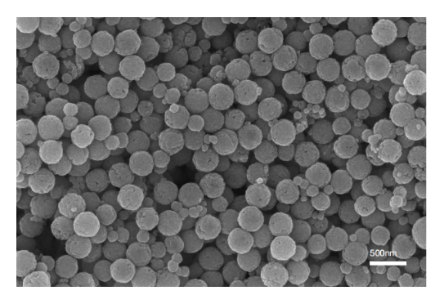
C

D
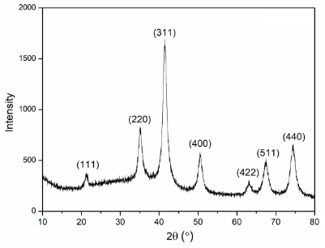
E
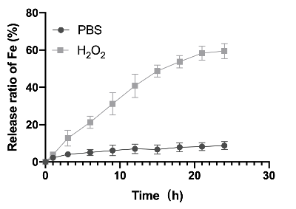
Figure S1：Characterization of HFON and DOX@HFON: (A) TEM of HFON；(B) SEM images of DOX@HFON; (C) Test result of BET: specific surface area of HFON; (D) XRD pattern of HFON; (E) Fe release curve in vitro.
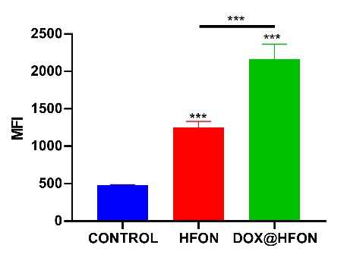
Figure S2：Quantitative analysis of ROS generation. (***P < 0.001)
Figure S3：CCK8 assay of MDA-MB-231 cells in different groups.
Concentration | 0ug/ml | 10ug/ml | 25ug/ml | 51.27±2.27 | 75ug/ml | 100ug/ml
Mean±SD | 101.44±0.47 | 91.08±63 | 65.20±1.41 | 51.27±2.27 | 36.56±2.36 | 16.99±0.35

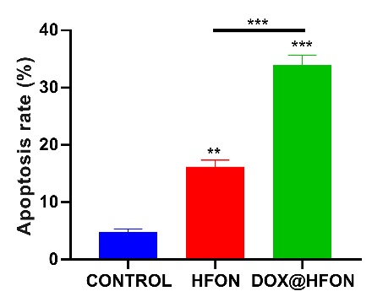
Figure S4：Quantitative analysis of apoptosis levels. (***P<0.001, **P < 0.01)
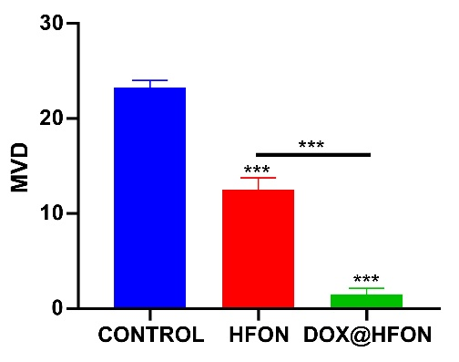
Figure S5：Quantitative analysis of angiogenesis levels.(***P < 0.001)
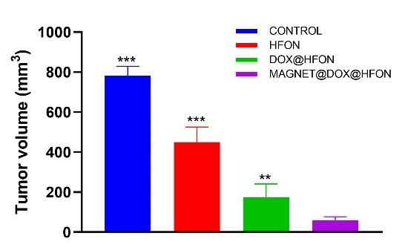
Figure S6：Tumor volume of isolated tumors in different treatment groups after 21 days of therapy(***P < 0.001, **P < 0.01).
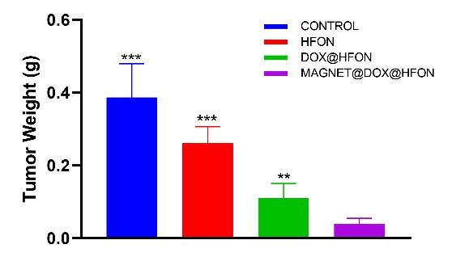
Figure S7：Tumor weight of isolated tumors after 21 days of therapy.(***P < 0.001, **P < 0.01)
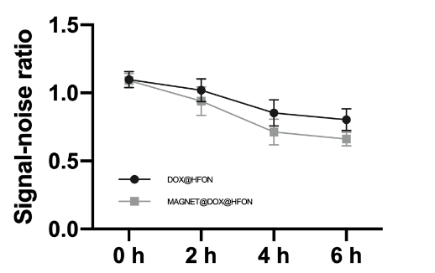
Figure S8：T2-weighted MRI signal-noise ratio.
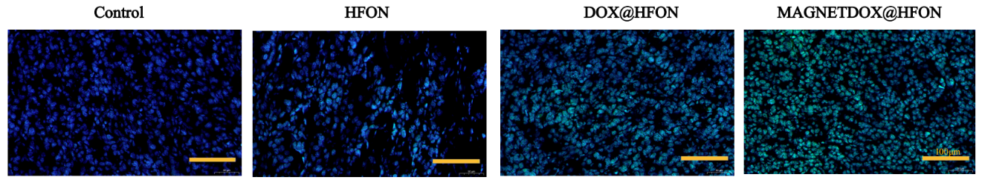
Figure S9 : LPO immunofluorescence staining detection pictures of tumor sections in each group (the scale bar is 100μm).

