Combined Biomimetic MOF-RVG15 nanoformulation efficient over BBB for effective anti-glioblastoma in mice model

Hao Wu^{1, 2}, Yanhong Liu², Liqing Chen², Shuangqing Wang^{1, 2}, Chao Liu², Heming Zhao², Mingji Jin ^{1, 2}, Shuangyan Chang², Xiuquan quan³, Minhu Cui³, Hongshuang Wan^{2, 3}, Zhonggao Gao^{1, 2} *, Wei Huang² *

^{1.} Key Laboratory of Natural Medicines of the Changbai Mountain, Ministry of Education, College of Pharmacy, Yanbian University, Yanji, 133002, Jilin Province, China
^{2.} State Key Laboratory of Bioactive Substance and Function of Natural Medicines, Department of Pharmaceutics, Institute of Materia Medica, Chinese Academy of Medical Sciences and Peking Union Medical College, Beijing 100050, China
^{3.} Department of Gastroenterology, Yanbian University Hospital, Yanji 133000, Jilin Province, China

* Corresponding authors: Zhonggao Gao, zggao@imm.ac.cn, Tel.: +86 010 63028096. Wei Huang, huangwei@imm.ac.cn, Tel.: +86 010 63026505

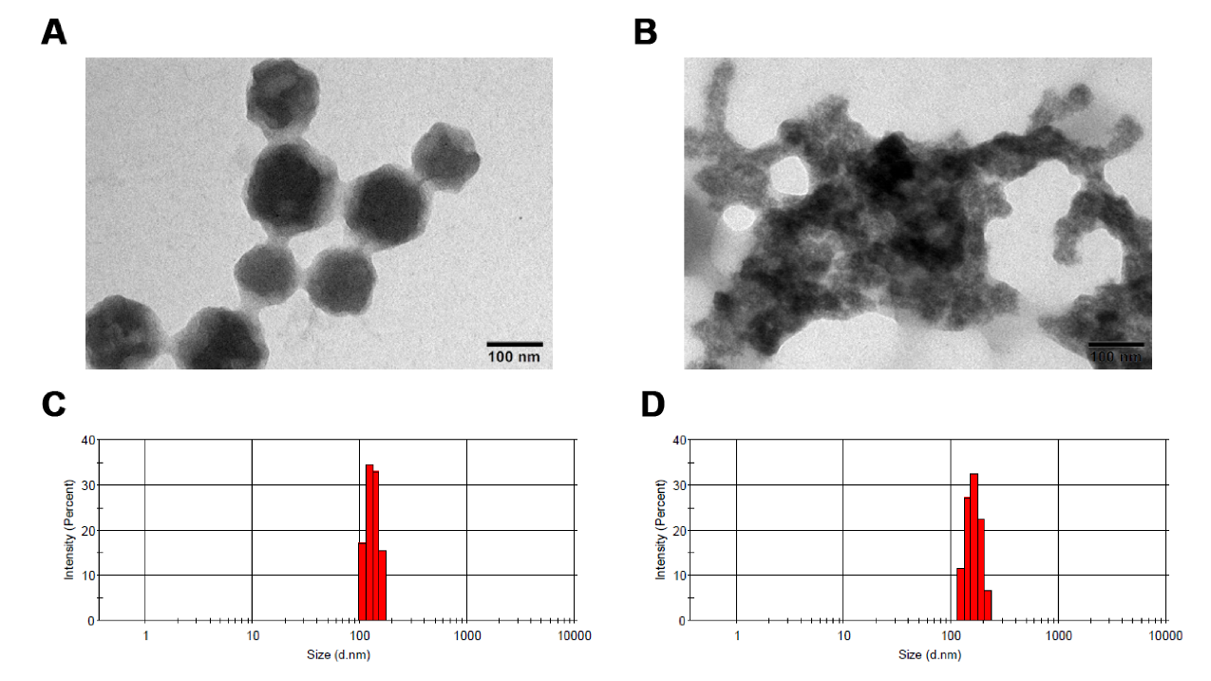
Figure S1. (A) RVG₁₅-PEG@DTX@ZIF-8 incubated in PBS (pH 6.8) buffer for 24 h. (B) RVG₁₅-PEG@DTX@ZIF-8 incubated in PBS (pH 5.5) buffer for 24 h. (C) Size distribution of RVG₁₅-PEG@DTX@ZIF-8 after 24 h incubation in pH 6.8 PBS buffer. (D) Size distribution of RVG₁₅-PEG@DTX@ZIF-8 after 24 h incubation in pH 5.5 PBS buffer.
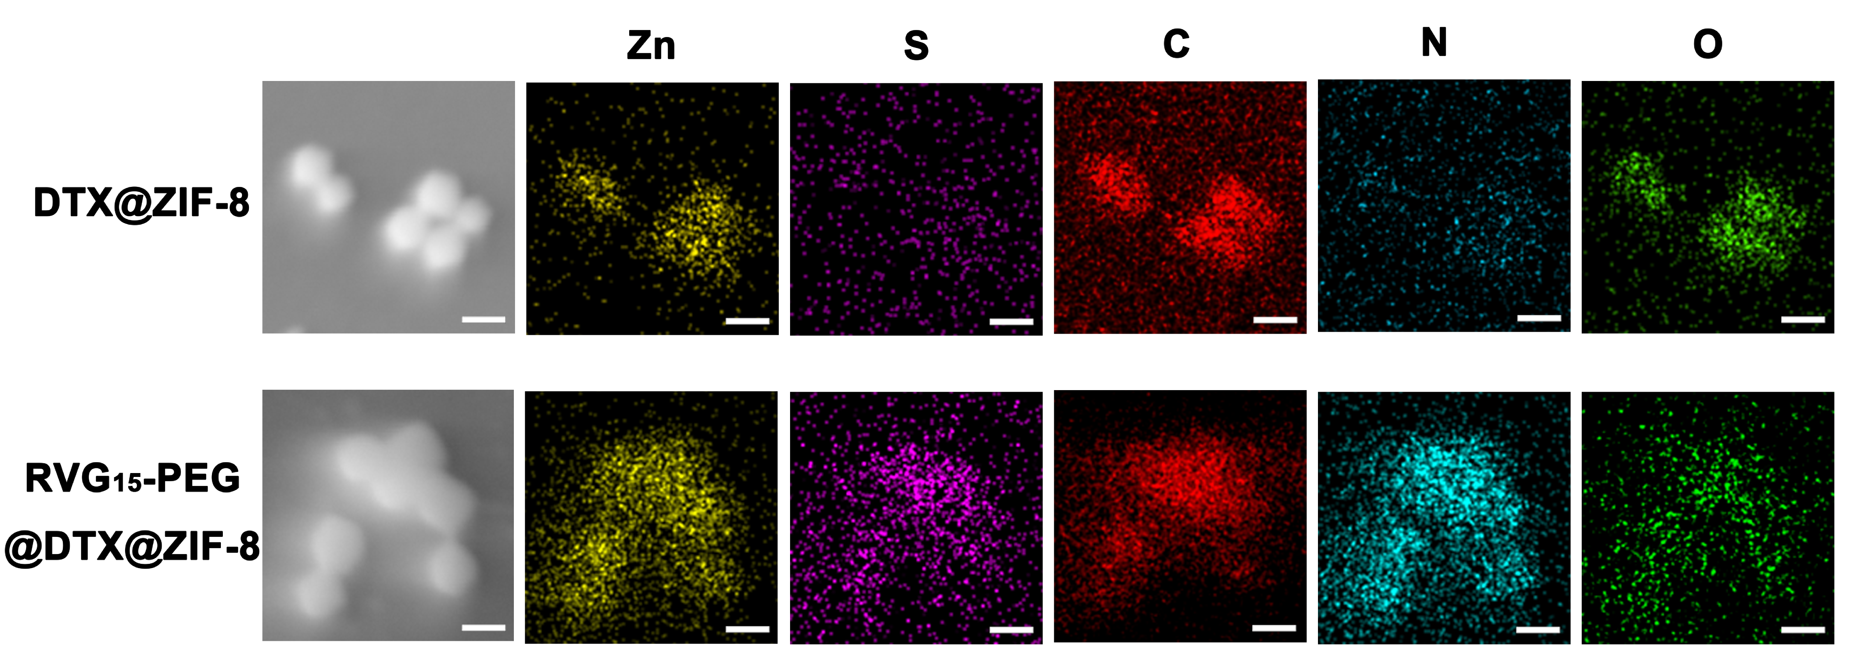
Figure S2. EDX of DTX@ZIF-8 and RVG₁₅-PEG@DTX@ZIF-8. Scale bar = 100 μm.
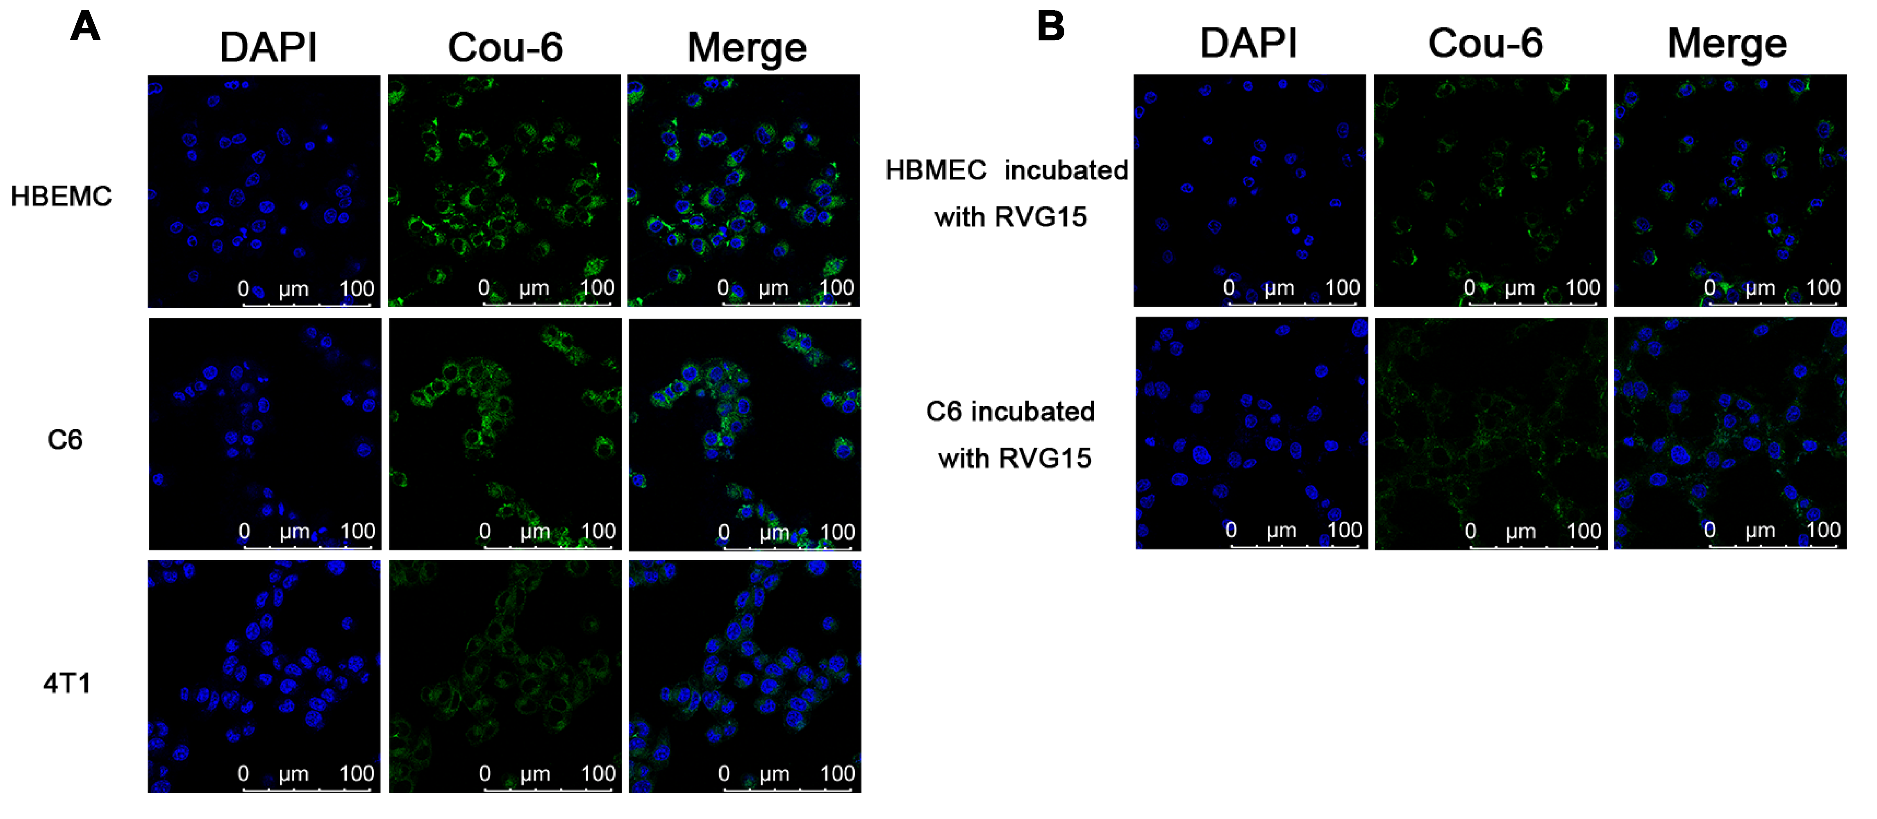
Figure S3. In vitro cellular uptake in HBMEC, C6 and 4T1 cells. (A) CLSM observation of HBMEC, C6 and 4T1 cells after treatment with RVG₁₅-PEG@Cou-6@ZIF-8 for 240 min. (B) After incubation with an excess of RVG15, HBMEC and C6 cells were treated with RVG₁₅-PEG@Cou-6@ZIF-8 for 240 min for CLSM observation.

