SUPPLEMENTAL MATERIAL

TABLE OF CONTENTS
Table S1. Fit statistics for 1- to 6- class models.
Figure S1. Mean high-sensitivity C-reactive protein levels at admission, 1-, and 12-month after discharge.
Figure S2. Spaghetti plots by high-sensitivity C-reactive protein trajectories.
Figure S3. High-sensitivity C-reactive protein trajectories by patients < 65 and ≥ 65 years old.
Figure S4. High-sensitivity C-reactive protein trajectories by sex.
Figure S5. High-sensitivity C-reactive protein trajectories by heart failure presentation.
Figure S6. High-sensitivity C-reactive protein trajectories by left ventricular ejection fraction subtypes.
Figure S7. High-sensitivity C-reactive protein trajectories by patients with low and high level of N-terminal pro-B type natriuretic peptide levels at baseline.
Figure S8. Factors associated with high-sensitivity C-reactive protein trajectories.
Figure S9. Sensitivity analyses of high-sensitivity C-reactive protein trajectories.
Figure S10. Sensitivity analyses of adjusted association between high-sensitivity C-reactive protein trajectories and following clinical outcomes.

Table S1. Fit statistics for 1- to 6- class models.
Model | Bayesian information criterion | Proportion in each group (%)
1-class | -7787.31 | 100
2-class | -7558.21 | 57.5, 42.5
3-class | -7508.89 | 30.8, 60.7, 8.4
4-class | -7467.37 | 32.7, 50.7, 7.7, 8.9
5-class | -7461.77 | 9.5, 43.7, 31.9, 8.5, 6.5
6-class | -7455.07 | 8.6, 40.7, 31.9, 2.7, 9.1, 7.0

Figure S1. Mean high-sensitivity C-reactive protein levels at admission, 1-, and 12-month after discharge.
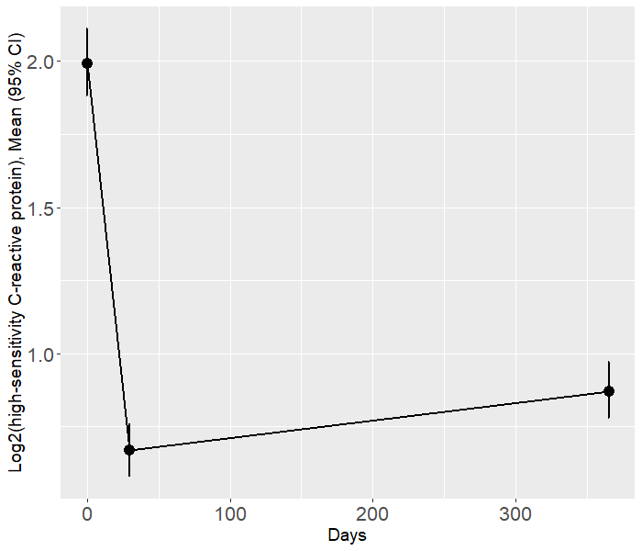
Abbreviation: CI: confidence interval.

Figure S2. Spaghetti plots by high-sensitivity C-reactive protein trajectories.
- Spaghetti plots in the persistently low trajectory;
- Spaghetti plots in the very high-marked decrease trajectory;
- Spaghetti plots in the persistently high trajectory;
- Spaghetti plots in the persistently very high trajectory.
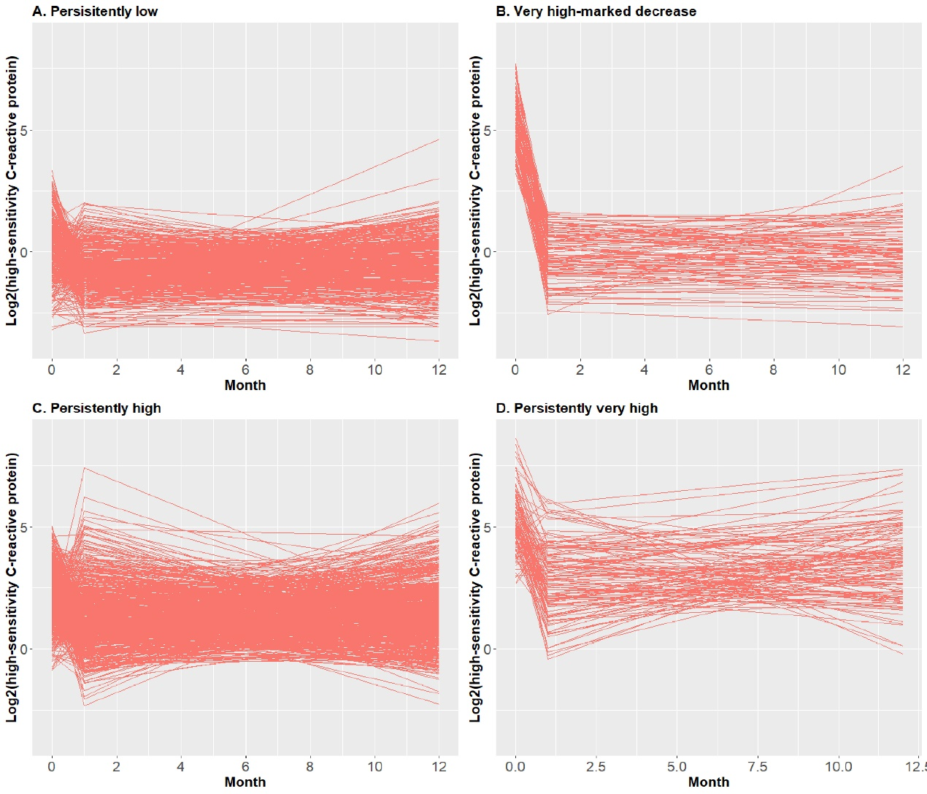

Figure S3. High-sensitivity C-reactive protein trajectories by patients < 65 and ≥ 65 years old.
- High-sensitivity C-reactive protein trajectories in patients < 65 years old;
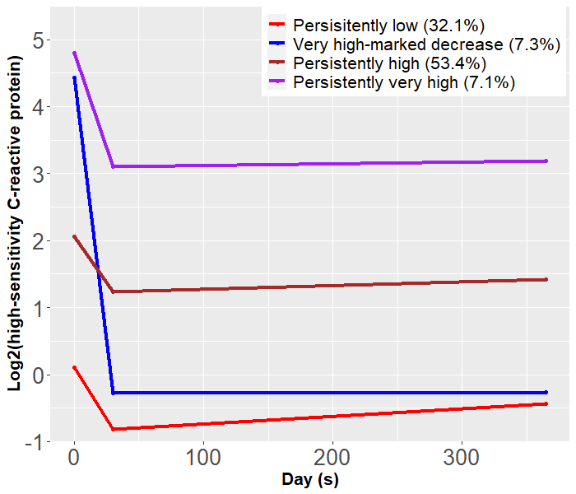

- High-sensitivity C-reactive protein trajectories in patients ≥ 65 years old.
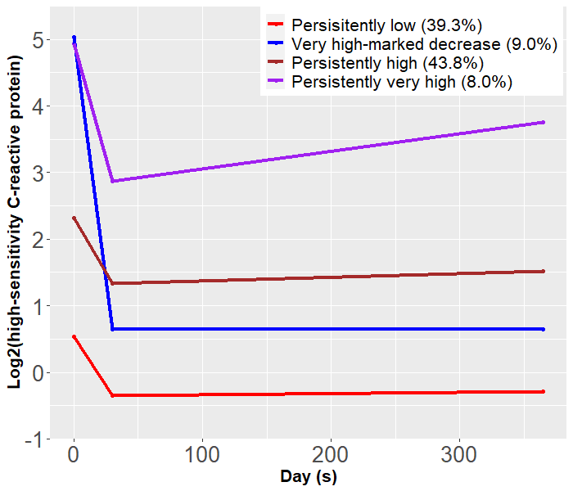
Figure S4. High-sensitivity C-reactive protein trajectories by sex.
- High-sensitivity C-reactive protein trajectories in male patients;
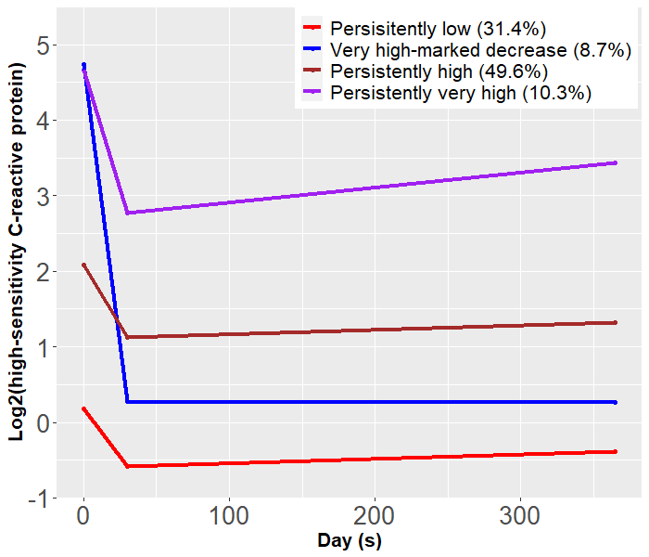
- High-sensitivity C-reactive protein trajectories in female patients.
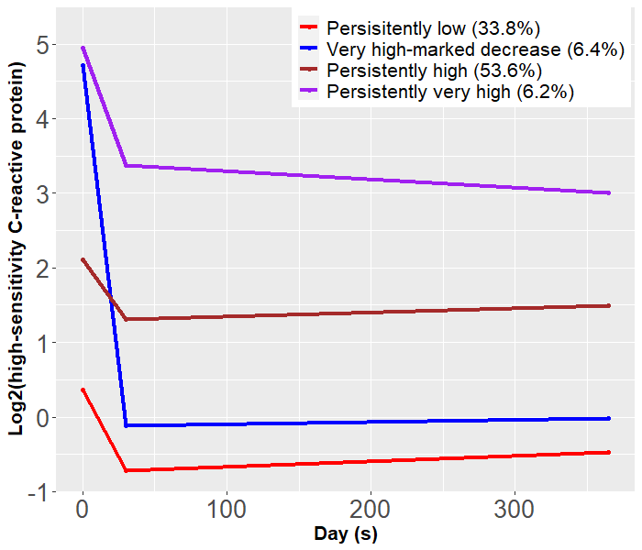

Figure S5. High-sensitivity C-reactive protein trajectories by heart failure presentation.
- High-sensitivity C-reactive protein trajectories in patients with new-onset heart failure;
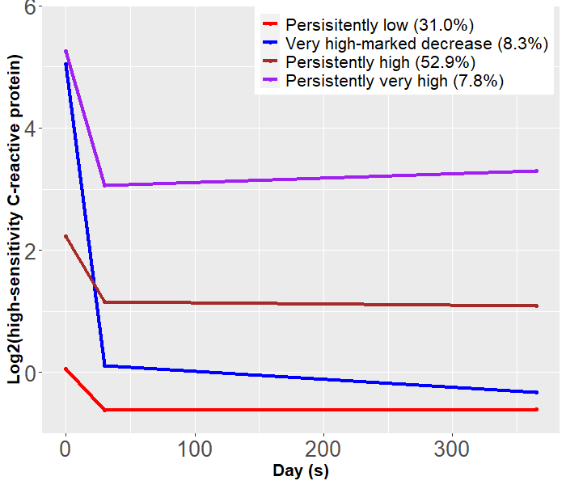

- High-sensitivity C-reactive protein trajectories in patients with decompensated chronic heart failure.
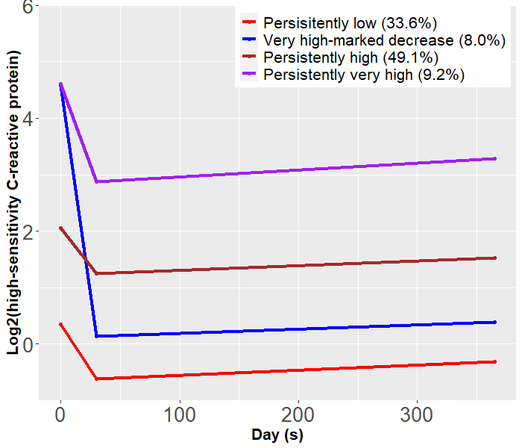

Figure S6. High-sensitivity C-reactive protein trajectories by left ventricular ejection fraction subtypes.
- High-sensitivity C-reactive protein trajectories in heart failure with reduced ejection fraction;
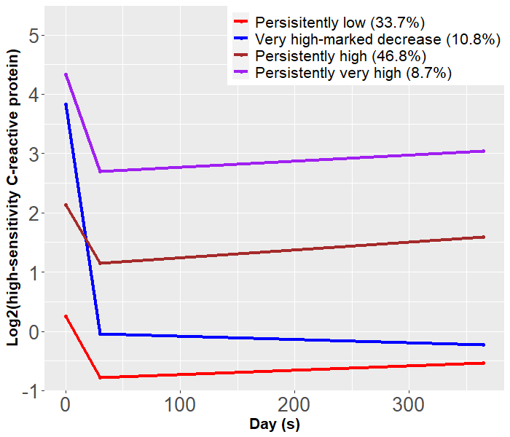

- High-sensitivity C-reactive protein trajectories in heart failure with mildly reduced ejection fraction;
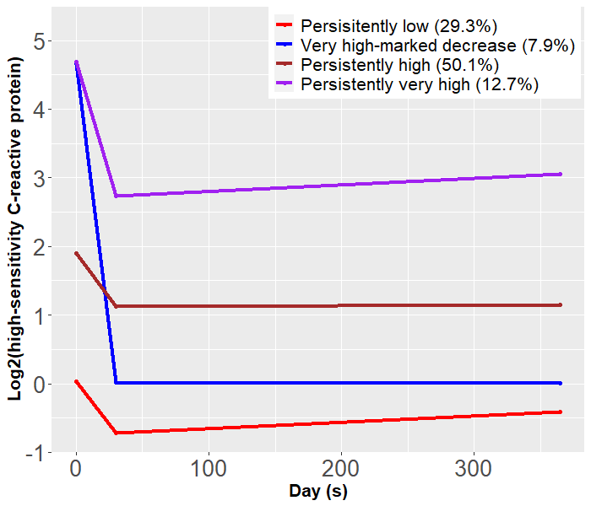

- High-sensitivity C-reactive protein trajectories in heart failure with preserved ejection fraction.
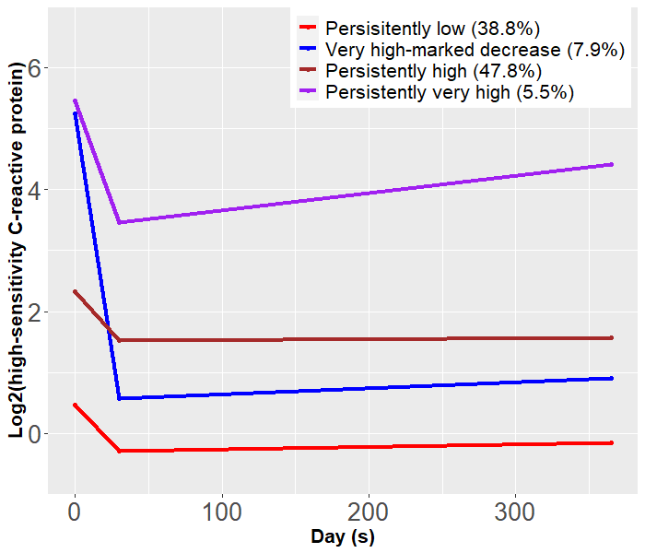

Figure S7. High-sensitivity C-reactive protein trajectories by patients with low and high level of N-terminal pro-B type natriuretic peptide levels at baseline.
- High-sensitivity C-reactive protein trajectories in patients with N-terminal pro-B type natriuretic peptide lower than median level at baseline;
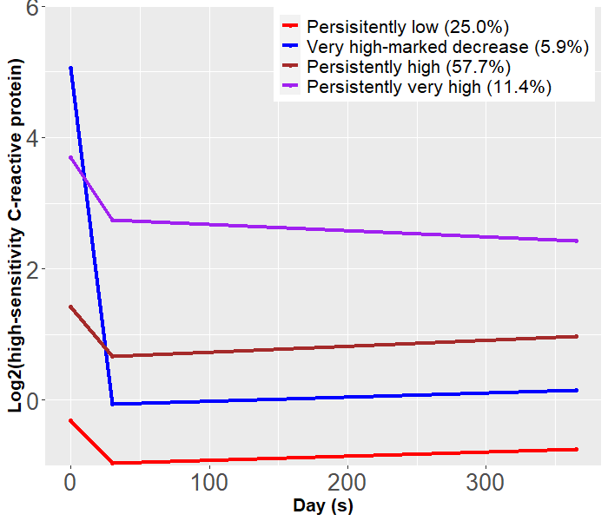

- High-sensitivity C-reactive protein trajectories in patients with N-terminal pro-B type natriuretic peptide above median level at baseline.
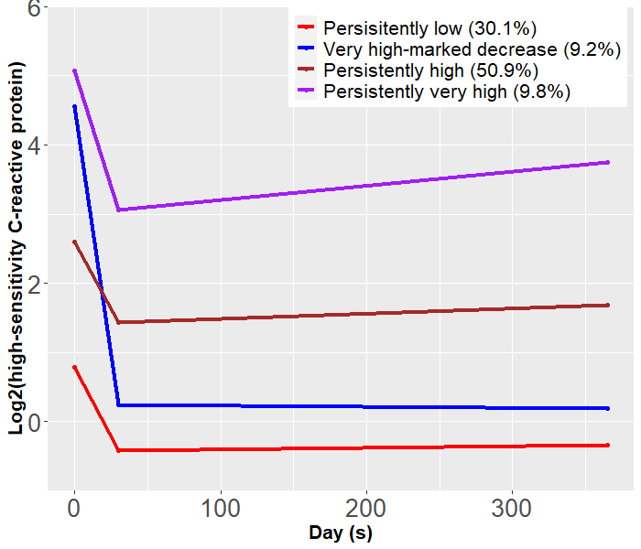

Figure S8. Factors associated with high-sensitivity C-reactive protein trajectories.
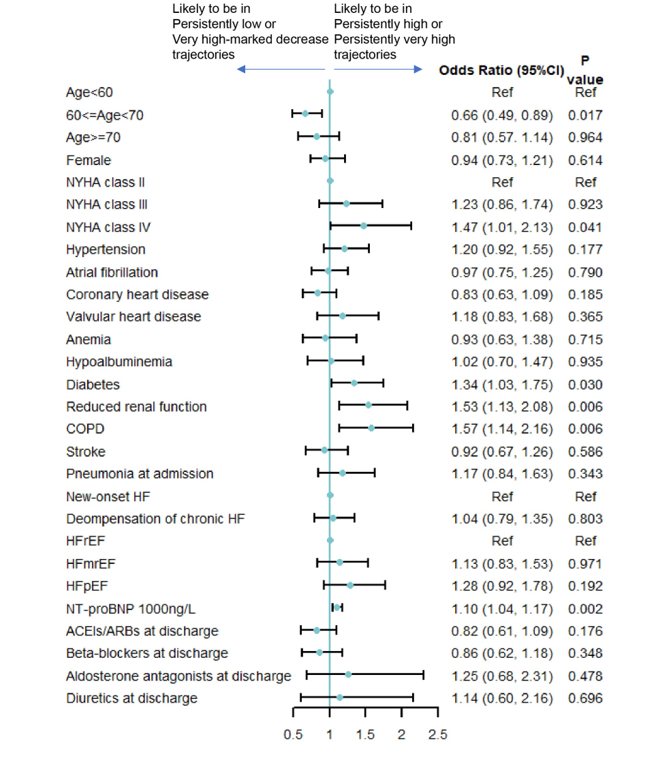
Abbreviation: NYHA: New York Heart Association; Reduced renal function: estimated glomerular filtration rate <60 ml/min/1.73m²; COPD: chronic obstructive pulmonary disease; HF: heart failure; HFrEF: heart failure with reduced ejection fraction; HFmrEF: heart failure with mildly reduced ejection fraction; HFpEF: heart failure with preserved ejection fraction; NT-proBNP: N-terminal pro-B type natriuretic peptide; ACEI: angiotensin-converting enzyme inhibitor; ARB: angiotensin receptor blocker.
Figure S9. Sensitivity analyses of high-sensitivity C-reactive protein trajectories.
- Sensitivity analyses of high-sensitivity C-reactive protein trajectories in patients without pneumonia at admission;
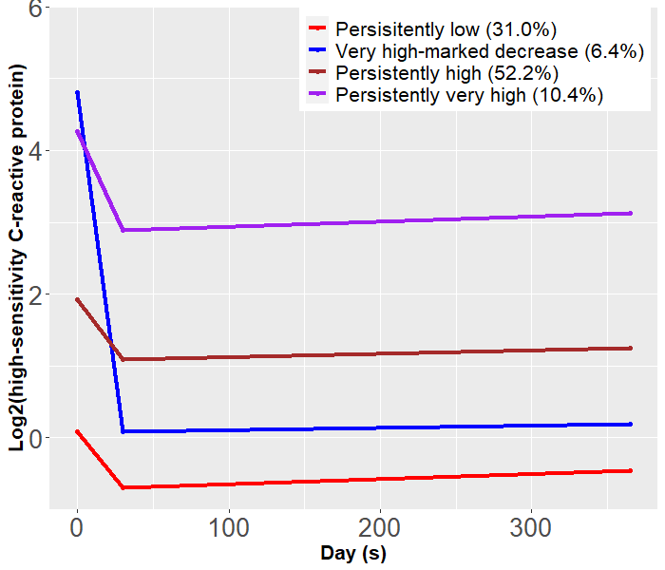

- Sensitivity analyses of high-sensitivity C-reactive protein trajectories in patients without rehospitalization of heart failure, myocardial infarction, stroke, or infection within 12-month.
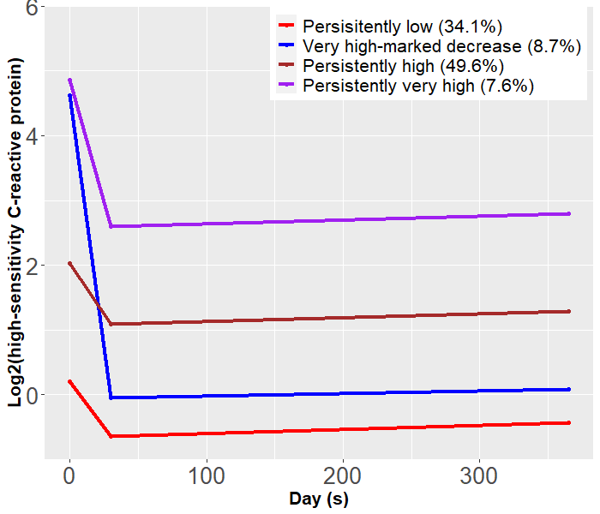

- Sensitivity analyses of high-sensitivity C-reactive protein trajectories in patients in patients at least 2 high-sensitivity C-reactive protein data at admission, 1-, and 12-month after discharge.
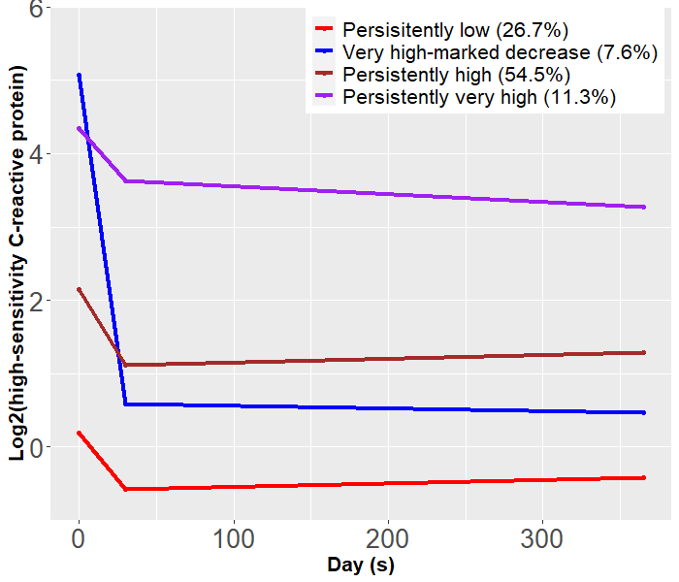

Figure S10. Sensitivity analyses of adjusted association between high-sensitivity C-reactive protein trajectories and following clinical outcomes.
- Sensitivity analyses of adjusted association between high-sensitivity C-reactive protein trajectories and following clinical outcomes in patients without pneumonia at admission;
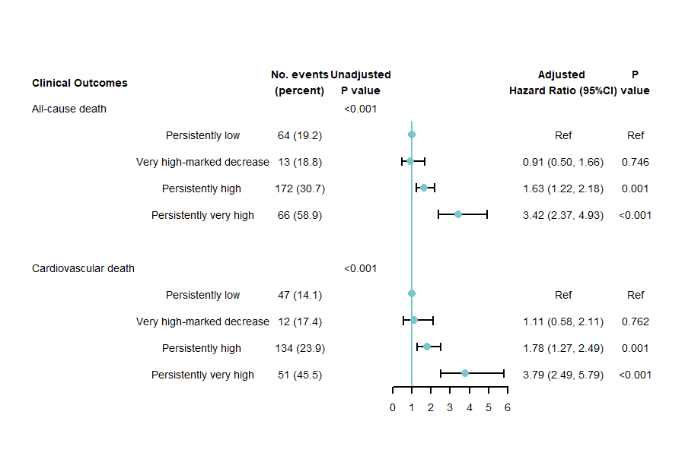

- Sensitivity analyses of adjusted association between high-sensitivity C-reactive protein trajectories and following clinical outcomes in patients without rehospitalization of heart failure, myocardial infarction, stroke, or infection within 12-month.
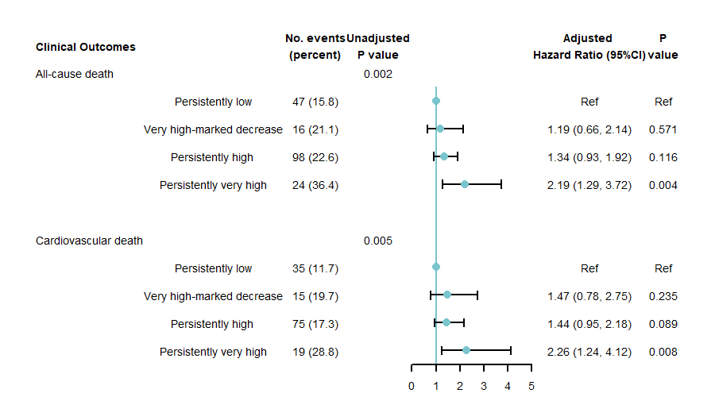

- Sensitivity analyses of adjusted association between high-sensitivity C-reactive protein trajectories and following clinical outcomes in patients at least 2 high-sensitivity C-reactive protein data at admission, 1-, and 12-month after discharge.
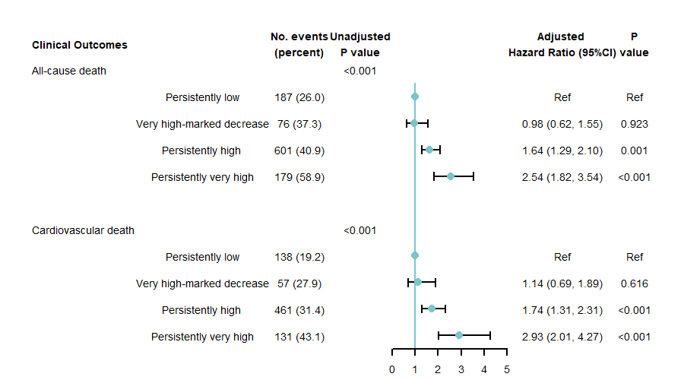

Note: Adjusted for age, sex, New York Heart Association class, history of hypertension, atrial fibrillation, coronary heart disease, valvular heart disease, anemia, hypoalbuminemia, diabetes, reduced renal function, COPD, stroke, pneumonia at admission, heart failure presentation (new-onset heart failure, decompensated chronic heart failure), left ventricular ejection fraction subtypes (heart failure with reduced ejection fraction, heart failure with mildly reduced ejection fraction, heart failure with preserved ejection fraction), 12-month N-terminal pro-B type natriuretic peptide levels, self-reported 12-month medication of angiotensin-converting enzyme inhibitors/angiotensin receptor blockers/angiotensin receptor neprilysin inhibitors, β-blockers, and aldosterone antagonists.
Abbreviation: CI: confidence interval.

