﻿Supporting Information

Figure S1 Zeta potential of different nanoparticles.

﻿Figure S2 FL intensities of Hepa1-6 cells incubated with DiI-NDs or DiI-IR780 NDs for different durations of coincubation.
Figure S3 Subcellular localization of DiI-NDs compared to lysosome and mitochondria trackers using CLSM. The scale bars are 20 μm.

Figure S4 The relative PA intensities changing at the tumor site at the corresponding time points.

Figure S5 Ex vivo biodistribution. (a) ﻿Ex vivo fluorescence images of major organs and the tumor collected 24 h post tail vein injection of PFP@IR780@O₂. (b) Semi-quantitative biodistribution analysis of PFP@IR780@O₂ in mice. (Data is shown as mean ± SD. n=3 per group. **p < 0.01)
Figure S6 The gray values in US mode of pre- and post-irradiation. (Data is shown as mean ± SD. n=3. ***p < 0.001)
﻿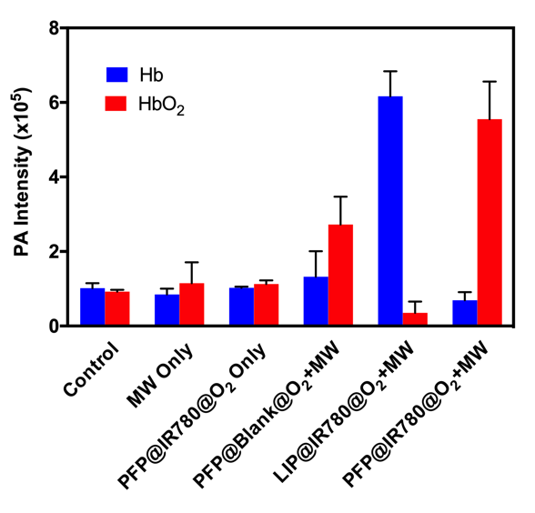
Figure S7 PA intensity of HbO₂ and Hb after different treatments.

﻿Figure S8 For ﻿subcutaneous tumor models, temperature curves of tumor surface with various treatments.

﻿ Figure S9 For orthotopic tumor models, body weight changes of mice with various treatments.

