
King Saud University
College of Applied Medical Sciences

Department of Community Health Sciences


Supplementary Materials for
''The Efficacy of GLP-1 Analogues on Appetite Parameters, Gastric Emptying, Food Preference and Taste Among Adults with Obesity: Systematic Review of Randomized Controlled Trials''

By:
Fatima Almadani
Malikah Aldawsari
Nujud Almuhammadi
Sarah Algabsani
Yara Alamro
Dr. Madhawi Aldhwayan

Contact address: King Saud University, College of Applied Medical Sciences, Department of Community Health Sciences, Riyadh, Saudi Arabia.

Table of Contents
Appendices 4
References 74

Appendices
Appendix A. Table.1 Search Term and Used Keywords
 | First investigator
PubMed | (("Glucagon-Like Peptide 1"[Mesh]) AND ("Obesity"[Mesh]) AND ("Satiation"[Mesh])) | 110 | 25/10/2021
PubMed | (("Glucagon-Like Peptide 1"[Mesh]) AND ("Obesity"[Mesh]) AND ("Appetite"[Mesh])) | 151 | 25/10/2021
PubMed | (("Glucagon-Like Peptide 1"[Mesh]) AND ("Obesity"[Mesh]) AND ("Feeding Behavior"[Mesh])) | 137 | 25/10/2021
PubMed | (("Glucagon-Like Peptide 1"[Mesh]) AND ("Obesity"[Mesh]) AND ("Tongue"[Mesh] OR “taste sensitivity” OR “sweet taste” OR “sweet” OR “sweet taste receptors”)) | 14 | 25/10/2021
PubMed | (("Glucagon-Like Peptide 1"[Mesh]) AND ("Obesity"[Mesh]) AND ("Food Preferences"[Mesh] OR “palatability”)) | 23 | 25/10/2021
 | Total, before remove duplicates. | 435 | 26/10/2021
 | ((semaglutide[Title/Abstract]) AND (obesity[Title/Abstract])) AND (satiety[Title/Abstract])) Filters: Abstract, Randomized Controlled Trial | 1 | Time restriction filter (27/10/2021)
 | ((semaglutide[Title/Abstract]) AND (obesity[Title/Abstract]))) AND (appetite[Title/Abstract]) Filters: Abstract, Randomized Controlled Trial | 2 | Time restriction filter (27/10/2021)
 | ((semaglutide[Title/Abstract]) AND (obesity[Title/Abstract])))) AND (food behaviour[Title/Abstract])) OR (eating behaviour[Title/Abstract]) Filters: Abstract, Randomized Controlled Trial | 212 | Time restriction filter (27/10/2021)
 | ((semaglutide[Title/Abstract]) AND (obesity[Title/Abstract]))) AND (taste[Title/Abstract])) OR (sweet taste[Title/Abstract])) OR (taste buds[Title/Abstract]) Filters: Abstract, Randomized Controlled Trial | 79 | Time restriction filter (27/10/2021)
 | ((semaglutide[Title/Abstract]) AND (obesity[Title/Abstract]))) AND (food preference[Title/Abstract])) OR (palatability[Title/Abstract]) Filters: Abstract, Randomized Controlled Trial | 320 | Time restriction filter (27/10/2021)
 | ((((((glucagon-like peptide[Title/Abstract]) OR (agonist[Title/Abstract])) OR (liraglutide[Title/Abstract])) OR (saxenda[Title/Abstract])) OR (semaglutide[Title/Abstract])) AND (obesity[Title/Abstract]) AND (gastric emptying[Title/Abstract]) Filters: Abstract, Randomized Controlled Trial | 21 | Time restriction filter (27/10/2021)
 | Total, before remove duplicates. | 635
 | Second investigator
 | ((((glucagon-like peptide[Title/Abstract]) OR (agonist[Title/Abstract])) OR (liraglutide[Title/Abstract])) OR (saxenda[Title/Abstract])) AND (obesity[Title/Abstract])) AND (satiety[Title/Abstract])) Filters: Abstract, Randomized Controlled Trial | 43 | 27 October 2021
 | ((((glucagon-like peptide[Title/Abstract]) OR (agonist[Title/Abstract])) OR (liraglutide[Title/Abstract])) OR (saxenda[Title/Abstract])) AND (obesity[Title/Abstract]))) AND (appetite[Title/Abstract]) Filters: Abstract, Randomized Controlled Trial | 76 | 27 October 2021
 | ((((glucagon-like peptide[Title/Abstract]) OR (agonist[Title/Abstract])) OR (liraglutide[Title/Abstract])) OR (saxenda[Title/Abstract])) AND (obesity[Title/Abstract])))) AND (food behaviour[Title/Abstract])) OR (eating behaviour[Title/Abstract]) Filters: Abstract, Randomized Controlled Trial | 204 | 27 October 2021
 | ((((glucagon-like peptide[Title/Abstract]) OR (agonist[Title/Abstract])) OR (liraglutide[Title/Abstract])) OR (saxenda[Title/Abstract])) AND (obesity[Title/Abstract]))) AND (taste[Title/Abstract])) OR (sweet taste[Title/Abstract])) OR (taste buds[Title/Abstract]) | 82 | 27 October 2021
 | ((((((glucagon-like peptide[Title/Abstract]) OR (agonist[Title/Abstract])) OR (liraglutide[Title/Abstract])) OR (saxenda[Title/Abstract])) AND (obesity[Title/Abstract]))) AND (food preference[Title/Abstract])) OR (palatability[Title/Abstract])Filters: Abstract, Randomized Controlled Trial | 311 | 27 October 2021
 | Total, before remove duplicates. | 716
Scopus | TITLE-ABS-KEY ( ( "glucagon-like peptide" 1 OR "GLP 1" OR agonist OR "liraglutide " OR "saxenda" ) AND ( "obesity" ) AND ( "satiety" ) ) AND ( LIMIT-TO ( EXACTKEYWORD , "Human" ) OR LIMIT-TO ( EXACTKEYWORD , "Randomized Controlled Trial" ) OR LIMIT-TO ( EXACTKEYWORD , "Clinical Trial" ) ) AND ( EXCLUDE ( EXACTKEYWORD , "Animal" ) ) AND ( LIMIT-TO ( LANGUAGE , "English" ) ) AND ( LIMIT-TO ( EXACTKEYWORD , "Controlled Clinical Trial" ) OR LIMIT-TO ( EXACTKEYWORD , "Randomized Controlled Trial (topic)" ) ) | 70 | 25/10/2021
Scopus | TITLE-ABS-KEY ( ( "glucagon-like peptide" 1 OR "GLP 1" OR agonist OR "liraglutide" OR "saxenda" ) AND ( "obesity" ) AND  ( "appetite" ) ) AND ( LIMIT-TO ( LANGUAGE , "English" ) ) AND ( LIMIT-TO ( EXACTKEYWORD ,  "Randomized Controlled Trial" ) OR LIMIT-TO ( EXACTKEYWORD , "Clinical Trial" ) OR LIMIT-TO ( EXACTKEYWORD , "Placebo" ) ) AND ( LIMIT-TO ( EXACTKEYWORD , "Human" ) OR LIMIT TO ( EXACTKEYWORD , "Humans" ) OR LIMIT TO ( EXACTKEYWORD , "Human Experiment" ) ) AND ( EXCLUDE ( EXACTKEYWORD , "Nonhuman" ) OR  EXCLUDE ( EXACTKEYWORD , "Animals" ) ) AND ( EXCLUDE ( DOCTYPE , "re" ) ). | 203 | 25/10/2021
Scopus | TITLE-ABS-KEY ( ( "glucagon-like peptide" 1 OR "GLP 1" OR agonist OR "liraglutide " OR "saxenda" ) AND ( "obesity" ) AND ( "food behaviour" OR "eating behaviour" ) ) AND ( LIMIT-TO ( LANGUAGE , "English" ) ) AND ( LIMIT-TO ( EXACTKEYWORD , "Human" ) OR LIMIT-TO ( EXACTKEYWORD , "Clinical Trial" ) OR LIMIT-TO ( EXACTKEYWORD , "Randomized Controlled Trial" ) ) AND ( EXCLUDE ( DOCTYPE , "re" ) ). | 40 | 25/10/2021
Scopus | TITLE-ABS-KEY ( ( "glucagon-like peptide" 1 OR "GLP 1" OR agonist OR "liraglutide " OR "saxenda" ) AND ( "obesity" ) AND ( "taste sensitivity" OR "sweet taste" OR "sweet" OR "taste buds" OR "tongue" OR "sweet taste receptors" ) ) AND ( LIMIT-TO ( EXACTKEYWORD , "Human" ) ) AND ( LIMIT TO ( LANGUAGE , "English" ) ) AND ( EXCLUDE ( EXACTKEYWORD , "Mice" ) )  AND ( EXCLUDE ( EXACTKEYWORD , "Nonhuman" ) OR EXCLUDE ( EXACTKEYWORD ,  "Animals" ) ) AND ( EXCLUDE ( DOCTYPE , "re" ) ) AND ( LIMIT-TO ( EXACTKEYWORD , "Controlled Study" ) OR LIMIT-TO ( EXACTKEYWORD ,  "Randomized Controlled Trial" ) OR LIMIT-TO ( EXACTKEYWORD , "Randomized Controlled Trial (topic)" ) OR LIMIT-TO ( EXACTKEYWORD , "Randomized Controlled Trials As Topic" ) ). | 13 | 25/10/2021
Scopus | TITLE-ABS-KEY ( ( "glucagon-like peptide" 1 OR "GLP 1" OR agonist  OR "liraglutide " OR "saxenda" ) AND ( "obesity" ) AND ( "food preference" OR "palatability" ) ) AND ( EXCLUDE ( EXACTKEYWORD , "Rat" )  OR EXCLUDE( EXACTKEYWORD , "Rats" ) OR EXCLUDE ( EXACTKEYWORD , "Mouse" ) )  AND ( EXCLUDE ( DOCTYPE , "re" ) ) AND ( LIMIT-TO ( EXACTKEYWORD , "Controlled Study" ) OR LIMIT-TO ( EXACTKEYWORD , "Randomized Controlled Trial" ) ) | 25 | 25/10/2021
 | Total, before remove duplicates. | 351 | 26/10/2021
 | Total, after remove duplicates (from Scopus search). | 294 | 26/10/2021
 | ( "Semaglutide" ) AND ( "obesity" ) AND ( "satiety" )  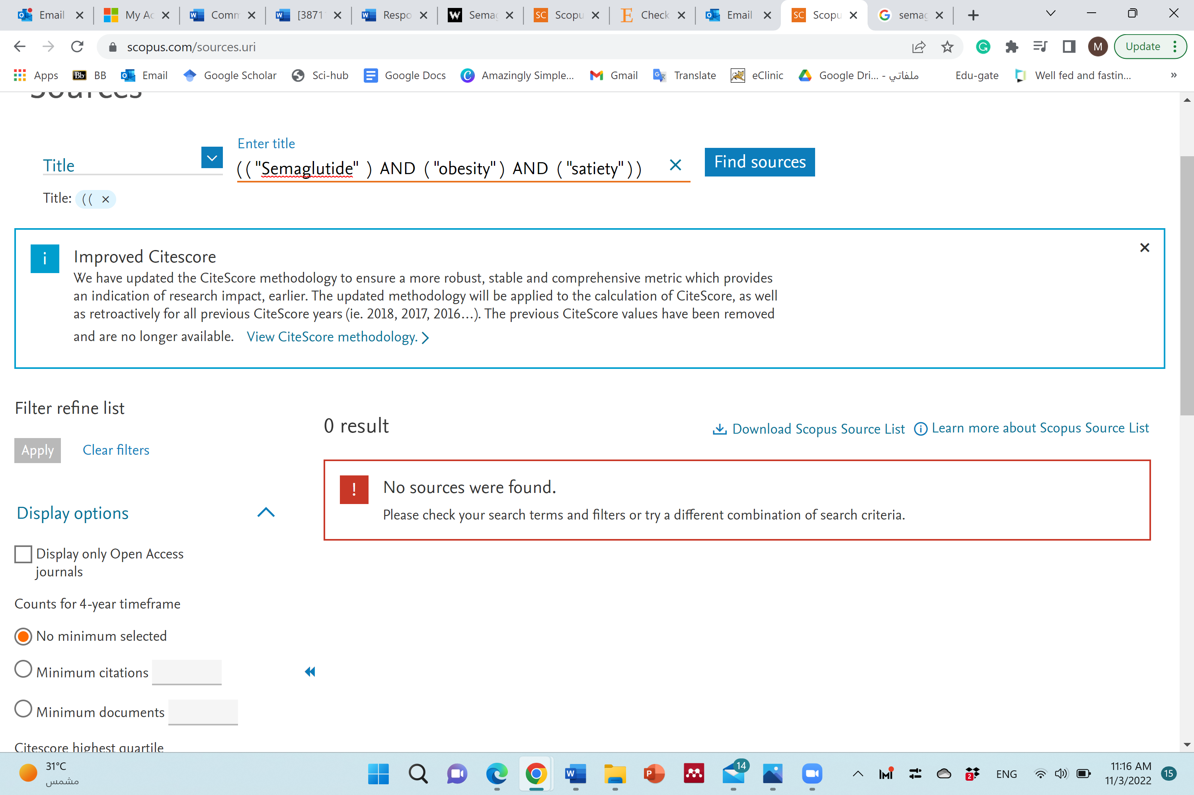 | 0 | 3/11/2021
 | ( "Semaglutide" ) AND ( "obesity" ) AND ( "appetite" ) 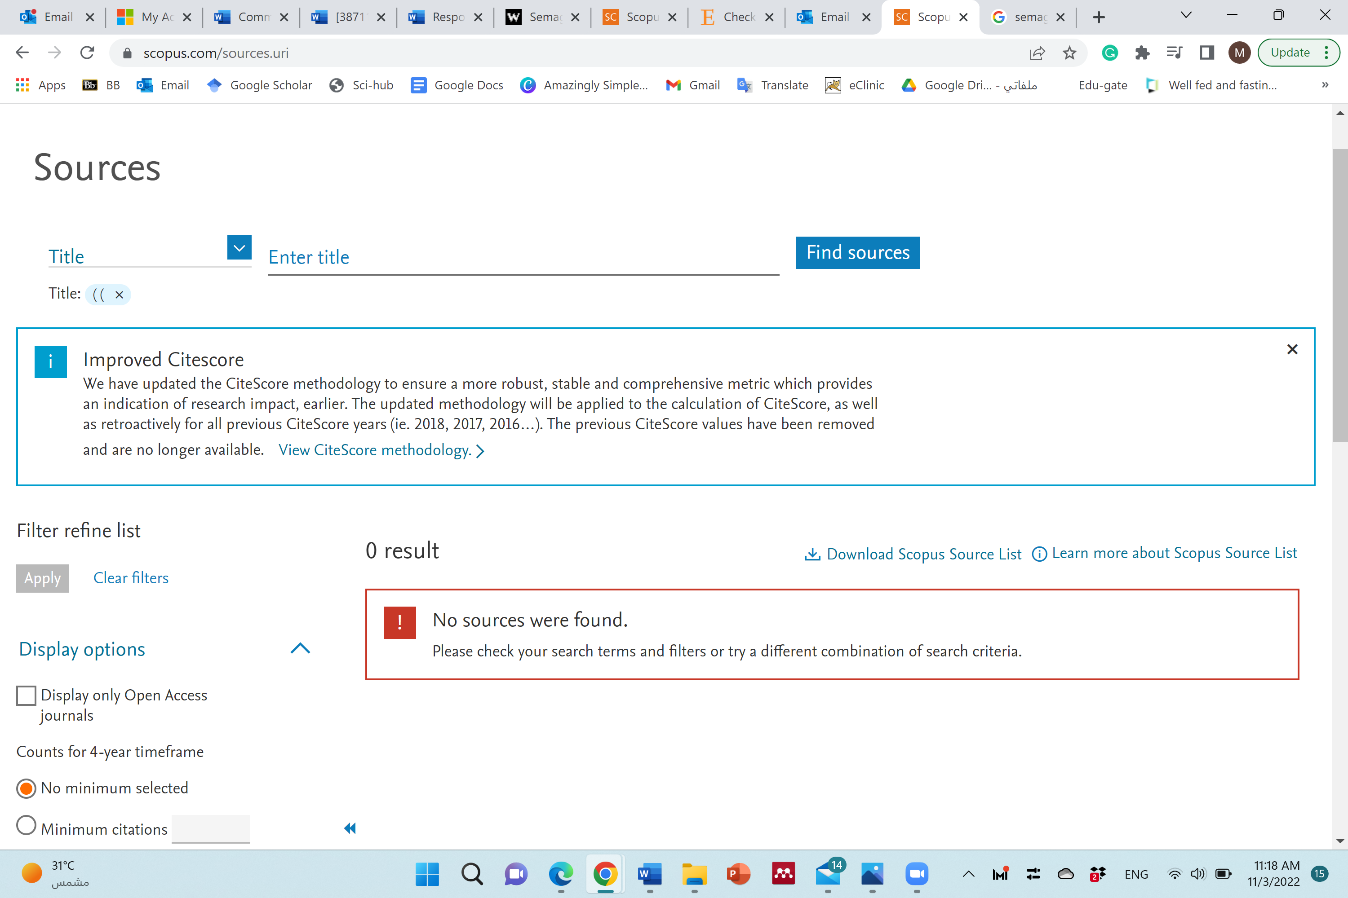 | 0 | 3/11/2021
 | ( "Semaglutide" ) AND ( "obesity" ) AND ( "food behaviour" OR "eating behaviour" )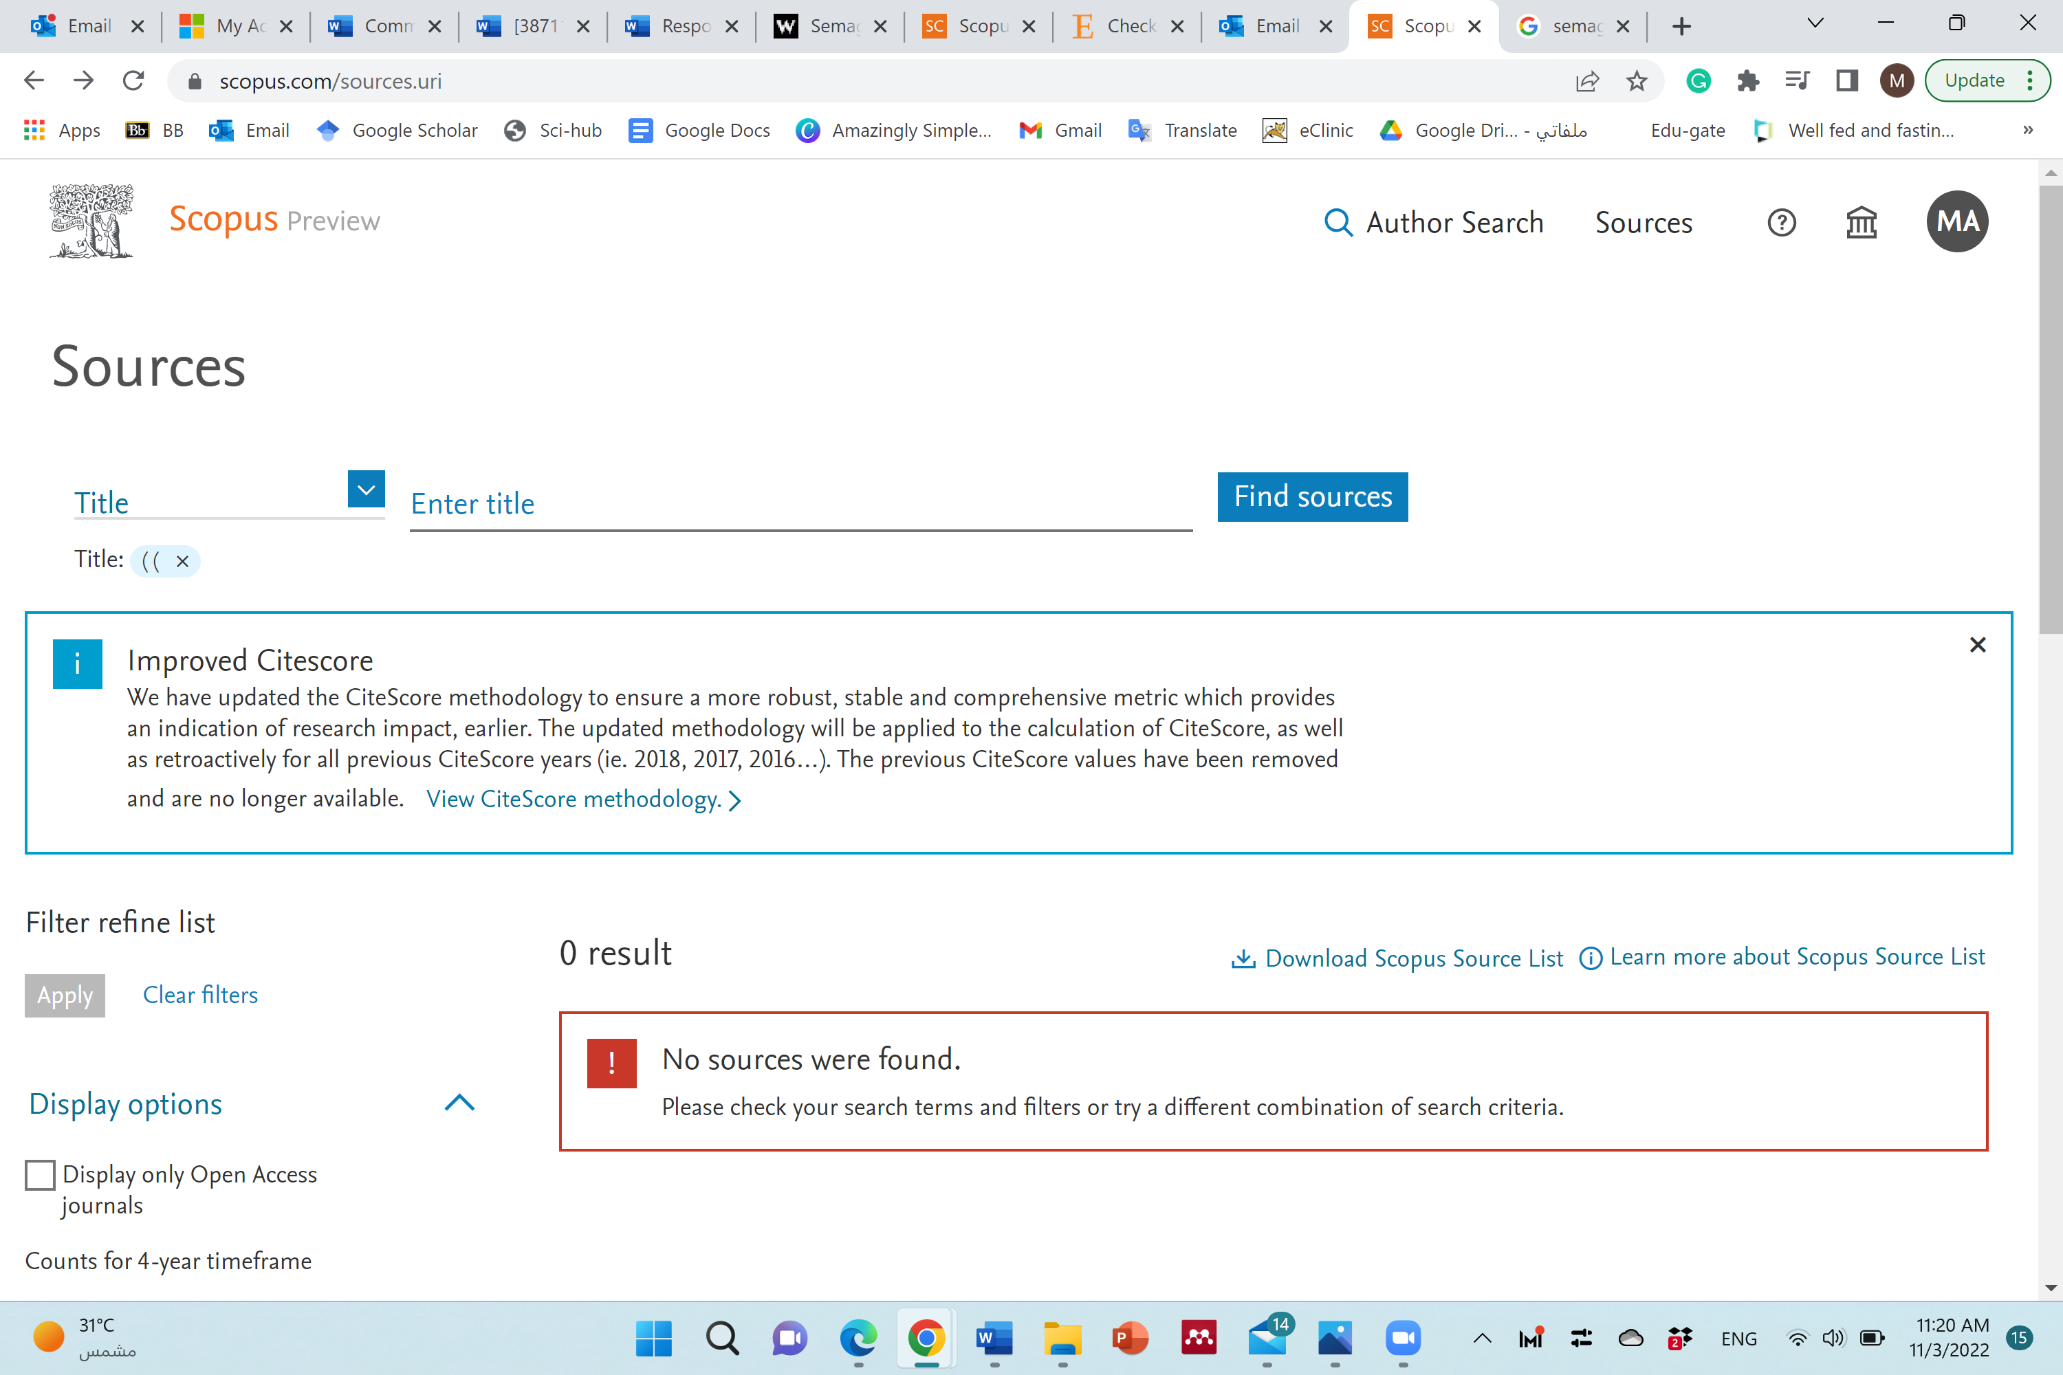 | 0 | 3/11/2021
 | ( "Semaglutide" ) AND ( "obesity" ) AND ( "taste sensitivity" OR "sweet taste" OR "sweet" OR "taste buds" OR "tongue" OR "sweet taste receptors" )  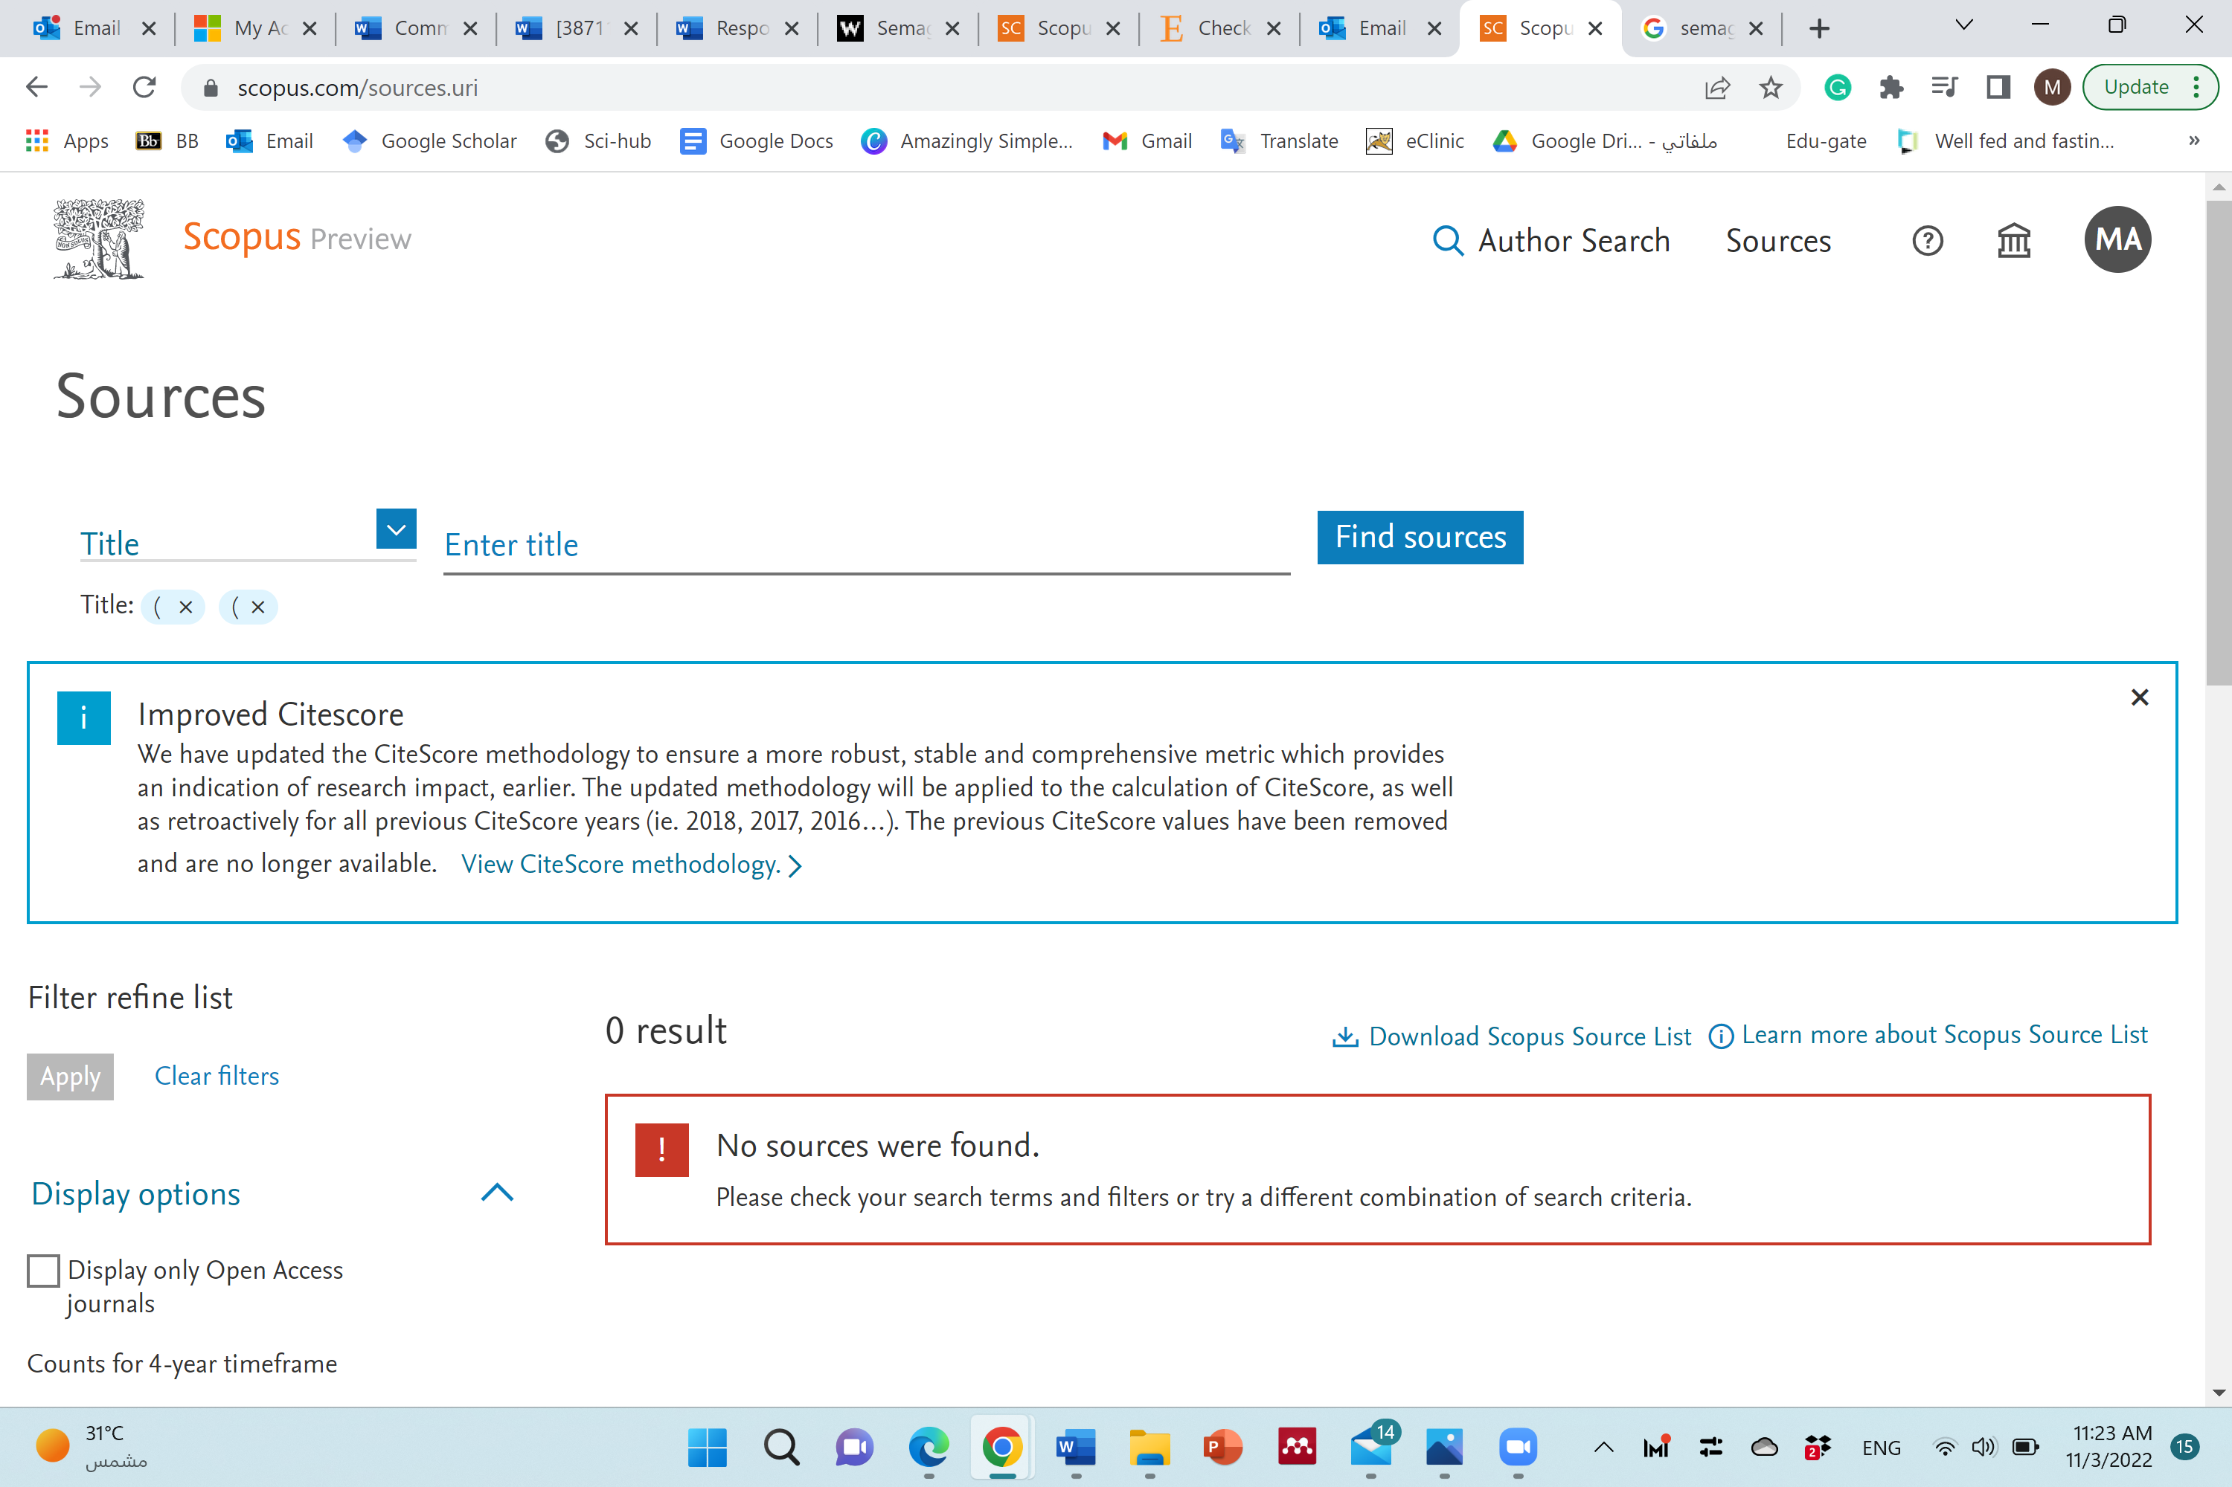 | 0 | 3/11/2021
 | ( "Semaglutide" ) AND ( "obesity" ) AND ( "food preference" OR "palatability" ) 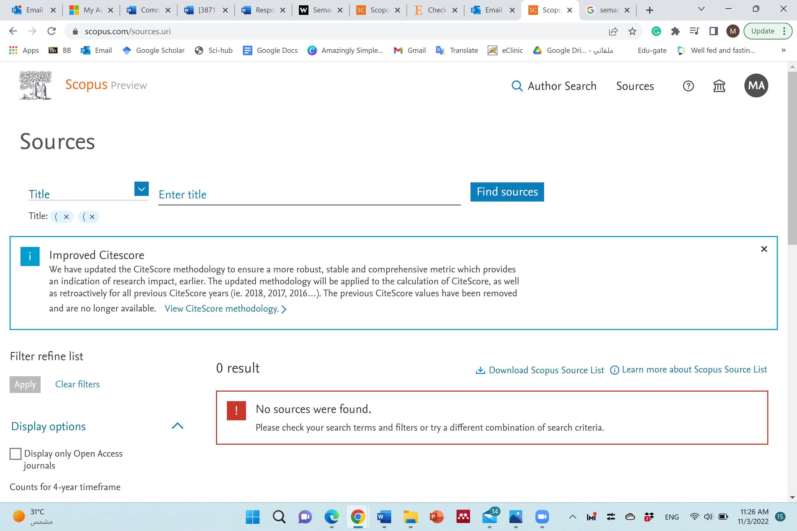 | 0 | 3/11/2021
Science Direct | (“glucagon-like peptide” 1 OR “GLP 1” OR agonist OR “liraglutide “OR “saxenda”) AND (“obesity”) AND (“satiety”). | 7 | 27/10/2021
 | (“glucagon-like peptide” 1 OR “GLP 1” OR agonist OR “liraglutide “OR “saxenda”) AND (“obesity”) AND (“appetite”). | 7 | 27/10/2021
 | (“glucagon-like peptide” 1 OR “GLP 1” OR agonist OR “liraglutide “OR “saxenda”) AND (“obesity”) AND (“food behaviour” or “eating behaviour”). | 0 | 27/10/2021
 | (“glucagon-like peptide” 1 OR “GLP 1” OR agonist OR “liraglutide “OR “saxenda”) AND (“obesity”) AND (“taste sensitivity” or “sweet taste” or “sweet” or “taste buds” or “tongue” or “sweet taste receptors”). | 0 | 27/10/2021
 | Total, before remove duplicates. | 14
 | Total, after remove duplicates (from Science Direct search). | 12
 | (semaglutide) AND (“obesity”) AND (“satiety”). | 19 | Time restriction filter (27/10/2021)
 | (semaglutide ) AND (“obesity”) AND (“appetite”) | 33 | Time restriction filter (27/10/2021)
 | semaglutide ) AND (“obesity”) AND (food behaviour) OR (eating behaviour) | 0 | Time restriction filter (27/10/2021)
 | (semaglutide ) AND (“obesity”) (taste) OR (sweet taste) OR (taste buds) | 0 | Time restriction filter (27/10/2021)
 | (semaglutide ) AND (“obesity”) (food preference) OR (palatability) | 0 | Time restriction filter (27/10/2021)
 | (semaglutide ) AND (“obesity”) AND (“gastric emptying) | 30 | Time restriction filter (27/10/2021)

Appendix B. Tabulation and Table of studies’ intervention
 | Author | Country | Study  design | Setting | Number of participants | Age | Intervention | Type of GLP-1 | Placebo | Duration | Outcomes | Statistical significance | Tool |  |  | DOI
GLP-1 (Liraglutide)
1 | Saxena et al | 2021  ¹ | United State | RCT, double-blind, two-arm, parallel-group. | Clinical Research Unit (AdventHealth Translational Research Institute) | 56 adults with obesity (28, 26). | 18-75 years old. | Liraglutide (Saxenda®, initiated at a dose of 0.6 mg/day and escalated by 0.6 mg/week up to a maximum of 3.0 mg/day). | Liraglutide | Placebo (0.9% w/v sodium chloride). | 6 weeks | Appetite and gastric emptying. | Appetite: significant differences in appetite (indicating decreased appetite) at weeks 3 and 6, in prospective food consumption in 30-min postprandial at weeks 3 and 6, and for hunger at week 3 only.  Gastric emptying: liraglutide caused a significant delay in gastric emptying when administered over six weeks. There was a statistically significant difference between the groups at week 6 (1 hour, p = 0.0348; 5 hours, p = 0.0152). |  | 100-m VAS +  acetaminophen absorption. | 10.1002/osp4.486
2 | Kadouh et al | 2020.  ² | United States | Single-center, double-blind, parallel group, RCT. | At home,  (Residing within 125 miles of Mayo Clinic were recruited). | 35 adults with obesity, in 2 groups (17, 18). | 18-65 years old. | Liraglutide 3.0mg (escalated by 0.6 mg per week to a maintenance dose of 3.0 mg SQ daily).  Placebo. | Liraglutide | Placebo.  No mention regarding the type of placebo. | 16 weeks. | Appetite and taste. | Appetite: liraglutide group was reported more fullness (P = 0.02) and lower prospective food consumption (P = 0.03) compared to baseline.  Taste: liraglutide resulted in a significantly less desire for sweet, salty, fatty, and savory foods with (p < 0.05) when compared to placebo. |  | Standardized nutrient drink test +  100-m VAS. | 10.1210/clinem/dgz140
3 | Tronieri et al | 2020  ³ | United States | Single-site, open-label, parallel-group RCT. | Academic medical center. | 113 adults with obesity, in 3 groups (36,37,40). | 21-70 years old. | 3 groups: -  1- IBT-alone.  2- IBT-liraglutide: IBT intervention combined with once daily subcutaneous injections of liraglutide 3.0mg/day (Dosing started at 0.6 mg per day and increased by weekly 0.6 mg increments).  3- Multi-component: IBT intervention combined with once daily subcutaneous injections of liraglutide 3.0mg/day (Dosing started at 0.6 mg per day and increased by weekly 0.6 mg increments), combined with the prescription at week 4 of a 12-week, 1000–1200 kcal/day meal replacement diet (this diet included four daily servings of a liquid shake (Health Management Resources–HMR; 160 kcal/shake), a prepackaged entrée (250–300 kcal), 1–2 servings of fruit, and a salad). | Liraglutide. | No placebo. | 52 weeks | Appetite. | Appetite: compared to IBT-alone, IBT-liraglutide participants reported larger reductions at week 6 in hunger (, p = .005) and food preoccupation (p = .002) and larger increases in fullness (p = .001). Significant differences in appetite persisted for 24 weeks but were not maintained at week 52.  IBT-liraglutide participants reported greater improvements in hunger, fullness, and food preoccupation than those assigned to IBT-alone. |  | 100-m VAS. | 10.1038/s41366-019-0348-6
4 | Van Can et al | 2014  ⁴ | Netherlands. | Single-center, RCT, double-blind, two-period incomplete crossover trial. | At home + clinic. | 49 adults with obesity. | 18-75 years old. | 3 groups: -  1- Liraglutide 1.8 mg.  2- Liraglutide 3.0 mg  3- Placebo  were administered once daily by evening subcutaneous injections. | Liraglutide. | Placebo.  No mention regarding the type of placebo. | 2 treatment periods, each consisting of 5 weeks at home plus a subsequent 2-day stay in the clinic, with 6-8 weeks washout period. | Gastric emptying and appetite. | Appetite: all liraglutide doses showed similar effects on appetite, increased satiety and fullness, and decreased hunger. Overall appetite score (indicating reduced appetite), satiety, fullness and ‘100-prospective food consumption' were statistically significantly and similarly increased with liraglutide 1.8 and 3.0 mg groups compared with placebo group  Gastric emptying: significant difference between the liraglutide 3.0 mg group and the placebo group after 1 hour. The liraglutide 3.0 mg group was lower by 23% of gastric emptying than the placebo with (P = 0.007), but there was no significant difference between the placebo group with the liraglutide 1.8 mg group gastric emptying was lower 13% only (P = 0.14). |  | 100-m VAS +  acetaminophen absorption. | 10.1038/ijo.2013.162
GLP-1 (infusion)
5 | Näslund et al | 1998  ⁵ | Sweden | RCT, double-blind fashion on 2 occasions 5 d apart. | Outpatient Obesity Unit at the Karolinska Hospital. | 6 males with obesity. | Mean age 34.7 years old. | GLP-1 infusion (0.75 pmol kgU1 minU1).  Placebo. | GLP-1 (0.75 pmol GLP-1 · kg-1 · min-1;) | Normal saline (9 g/L) | 2 occasions, 5 days apart. | Appetite, gastric emptying, and food Preferences. | Appetite: hunger and prospective consumption of food were significantly lower (P = 0.03, P = 0.04, respectively) with GLP-1 than with placebo (saline infusion). In contrast, feelings of fullness were not significantly different between GLP-1 infusion and placebo (saline infusion) (P = 0.4).  Gastric emptying: was significantly slower during GLP-1 infusion (P = 0.0001)  food Preferences: no significant difference between the GLP-1 analogous (GLP-1 infusion) group and the placebo group in the proportion of food selected as carbohydrate, protein, fat, or low energy from the food-choice list (data not shown). Also, no significant difference in the ratio of high-carbohydrate to high-protein items selected between the GLP-1 analogous (GLP-1 infusion) group and the placebo group (P = 0.7). There was a significant difference in the number of items selected from the food-choice list. It was significantly lower in the GLP-1 analogous (GLP-1 infusion) group than in the placebo group immediately after food intake and four hours after intake (P = 0.03). | 100-m VAS +  acetaminophen absorption+ The forced-choice list |  |  | 10.1093/ajcn/68.3.525
6 | Näslund et al | 1999.  ⁶ | Sweden | RCT, double-blind, cross-over fashion on 2 occasions, 1 week apart. | Obesity Unit at the Huddinge University Hospital. | 8 males with obesity. | Mean 35 years old. | GLP-1 infusion (0.75 pmol /kg/ min) dissolved in 0.9% saline containing 1% albumin (Albumin Kabi 200mgaml)  . | intravenous infusion of GLP-1. | Normal saline. | 2 occasions, 1 week apart. | Appetite, and gastric emptying. | Appetite: GLP-1 infusion during the period between breakfast and lunch and between lunch and dinner decreased the ratings of hunger (P`0.05; P = 0.01 respectively) and prospective consumption (P ` 0.05; P = 0.07 respectively) and fullness (P ` 0.05; P = 0.09 respectively).  Gastric emptying: was significantly slower during GLP-1 infusion (P = 0.0001) | 100-m VAS + paracetamol absorption |  |  | 10.1038/sj.ijo.0800818
7 | Flint et al | 2001  ⁷ | Denmark | RCT, single-blinded, cross-over study. | Clinic | 18 males with obesity (9,9). | 21-57 years old. | GLP-1 infusion (0.75 pmol kg-1 min-1).  Placebo. | GLP-1 | Normal saline. | Two test days were separated by at least 3 weeks and by no more than 8 weeks. | Appetite, , gastric emptying and palatability | Appetite: decreased the ratings of hunger and prospective food consumption decreased in the GLP-1 infusion compared with saline (P ` 0.05).  Gastric emptying: was significantly slower during GLP-1 infusion (P = 0.0001)  No differences were seen in palatability ratings (appearance, smell, taste, after taste and overall palatability) of the breakfast, whereas the appearance of the lunch was found to be more attractive during the GLP-1 infusion (P < 0.05). | 100-m VAS + paracetamol absorption + rating palatability. |  |  | 10.1038/sj.ijo.0801627
8 | Näslund et al | 2004  ⁸ | Sweden | RCT, cross-over, double-blind. | Clinic | 17 adults with obesity. | 18-65 years old. | GLP-1 infusion (45 to 75 pmol/kg per h).  Two methods of administration for each GLP-1 and Placebo: prandial subcutaneous injections (PSI) and continuous subcutaneous infusion (CSI).  Subjects received:  Recombinant glucagon-like peptide-1 (rGLP-1) or saline as a continuous subcutaneous infusion  or rGLP-1 or saline as prandial subcutaneous injections for 5 d in a row, with a wash-out period of 9 d in between. | GLP-1 infusion | Normal saline | 5 days for each intervention. | Appetite, and gastric emptying. | Appetite: group PSI reported increased satiety ratings compared with the placebo group after day one (P=0·03), but after day five, they didn’t find significant differences in satiety. Group CSI has no effects on satiety and hunger.  Gastric emptying: gastric emptying rate was reduced during both PSI (P,0·001) and CSI (P,0·05) treatment. However, it was more effective and faster with the PSI of GLP-1. | 100-m VAS +  paracetamol absorption. |  |  | 10.1079/BJN20031064
9 | Bergmann at el | 2019.  ⁹ | Denmark | RCT, double-blind, crossover study. | Clinical Metabolic Physiology, Steno Diabetes Center Copenhagen, Gentofte Hospital, Hellerup, Denmark | 17 males with obesity/overweight. | 25-70 years old. | Four groups:  - IIGI+ GIP (4 pmol kg−1 min−1).  - IIGI+ GLP-1 (1 pmol kg−1 min−1).  - IIGI+ GIP+ GLP-1 (4 and 1 pmol kg−1 min−1).  - IIGI+ saline. | GLP-1 infusion | Normal saline (154 mmol/l NaCl). | 5 days. | Appetite. | No significant differences among the interventions were observed for the appetite profile at the beginning of the study. But at the end of the study, hunger and prospective food consumption were significantly lower (P= 0.031, P= 0.028 respectively) in the groups that used GLP-1 infusion as part of the intervention than the placebo group. | 100-m VAS. |  |  | 10.1007/s00125-018-4810-0
GLP-1 (Semaglutide)
10 | Blundell et al | 2017  ¹⁰ | United Kingdom | RCT, double‐blind, , 2‐period crossover trial. | At home. | 28 adults with obesity. | ≥18 years old. | Semaglutide (1.34 mg/mL).  placebo. | Semaglutide | Placebo.  No mention regarding the type of placebo. | 12 weeks.  a wash-out period of 5–7 weeks | Appetite and food preferences. | Appetite: the overall appetite suppression score indicates decreases in appetite (P = 0.0023).  Food references: the study evaluated the effect of semaglutide on hedonics (food preferences and cravings), indicating a lower liking for high-fat and non-sweet foods (P=0.0016) ²⁵. In addition to lower ratings of wanting high-fat and non-sweet foods (P=0.0203) compared to placebo | 100-m VAS +  validated 16-item short form CoEQ.  +  LFPQ |  |  | 10.1111/dom.12932
11 | Hjerpsted et al | 2018  ¹¹ | United Kingdom | RCT, double-blind, 2-period, crossover trial. | In- house stay. | 28 adults with obesity. | ≥18 years old. | Semaglutide subcutaneously once weekly.  The starting dose was 0.25mg (4 weeks), escalating to 0.5 mg (4 weeks) and thereafter to 1.0 mg (4 weeks). | Semaglutide | Placebo.  No mention regarding the type of placebo. | 12-week treatment period.  The 2 treatment periods were separated by a washout period of 5 to 7 weeks. | Gastric emptying. | Gastric emptying: There was no significant difference between treatments for the overall postprandial gastric emptying [95% CI: 0.88; P=1.01])  Overall gastric emptying was not statistically different between treatments.  Semaglutide group was 27% lower gastric emptying during the first hour than the placebo (P = 0.0012). However, there was no significant difference between treatments for overall postprandial gastric emptying (P = 1.01). | Paracetamol concentration. |  |  | 10.1111/dom.13120
12 | Friedrichsen et al | 2021¹² | Germany | RCT, single‐center, double‐blind, parallel‐group. | At home. | 72 adults with obesity (36,36). | 18-65 years old. | Subcutaneous semaglutide (dose-escalated to 2.4 mg/week). | Semaglutide | Placebo.  No mention regarding the type of placebo. | 20 weeks. | Appetite, gastric emptying, and food preferences. | Appetite: the overall postprandial appetite suppression score with the semaglutied group (p = 0.001). Increases in fullness and satiety and decreases in hunger and prospective food consumption with the semaglutide group compared to the placebo (P <0.02).  Gastric emptying: subcutaneous semaglutide (dose-escalated to 2.4 mg/week) for 20 weeks. No differences were found between semaglutide and placebo (P = 0.8474)  Food reference: significantly less craving for sweet, savory, and dairy products after 20 weeks of semaglutide intervention compared to placebo (P <0.05) | 100-m VAS.  +  paracetamol absorption.  +  CoEQ |  |  | 10.1111/dom.14280

 | Study | Intervention
1 | Tronieri et al | 2020 | A combination of intensive behavioral therapy (IBT) and liraglutide (once daily subcutaneous injections 3.0mg daily for 52 weeks, dosing started at 0.6 mg per day and increased by 0.6 mg weekly)
2 | Van Can et al | 2014 | Liraglutide of 1.8 and 3.0 mg (once daily for 5 weeks, dosing started at 0.6 mg per day and increased by 0.6 mg weekly)
3 | Kadouh et al | 2020. | Liraglutide of 3 mg (once daily for 16 weeks, dosing started at 0.6 mg per day and increased by 0.6 mg weekly)
4 | Näslund et al | 1999. | Intravenous infusion of GLP-1 (0.75 pmol/kg/min, on two  occasions, one week apart)
5 | Näslund et al | 1998 | Intravenous infusion of GLP-1 (0.75 pmol/kg/min, on two  occasions, 5 days apart)
6 | Näslund et al | 2004 | Intravenous infusion of GLP-1 (0.75 pmol/kg/min, on two  occasions, 5 days apart)
7 | Saxena et al | 2021 | Liraglutide 3 mg (once daily for 6 weeks, dosing started at 0.6 mg per day and increased by 0.6 mg weekly).
8 | Bergmann at el | 2019. | Intravenous infusion of GLP-1 by prandial subcutaneous injections (76 nmol 30 min before meals, four times daily; a total of 302.4 nmol/24 h) or by continuous subcutaneous infusion (12.7 nmol/h; a total of 304.8 nmol/24 h) for 5 days
9 | Blundell et al | 2017 | Semaglutide 1.34 mg/mL (once-weekly subcutaneous semaglutide for 12 weeks, dosing he starting dose was 0.25 mg (4 weeks), escalating to 0.5 mg (4 weeks) and then 1.0 mg (4 weeks))
10 | Flint et al | 2001 | GLP-1 infusion (0.75 pmol/kg/min two test days were separated by at least three weeks)
11 | Friedrichsen et al | 2021 | Semaglutide 2.4 mg (Once weekly 20 weeks, initially undergoing a 16‐week dose‐escalation consisting of 0.25, 0.5, 1.0 and 1.7 mg once weekly for 4 weeks each, followed by 2.4 mg for five doses; 21 doses in total over 20 weeks dose-escalated to 2.4 mg/week).
12 | Hjerpsted et al | 2018 | Semaglutide (once-weekly for 12 weeks, the starting dose was 0.25 mg (4 weeks), escalating to 0.5 mg (4 weeks) and thereafter to 1.0 mg (4 weeks))

Appendix C. Risk of bias tables
- Tronieri et al/ 2020
Bias | Author's judgment | Support for judgment
Random sequence generation (selection bias) | Unclear Risk | Participants were randomized to intensive behavioral therapy alone (IBT-alone)  IBT with liraglutide 3.0 mg/day (IBT-liraglutide) Or IBT-liraglutide combined with a 12-week meal replacement diet (multi-component).  Comment: Uncertain - Randomization methods was not described
Allocation concealment (selection bias) | High Risk | Comment: Not mentioned!
Blinding of participants and personnel (performance bias) | High Risk | “A major limitation, however, of our study concerns the absence of a placebo-control (i.e., IBT combined with placebo or liraglutide in a double-blind fashion)”.
Blinding of outcome assessment (detection bias) | High Risk | “We cannot rule out the possibility that participants’ attributions about the study medication contributed to their reports of perceived changes in appetite. “  Comment: No blinding!
Incomplete outcome data (attrition bias) | High Risk | “Missing values at baseline were due to skipped items: N = 112 completed baseline ratings of fullness after meals and liking of meals; N = 111 rated food preoccupation; and N = 104 rated hungers. P > 0.05 for all comparisons between treatment groups, except as noted by superscript “
Selective reporting (reporting bias) | Low Risk | All prespecified outcomes were reported
Other bias | Unclear risk | Recall bias also could have influenced the accuracy of participants’ appetite ratings in the present study."  Trail completed successfully  No adverse event was reported

- Van Can et al 2014
Bias | Author's judgment | Support for judgment
Random sequence generation (selection bias) | Unclear Risk | “Eligible individuals were randomized to receive two of three possible treatments (liraglutide 1.8 mg, 3.0 mg, or placebo).”.  Comment: probably done!
Allocation concealment (selection bias) | High Risk | Comment: Not mentioned!
Blinding of participants and personnel (performance bias) | Low  Risk | “To maintain blinding, placebo treatment was subdivided into two groups with different injection volumes.”
Blinding of outcome assessment (detection bias) | Low Risk | “Participants and investigators were thus blinded with respect to treatment (liraglutide or placebo) but not dose volume.”
Incomplete outcome data (attrition bias) | Low Risk | Comment: probably reported!
Selective reporting (reporting bias) | Low Risk | All prespecified outcomes were reported include side effect
Other bias | Unclear Risk | No other source bias is shown in this study.

- Kadouh et al/2020
Bias | Author's judgment | Support for judgment
Random sequence generation (selection bias) | Low Risk | “Sub study of a single-center, double-blind, placebo-controlled, parallel group, randomized,  From pilot “Participants were randomly allocated (1:1) by a computer-generated randomization schedule”  Comment: probably done!
Allocation concealment (selection bias) | Low Risk | From pilot: Allocation was concealed from participants and study investigators.  Comment: probably done!
Blinding of participants and personnel (performance bias) | Low Risk | “To maintain blinding, placebo treatment was subdivided into two groups with different injection volumes.”
Blinding of outcome assessment (detection bias) | Low Risk | “Group assignments were blinded to the participants, study staff, and care providers until data were transmitted to the statistician for data lock.”  “A major strength of our study is the double-blind, randomized, placebo-controlled design”
Incomplete outcome data (attrition bias) | Low Risk | Comment: probably reported!
Selective reporting (reporting bias) | Unclear Risk | All prespecified outcomes were reported but the side effect wasn’t mentioned
Other bias | Unclear Risk | No other source bias is shown in this study.

- NaÈslund et al/1999
Bias | Author's judgment | Support for judgment
Random sequence generation (selection bias) | Unclear Risk | “The study was performed in a randomized double-blind, cross-over fashion on two occasions, one week apart. “  Comment: method not mentioned!
Allocation concealment (selection bias) | High Risk | Comment: method not mentioned!
Blinding of participants and personnel (performance bias) | Unclear Risk | The study was performed in a randomized double-blind, cross-over fashion on two occasions, one week apart. “  Comment: method not mentioned!
Blinding of outcome assessment (detection bias) | Unclear Risk | The study was performed in a randomized double-blind, cross-over fashion on two occasions, one week apart.  Comment: probably done!
Incomplete outcome data (attrition bias) | Low Risk | Comment: probably reported!
Selective reporting (reporting bias) | Low Risk | All prespecified outcomes were reported
Other bias | Unclear Risk | No other source bias is shown in this study.

- NaÈslund et al/1998
Bias | Author's judgment | Support for judgment
Random sequence generation (selection bias) | Low Risk | “The study was performed in a randomized, double-blind fashion on 2 occasions 5 d apart. Randomization was performed by the Karolinska Hospital Pharmacy when preparing the solutions for intravenous administration. “  Comment: probably done!
Allocation concealment (selection bias) | High Risk | Comment: method not mentioned!
Blinding of participants and personnel (performance bias) | Unclear Risk | The study was performed in a randomized, double-blind fashion on 2 occasions 5 d apart.  Comment: method not mentioned!
Blinding of outcome assessment (detection bias) | Unclear Risk | “The study was performed in a randomized, double-blind fashion on 2 occasions 5 d apart. - The results of the VAS and food-choice and forced- choice lists were interpreted by a registered dietitian not involved in the project.”  Comment: method not mentioned!
Incomplete outcome data (attrition bias) | Low Risk | All participants completed the visits, no dropout was reported  Comment: probably reported!
Selective reporting (reporting bias) | Low Risk | All prespecified outcomes were reported
Other bias | Unclear Risk | No other source bias is shown in this study.

- NaÈslund et al/2004
Bias | Author's judgment | Support for judgment
Random sequence generation (selection bias) | Unclear risk | Yes, Random allocation "The study design was a randomized cross-over, double-blind, placebo-controlled study"  (Material and methods section)  Comment: Not enough details on randomization process!
Allocation concealment (selection bias) | Unclear risk | Study mention in methodology that it is a double blind, but there is not clarification regarding the concealment  Comment: Not mentioned
Blinding of participants and personnel (performance bias) | Low risk | Subjects received either rGLP-1 or saline CSI or rGLP-1 or saline PSI for five continuous days.  Comments: probably done!
Blinding of outcome assessment (detection bias) | Unclear risk. | Comments: Study mention in methodology that it is a double blind, but there is not clarification regarding the outcome blinding.
Incomplete outcome data (attrition bias) | Unclear risk | Comment: They did not mention the participation procedure (baseline participants and endpoint)!
Selective reporting (reporting bias) | Low risk | All prespecified outcomes were reported, in addition to adverse events. ''No adverse event of GLP injection was observed'‘, "Adverse events Feelings of sickness and abdominal pain were the most frequently reported side effects:". (Results section)  Comments: probably done!
Other bias | High Risk | Comment: There were no flow up for participant presented (to check the withdrawals). And There were more males (13) than female (2), and no reported baseline characteristics.

- Saxena et al/2021
Bias | Author's judgment | Support for judgment
Random sequence generation (selection bias) | Unclear risk | Yes, Random allocation "randomized, double‐blind, placebo‐controlled, two‐arm, parallel‐ group" (methodology)  Comment: Not enough details on randomization process! or there is no clear discerption of randomization method
Allocation concealment (selection bias) | Low risk | "Participants used noise‐canceling headphones and blindfolds during treatment to preserve the blind.", "a pharmacist and a designated administrator were unblinded.", "Each dose was given by the unblinded administrator into a participant's abdomen, thigh, or upper arm." (methodology)  Comments: probably done!)
Blinding of participants and personnel (performance bias) | Low risk | "Liraglutide (Saxenda®, initiated at a dose of 0.6 mg/day and escalated by 0.6 mg/week up to a maximum of 3.0 mg/day) or placebo (0.9% w/v sodium chloride) were administered subcutaneously by pen or syringe injections, respectively. Volumes of placebo injections matched titrated volumes of liraglutide." (methodology)  Comments: probably done!
Blinding of outcome assessment (detection bias) | Low risk | "Randomized, double‐blind, placebo‐controlled, two‐arm, parallel‐ group", " a pharmacist and a designated administrator were unblinded.", " Each dose was given by the unblinded administrator into a participant's abdomen, thigh, or upper arm." (methodology)  Comments: probably done!
Incomplete outcome data (attrition bias) | Low risk | "Of the 60 participants who received the study medication, 56 participants (n = 30, liraglutide; n = 26, placebo) were included in the FAS, and 54 completed the study (n = 28, liraglutide; n = 26 placebo), with six participants discontinuing during the treatment phase." (results section)  So, dropout rate (7/61x100= 11.4%) which considered acceptable for the sample size.  Comment: Probably done!
Selective reporting (reporting bias) | Low risk | All prespecified outcomes were reported, in addition to adverse events. (method &result)  "Vital sign measurements, ECG monitoring, clinical laboratory testing, and reporting of adverse events (AEs)", "AEs were determined by direct observation or spontaneous reporting from participants " (Methods section)  Comment: Probably done!
Other bias | Unclear risk | Comment: Reasons of withdraw due to adverse effect of the intervention. " Reasons for discontinuation were AEs (adverse events) (n= 4, liraglutide) and other reasons (n = 2, placebo)" (Results section)

- Bergmann at el \2019
Bias | Author's judgment | Support for judgment
Random sequence generation (selection bias) | Low risk | Yes, Random allocation "The randomization order followed a prespecified random-numbers table generated from www. random.org"  (Methods section)  Comment: Probably done!
Allocation concealment (selection bias) | Low risk | "The randomization order was blinded for the participants and investigators, and generated independently for each study participant by a third person who was not involved in participant enrolment or data collection"  (Methods section)  Comment: Probably done!
Blinding of participants and personnel (performance bias) | Low risk | "The study was designed as a randomized, double-blind, placebo-controlled, crossover study", "The randomization order was blinded for the participants and investigators and generated independently for each study participant by a third person who was not involved in participant enrolment or data collection. "  (Methods section)  Comment: Probably done!
Blinding of outcome assessment (detection bias) | Low risk | "The randomization order was blinded for the participants and investigators and generated independently for each study participant by a third person who was not involved in participant enrolment or data collection. "  (Methods section)  Comment: Probably done!
Incomplete outcome data (attrition bias) | Low risk | "Twenty participants were included in the study; 18 completed the five interventions, but one participant was excluded from the data analysis because we could not measure a rise in plasma GLP-1 on the day of supposed GLP-1 infusion." (Results section)  So, dropout rate (2/20x100= 10%) which considered acceptable for the sample size.  Comment: Probably done!
Selective reporting (reporting bias) | Low risk | All prespecified outcomes were reported, ''No adverse event of GLP injection was observed'' (method &result)  Comment: Probably done!
Other bias | Unclear risk | Comment: Adverse event has not been mentioned or measured.

- Blundell et al\ 2017
Bias | Author's judgment | Support for judgment
Random sequence generation (selection bias) | Unclear risk | Yes, Random allocation "single-center, randomized, double-blind, placebo-controlled, two-period crossover trial (NCT02079870, EudraCT number: 2013-000012-24)" (MATERIALS AND METHODS section)  Comment: Not enough details on randomization process!
Allocation concealment (selection bias) | Unclear risk | "a single-center, randomized, double-blind, placebo-controlled, two- period crossover trial" (MATERIALS AND METHODS Section)  Comment: Not mentioned
Blinding of participants and personnel (performance bias) | Low risk | "Eligible subjects were randomized 1:1 to one of two treatment sequences: semaglutide–placebo or placebo– semaglutide." (methodology).  "Double (Participant, Investigator)"  https://clinicaltrials.gov/ct2/show/NCT02079870  Comment: probably done!
Blinding of outcome assessment (detection bias) | Unclear risk | "a single-center, randomized, double-blind, placebo-controlled, two- period crossover trial" (MATERIALS AND METHODS Section)  Comment: Not mentioned
Incomplete outcome data (attrition bias) | Low risk | "28 completed both treatment periods of the trial.", "Two female subjects took contraceptives during both treatment periods.", "Two subjects withdrew during treatment period 1 while receiving semaglutide due to gastrointestinal (GI) AEs."  So, dropout rate (2/30x100= 6.6%) which considered acceptable for the sample size. (Results section)  Comment: probably done!
Selective reporting (reporting bias) | Low risk | All prespecified outcomes were reported, ''No adverse event of semaglutide injection was observed'' (method &result)  Comment: probably done!
Other bias | Unclear risk. | No other source bias is shown in this study.

- Flint et al\ 2001
Bias | Author's judgment | Support for judgment
Random sequence generation (selection bias) | Unclear risk | Yes, Random allocation ''The subjects were tested on two different occasions in a placebo-controlled, randomized, single-blinded, cross-over design'' (Subjects and methods section)  Comment: Not enough details on randomization process!
Allocation concealment (selection bias) | Unclear risk | Comment: Not mentioned
Blinding of participants and personnel (performance bias) | Low risk | "Placebo-controlled, randomized ","Half of the subjects had GLP-1 on the test day and half had saline, and vice versa on the second test day"  Comments: probably done!
Blinding of outcome assessment (detection bias) | High  risk | "a single-center, randomized, single-blind, placebo-controlled, crossover trial. " (methodology).  Comments: Lack of blinding.
Incomplete outcome data (attrition bias) | Unclear risk | Comment: They did not mention the participation procedure (baseline participants and endpoint)! (methodology).
Selective reporting (reporting bias) | Unclear risk | All prespecified outcomes were reported. However, adverse effect has not been mentioned (method &result).  Comment: Not mentioned!
Other bias | Unclear risk. | No adverse event assessment and no flow up diagram presented.

- Friedrichsen et al.,2020
Bias | Author's judgment | Support for judgment
Random sequence generation (selection bias) | Low risk | Yes, Random allocation "Subjects were randomized ", "The randomization schedule was generated by the sponsor", "subjects were assigned randomization numbers in ascending numerical order at the trial site" (Materials and methods section)  Comment: probably done!
Allocation concealment (selection bias) | Unclear risk | "The randomization schedule was generated by the sponsor before the trial, and participants were assigned randomization numbers in ascending numerical order at the trial site" (Materials and methods section)  Comment: Can't tell
Blinding of participants and personnel (performance bias) | Low risk | "Subjects were randomized equally to once-weekly s.c. semaglutide 2.4 mg (initially undergoing a 16- week dose-escalation consisting of 0.25, 0.5, 1.0 and 1.7 mg once weekly for 4 weeks each, followed by 2.4 mg for 5 doses; 21 doses in total over 20 weeks) or volume-matched placebo (with matching dose-escalation procedure)" (Materials and methods section)  Comment: probably done!
Blinding of outcome assessment (detection bias) | Unclear  risk | "A single-center, randomized, double-blind, placebo-controlled, parallel-group" (methodology)  Comment: Not mentioned
Incomplete outcome data (attrition bias) | Low risk | "Almost all subjects (97.2%) completed the study; one subject in the semaglutide group withdrew consent before study end, and one subject in the placebo group was withdrawn following an AE (colonic abscess)."  So, dropout rate (2/29x100= 6.8%) which considered acceptable for the sample size.  Comment: probably done!
Selective reporting (reporting bias) | Low risk | All prespecified outcomes were reported, and the adverse effect has been assessed and mentioned. "Safety assessments included adverse event (AE) reporting". (Results section)  Comment: probably done!
Other bias | Unclear risk | No other source bias is shown in this study.

- Hjerpsted et al.,2018
Bias | Author's judgment | Support for judgment
Random sequence generation (selection bias) | Unclear risk | Subjects were randomized 1:1 to 1 of 2 treatment sequences.  Comment: Not mentioned properly
Allocation concealment (selection bias) | Unclear risk | Comment: Not mentioned
Blinding of participants and personnel (performance bias) | Low Risk | Double (Participant, Investigator)  (NCT02079870, EudraCT no. 2013- 000012-24)  Comment: probably done!
Blinding of outcome assessment (detection bias) | Unclear risk | Comment: Not mentioned
Incomplete outcome data (attrition bias) | Low Risk | '' Two subjects withdrew because of gastrointestinal adverse events during the first treatment period while receiving semaglutide, resulting in 28 subjects who completed both treatment periods '' So dropout rate (2/30x100= 6.6%) which considered acceptable for the sample size. (Methodology section)  Comment: probably done!
Selective reporting (reporting bias) | Unclear risk | No specification of the adverse event happened Comment: Not mentioned probably
Other bias | Unclear Risk | No other source bias is shown in this study.

References
1. Saxena AR, Banerjee A, Corbin KD, Parsons SA, Smith SR. Energy intake as a short-term biomarker for weight loss in adults with obesity receiving liraglutide: A randomized trial. Obes Sci Pract. 2021;7(3):281-290. doi:10.1002/osp4.486
2. Kadouh H, Chedid V, Halawi H, Burton DD, Clark MM, Khemani D. GLP-1 Analog Modulates Appetite, Taste Preference, Gut Hormones and Regional Body Fat Stores in Adults with Obesity Hoda. Cad Saude Publica. 2020;12(1):1-30. http://dx.doi.org/10.1016/j.ijpara.2016.09.005%0Ahttp://dx.doi.org/10.1016/j.vaccine.2015.09.060
3. Tronieri JS, Wadden TA, Walsh O, et al. Effects of liraglutide on appetite, food preoccupation, and food liking: results of a randomized controlled trial. Int J Obes. 2020;44(2):353-361. doi:10.1038/s41366-019-0348-6
4. Van Can J, Sloth B, Jensen CB, Flint A, Blaak EE, Saris WHM. Effects of the once-daily GLP-1 analog liraglutide on gastric emptying, glycemic parameters, appetite and energy metabolism in obese, non-diabetic adults. Int J Obes. 2014;38(6):784-793. doi:10.1038/ijo.2013.162
5. Näslund E, Gutniak M, Skogar S, Rössner S, Hellström PM. Glucagon-like peptide 1 increases the period of postprandial satiety and slows gastric emptying in obese men. Am J Clin Nutr. 1998;68(3):525-530. doi:10.1093/ajcn/68.3.525
6. Näslund E, Barkeling B, King N, et al. Energy intake and appetite are suppressed by glucagon-like peptide-1 (GLP-1) in obese men. Int J Obes. 1999;23(3):304-311. doi:10.1038/sj.ijo.0800818
7. Flint A, Raben A, Ersbøll AK, Holst JJ, Astrup A. The effect of physiological levels of glucagon-like peptide-1 on appetite, gastric emptying, energy and substrate metabolism in obesity. Int J Obes. 2001;25(6):781-792. doi:10.1038/sj.ijo.0801627
8. Näslund E, King N, Mansten S, et al. Prandial subcutaneous injections of glucagon-like peptide-1 cause weight loss in obese human subjects. Br J Nutr. 2004;91(3):439-446. doi:10.1079/bjn20031064
9. Bergmann NC, Lund A, Gasbjerg LS, et al. Effects of combined GIP and GLP-1 infusion on energy intake, appetite and energy expenditure in overweight/obese individuals: a randomised, crossover study. Diabetologia. 2019;62(4):665-675. doi:10.1007/s00125-018-4810-0
10. Blundell J, Finlayson G, Axelsen M, et al. Effects of once-weekly semaglutide on appetite, energy intake, control of eating, food preference and body weight in subjects with obesity. Diabetes, Obes Metab. 2017;19(9):1242-1251. doi:10.1111/dom.12932
11. Hjerpsted JB, Flint A, Brooks A, Axelsen MB, Kvist T, Blundell J. Semaglutide improves postprandial glucose and lipid metabolism, and delays first-hour gastric emptying in subjects with obesity. Diabetes, Obes Metab. 2018;20(3):610-619. doi:10.1111/dom.13120
12. Friedrichsen M, Breitschaft A, Tadayon S, Wizert A, Skovgaard D. The effect of semaglutide 2.4 mg once weekly on energy intake, appetite, control of eating, and gastric emptying in adults with obesity. Diabetes, Obes Metab. 2021;23(3):754-762. doi:10.1111/dom.14280

